**续写原文及出处**

**The Wolf at the Door**

By Andy Simmons (Reader’s Digest, April 2020)

Russ Fee was asleep inside his tent last summer when a series of screams jolted him awake. Throwing on his shoes, he ran out to investigate. Fee and his wife were traveling through Canada’s Banff National Park to enjoy its stunning beauty and awesome wildlife. It was the latter he now encountered. Although it was dark, Fee could discern a neighboring tent in shambles. Backing out was a wolf, dragging something in his teeth. That thing was a man.

Moments earlier, Elisa and Matt Rispoli, from New Jersey, were asleep with their two young children when the wolf tore into their tent. “It was like something out of a horror movie,” Elisa posted on Facebook. For three minutes, “Matt threw his body in front of me and the boys and fought the wolf.” At one point, Matt got the upper hand, pinning the wolf to the ground. But the wolf clamped its jaw onto Matt’s arm, set its powerful legs, and began tugging Matt outside “while I was pulling on his legs trying to get him back,” Elisa wrote.

It was then that Russ Fee entered the picture. He ran at the beast, kicking it “like I was kicking in a door,” he told ABC New York. The wolf dropped Matt and emerged from the tent. Wolves are large, Fee told the radio show Calgary Eyeopener. “I felt like I had punched someone that was way out of my weight class.”

Before the wolf could turn its ire on Fee, Matt, his arms bloodied, flew out of the tent to resume the battle. The men pelted the wolf with rocks, forcing it back, then the Fees and the Rispolis fled to the shelter of the Fees’ minivan. An ambulance was called, and Matt was taken to a local hospital suffering puncture wounds and lacerations. He has fully recovered. The wolf was tracked down by park officials and euthanized.

As for Fee, whom Elisa dubbed their guardian angel, he does admit to a fleeting, if less-than-heroic, thought during the heat of battle. The moment the wolf locked eyes with him, Fee says, “I immediately regretted kicking it.”

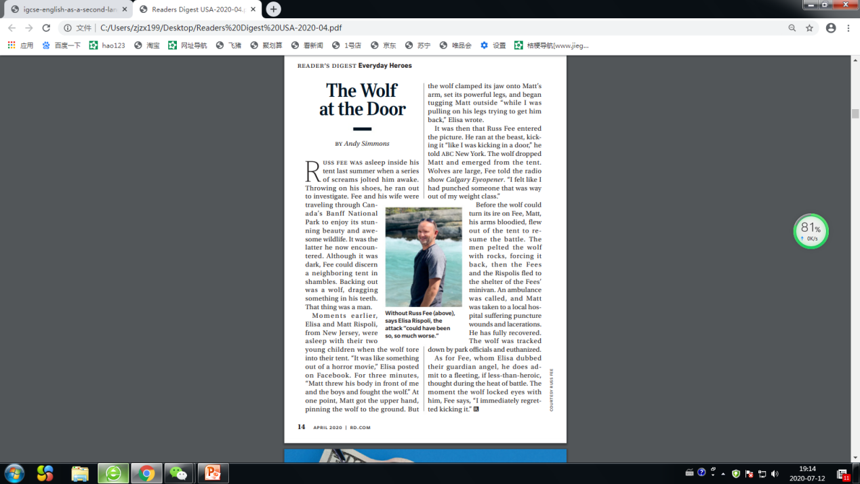

**续写题目：**

读后续写(满分25分）

阅读下面短文，根据所给情节进行续写，使之构成一个完整的故事。

Russ Fee was asleep inside his tent last summer when a series of screams jolted him awake. Throwing on his shoes, he ran out to investigate. Fee and his wife were traveling through Canada’s Banff National Park to enjoy its stunning beauty and awesome wildlife. It was the latter he now encountered(遇到). Although it was dark, Fee could detect a neighboring tent in a mess. Backing out was a wolf, dragging something in his teeth. That thing was a man.

Moments earlier, Elisa and Matt Rispoli, from New Jersey, were asleep with their two young children when the wolf tore into their tent. It was like something out of a horror movie. For three minutes Matt threw his body in front of Elisa and the boys who would stand little chance of running faster than a wolf and fought the wolf with bare hands. At one point, Matt got the upper hand, pinning the wolf to the ground. But the wolf clamped its jaw onto Matt’s arm, set its powerful legs, and began tugging Matt outside while Elisa was pulling on his legs trying to get him back.

It was then that Russ Fee entered the picture. He ran at the beast, kicking it like he was kicking in a door. The wolf dropped Matt and emerged(出现) from the tent. Wolves are large, Fee felt like he had punched someone that was way out of his weight class. He could feel its heavy breath on his face and he could smell the terrible pungent(刺激性的) ordor it emitted, fishy, oily and bloody.

The wolf turned its anger on Fee, exposing his sharp teeth and snarling at him. Terrified, Fee withdrew a bit. Out of the corner of his eyes, he saw his minivan was not far away. Meanwhile, panicked as they were, the two boys concealed themselves at a safe distance from the battle. The elder boy used the satellite phone to call for help.

注意：

1. 所续写短文的词数应为150左右；

2. 至少使用5个短文中标有下划线的关键词语；

3. 续写部分分为两段，每段的开头语已为你写好；

4. 续写完成后，请用下划线标出你所使用的关键词语。

Para 1: *Matt, his arms bloodied, flew out of the tent to resume the battle.* ________________

____________________________________________________________________________________________________________________________________________________________________________________________________________________________________________________________________________________________.

Para 2: *Just at that moment, a police car came, along with an ambulance.*________________

___________________________________________________________________________________________________________________________________________________________________________________________________________________________________________________________________________________.

**Possible version：**

Para1: *Matt, his arms bloodied, flew out of the tent to resume the battle.* Elisa showed great courage, waving her fists at the wolf, shouting and screaming with the intention of intimidating and scaring it away. The men pelted the wolf with rocks, forcing it back, then the Fees and the Rispolis fled to the shelter of the Fees’ minivan. The wolf chased them tightly. Howling wildly, the wolf crashed the van violently and scratched at it with its sharp claws fierecely.

Para2: *Just at that moment, a police car came, along with an ambulance.* Hearing the sirens, the wolf tried to flee, but was tracked down by park officials and euthanized(安乐死). Matt was taken to a local hospital suffering puncture wounds. He soon fully recovered. When Elisa thanked Fee for his heroic, whom Elisa nicknamed their guardian angel, he did admit to a fleeting thought during the heat of battle. The moment the wolf locked eyes with him, Fee said, “I immediately regretted kicking it.”