**The World**（**0501-0531**）材料分析和教学目标：

本次选用的材料：①、*USA Today*的*How effective are blue light glasses?*（ 蓝光眼镜是智商税吗？）②、*Reader’s Digest*的*News From the WORLD OF MEDICINE* （医学新知）③、*The Washington Post*的*Consumers curb growth in first quarter*（美第一季度经济增速放缓）④*The Times*的*Full-time WFH can make you fat and depressed*（全职居家办公会使人变胖和抑郁？）和⑤BBC的新闻报道。通过语法填空、阅读理解、分析长难句、翻译句子、听力填空和词汇拓展等方式，让学生从多角度提升学习兴趣，提高分析句子、运用词块和听力能力。外媒英语新闻可以让学生体验真实语境下的语言运用，拓展学生的国际视野，了解时事，逐步提升跨文化沟通能力，形成正确的世界观、人生观和价值观。

**教学思路：**

**Part 1&2: News Report 1 *USA Today* (May 20, 2024 P2A)**

**How effective are blue light glasses? 蓝光眼镜是智商税吗？**

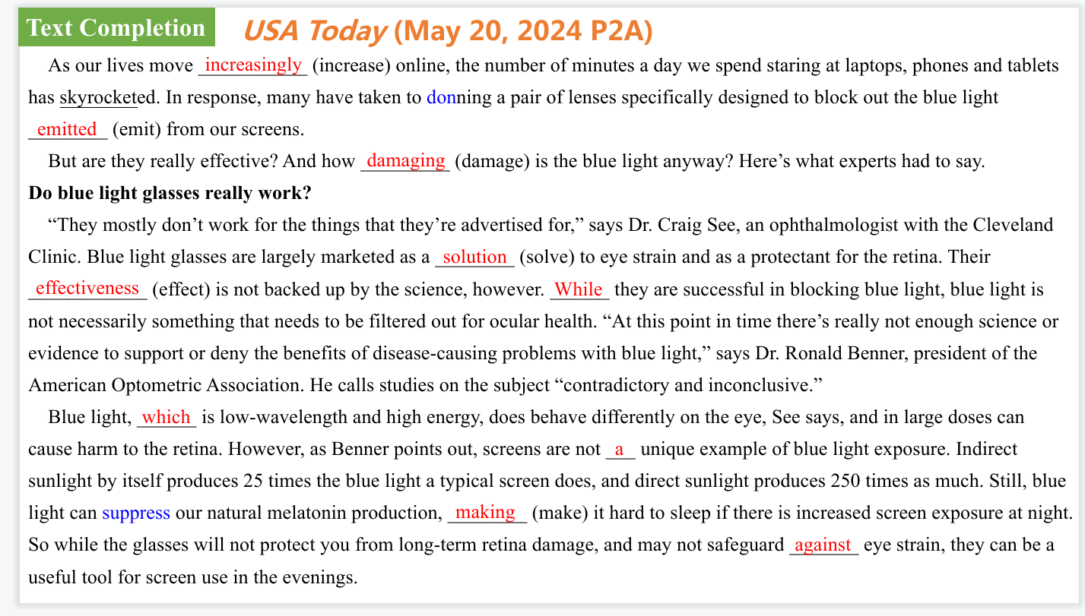

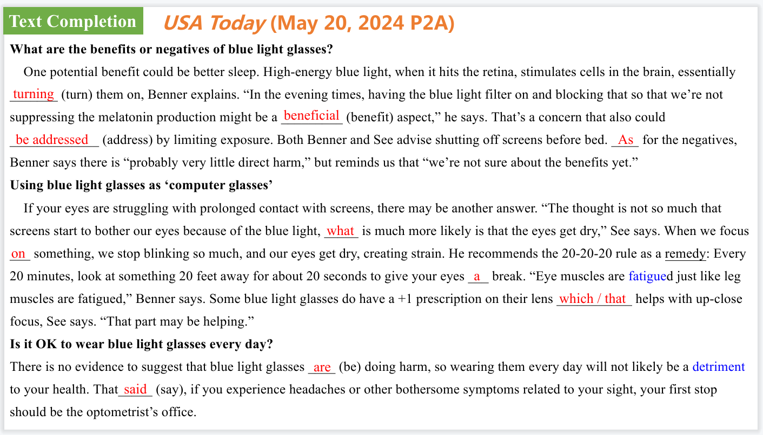

【设计意图】通过语篇填空的形式帮助学生理解新闻的主要内容，同时训练语言语法的运用能力：在语篇的视角下如何正确使用所给词汇，根据语法规则确定词汇的正确形式，使得文章通顺，激活学生的思维和语言。该新闻主题语境是关于“人与社会”中“科学与技术”这一子主题，通过学习让学生了解关于蓝光眼镜的知识。

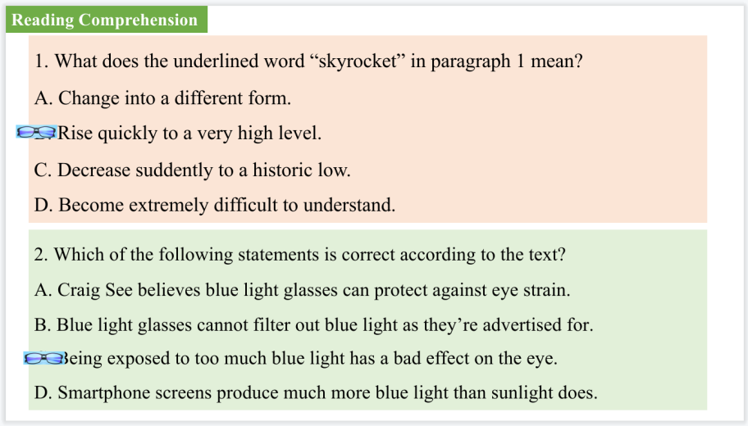

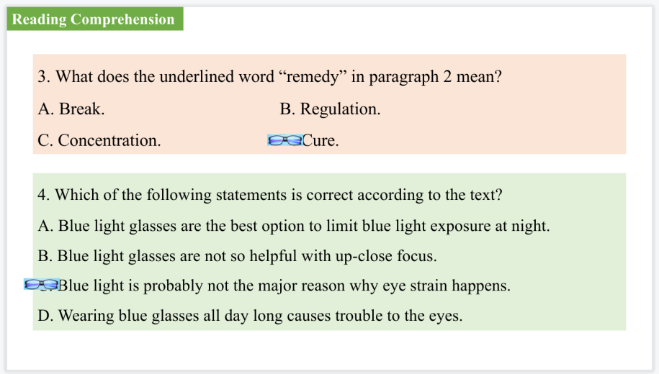

【设计意图】通过阅读理解的形式帮助学生理解新闻的主要内容。



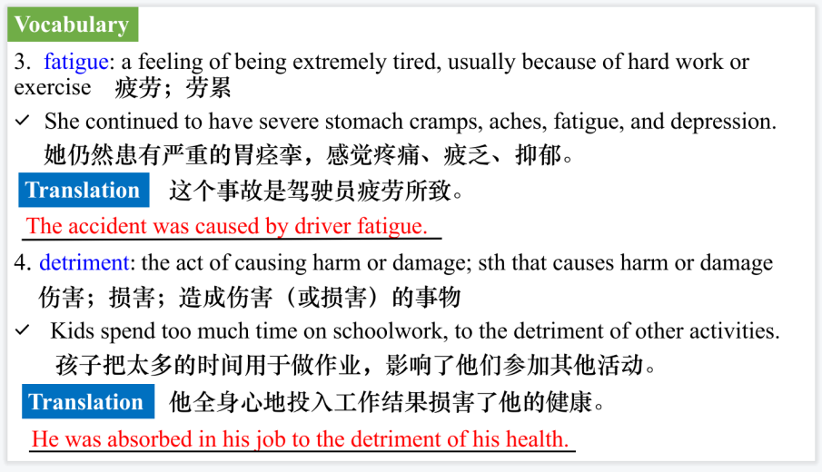

【设计意图】对文本中的词汇进行解读，并通过翻译句子对其进行巩固。

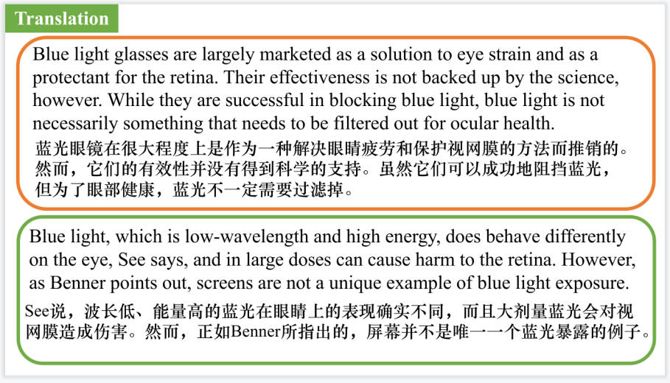

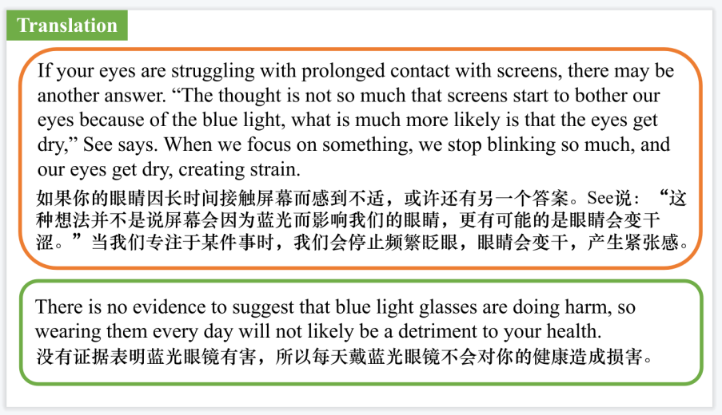

【设计意图】对文中的四个句子进行翻译练习，对其中单词、词组、句法进行巩固并关注句子结构。

**Part 3: News Report 2 *Reader’s Digest* (June, 2024 P35)**

**News From the WORLD OF MEDICINE 医学新知**

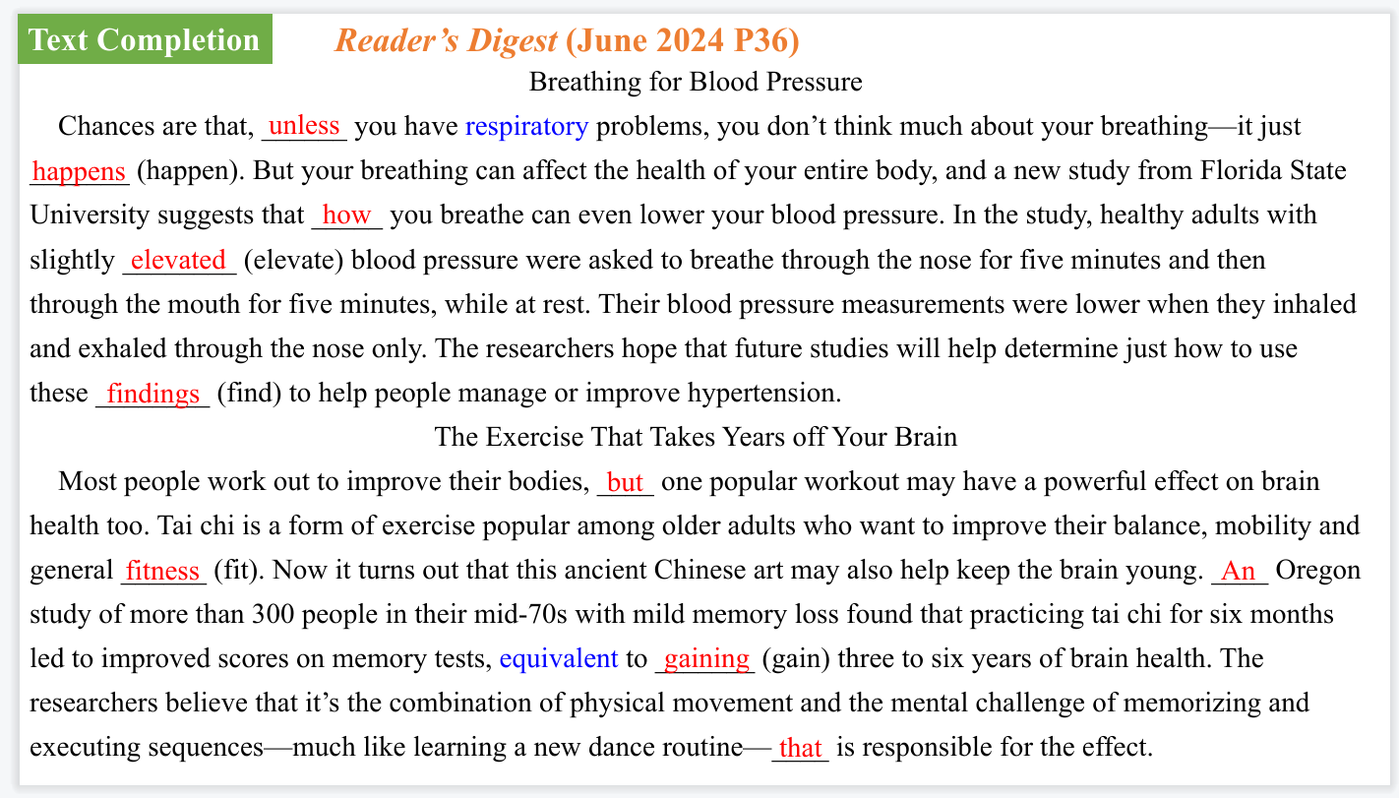

【设计意图】通过语篇填空的形式帮助学生理解新闻的主要内容，同时训练语言语法的运用能力：在语篇的视角下如何正确使用所给词汇，根据语法规则确定词汇的正确形式，使得文章通顺，激活学生的思维和语言。该新闻主题语境是关于“人与社会”中“科学与技术”这一子主题，通过学习让学生了解一些医学新知。



【设计意图】对文本中的词汇进行解读，并通过翻译句子对其进行巩固。

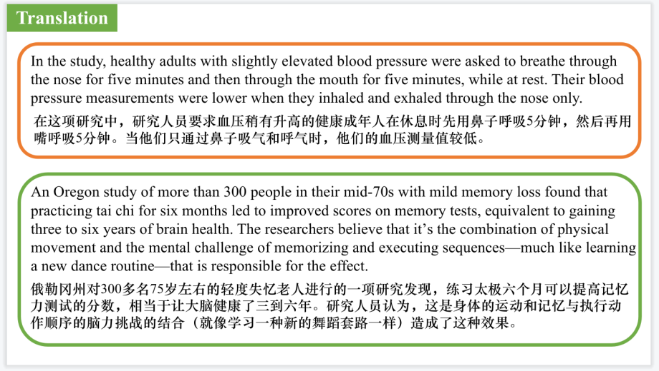

【设计意图】对文中的两个句子进行翻译练习，对其中单词、词组、句法进行巩固并关注句子结构。

**Part 4: News Report 3 *The Washington Pos*t (May 31st, 2024 A14)**

**Consumers curb growth in first quarter 美第一季度经济增速放缓**

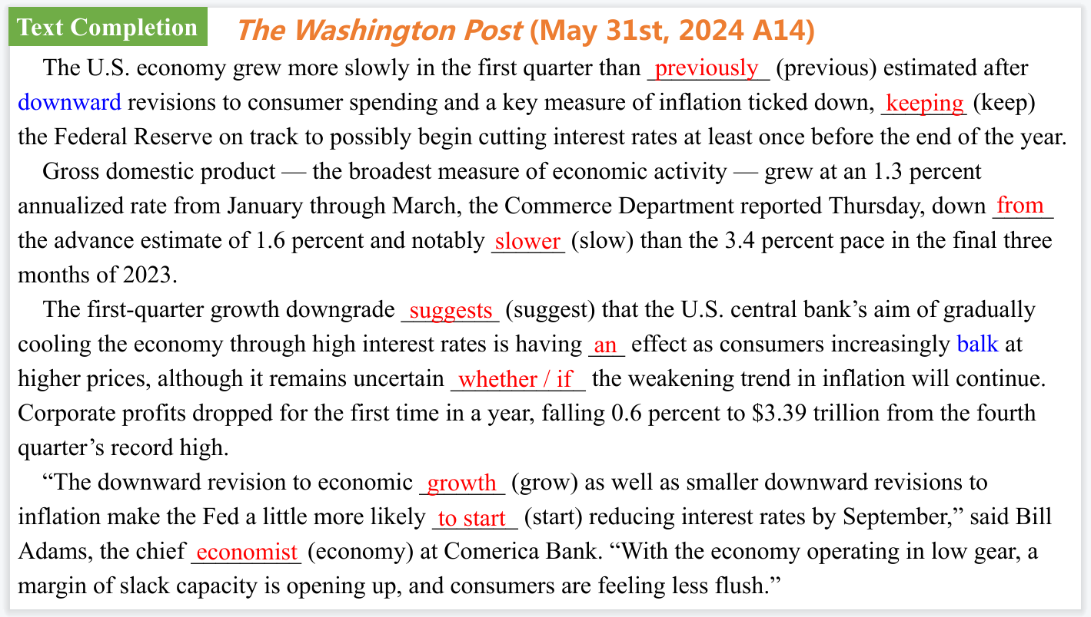

【设计意图】通过语篇填空的形式帮助学生理解新闻的主要内容，同时训练语言语法的运用能力：在语篇的视角下如何正确使用所给词汇，根据语法规则确定词汇的正确形式，使得文章通顺，激活学生的思维和语言。该新闻主题语境是关于“人与社会”中“社会热点问题”这一子主题，通过学习让学生了解美国的经济现状。

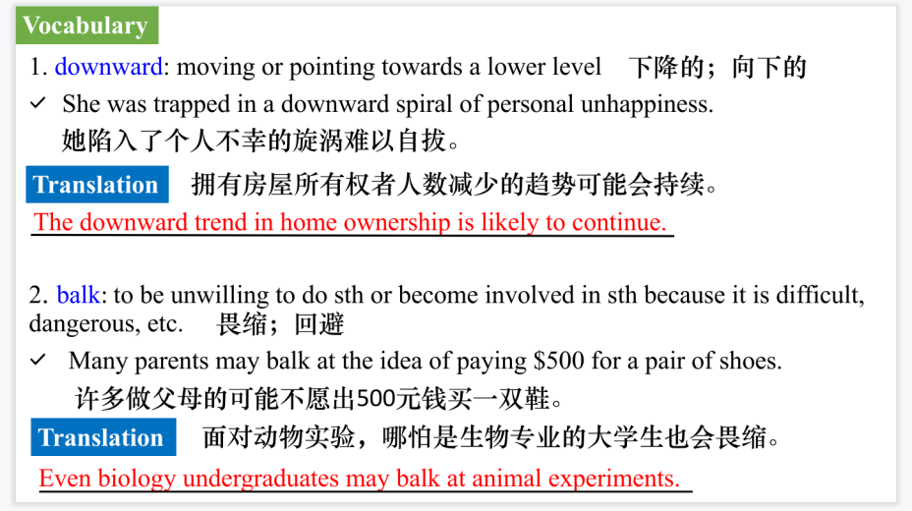

【设计意图】对文本中的词汇进行解读，并通过翻译句子对其进行巩固。

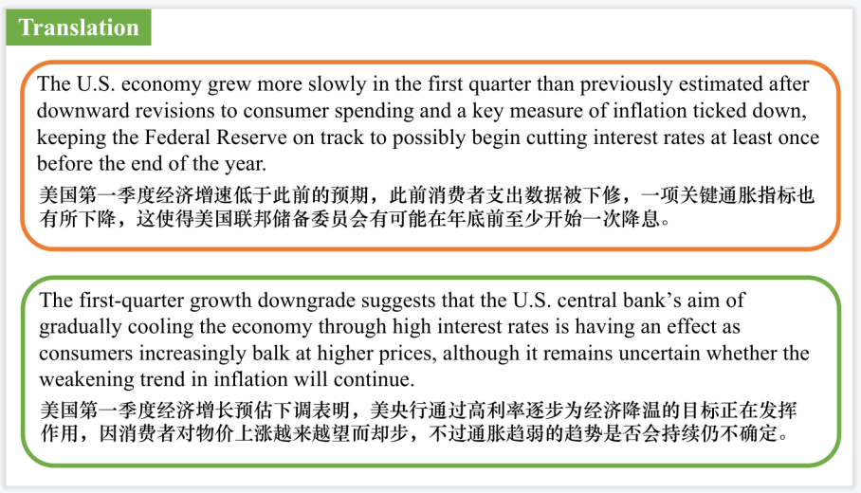

【设计意图】对文中的两个句子进行翻译练习，对其中单词、词组、句法进行巩固并关注句子结构。

**Part 5: News Report 4 *The Times (May 25, 2024 P4)***

**Full-time WFH can make you fat and depressed**

**全职居家办公会使人变胖和抑郁？**

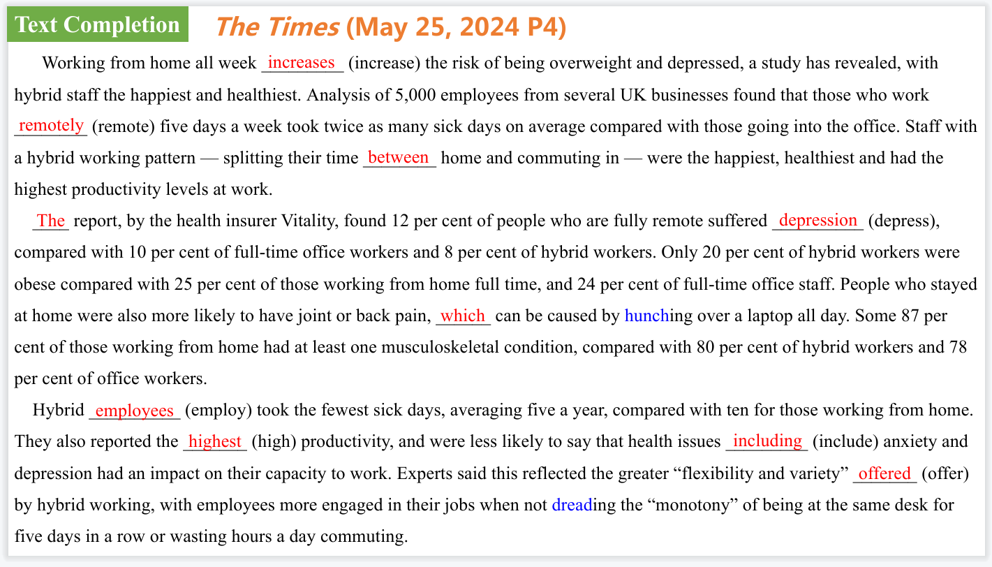

【设计意图】通过语篇填空的形式帮助学生理解新闻的主要内容，同时训练语言语法的运用能力：在语篇的视角下如何正确使用所给词汇，根据语法规则确定词汇的正确形式，使得文章通顺，激活学生的思维和语言。该新闻主题语境是关于“人与社会”中“社会热点问题”这一子主题，通过学习让学生了解关于全职居家办公会使人变胖和抑郁的新发现。



【设计意图】对文本中的词汇进行解读，并通过翻译句子对其进行巩固。

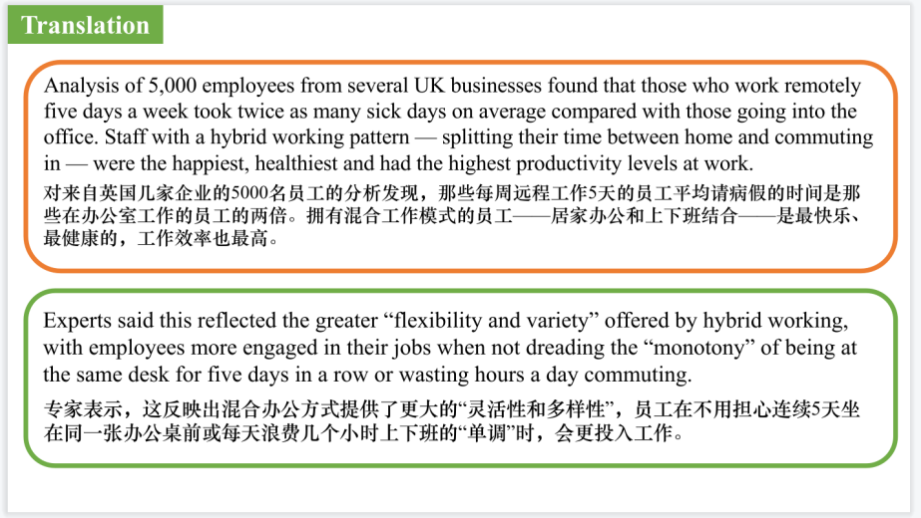

【设计意图】对文中的两个句子进行翻译练习，对其中单词、词组、句法进行巩固并关注句子结构。

**Part 6: BBC News 05/31/2024**



【设计意图】听一则材料，通过听力填空的方式理解文本，考察听力辨识词汇的能力。



【设计意图】对文本中的词汇进行解读，并通过翻译句子对其进行巩固。



【设计意图】对文中的两个句子进行翻译练习，对其中单词、词组、句法进行巩固并关注句子结构。

附：外刊原文

**Part 1&2: News Report 1 *USA Today* (May 20, 2024 P2A)**

**How effective are blue light glasses? 蓝光眼镜是智商税吗？**

As our lives move increasingly online, the number of minutes a day we spend staring at laptops, phones and tablets has skyrocketed. In response, many have taken to donning a pair of lenses specifically designed to block out the blue light emitted from our screens.

But are they really effective? And how damaging is the blue light anyway? Here’s what experts had to say.

**Do blue light glasses really work?**

“They mostly don’t work for the things that they’re advertised for,” says Dr. Craig See, an ophthalmologist with the Cleveland Clinic. Blue light glasses are largely marketed as a solution to eye strain and as a protectant for the retina. Their effectiveness is not backed up by the science, however. While they are successful in blocking blue light, blue light is not necessarily something that needs to be filtered out for ocular health.

“At this point in time there’s really not enough science or evidence to support or deny the benefits of diseasecausing problems with blue light,” says Dr. Ronald Benner, president of the American Optometric Association. He calls studies on the subject “contradictory and inconclusive.”

Blue light, which is low-wavelength and high energy, does behave differently on the eye, See says, and in large doses can cause harm to the retina. However, as Benner points out, screens are not a unique example of blue light exposure. Indirect sunlight by itself produces 25 times the blue light a typical screen does, and direct sunlight produces 250 times as much.

Still, blue light can suppress our natural melatonin production, making it hard to sleep if there is increased screen exposure at night. So while the glasses will not protect you from long-term retina damage, and may not safeguard against eye strain, they can be a useful tool for screen use in the evenings.

**How do blue light glasses work?**

Blue light glasses work by reflecting the light waves coming in so they bounce off the surface. There’s a coating or filter on the lens that reflects the wavelength, or “blue” spectrum of light, preventing it from coming through.

**What are the benefits or negatives of blue light glasses?**

One potential benefit could be better sleep. High-energy blue light, when it hits the retina, stimulates cells in the brain, essentially turning them on, Benner explains.

“In the evening times, having the blue light filter on and blocking that so that we’re not suppressing the melatonin production might be a beneficial aspect,” he says.

That’s a concern that also could be could be addressed by limiting exposure. Both Benner and See advise shutting off screens before bed.

As for the negatives, Benner says there is “probably very little direct harm,” but reminds us that “we’re not sure about the benefits yet.”

**Using blue light glasses as ‘computer glasses’**

If your eyes are struggling with prolonged contact with screens, there may

be another answer.

“The thought is not so much that screens start to bother our eyes because of the blue light, what is much more likely is that the eyes get dry,” See says. When we focus on something, we stop blinking so much, and our eyes get dry, creating strain.

He recommends the 20-20-20 rule as a remedy: Every 20 minutes, look at something 20 feet away for about 20 seconds to give your eyes a break.

“Eye muscles are fatigued just like leg muscles are fatigued,” Benner says.

Some blue light glasses do have a +1 prescription on their lens which helps with up-close focus, See says. “That part may be helping.”

**Do blue light glasses help with headaches?**

Like with other purported benefits to the frames, there is not enough evidence to strongly confirm this claim.

“If you’re getting headaches while staring at screens, the first thing I would recommend is people seek out their local optometrist to get their eyes checked,” Benner advises.

It may be that you’re experiencing a focusing issue or an uncorrected astigmatism.

Blue-blocking lenses may help with fatigue, he says, and anti-glare filters can do the same, but a persistent problem should be addressed with a doctor.

**Is it OK to wear blue light glasses every day?**

There is no evidence to suggest that blue light glasses are doing harm, so wearing them every day will not likely be a detriment to your health.

That said, if you experience headaches or other bothersome symptoms related to your sight, your first stop should be the optometrist’s office.

**What is macular degeneration?**

Macular degeneration is a condition in which a small part of the back of the eye that focuses on facial recognition and reading is damaged and vision becomes greatly inhibited. That part of the eye has a very specific design, and if it is altered vision can become significantly impaired.

Smoking is a big factor in macular degeneration, Benner says, but blue light is more of a question mark.

While it could increase macular degeneration and cataract development, “the studies have been inconclusive and basically contradictory at times,” he eplains.

**Part 3: News Report 2 *Reader’s Digest* (June, 2024 P35)**

**News From the WORLD OF MEDICINE 医学新知**

Breathing for Blood Pressure

Chances are that, unless you have respiratory problems, you don’t think much about your breathing—it just happens. But your breathing can affect the health of your entire body, and a new study from Florida State University suggests that how you breathe can even lower your blood pressure. In the study, healthy adults with slightly elevated blood pressure were asked to breathe through the nose for five minutes and then through the mouth for five minutes, while at rest. Their blood pressure measurements were lower when they inhaled and exhaled through the nose only. The researchers hope that future studies will help determine just how to use these findings to help people manage or improve hypertension.

The Exercise That Takes Years off Your Brain

Most people work out to improve their bodies, but one popular workout may have a powerful effect on brain health too. Tai chi is a form of exercise popular among older adults who want to improve their balance, mobility and general fitness. Now it turns out that this ancient Chinese art may also help keep the brain young. An Oregon study of more than 300 people in their mid-70s with mild memory loss found that practicing tai chi for six months led to improved scores on memory tests, equivalent to gaining three to six years of brain health. The researchers believe that it’s the combination of physical movement and the mental challenge of memorizing and executing sequences—much like learning a new dance routine—that is responsible for the effect.

**Part 4: News Report 3 *The Washington Pos*t (May 31st, 2024 A14)**

**Consumers curb growth in first quarter 美第一季度经济增速放缓**

The U.S. economy grew more slowly in the first quarter than previously estimated after downward revisions to consumer spending and a key measure of inflation ticked down, keeping the Federal Reserve on track to possibly begin cutting interest rates at least once before the end of the year.

Gross domestic product — the broadest measure of economic activity — grew at an 1.3 percent annualized rate from January through March, the Commerce Department reported Thursday, down from the advance estimate of 1.6 percent and notably slower than the 3.4 percent pace in the final three months of 2023.

The first-quarter growth downgrade suggests that the U.S. central bank’s aim of gradually cooling the economy through high interest rates is having an effect as consumers increasingly balk at higher prices, although it remains uncertain whether the weakening trend in inflation will continue. Corporate profits dropped for the first time in a year, falling 0.6 percent to $3.39 trillion from the fourth quarter’s record high.

“The downward revision to economic growth as well as smaller downward revisions to inflation make the Fed a little more likely to start reducing interest rates by September,” said Bill Adams, the chief economist at Comerica Bank. “With the economy operating in low gear, a margin of slack capacity is opening up, and consumers are feeling less flush.”

**Part 5: News Report 4 *The Times (May 25, 2024 P4)***

**Full-time WFH can make you fat and depressed**

**全职居家办公会使人变胖和抑郁？**

Working from home all week increases the risk of being overweight and depressed, a study has revealed, with hybrid staff the happiest and healthiest.

Analysis of 5,000 employees from several UK businesses found that those who work remotely five days a week took twice as many sick days on average compared with those going into the office. Staff with a hybrid working pattern — splitting their time between home and commuting in — were the happiest, healthiest and had the highest productivity levels at work.

The report, by the health insurer Vitality, found 12 per cent of people who are fully remote suffered depression, compared with 10 per cent of full-time office workers and 8 per cent of hybrid workers. Only 20 per cent of hybrid workers were obese compared with 25 per cent of those working from home full time, and 24 per cent of full-time office staff. People who stayed at home were also more likely to have joint or back pain, which can be caused by hunching over a laptop all day. Some 87 per cent of those working from home had at least one musculoskeletal condition, compared with 80 per cent of hybrid workers and 78 per cent of office workers.

Hybrid employees took the fewest sick days, averaging five a year, compared with ten for those working from home. They also reported the highest productivity, and were less likely to say that health issues including anxiety and depression had an impact on their capacity to work. Experts said this reflected the greater “flexibility and variety” offered by hybrid working, with employees more engaged in their jobs when not dreading the “monotony” of being at the same desk for five days in a row or wasting hours a day commuting.

Neville Koopowitz, chief executive of Vitality, said: “Employers need to strike the balance and there are tangible benefits to spending some time each week in the office.”