**M3U5 The Value Of Money**

**Reading for Writing**

**Teaching Objectives：**

By the end of the class, students will be able to

1. master following new words and phrases: tailor, element, clerk, option, downstairs, plot, in that case, be willing to do, etc.

2. understand what Henry experienced in the tailor shop, and the change of the characters’ feelings.

3. know the main feature of the play, especially the function of the dialogue and the stage direction.

4. write another small play based on the analysis of this play.

**Teaching Important and Difficult Points：**

How to make students work out the change of the characters’ feelings.

How to make students work out the function of the dialogue and the stage direction.

**Teaching Procedures:**

**hundred**

**thousand**

**million**

**____________关于**

**Step 1: Retell the Experience**

Students will be asked to retell the experience of Henry with the help of the pictures and key words:

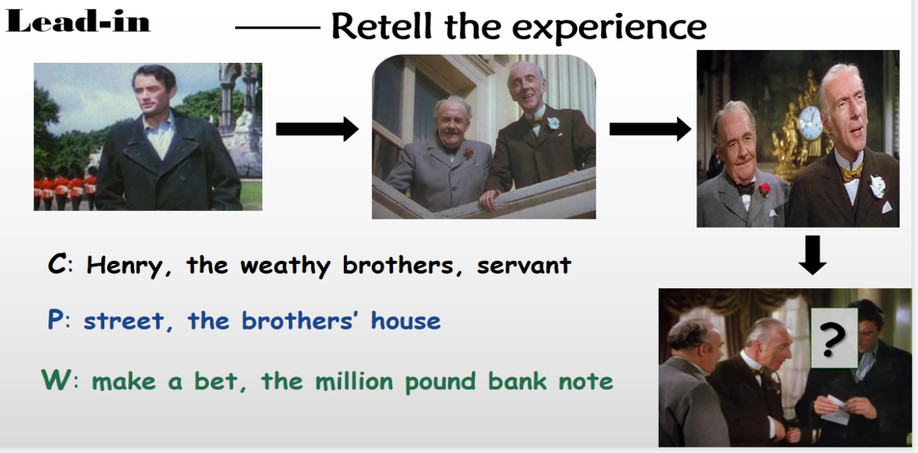

Teachers: Now let’s continue Henry’s journey with the bank notes.

Where would Henry go? (a picture)—— tailor’s shop

What would happen in the tailor’s shop?

**Step 2: Prediction**

**Activity: Match**

1. Student will be asked to recall the six elements of a play first:

(title of play, scene, character names, narration, lines of dialogue, stage directions)

1. Student will be asked to find the parts of the six elements

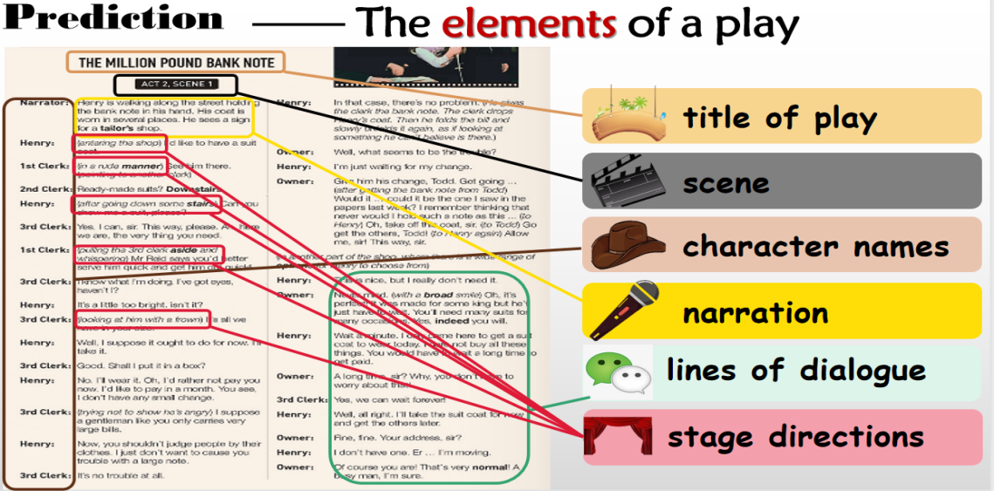

**The teacher comments on this part**: So what happened in the tailor’s shop? Let’s read for more details.

**Step 3: Read for Structure**

Students will be asked to skim the play within 1 minute and answer the questions:

1. Can you divide the scene into three parts, according to the bank note?

( Before showing the note, while showing the note, after showing the note)

1. What’s the main idea of each part?

(Henry was treated badly in the tailors shop, The change of the owner’s and clerks’ attitudes, Henry was treated enthusiastically in the tailors shop)

**The teacher comments on this part**: Wow, the clerks and the tailor changed their attitude so obviously, but what happened detailedly in the scene? Why did their attitude changed so much?

**Step 4: Read for Plots**

1. Students will be asked to read the play carefully and finish the following chart with their own words:

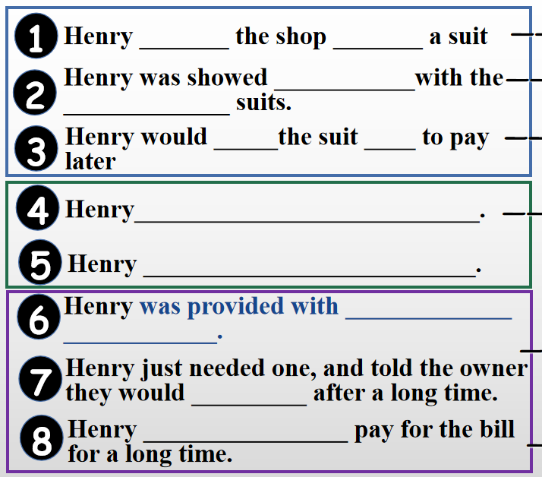

1. Students will be asked to read more carefully and discuss with their partners about the following questions:

What were their attitudes in different plots? Show your opinion with the key information/words.

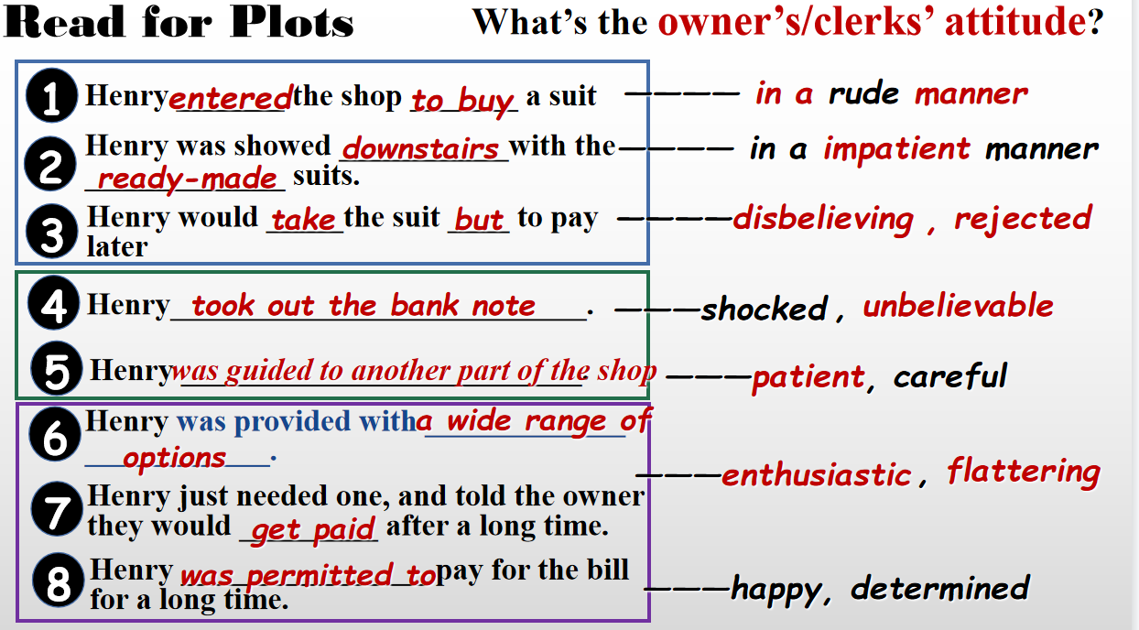

**The teacher comments on this part**: sometimes we can get the hidden message and the emotions of characters from their lines, and the stage directions. And never judge a person from his appearance.

1. Students will be asked to look through the play again and answer the following questions:

How does the writer organize the plots? Or how did the atmosphere change with the development of the plots?

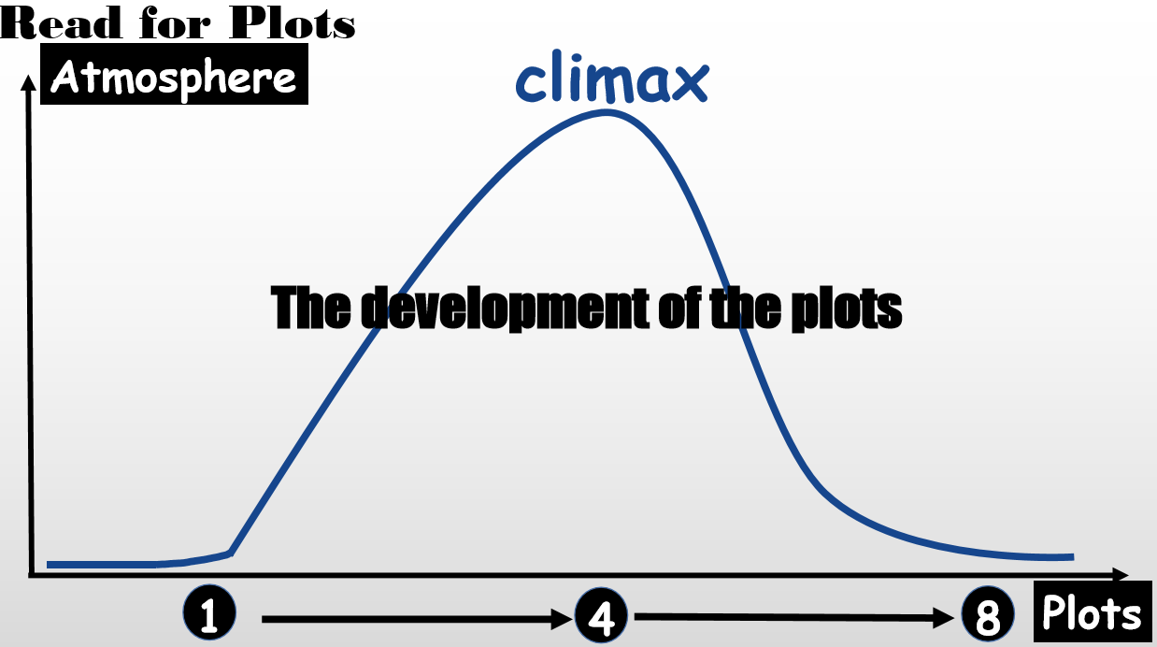

**The teacher comments on this part**: So when organizing a play, we should also pay attention to the atmosphere in different plots. Now it’s your turn to write another scene of the play.

**Step 5: Writing**

After leaving the tailor shop, Henry wanted to have his hair cut, so what would happen to Henry in the barbershop? Students will be asked to discuss and then write a short play with the help of the following clues

**1. Make a list of the characters.**

**2. Make an outline of the scenes(B--W--A) .**

**4. The dialogue happened among the characters.**

**3. The change of the characters’ feeling in different scenes.**

**5. The stage direction you may give.**

1. **The Million Pound Bank Note**
2. **Act1 Scene 5**
3. **Narrator:…**
4. **Henry: …**
5. **Character A: …**
6. **Henry:…**
7. **Character B: …**
8. **(stage direction)**
9. **...**

**Part of my version**

**N:** After leaving the tailor’s shop, Henry keeps walking along the street with the bank note in hand. When passing a barbershop, he sees his hair like straw. So he walks into it. (putting the note into pocket)

**1st Barber:** (in a normal manner) What can I do for you?

**Henry:** ( point to a famous start’s photo) I want to make my hair look like that one.

**1st Barber:** (in an impatient way) Are you sure? Do you know how much will it take?

**Henry:** I’m sure. Please have my hair cut like this.

**1st Barber:** OK. And Mary, wash his hair, please.

**Mary:** (with a “please” gesture) This way, sir.

**1st Barber:** (walking to another barber) See this man. I bet that he cannot afford the prize. I’m busy now, and I can’t offer him my service.

**2nd Barber:** Me too. Never brother me.

**Mary:** (after washing, and without looking at Henry) This way, sir. Please sit and wait here.

**Henry:** (nearly 15 minutes later). Huh, hello? Who can help to cut my hair?

(A few seconds later)

**3rd Barber:** (hurry to Henry) Sorry, sir? Can I help you?

**Henry:** Yeah, I want to have my hair cut like that one.(point to a famous start’s photo)

**3rd Barber:** Sorry, sir. But I have to tell you the prize of it first. Because I think that it may be a little expensive for you.

**Henry:** (raise his eyebrow) Yeah?

**3rd Barber:** It’s a little expensive. You may have to pay at least 50 dollars.

**Henry:** Thanks for telling me this. But I think maybe I can. (Then, he took out the bank note, unfold it on the table)

...