长郡中学2023级高一入学检测试卷

英 语

时量：90分钟 满分：100分

I.阅读(共两节，满分40分)

第一节(共15小题；每小题2分，满分30分)阅读下列短文，从每题所给的A、B、C、D四个选项中选出最佳选项。

A

A WONDERFUL NIGHT AT CHANGSHA AQUARIUM(海洋馆)

Have you ever seen sea animals at night? What do they do? Eat? Sleep? Swim? Let's go and enjoy the happy time.Time:6:30 p.m.～8:30 p.m.on Saturday.

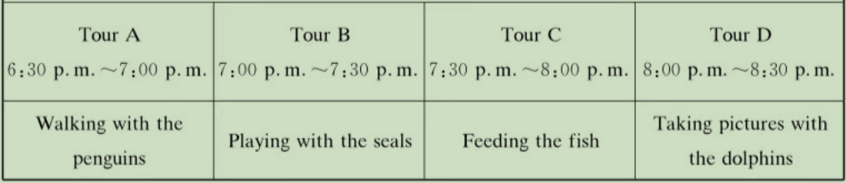

* You can enjoy dinner at our restaurant under the water from 6:00p.m. to 6:30 p.m.

*You can't eat anything while you are watching the sea animals.

*Each tour costs 15 yuan. You can buy the tickets at the gate of the aquarium.

*You can decide which tour you will join after you arrive at the aquarium.

1. If you want to enjoy 4 tours, how much will you pay for them?

A. 15 yuan. B. 30 yuan. C. 45 yuan. D. 60 yuan.

2. What can't you do while you are watching the sea animals?

A. Feed the fish. B. Eat food.

C. Take pictures. D. Walk with the penguins.

3. How long can you enjoy the activities at the aquarium at most in on enight?

A. Half an hour. B. One hour.

C. One and a half hours. D. Two hours.

B

Energy is the ability to do work. Solar energy comes from the Sun.There is also energy that comes from wind and water.

But do you know that energy can come from people, too? When you pedal a bike, you produce energy. You use your legs to push the pedals. Your energy is transferred(转移)to the bike. That makes the bike move.

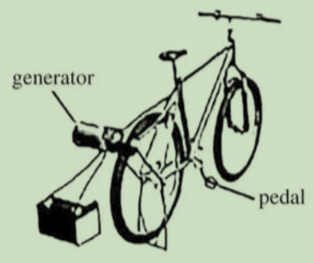

Now imagine riding your bike to create enough power to run a computer. Some students at one school did just that! They jumped on bikes connected to generators(发电机)and pedaled in place. Soon they were producing electricity. This energy is needed to run their computers.

Here is how bicycle-powered energy works. When a student pedals the bike, the back wheel spins(旋转). The wheel spins the generator.The generator produces electricity. As long as a student pedals the bicycle, electricity moves through the generator. The electricity can be used right away. This energy can also be stored and used later.

People use **bicycle-powered energy** to run small devices(设备)such as small televisions and fans. They often use less than 100 watts per hour. However, it would be a mistake to use pedal power to run a fridge. This large machine often uses more than 700 watts per hour.The electricity for these machines comes from power lines overhead or underground.

Pedal power can be seen in schools, gyms, and homes. What a fun way to provide electricity!

4. How does the writer lead into the topic "bicycle-powered energy"in Paragraph 2?

B. By telling a joke.

A. By asking a question.

D. By making a survey.

C. By using an old saying.

5. What is Paragraph 5 mainly about?

A. The future of new energy.

B. The forms of world's energy.

C. Producing bicycle-powered energy.

D. Using bicycle-powered energy.

6. What do we know about bicycle-powered energy?

A. It can't be seen in schools.

B. It can be stored and used later.

C. It comes from wind and water.

D. It's from power lines overhead.

C

People believe that every word has its correct meaning(s). When we are not sure, we usually check online, or turn to our teachers or dictionaries. But do you know how dictionaries were made in the past?

Dictionary writers first read the important books of the period or the subject that the dictionary was about. As they read, they copied necessary information on cards: interesting words, common words—both in their daily uses and unusual uses, and also the sentences where they were used. That is to say, the words, along with the uses of each word, were collected. For a really big dictionary, millions of such cards were collected. This task could last for years. As the cards we recollected, they were put in alphabetical order(A—Z). When this was done, there would be several hundred cards for each single word.

Then, to define(定义)a word, the dictionary writer placed its hundreds of cards before him. He read the cards closely, threw away some, read the rest again, and divided up the cards according to what he thought were the common uses of the word. Finally, he wrote the definitions, following the hard-and-fast rule: each definition must come from an example on a certain card in front of him.

So, the writing of a dictionary was not a task of inventing meanings of words, but a task of recording their meanings. The writer of a dictionary was a historian, not a law maker.

As time develops, the way of producing dictionaries has greatly changed. Nowadays, we can use online dictionaries too. When choosing our words in speaking or writing, we can be guided by the dictionary.However, we cannot be controlled by it, because new situations, new experiences, new inventions, and new feelings are always pushing us to give new uses to old words.

7. Why did dictionary writers read important books?

A. To know more about the period.

B. To collect words and their uses.

C. To understand different subjects.

D. To learn to use interesting words.

8. Which shows the correct steps of how dictionaries were made in the past?

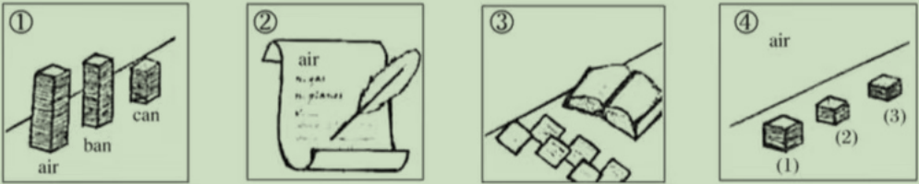

A.①—③—④—② B.①—②—④—③

C.③—①—④—② D.③—④—②—①

9. What can we learn from the passage about dictionary writing in the past?

A. It was long-time hard work.

B. It was a task of inventing and recording.

C. It should be done by historians.

D. It had to use the law-making rules.

10. What does the writer advise us to do when we choose words in communication?

A. Try to create new words.

B. Follow the dictionary strictly.

C. Use online dictionaries instead.

D. Be open to the new uses of words.

D

It is often said the laughter is the best medicine. But researchers at the University of Oxford think the ability to belly laughs(捧腹大笑)was unique to early humans. This, they believe, made our ancestors(祖先)able to form much larger groups.

The researchers first tested the pain thresholds(临界值)of some volunteers. They divided them into two groups. One group was shown15 minutes of comedy videos, while the other was shown boring programs.

Through this experiment, the researchers found that those who had recently experienced belly laughs were able to withstand(忍受)up to10% more pain than they had done before watching the videos. To their surprise, the scientists also found that the other group was less able to with stand pain after watching 15 minutes of the "boring" programs.

Professor Robin Dunbar of Oxford University, who led there search, believed that belly laughs **release** chemicals called endorphins(安多芬)into the body which make us feel less painful.

However, not all comedy programs had such effects, according to Prof Dunbar. For example, though clever stand-up comedy was found to be enjoyable, it had no effect on raising pain thresholds."Things that worked very well were interesting comedies such as Mr. Bean. Situation comedies such as Friends also seemed to be particularly successful,"he added.

In order to measure(测量)endorphin levels, the researchers put a bag of ice on the volunteers' arms to see how long they could withstand them. They found that the greater the increase in pain thresholds, the greater the amount of endorphins produced.

The purpose of Prof Dunbar's study was not to develop a new treatment. Instead, it was to study the role of laughter in the forming of human societies two million years ago.

"The next stage will be to see whether laughing really allows people to keep together and work as a group better and be more friendly towards each other. If that is the case, then it may explain why some two million years ago, the first humans were able to form large communities of up to 100,"Dunbar added.

11. Prof Dunbar's study was to _.

A. test the pain thresholds of humans

B. measure the endorphin levels while laughing

C. develop a new kind of medicine that reduces pain

D. explore the influence of laughter in forming human societies

12.In order to withstand more pain, we'd better .

A. watch some scary films B. watch some beautiful pictures

C. watch some boring programs D. watch some comedy videos

13. The meaning of the underlined word"release"in the passage may be

A. look out B. stand out C. find out D. give out

14. What did the researcher do to measure the level of endorphins?

A. Let the volunteers watch videos.

B. Ask the volunteers to live in the lab.

C. Make the volunteers have medicines.

D. Put ice bags on the volunteers' arms.

15. What can we know from the last paragraph?

A. More experiments about laughter will be carried out.

B. Laughter makes people keep together and work as a group.

C. People who laugh a lot are more friendly towards each other.

D. The first humans could only form small communities less than 100.

第二节(共5小题；每小题2分，满分10分)

阅读下面短文，从短文后的选项中选出能填入空白处的最佳选项。选项中有一项为多余项。

In a video, someone cuts open a coconut(椰子),pours its juice and takes away meat in about five seconds. What does it take to master a skill like that?

Many people see it as a rule that says,"Just spend a lot of time practicing." 16 Many studies have shown that to improve our skills,we cannot just practice, but must use "deliberate(刻意的)practice".

So what is deliberate practice? Imagine you want to become a professional violin player. You can already play some great pieces. Do you get better by only playing those same pieces over and over again? Or do you try to learn new songs? 17 "Deliberate practice"is different from"common practice". It requires feedback(反馈)and constant(不断的)challenges to yourself.

18 Teachers can find mistakes and make corrections. But they cannot be there for us every step of the way. So we must be able to provide our own feedback and learn from our own mistakes. 19 If you are a runner who can run 100 meters in 12 seconds, you can try to achieve the same success in 11 seconds or even 10 seconds. Even if you are already the best in the world at something, your goals to challenge yourself and do better should never disappear.

"Professional"coconut openers can complete their tasks in five seconds. 20 The only difference between them is that professional openers make efforts to constantly improve themselves, while others are just continuing to"practice".

A. But it is not the real reason.

B. Constant challenges are pretty easy.

C. There are others who take much longer.

D. They offer us something that we need.

E. Do you also record yourself and listen for mistakes?

F. Feedback commonly comes from teachers and ourselves.

Ⅱ.语言运用(共三节，满分40分)

第一节(共10小题；每小题1.5分，满分15分)

阅读下面短文，从短文后各题所给的A、B、C、D四个选项中，选出可以填入空白处的最佳选项。

I knew Marty's magic was fake(假的),but I just couldn't prove it.One day I caught a lucky break. At lunch, Marty was going on about how he could make things 21 . He had a ring in one hand and a pencil in the other.

That's when I 22 it: a thin piece of fishing line around the end of the pencil and attached(连接)to Marty's shirt! Sure enough, he made it by sliding(滑动)the ring over the pencil and hanging it from the line. No one else 23 the line, and soon the whole dining hall was cheering. When the crowds were gone, I walked over. It was time to24 the Magic Marty show.

"I know how you did it,"I said, looking him right in the eye.

" 25 ,"Marty replied."But the first law of magic is that..""It was the fishing line."

Marty became 26 . He looked a bit worried. Without all his confidence, he seemed more normal(平常). I suddenly felt bad.

"So, are you going to tell other people?" he asked. I thought about it for a moment. If I did, I would 27be able to prove that Marty's magic was fake. But would that really make me feel happy? What about Marty? He might 28 his new friends. How would that make him feel?

"Nah,"I said."It will be a 29 between you and me."

Marty let out a relieved sigh, and I turned to walk away.

"Wait!"Marty jumped in front of me."You've got a pretty good eye for magic. If you're 30 , I have an idea."

That's how the Magic Marty and Mysterious Matt Lunch Show began.

21. A. disappear B. grow C. float D. change

22. A. saw B. heard C. felt D. smelt

23. A. confirmed B. explained C. noticed D. supported

24. A. watch B.praise C. end D. create

25.A. Indeed B. However C. Maybe D. Anyway

26. A. polite B. silent C. crazy D. curious

27.A. finally B. properly C. easily D. mainly

28.A. make B. leave C. lose D. greet

29.A. secret B. trick C. present D. reward

30. A. surprised B. interested C. satisfied D. impressed

第二节(共10小题；每小题1.5分，满分15分)

阅读下面短文，在空白处填入括号内单词的正确形式。

Frederic Chopin was born in March 1810 near Warsaw in Poland and was one of the greatest musicians in the world. He composed twenty-four short 31 (piece)for the piano called preludes. The longest one, Prelude No.15, is better 32 (know)by its nickname,the"Raindrop"Prelude. How did it get its nickname?

One day in 1838, when Chopin's lover George Sand went out in a rainstorm, Chopin became worried. While he 33 (wait) for Sand,he wrote Prelude No.15.

When Sand came back, Chopin played 34 (she)the music.Sand thought the notes sounded like raindrops. She let Chopin listen to the raindrops 35 (fall)on the roof. This made Chopin 36 (happy). He insisted that he never paid attention to those sounds or37 (copy)them.

However, like Sand, many people hear raindrops in this prelude.Some notes repeating throughout the piece sound like raindrops. The flow of the music is like rain, too. The piece starts 38 (soft), but it gets louder, like rain getting 39 (heavy). Then the music gets quiet and finally 40 (end), like rain when it stops.

第三节(共5小题；每小题2分，满分10分)

阅读下面短文，将划线部分译成英文或中文。

Four rules for a healthy life

41.Thanks to better health care, most people are living healthier and longer lives. It's even thought that in the future more and more people will celebrate their hundredth birthdays. Here are four rules for a healthy life.

**1. Get off the sofa!**

Sure, it's comfortable to sit on the sofa and watch TV. But doctors say you should get off the sofa. 42.要保持健康，你每天至少应走10000步。In the past, people's jobs required more physical effort. They often had to walk for miles every day. When farmers were working,they were keeping fit at the same time. Think about it: Do you get the same amount of exercise today as they did in the past?

2. Eat healthy food!

43.吃新鲜自然的食物很重要，for example,fruit and vegetables.Fast food is not healthy. You should only have it once in a while. Eating too much of the wrong food will harm your health.

3. Rest while you can!

44.When we were babies, we slept for much of the night.Teenagers do not need as much sleep as babies, but it's important for you to get about eight hours' sleep a night. At weekends, you've got more time, so use it not just for your friends, but for rest too.

4. Don't worry. Be happy!

45.许多人认为幸福对我们的健康很重要。Sometimes it is not easy to be a teenager because of the difficulties of school, exams or friendships. If you're worried about something, talk to your parents or your teacher.

Ⅲ.写作(满分20分)

同学们，在过去的学习生活中，你一定经历过很多次尝试，可能有成功、有失败、有欣喜、有泪水……请以"My First Try"为题，用英语写一篇短文，记录你成长中的第一次尝试。

要求：

(1)100词左右(开头已给出，不计入总词数);

(2)文中不得出现真实人名和校名。

My First Try

When it comes to the topic of "My First Try",

