China to the Rescue! 教学设计

Teaching Objectives

Understand key information about CISAR’s formation, missions, and challenges.

Cultivate empathy for disaster victims and admiration for rescue workers.

Foster a sense of global responsibility and pride in China’s international humanitarian efforts.

Enhancing Cultural Confidence and Loving Our Motherland

Teaching Procedures

Activity1: Lead in

What are they doing?

Where are they?

What information can you get from the picture?

If you have a chance to ask them a question, what would you like to ask?

Read the whole text and try to find out the answers to the questions.

Activity2: Explore the text

Para. 1 Form & aim

Para.2-3 What do the numbers show?

By using **numbers,** the writer wants to show how *severe/terrible/serious/…*

the natural disasters were and how *important* the CISAR’s missions are.

Tips: Numbers speak louder than words!

Para.4-5 Mission & work & requirements

What kind of work will they do?

Activity3: Discussion

Discussion:

**What** is in their big hearts?

（Hints: qualities）

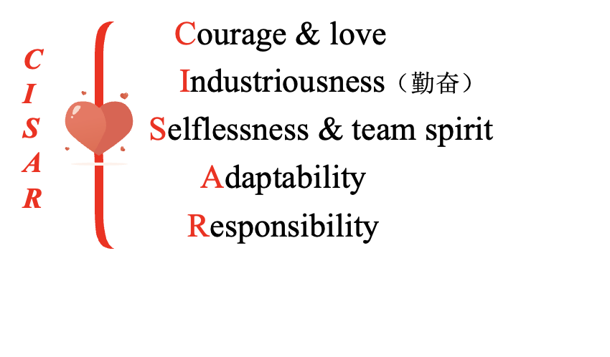

Discussion:

*Is it necessary to risk their life to save the people from other countries?*

*What do you think of the work that CISAR had done?*

Activity4: Explore the theme

China to the rescue! Why does the author use exclamation point ！

Assignment

1. Write a passage about “What I have learnt from CISAR?”

2. Search the Internet to learn more about rescue teams.