**M3U3 Diverse Cultures**

**Period 5 Reading for Writing**

**Teaching Objectives：**

By the end of the class, students will be able to

1. know more information of the Chinatown in San Francisco

2. master some good expressions of to introduce a place

3. infer the theme and the intention of writer’s writing such a passage, improving their critical thinking

**Teaching Important and Difficult Points：**

How to help students apply the writing skills into their writing

How to make students work out writer’s purpose of writing the passage

**Teaching Procedures:**

**hundred**

**thousand**

**million**

**____________关于**

**Step 1: Lead-in**

**Activity 1: Look and say**

Students will be asked to look at a picture and answer the following questions:

Q1: Do you still remember the place in the picture?

Q2: Do you know any information of it? The location? The feature of it?

Q3: There are a wide diversity of Chinatown in the world. So is it a good idea to develop Chinatown in other countries? Why? Or why not?

Sentence pattern: I think it is (not) a good idea to develop Chinatown in other countries, because ______________

Teacher comments on students’ opinions: There are more advantages than disadvantages, right? So in order to make Chinese culture known to more foreigners, we need to advertise for it in the brochure.

(此环节目的一方面能激活学生在reading课堂中学习到的关于中国城的知识，另一方面在于锻炼学生的思维能力，以及发展学生爱国主义情怀，同时提高其表达个人观点的能力。教师通过总结并让学生思考如何才能让一个地方为别人所熟知——宣传手册，从而衔接至下一活动。）

**Activity 2: Brochure**

Student will be asked to discuss the question: what should be included in the brochure to introduce it?

The brochure should contain the introduction of:

1. Location 2. population 3. climate 4. business 5. attractions 6. food ...

(此环节目的在于帮助学生了解涉及到介绍一个地方时，写作或介绍中应包含哪几个模块。）

**Step 2: Reading**

**Activity1: Read for structure**

Students will be asked to look through the passage quickly and answer the question:

Can you divide the passage into several parts? And tell the reasons.

Part1——para1: Brief introduction

Part2——para2-5: Detailed information (what you can learn and do)

Par3——para6: Summary (Stress the importance of the Chinatown in America)

**Activity2: Read for information**

Students will be asked to read the passage again and fill in blanks:

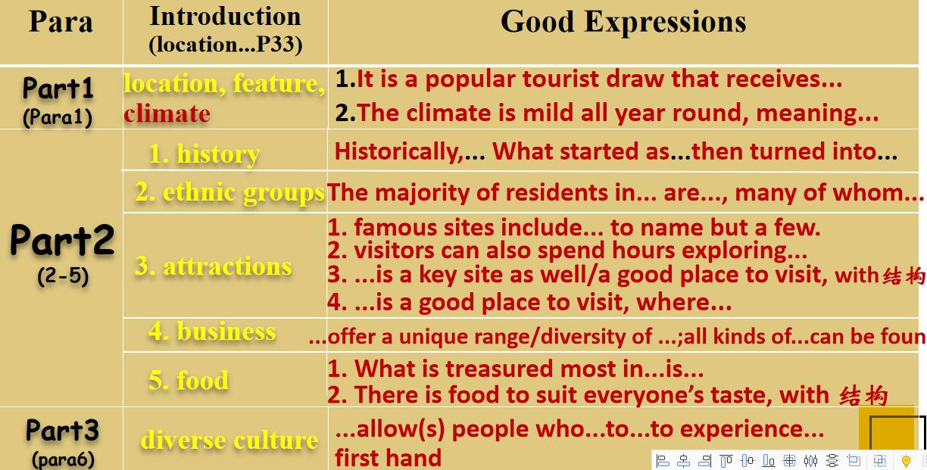

For the part 1, teacher will lead students to analyse together, then students will be asked to take Hainan for example to describe its climate and location by translation:

1. 海南是中国第二大岛，是中国著名的旅游景点，年接待游客近1亿。位于中国南部，海南是一座历史悠久的城市。这里终年温和，随时都可以来旅游。

Hainan, the second biggest island in China, is a well-known tourist draw that receives about 10million visitors every year. Located in South China, Hainan is a city with a long history. The climate here is mild all year round, meaning that it is always a good time to visit.

2. 杭州位于中国东南部，这里四季分明，冬季寒冷，夏季炎热

Situated in Southeast China, Hangzhou is a city with four distinct seasons, cold in winter and hot in summer.

For part2 and part3, students will be asked to find out the detailed information altogether and write down the good sentence patterns they can dig out.

**Step3: Writing**

Students will be asked to write a short passage to introduce Hainan with at least 3 points listed in the ppt, and use as many various expressions as possible.

**海南基本情况介绍：**

**1. 气候、地理位置，基本特征（先不写）**

**2. 居民构成：来自三十多个少数民族，大多数普通话带口音(accent)**

**3. 旅游景点：天涯海角、三亚湾(Sanya Bay)、民族村、阳光滩等**

**4. 商业：纪念品、民族服装**

**5. 食品：椰子(coconut)、椰子产品**

**6. 历史：一开始作为少数民族居住地(minority residence)，慢慢发展成休闲度假胜地(leisure resort)**

**7. 别称：东方夏威夷（oriental Hawaii)**

1. Before writing: students will be asked to pay attention to the writing tense and person address.

2. After writing, students will be asked to give a point to their desk mates’ writing according to the standard.

3. Then teacher share the writing sample with students.

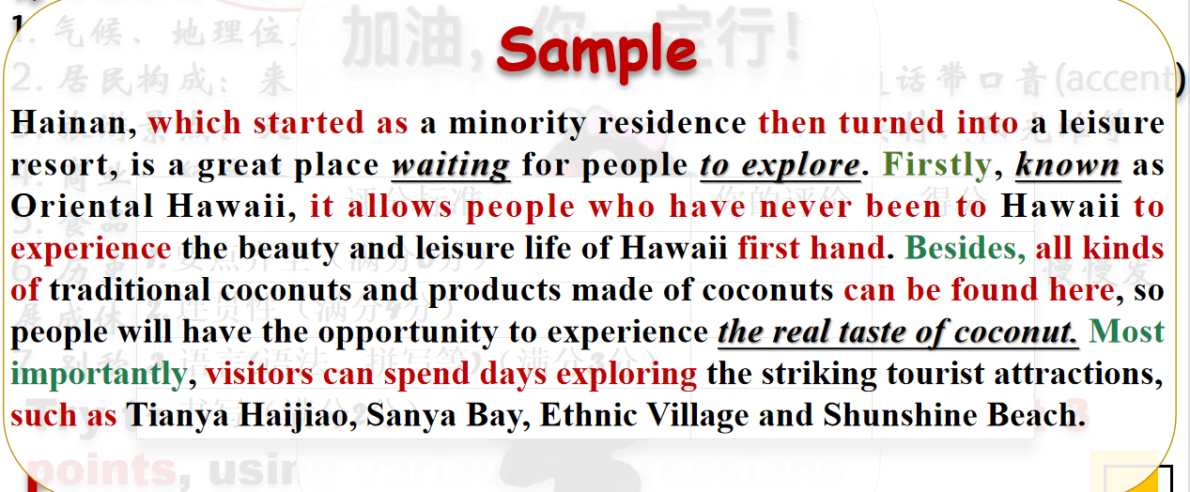

**Step 3: Thinking**

Students will be asked to read the passage again, but this time they need to think about something behind the passage.

1. Who are the intended readers?
2. What’s the theme of the passage?
3. What does the writer want to express in the passage?