**人教版新教材选择性必修三Unit1 Reading & Thinking导学案**

*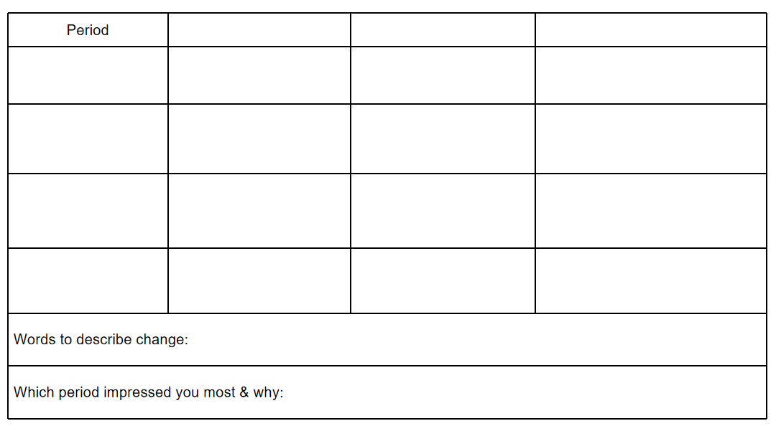A short history of western painting*

*What has made art change over time?*

*What do we do next? What’s your idea about the future development of art?*

What is art? What is the value or purpose of art?