选择性必修二Unit 3 Using Language Healthy Eating

文本简述
该部分的阅读语篇以健康饮食为题，阐述了健康饮食的基本原则。该板块的活动主题是“写一篇关于健康饮食的文章”，通过读写活动帮助学生积累有关健康饮食的知识，深化对健康饮食这一主题的理解，并反省自身的饮食习惯。
教学目标
By the end of the class, students will
- 阅读有关健康饮食的科普说明文，能够把握其文体结构、信息要点、语言特色等。
- 能够结合本单元所学内容审视自身饮食习惯，并就此话题写一篇文章，恰当运用连接词，使上下文衔接词自然、逻辑清晰。

- 教学设计
Step 1: Lead-in
Show students three meals of a day in China.
Questions:
Is it a healthy diet or not?
What do you think makes up a healthy diet?
What are some rules for healthy eating?

Step 2: Pre-reading
- When talking about healthy eating, what comes to your mind first?
- Don’t eat too much.
- Eat slowly.
- Eat more fruits and vegetables.
- Drink plenty of water.
- Don’t skip breakfast.
- Don’t eat food high in fat and sugar.
...
- What is a balanced diet?
- Is it when all the meals weigh the same?
- Is it when you eat the same food in every meal?
- Is it when you eat the same amounts of all foods?
- Is it when you eat your meals balanced on a see-saw?

Step 3: While-reading
Activity 1: Read for the main idea

Read the passage and then match the subheadings with the paragraphs.
Para.1 A. Slow Eating is Good.
Para.2 B. Reducing Sweets is Key.
Para.3 C. The Real Killer is Sugar.
Para.4 D. The Way You treat food matters.
Para.5 E. Keep It Fresh and Balanced.

Activity 2 Read for structure
According to the subheadings, draw the mind map of the passage structure.
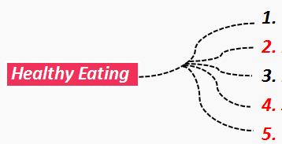

Activity 3: Read for language features
- What are the key details that support each point?

2. Find the linking words in the passage that introduce another way of saying what was already mentioned in the previous sentence.

3. Find the linking words in the passage which show that contrasting ideas are being introduced.

- Summary
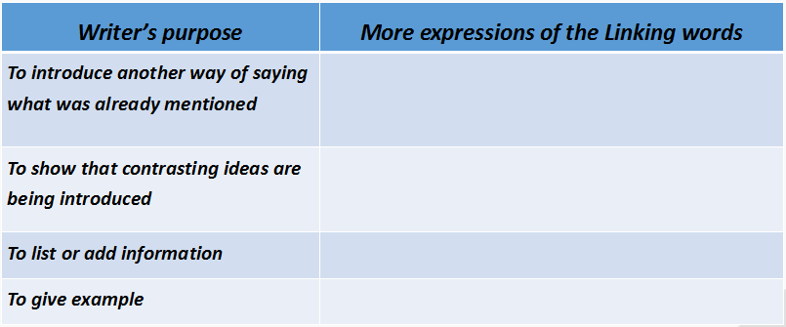

Activity 4 Summary
Make a list of healthy eating habits.

Activity 5: Group Discussion
Step 1: Write down everything you eat and drank over the last three days. And share your ideas about your eating habits, whether they are healthy or not?

Step 2: Compare what you have had over the last three days with the advice written in the article, and any facts about diet and nutrition that you know to be true. Make two lists：
·A list of your good eating habits
·A list of your bad eating habits

Step 3: If you have bad eating habits，make a list of things you can do to get rid of them.

Activity 6: Writing
Use what you have learnt and discussed to write an essay about your own diet.
Use your notes to write your essay. You can start like this:

Overall, I think I have healthy/unhealthy eating habits. As for the things that I am doing right, ... Still, I should improve my eating habits by...

