**M2U5 Music**

**Period 1 Listening and Speaking**

**Teaching Objectives：**

By the end of the class, students will be able to

1. master following new words and phrases: stringed, classical, perform, performer, touch my soul, give me energy, remind me of home, run food stand, set up equipment, have a preference for.

2. familiar with some types of music and stringed instrument

3. master the listening tip of listening for the explanation.

4. express their preference for music and their willing to take part in the school music festival fluently

**Teaching Important and Difficult Points：**

How to make students master the ability of listening---listen for explanation

**Teaching Procedures:**

**hundred**

**thousand**

**million**

**____________关于**

**Step 1: Lead-in**

**Task 1: Brainstorming**

Students will be asked to look at a symbol and answer the following questions:

1. What does the following symbol stand for?
2. Which instrument is contained in the symbol? What kind of instrument is it?
3. Stringed instruments can be divided into Western stringed instruments, and Eastern stringed instruments, do you know any of each? (There will be a short video for students to feel the magic of stringed music)
4. What others do you know about music? The types? (There will be some radios for students to guess)

**Task 2: Free Talk**

Student will be asked to share their preference for different types of music in the following sentence pattern:

I have a preference for _________, that's because _____________________________.

**The teacher comments on their sharing**: The reasons for one's preference vary from person to person.

**Step 2: Listening**

**Task1: listen and choose**

1. What kind of music does the first student like?

A. Hip-pop B. Chinese traditional C. country music

2. Why does the second student like classical music?

A. It touches his heart.

B. It can make him move.

C. It makes him feel like sitting beside a quiet stream...

3. Which one is not mentioned in the interview?

A. Hip-pop B. Chinese traditional C. Country music

**The teacher comments on this part**: Before listening, we should first read the questions and answers, and underline the key words.

**Task2: listen and fill in blanks**

1. Students will be asked to listen and finish the explanation
2. Listening Tip:

When you hear some words or phrases that are_________, you can pay attention to the following sentences, because there may be an __________ which use easier words with the same _________. This will help you to understand more easily.

**The teacher comments on this part:** Do you like music? Why? Music has the magical power, so there is no wonder that everyone will like music. But will you do anything for music?

**Task3: listen and tick**

Students will be asked to look at an announcement and answer the following questions:

1. Look at the announcement of a school music festival, will you join it?
2. What can you do for it? （to be a performer/worker/viewer)
3. Listen and tick the kinds of volunteers the festival needs.

**Task4: listen and finish the mind map**

1. Students will be asked to listen again to fill in the mind map

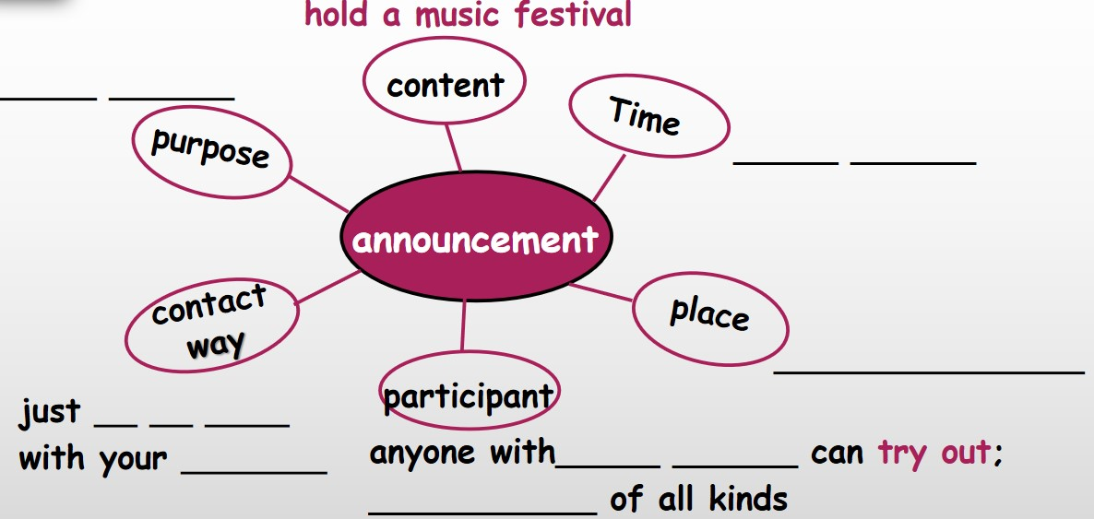

1. Students will be asked to find out the feature of an announcement according to the mind map.

**Step 3: Discussion**

Students will be asked to make a conversation about taking part in a music festival.

**Sample**

**A: You know there will be a music festival in our hometown, will you take part in it?**

**B: Music Festival?**

**A: Yes. It's going to be next week on the center square. I know that you can sing some hip-pop.**

**B: I would prefer to sing ... ,because... How about you?**

**A: You know I'm not talented in music, so I would rather help out with crowds. Can you give me any advice?**

**B: Well, I think you can...**

**A:...**

**B:...**

**Step 4: Practice**

1. **Students will be asked to translate the following phrases:**

**1. 触碰一个人的灵魂**

**2. 给我能量**

**3. 使某人想起**

**4. 感觉像/想要做...**

**5. 经营食品摊**

**6. 安装好设备**

**8. 表演**

**9. 参加选拔**

**10. 偏爱**

**2. Students will be asked to put the words and phrases into practice.**

1. Lydia doesn’t feel like ___________(work) abroad.After all, her parents are old.

2. The manager praised him for his _________(energetic) and enthusiasm

3. He felt it was teacher's duty to touch student's heart and ______

4. you are talented in music, why don't you try _____ for the school music festival? 5. Australians have a ____________(prefer) for sweet foods.

6. _________(string) instruments became popular in China during Song Dynasty.

7. The company has decided to buy some modern _____________(equip)

8. The ____________ giving a ______________ on the stage is my favorite singer, as well as an actor. (perform)