**B3U1 Reading and Thinking 教学设计**

**Teaching Objectives：**

In this lesson, students will:

1)identify the main ideas of a paragraph through locating the topic sentence

2)raise their cultural awareness regarding why people celebrate festivals at home and abroad

3)master key vocabularies and expressions required in this unit

4)develop their reading abilities through skimming and scanning

**Teaching Important Points：**

1)guide students to find the answers to why people celebrating festivals through analyzing passage

2)find topic sentence and locate key words in a paragraph to identify the main ideas of a text

**Teaching Difficult Points：**

1)understand the inner coherence between two paragraphs

2)foster students’ critical thinking by discussing commercialized festivals

3)analyse the structure of the whole text to better understand expository writing

**Teaching Process：**

**Step 1: Lead-in**

Q: T asks Ss 1) What festivals do you celebrate with your family or friends every year?

1. Why do you think people celebrate different festivals?

T names Ss to share their opinions and inform students to carry in their mind the second question throughout this lesson.

**Step 2: Skimming**

Ss read the passage fast in 2 minutes and T asks Ss to identify the main ideas in each paragraph to introduce the concept of topic sentence, including its function and its location in a paragraph. Then T asks Ss to underline the topic sentence of each paragraph and circle the key words within it and think about the function of each paragraph.

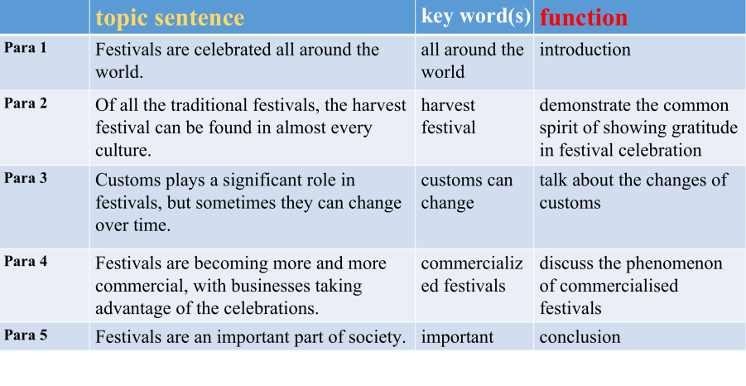

**Step 3: Scanning for details**

Task 1: Read para 1 and answer the following questions

Q:1) What are the different origins for different festivals?

2)What are the common spirit shared in all festivals around the world?

T should emphasize the contrast between the different customs and the same spirit which can be shown in the last sentence of the first paragraph which is also the transition sentence connecting para 1 and para 2. T should pay attention to the inner coherence between para 1 and para 2, which is that the example of harvest festival applied in paragraph 2 is used to support the common spirit of gratitude mentioned in paragraph 1. The details are as the following picture.

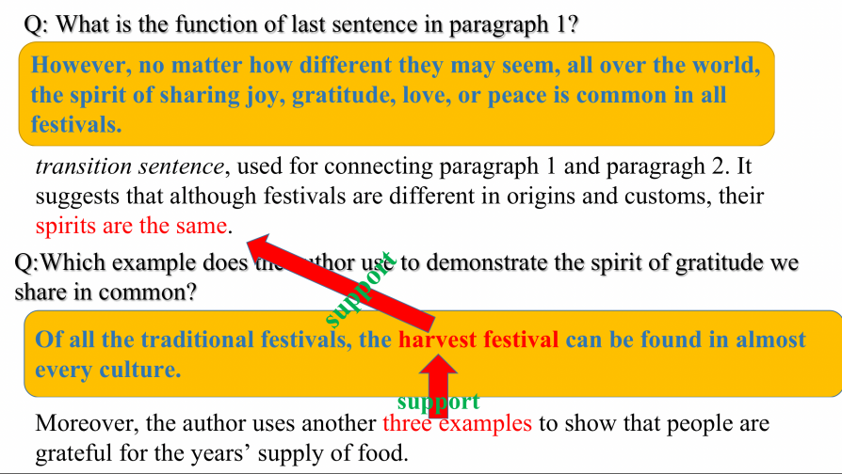

Task 2: Read para 2 and fill in the mind map

T asks Ss to find out the detail information from the three examples given in paragraph 2, including time and features. T asks Ss Why do people celebrate harvest festival and again emphasizes the function of paragraph 2.

Task 3: Read para 3 and complete the chart

The key words in this paragraph is changing customs.

T asks Ss: 1)What are the two examples used in this paragraph?

2)What have been changed in these two festivals?

3)What lead to such changes?

Task 4: Read para 4 and then complete the chart

The main idea in this paragraph is commercialization of festivals. After going through this paragraph, T asks Ss: 1)What is the phenomenon of festival celebrations nowadays?

2)What are the reasons contributing to this phenomenon?

3)What might be the author’s attitude to this phenomenon? Positive or Negative?

T presents pictures of those festivals which are greatly influenced by commercialization, e.g.Valentines Day, Mother’s Day, Father’s Day, Singles’ Day in China and Black Friday in western countries. T plays a videos about the commercialization of Singles’ Day a.k.a. Double 11 to show the huge benefits festivals can bring to economic development.

Activity: T asks Ss to work in groups to have brainstorming about pros and cons of commercialized festivals. T invites Ss to share their opinions and then provides possible pros and cons.

Task 5: Read paragraph 5 and answer the following questions

T asks Why festivals are an important part of society and let the whole class answer this question.

They reflect people’s wishes, beliefs, faiths and attitudes towards life.

They are occasions that allow us to relax and enjoy life and forget about work for a while.

They help us understand where we came from, who we are, and what to appreciate.

Through the multiple use of the word they, parallelism, a type of rhetorical device, is applied here.

**Step 4:Analyse the structure of the whole passage**

By asking Ss WHY DO WE CELEBRATE FESTIVALS, T inspires Ss to think about the main ideas conveyed in this passage and therefore leads them to analyse the structure of it.

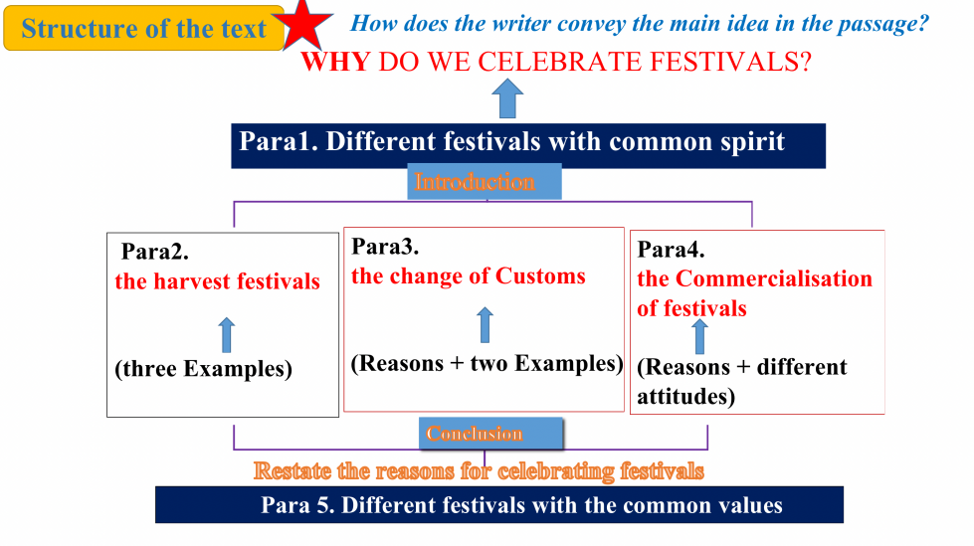

**Step 5: Review the key words**

By doing the fifth exercise on Page 5 on textbook, T helps Ss to review the main ideas and key words in this text.

**Step 6: Homework**

Search online about the festival customs that have faded away in home and abroad, them make a short speech to introduce the change, the reasons behind, and your opinions on that.