**The Student Sheet**

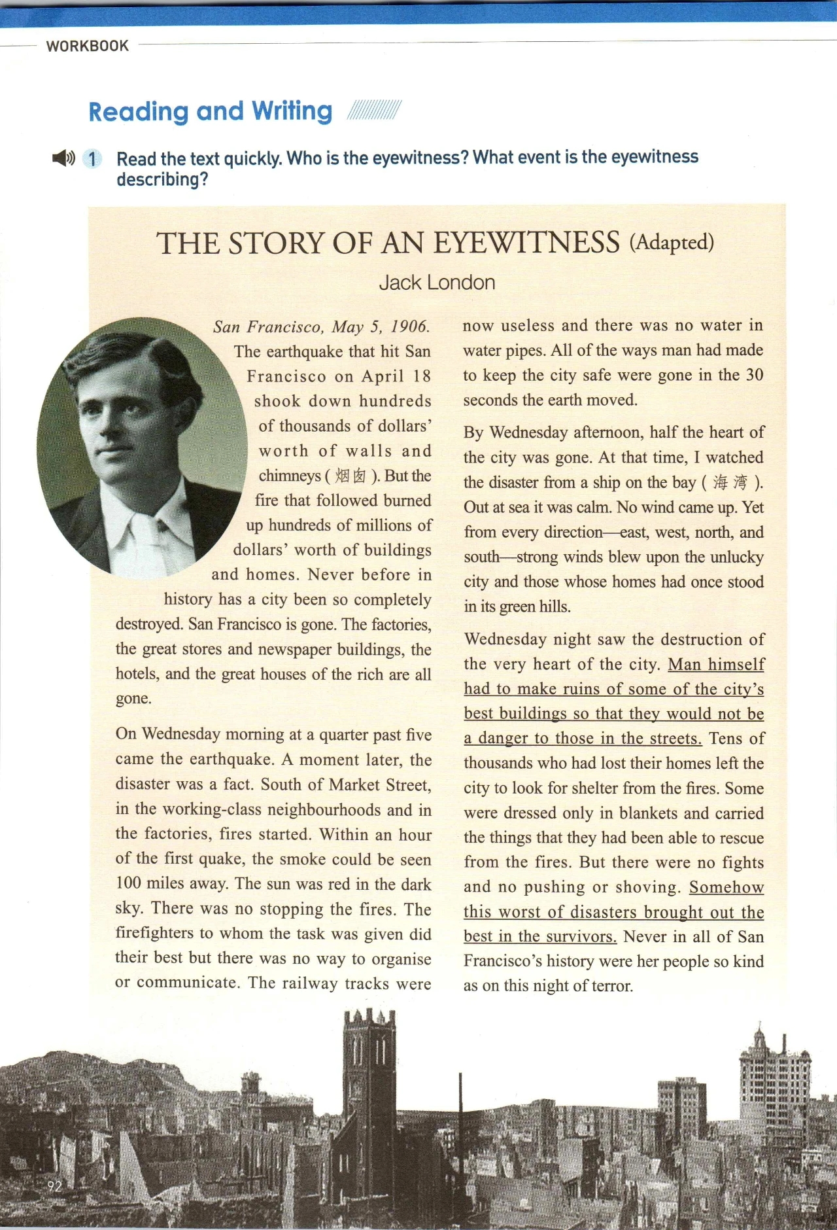

**1. Warming up**

Q: What are natural disasters in the video? Can you name some of them according to the first letter?

Natural Disasters: E ; T ; V ; F ;

H ;S ; W ; D

**2. Reading**

Activity One: Understand the title: The Story of an Eyewitness (Adapted)---Jack London

Q1. Who is the eyewitness?

Q2. What event is the eyewitness describing?

story1Q3. Which do you think is the proper meaning of “The story”? ( )

story2

story3story4

The western American city of San Francisco, California suffered a huge earthquake on April 18th, 1906.

More than three thousand people are known to have died. The true number of dead will never be known. Two hundred fifty thousand people lost their homes.

Just a few hours after the terrible earthquake, a magazine named Collier's sent a telegraph message to the famous American writer Jack London. They asked Mister London to go to San Francisco and report about what he saw.

He arrived in the city only a few hours after the earthquake.The report he wrote is called, "THE STORY OF AN EYEWITNESS." In more than two weeks, it was published.

Activity Two: Understand the text

The earthquake (when where )

The fire that followed

***April 18***



Time:

Destruction:

Q: How did the people of San Francisco behave during the disaster?

Q: How can you describe *The earthquake* and *The people*?

The earthquake The people

Activity Three: Read between lines

a. Man himself had to make ruins of some of the city's best buildings so that they would not be a danger to those in the streets.

b. Somehow this worst of disasters brought out the best in the survivors.

**3. Further thinking:** What can youget from the story?