本文全文摘选自Chicken Soup for the Soul_101 Stories About Self-Care and Balance_ Making Me Time [2021] -- Amy Newmark，可改编为高考“完形填空”，供高中英语学习使用。
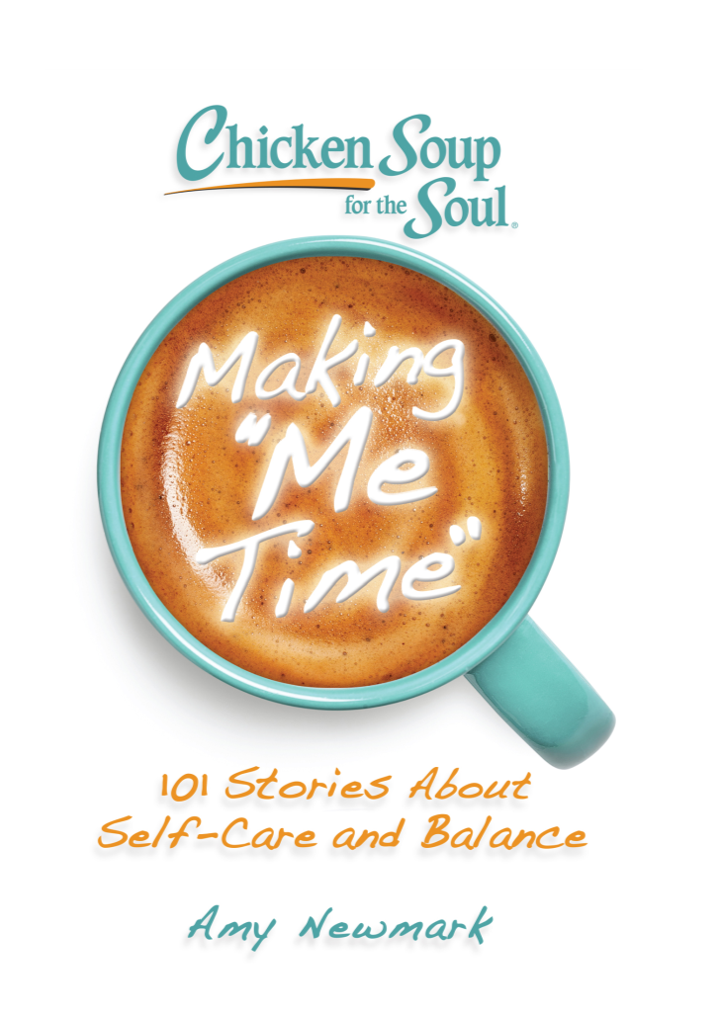
A Splash of Insight顿悟的火花
—By Lynn Kinnaman

The ability to be in the present moment is a major component of mental wellness.
——Abraham Maslow

I was stumped. The question posed on social media wasn’t difficult, at least for most people, but it was like being hit with a bucket of cold water for me, shocking me into a realization.
What do you do for fun?
I couldn’t come up with a single answer.
Had my existence become so empty? Living alone, with an office in my home, work time had overflowed like lava, consuming more and more of my days until there was no boundary safeguarding my personal time. It was all work, all the time.
The worst part was that, at the end of the week, I could not successfully justify it. What had I accomplished? Ryder Carroll says, “Inevitably we find ourselves… spreading our focus so thin that nothing gets the attention it deserves. This is commonly referred to as ‘being busy.’ Being busy, however, is not the same thing as being productive.”
I was not productive, and I was not happy. However, I was end-lessly busy.
Something needed to change. I had no idea how to make it happen or where to begin. That is, until a four-legged fluffball entered the picture, upended the status quo, and made it clear that there was so much in the world yet to be discovered.
Dogs had always been a part of my life. For this next dog, I had specific requirements. My someday dreams included doing some traveling in my RV, visiting new places, and meeting new people. I needed a dog that would be happy with that. My last dogs had been Jack Russells, bright and energetic, but needing a lot of stimulation and challenges. Besides the Terriers, I’d owned Labradors and Belgian Tervurens. They were all lovely animals, but each bred with a purpose. They had active, outside-focused motivations and were driven to stalk, retrieve, or herd.
I wanted a dog that had been created to be with me. I wanted to know that, when she cuddled next to me, she was fulfilling her purpose and was satisfied. After much research, I settled on the breed: Havanese.
When I got my puppy, she was eleven weeks old and the smallest dog I’d ever owned. She weighed a mere four pounds and moved like a wind-up toy. I wanted to start her off right, as a socialized pup who was comfortable around other dogs and humans, so I took her to weekly playdates hosted by a local dog trainer.
I remember walking into the room, my tiny puppy cradled in my arms, and watching the rambunctious puppies jumping, running, and roughhousing. My eyes began to fill with tears. “I can’t do this,” I mumbled, turning to go.
“Wait.” One of the puppy moms stopped me. “Just sit here beside me and let her stay in your lap.”
I sat next to her. Her pup was a Cavalier King Charles Spaniel about the same age and size as my Trixie. Both our puppies were a little shy. However, my initial panic eased, and I returned week after week. In a short time, Trixie was running around, dodging the bigger puppies and finding a spot on a piece of equipment or a box where she had height equality. She was having a blast.
Then Ziggy came.
He was also a Havanese, three months older. Before long, Trixie and Ziggy were obsessed with each other, wrestling without a sound and ignoring the other dogs.
It wasn’t long before Ziggy’s mom and I decided we could hold our own playdates since our puppies only had eyes for each other. The first time we met at Jane’s house, we drank tea and watched the puppies tumble nonstop for nearly three hours. It was Zen-like for me, calming and mesmerizing, taking me to a new level. When I left that day, my stress level was nonexistent, and I felt like I’d had a relaxing two-hour massage.
Our friendship grew, and we found we had more in common than just our good taste in dogs. We both wanted to visit places in Montana and the surrounding areas, and we both liked to cook. That led to a regular and sacrosanct tradition of Friday playdates. We’d try new recipes while the dogs entertained each other, or we’d take day trips with them.
Trixie and Ziggy will be five years old this year, and our pack of four has had many adventures. We’ve expanded our travel time, taking the RV on extended trips to Yellowstone, Glacier National Park, Canada, and shorter jaunts around our state. We share an interest in birds and other wildlife, and we’ve photographed bears, moose, eagles, and waterfowl.
The dogs, true to their natures, are happy to be part of the activities and never fail to bring us joy and laughter.
We keep a running list of new places to go, things to see, and recipes to tackle. I find the planning to be just as much a delight as the actual events. My weeks no longer pass by, indistinguishable from one another, without meaning. My Fridays are my oasis, a place where the whole day is simply about having fun and celebrating being alive.
As I recall my past habits, I realize I am accomplishing as much, if not more, by changing my focus from being busy to being present. That question, that splash of cold water, made me aware of how much I’d been missing by not carving out time for the things that really matter.
Now, I treasure every minute. By creating clear boundaries and giving myself designated time for fun, I have an easy answer to that question that once baffled me: What do you do for fun?
Where do I begin?（988 words）

— Lynn Kinnaman —

