**教学设计**

**一、教学思路：**

本课以英语学科核心素养为导向，通过引导学生观察语言和语篇结构、分析语篇所承载的观点、态度、情感和意图等，锻炼学生观察、分析、推断、归纳、评价、创新等思维方式，增强思维的逻辑性、批判性和创造性，提高思维品质。

教学设计以课文标题A Master of Non-Verbal Humor为主线，围绕WHO (Who is the master of non-verbal humor?), HOW(How did he become a master of non-verbal humor?), WHY (Why is he considered a master of non-verbal humor? )这三个问题进行组织架构。通过分析卓别林的生平和成就，让学生推断和评价卓别林的精神品质以及他和他的角色所造就的时代意义。

语篇解读的路径如下：读标题，预测主题→快速浏览，获取大意→提取信息，分析、推断→深层思考，归纳品质→回归预测，做出解答→撰写概要，迁移创新。

俞老师根据单元话题的主题意义，引导学生通过学习语篇发现事实细节，并以问题链的形式引导学生进行深入思考这些细节之间的联系和其背后所指向的要素。在这一过程中发展学生的分析、判断、推测、归纳等高阶思维能力，把语言学习和思维品质的发展统一起来。通过挖掘卓别林的个人品格，帮助学生树立正确的人生观、价值观和世界观，从而发挥英语学科的育人价值。

**二、文本特征：**

本文属于“人与社会”主题语境下“对社会有突出贡献的人物”这一主题群。和本册书前两个单元Women of achievements、Working the land同属于一个主题语境和主题群。

文章共五段，包含卓别林的历史贡献（第一段）、生平经历（第二段）、职业生涯和经典角色（第三段、第四段）以及荣誉成就（第五段）。 围绕how and why这两个问题，在语篇处理时，可将第一段和第五段合并处理，分析在二战背景下卓别林的幽默给痛苦压抑中的人民带来的欢乐所产生的时代意义，即：给人绝处逢生的希望。此外，通过查找第五段中的信息，了解卓别林的成就，从而归纳和推测出他的个性和品格，进而帮助学生理解Why Chaplin is considered a master of nonverbal humor；再把第二段、第三段、第四段合并处理，分析他贫苦的家庭背景、坎坷的童年经历对他成功塑造小流浪汉形象的作用以及这个人物形象所带来的时代意义，从而归纳出How Chaplin become a master of nonverbal humor.

**三、教学过程**

**Step1: Warming up and lead in**

1. 教师引导学生根据描述猜测几位幽默大师，在描述中呈现本单元涉及到的主题语境相关词汇，自然而然地引出话题。

如：He is both a film maker and an actor.

He has received many awards.

His comedy A Chinese Odyssey (大话西游)is known throughout the world.

Who is he?

A: He is Stephen Chow. (周星驰)

1. 教师引导学生总结前两位幽默大师（郭德纲、周星驰）的表演形式的共同之处，即：They make us laugh by playing on words.从而总结出这种形式的幽默就叫verbal humor；而憨豆先生的mime表演中不包含言说的成分，故这种形式的幽默就叫做nonverbal humor。本课就要学习一位非言语的幽默大师——卓别林。

【设计意图】利用“你说我猜”的游戏吸引学生的注意，激发其学习兴趣，并通过猜测的内容来创设语境。在猜测幽默大师的过程中，学生学到了comedy,mime等本单元新词；而在分析、归纳几位幽默大师的共同点的过程中，学生总结出幽默的两种形式，即verbal humor和nonverbal humor, 并接触到更多本单元新词汇（humor, verbal, non-verbal等），有利于他们在情境中认知和理解这些新词。

**Step2: Predicting**

教师引导学生读标题，预测课文内容。即：

Who is the master of non-verbal humor?

How did he become a master of non-verbal humor?

Why is he considered a master of non-verbal humor?

【设计意图】本课的标题是全文的内容要点。从标题入手，预测文章的内容和主题，一方面能够帮助学生找到文章的主线，另一方面也帮助学生设定了阅读目标，激发了他们的阅读兴趣。

**Step3: Reading**

1. Fast reading：学生根据预测中所涉及的三个问题，快速浏览全文，理清文章结构，即第一段和第五段回答why,第二段至第四段回答how.

【设计意图】通过快速阅读验证预测的正确性，理清文章脉络。

1. Detailed reading:

Para 1:

*Laughter is the sun that drives winter from the human face.*

1. Q&A

Q1: What does the sun and winter mean?

Q2: What is the function of humor?

Q3: What did Chaplin do during two world wars to “drive winter from human face”?

1. Appreciate a quotation of Chaplin: Nothing is permanent in this wicked world-not even our troubles.

【设计意图】解读维克多*雨果的话，探索幽默的作用，从而解读卓别林在二战期间带给人们幽默的时代意义。并引用卓别林的名言加以例证，加深学生对此的理解。

Para 2

Q1: What was Chaplin’ s childhood like ?

Q2: Did his childhood helped him in his work?

【设计意图】阅读文章，查找文章事实细节信息。学生通过根据PPT提示填空的形式，找出卓别林的成长背景和童年境遇，并探讨这种环境和经历给他日后演艺生涯带来的影响。通过观察、推测、分析，学生的思维不断深化，从而提升了他们的阅读深度和思维品质。

Para 3

*He grew more and more popular as his charming character, the little tramp became known throughout the world.*

Q1: What does the little tramp look like?

Q2: Why was this character loved by people?

Q3: What is the value of Chaplin' s performance?

【设计意图】阅读文章，查找文章事实细节信息。通过解读小流浪汉的外貌和意象，分析这样一个社会底层形象受欢迎的原因，从而归纳出卓别林的表演所体现的时代价值，即：inspired many people with optimism, determination and kindness。并照应第一段中提到的“He brightened the lives of Americans and British”。

Para 4

An example: The Gold Rush

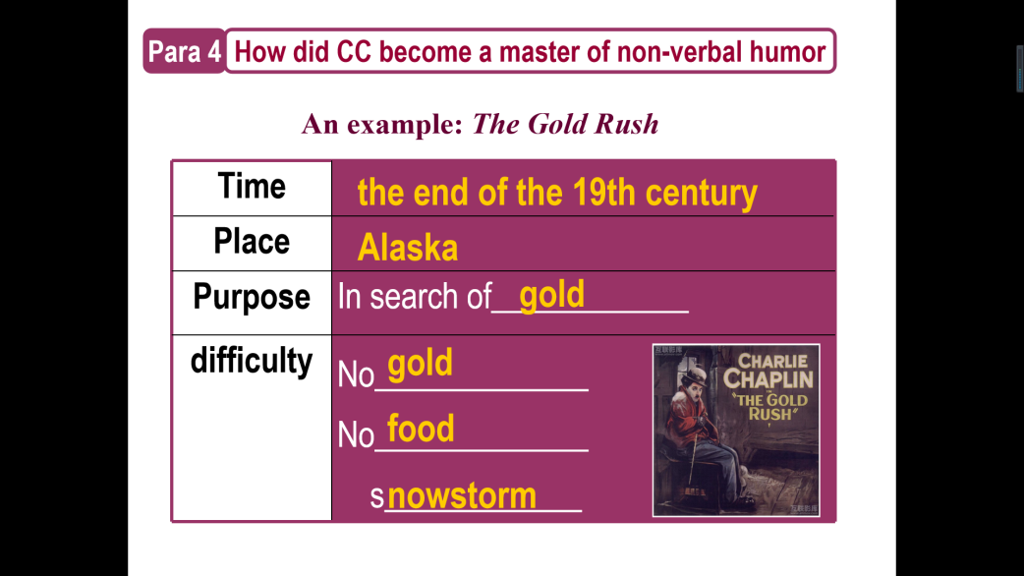

Q1: How did the little tramp make the sad situation entertaining?

Q2: What’ s the difference between the little tramp and his friend when they were eating the shoe？

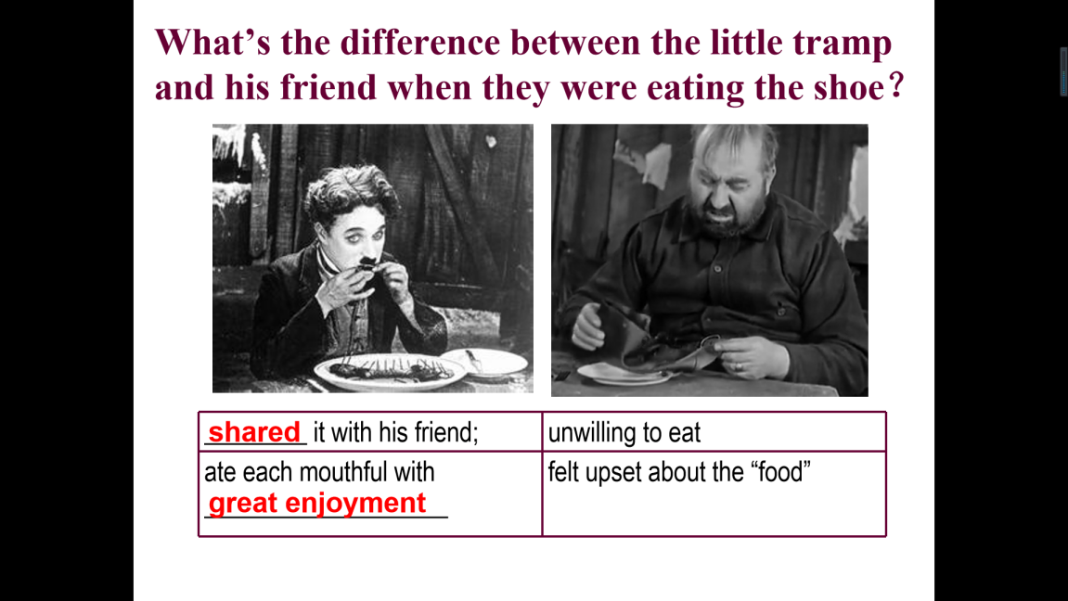

Q3: What qualities do the little tramp possess?

Q4: What is the value of Chaplin' s performance?

Appreciate a quotation of Chaplin: It is humor that highlights the meaning of being alive and clears our minds. Because of humor, we get less affected in the changeable life and we come to realize how absurd we are when we overweigh something less important.

【设计意图】阅读文章，查找文章事实细节信息。通过解读小流浪汉淘金的背景分析这个人物形象的处境；通过对比小流浪汉和他的同伴对待逆境的不同态度，从而感受他身处困境却仍保持乐观，热爱生活、与朋友福祸与共的精神品质，并归纳出卓别林的表演所体现的时代价值，即：inspired many people with optimism and kindness。同时，呈现卓别林的名言It is humor that highlights the meaning of being alive and clears our minds. Because of humor, we get less affected in the changeable life and we come to realize how absurd we are when we overweigh something less important.加深学生对幽默的作用的理解，更进一步体会卓别林所造就的时代意义，即第一段中提到的“He brightened the lives of Americans and British”。

Para 5

1. Read and find out Chaplin’ s achievements.

* He __________, ____________ and produced the films he starred in.
* In 1972 he was given a ______________ for his lifetime outstanding work.
* He _________ people with ___________.

1. What qualities does Chaplin possess?

【设计意图】阅读文章，查找文章事实细节信息。通过寻读卓别林的成就，分析、归纳出卓别林的个人品质，进而感知他为什么会被认为是“a master of nonverbal humor”。

**Step4: Thinking & Creating**

Q: What are conveyed in the passage?

Who? How? Why?

Write a summary within 80 words on HOW and WHY Charlie Chaplin became a master of non-verbal humor.

【设计意图】照应读前的预测，检验预测的准确性。通过再次梳理Who,How,Why这三个问题，总结语篇内容，再现文章主线，从而为学生撰写概要搭建内容支架。

**Step5: Assignment**

1. Polish your summary. Try to use as many expressions you learned as possible.
2. Create a humorous motto to help you undertake the difficult times.

【设计意图】这是基于课堂输出活动的提升，意在让学生在语境中运用所学的语言，从理解、运用到迁移、创新，促进思维品质的提升。