BOOK3 Unit 2 Morals And Virtues
Part 1 Listening and Speaking
教学设计
活动主题:本单元的Listening and Speaking板块与后续的Reading and Thinking板块关系密切，听力内容为后面的阅读内容提供了话题和背景的铺垫。这一板块以“谈论道德困境”( Talk about moral dilemmas)切入单元主题，介绍了什么是道德困境，探讨了处于道德困境中的人所面临的不同选择和结果，以及选择背后所隐含的道德观和处事原则。探讨这些问题，主要是为了让学生了解和感受道德困境在日常社会生活中的普遍性和复杂性，能够结合自身的体验和生活经验反思与道德困境相关的实际问题，提升辩证思维能力，使其能够更加全面客观地观察和看待社会现象，以理性的态度认识世界。
文本分析:该板块的听力文本展示了Jane 与Luke两个好友关于道德困境的对话。在对话中， Jane根据我国妇科专家林巧稚年少时的一段真实经历，描绘出一个典型的道德困境:正参加医学院考试的女学生遇到旁边的考生晕倒，她应该暂停考试去救助他人，还是应继续考试等候其他人施以援手?如果照顾晕倒的考生，她可能无法完成考试，考不上医学院，就无法成为一个以治病救人为己任的医生;如果她无视晕倒的考生坚持考试，那么她违背了医生的基本职业素养--救死扶伤。面临这一困境，年少的林巧稚毅然决定照顾晕倒的考生。将他人的安危放在自身的利益之上，这是贯穿了林巧稚一生的处事原则，也正因为这样，她成为被无数人敬仰的妇科专家。
教学步骤：
Step 1 Brainstorm
1. What do you think the teenagers in the picture are doing?
2. What qualities do you think are the most important when people are doing teamwork?
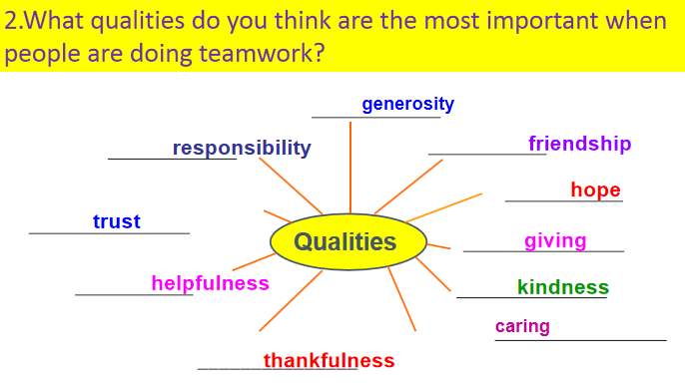

Step 2 Lead-in
Explain the saying.
Step 3
Pre-listening: make a story
Work in pairs and try to tell your partner the story
Step 4
Pre-listening: discussion
- If you were the boy, would you help the old woman?
- Now we will watch a video and discuss the moral dilemmas in the video.
Step 5
Listening
(1)P14 E2: Listen to the conversation and complete the table to describe the moral dilemma that Jane is talking about.
(2)P14 E3: Listen again and decide whether the statements are T or F.


(3)P15 E4: Listen to the conversation carefully and answer the questions.
Step 6
(1)Group Work： Speaking
P15 Exercise5: Talk about what you would do if you were ever faced with the same situation as the girl. Then share your thoughts with your group, and explain the reasons for your choice.
- Critical thinking
Apart from helping the student and finishing the exam, is there a third choice?Can you think of better ways to handle the dilemma?

