**Vocabulary Revision in Thematic Contexts**

**--****Environment and Protection**

基于主题意义引领的高三英语词汇复习教学

盘州市第二中学 陈翠媚

**一、课前整理复习**

将新人教版必修二 Unit2 Wildlife protection、选择性必修三 Unit3 Environmental protection两个单元文本和2021年全国新课标I：阅读理解C篇以及的主题词汇从以下四个方面用思维导图进行**分类整理**。

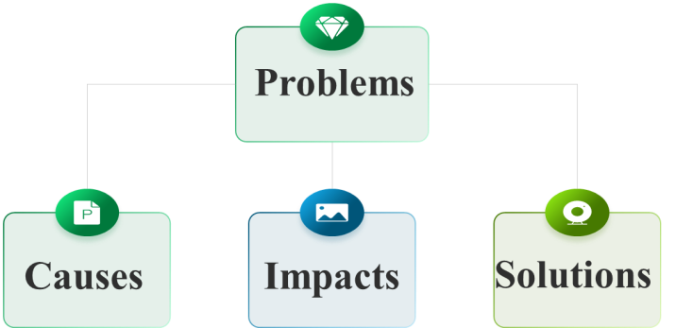

2021年全国新课标I

When the explorers first set foot upon the continent of North America, the skies and lands were alive with an astonishing variety of wildlife. Native Americans had taken care of these precious natural resources wisely. Unfortunately, it took the explorers and the settlers who followed only a few decades to decimate a large part of these resources. Millions of waterfowl (水禽) were killed at the hands of market hunters and a handful of overly ambitious sportsmen. Millions of acres of wetlands were dried to feed and house the ever-increasing populations, greatly reducing waterfowl habitat.

In 1934, with the passage of the Migratory Bird Hunting Stamp Act (Act), an increasingly concerned nation took firm action to stop the destruction of migratory (迁徙 ) waterfowl and the wetlands so vital to their survival. Under this Act, all waterfowl hunters 16 years of age and over must annually purchase and carry a Federal Duck Stamp. The very first Federal Duck Stamp was designed by J.N. “Ding” Darling, a political cartoonist from Des Moines, Lowa, who at that time was appointed by President Franklin Roosevelt as Director of the Bureau of Biological Survey. Hunters willingly pay the stamp price to ensure the survival of our natural resources.

About 98 cents of every duck stamp dollar goes directly into the Migratory Bird Conservation Fund to purchase wetlands and wildlife habitat for inclusion into the National Wildlife Refuge System — a fact that ensures this land will be protected and available for all generations to come. Since 1934, better than half a billion dollars has gone into that Fund to purchase more than 5 million acres of habitat. Little wonder the Federal Duck Stamp Program has been called one of the most successful conservation programs ever initiated.

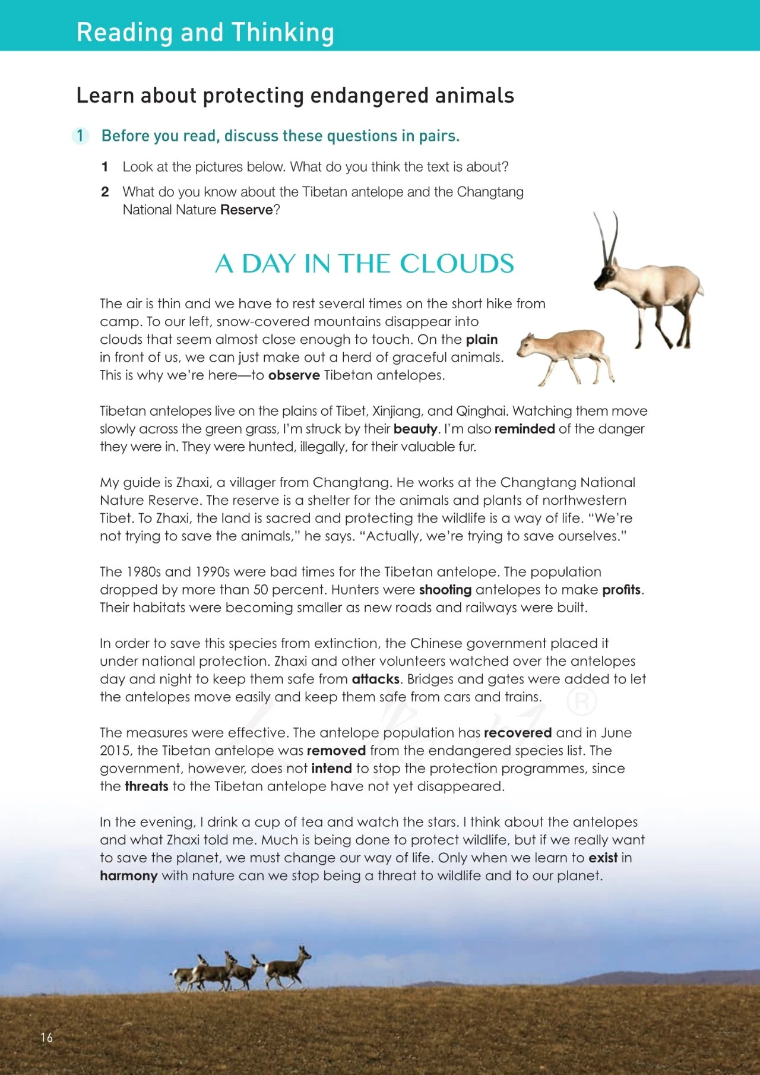

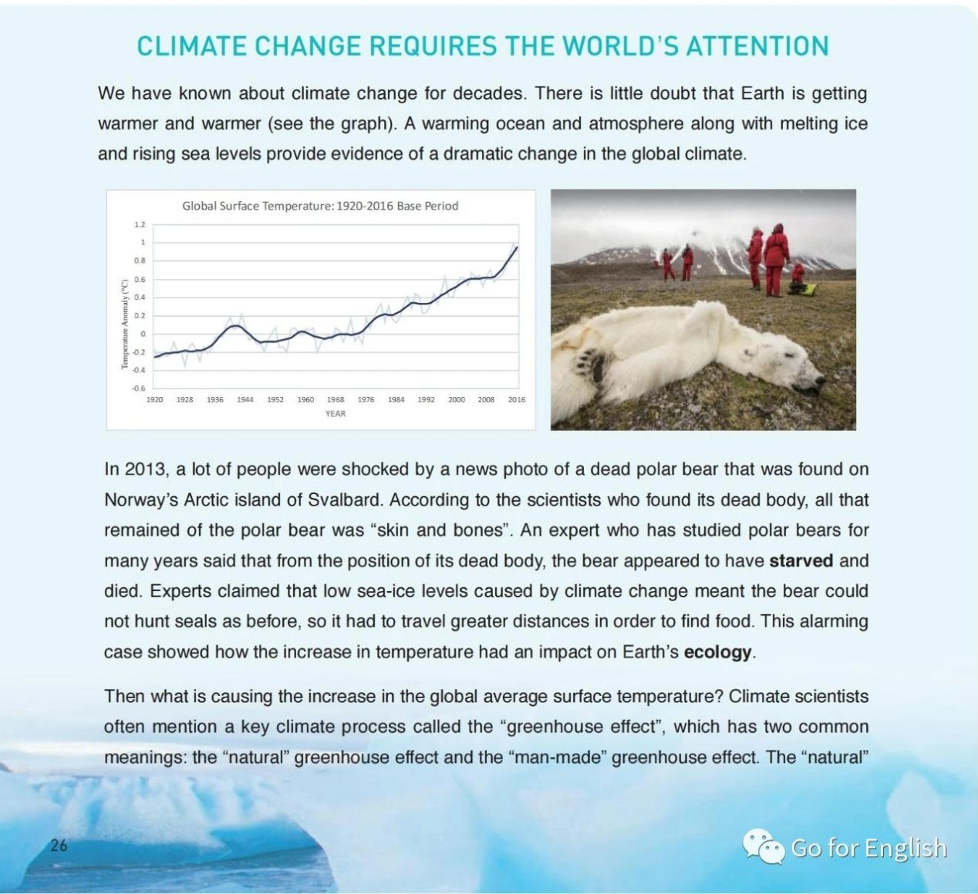

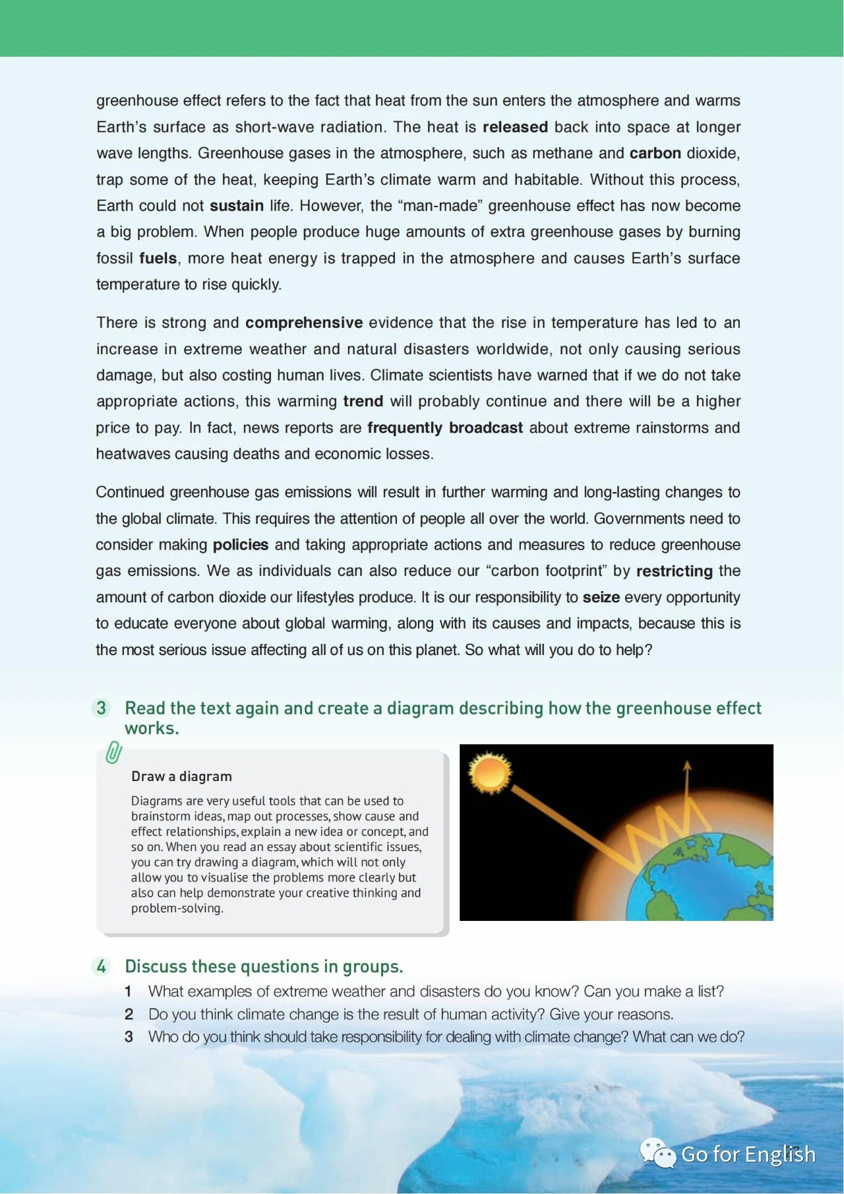

**二、课中主题词汇运用**

(1) Wildlife plays a vital role in keeping the ____________(ecology) balance, however, many wild animals are facing the danger of__________ (extinct); there are several possible reasons for this. Above all, some wild animals are being hunted illegally, for food or money each year, causing their population____________(急剧下降).Besides, as the human population grows rapidly, a growing number of people came to live where wild species have been living. Habitats_______(lose) , many of the wild animals are confronted with food crisis. A lot of wild animals _______(die) out, and we should recognize how serious the situation is and _____________(立即采取行动）. To protect these endangered species,___________(国家自然保护区) have been established. Protection programmes aim to save animals from extinction by placing them under national_____________( protect) and watching over them to _______________(保护他们免受攻击keep...from..). These measures have been effective, as the population has recovered and some species have been removed from the_________( endanger) list .Only when we learn to exist______________(与......和谐相处) nature can we stop being a _____________ (threaten) to wildlife and to our planet.

(2) No one can deny that the world we live in is becoming increasingly intolerable because of the effects of global warming. There are numerous causes that contribute to this problem. On one hand, ____________(与人类有关的碳排放) ,such as the____________ (燃烧化石燃料), into the air, deforestation and land__________( destruct) because of the urbanization, are blamed for the continued greenhouse gas. On the other hand, more _________(化肥) are used to increase the food production to meet the need of the increasing global population, which, in turn,_______________(对......造成严重损害) the natural environment. What’s more, global warming leads to________(极端天气) , natural disasters, and even causes deaths and_________ (经济损失). It is urgent that immediate and effective actions should be taken right way. First of all, stricter laws concerning global warming and irresponsible use of fuel resources have to be___________(实行；实施) . What’s more, we ought to _____________(培养.....的意识）environmental protection and cherish forests resources. We should also promote a__________( harmony) relationship between humans and nature, advocate an eco-friendly lifestyle, and encourage the use of clean energy. By doing so, we can improve water quality, conserve resources, and head towards a clean and ___________(sustain) future.

**三、课中讨论及观点产出**

Discuss in groups about how we can protect environment using words and expressions revised in this class and present your opinions.

**四、课后巩固及写作运用**