**Reading for writing ( write a blog about English study) 导学案**

**Learning English**



**Wang Le**



**Liu Wen**

**2 2 1**



**Jia Xin**

**0 0 2**



**Li Rui**

**4 0 0**

Hey, everybody, what are your biggest problems with learning English?

Hi! I've been studying English since primary school. I used to get high marks in English, but now I' m having a lot of trouble with my listening. When I listen to native English speakers talking in a video, I can catch only a few words. I can never quite get the main idea. Any advice?

Listening to English radio programmes helps me get used to how fast native speakers talk. I also repeat what I hear to help myself to experience the feeling of the language. Sometimes I even record my voice so I can listen to myself and compare my pronunciation with the radio host's! My biggest headache is how to be polite in English. It's so much easier to just say "Open the window!", but in English that can sound really terrible. I have to think about who I'm talking to and then decide whether to say,"Open the window, please!"or"Could you open the window, please?" or even longer "Would you mind opening the window, please?"

Yeah, that's really hard! I think it all depends on who you' re talking to. If I' m talking to a close friend, I can use short requests, like "Open the window"-our relationship is close and we' re equals, so I only need a few words to bridge the gap between us. But if I' m talking to someone who isn’t very close to me, I must make my request longer-and I must make it a question, not a demand, e.g. "Could you open the window, please" If I'm talking to someone senior to me, then I should say, "Would you mind opening the window, please?" For me, vocabulary is my biggest problem-there are just SO MANY new words! I can't keep all the new vocabulary straight in my head, and certainly can't remember how to use them all properly. HELP!

**Step I: Lead-in**

Free-talk

1. What's your biggest problem with learning English?
2. Who do you often ask for help when you have these problems?

**Step Ⅱ: Reading for organisation**

**A** : Read the blog from an online forum and answer the following questions.

1. What is an online forum?
2. What’s the tone of the blog?
3. What does each of the students write about?

**B :** Read and fill in the table.

|  |  |  |
| --- | --- | --- |
| **Name** | **Problem**  **Jia Xin’s advice** | **Advice** |
| Liu Wen |  |  |
| Jia Xin |  | **Li Rui’s advice**  **Your advice** |
| Li Rui |  |  |

**Step Ⅲ: Reading for expressions**

Read and underline the expressions used to state problems and give advice.

More expressions:

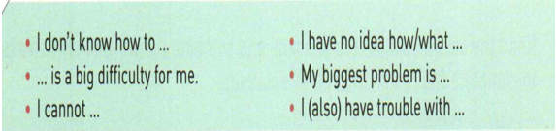



**Step Ⅳ: Pre-Writing**

Write down your biggest problem about English study and then work in groups of 4 to ask for advice.

|  |  |  |
| --- | --- | --- |
| **Name** | **The biggest problem** | **Advice** |
|  |  |  |

**Step** Ⅴ**: While-Writing**

Write a logical blog on your biggest problem and the advice given by your partners according to the table.

**Step** Ⅵ**: Post-Writing**

Exchange drafts. Access each other’s work according to the checklist.

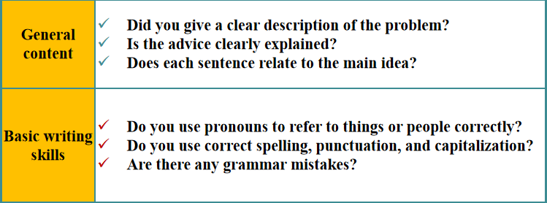

**Step Ⅶ: Homework**

1. Revise your blogs again and hand them in.

2. Post your blog to give KienelUnni some advice on learning Chinese.

( Links: <https://m.weibo.cn/7502277407/4564303975286681)>

