浙江宁波市2021届高三一模概要教案

教学目标：

1. 正确理解和归纳概要的主旨大意，在阅读活动中提升思维训练；
2. 运用不同于原文的方式表达要点，提升语言表达能力和逻辑思维能力。

教学重难点：

1. To write a complete,correct,coherent,concise and clear summary writing is a big challenge.

教学过程：

1. Lead in:

Warm up with the introduction to requirements of summary, some main problems and a piece of music. Now here come the procedures.

1). Introduce the requirements about summary writing from *Exam Instructions of Zhejiang Province &* principles of 5C

2). List main problems of summary writing including content, language, logic & handwriting

3). Review the theme of passage using music with a question”What do you think of the music?”

1. Summary problems solving

Activity 1: Locate the topic sentence or find out the main idea

1). Skim for main idea & Answer the following questions:

1. What’s the topic?

2. What’s the writing style of the passage?

A. Narration B. Exposition C. Argumentation

3. What’s the structure of the passage?

A. 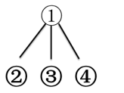 B. 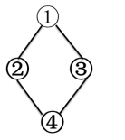 C. 

4. Students are asked to summarize the main idea of each paragraph with one word.

Para.1 The __________of Music therapy

Para.2 The __________of Music therapy

Para.3 The __________of Music therapy

Para.4 The __________of Music therapy

2). Read to locate the topic sentence or summary the main idea:

Students are asked to attempt to find the topic sentence, main and minor points, and meanwhile delete detailed or further explanations.

Para.1 _____________________________________________________________________

Para.2 _____________________________________________________________________

Para.3______________________________________________________________________

Para.4______________________________________________________________________

Activity 2: Draw a mind map or an outline with the main idea

Students are required to draw a mind map and meanwhile find out the logic between Para.2 & Para.3. Then they are encouraged to share their mind maps. Here is one possible version.

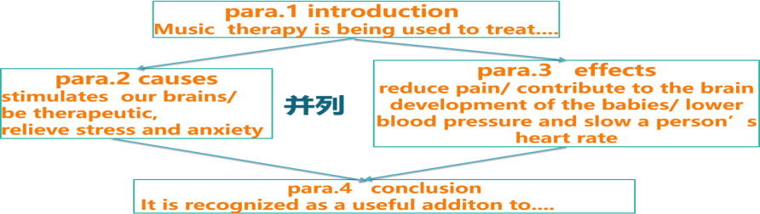

Activity 3: Paraphrase the topic sentence or the main idea with five summary techniques

1). Introduce five distinctive summary techniques

1. Employ the synonyms
2. Change the part of speech of words
3. Apply converse expressions
4. Change the sentence patterns
5. Diversify the sentence patterns

2). Paraphrase the four paragraphs

Students are asked to apply the five summary techniques to substitute what each paragraph is focused on. They will probably find out some words, phrases, sentences or main ideas are tough to replace, which may show that the English needs to be improved.

Para.1

Change of words and phrases

around the world

__________/______________/_______________/_________________/______________

/____________________

be being used to treat ....

be being _________/__________ to treat...

be a ________/__________/_______/_________/___________way/________/_______of/ __________ to ________

different

_________/_______/_________/___________/___________

One version

___________________________________________________________________

Para.2

Change of words and phrases

stimulate __________/___________

therapeutic _________/_________/________/__________

relieve _________/_________/________/______________

Change of sentence

___________ (why music is a useful/helpful therapy) is ______...

One version

_________________________________________________________________

_________________________________________________________________

Para.3

Change of sentences

Music has been proved to generate_______ effects of __________(reduce) pain, _________(develop) the babies’ brain, _______(lower) blood pressure and _________(slow) heart rate.

Music, ____________________________, can bring about positive effects, including reducing pain, developing the babies’ brain, lowering blood pressure and slowing heart rate.

Para.4

Change of sentences

although

______/_________/________/__________

___________________as music therapy is not yet considered, it is....

Despite/In spite of the fact _____________________________________,...

it is recognized more and more as a useful addition to...

1. it is ________________ regarded/considered as an effective ________ /________ to traditional...
2. it is gaining _________________ as an _____ way to assist ...

Students are asked to share their summary of Para.4, compare the following three sentences with their own version, and then choose which one is their preference.

A. Major treatment as music therapy is not yet considered, it is increasingly recognized as an effective supplement to traditional treatment.

B. Despite the fact that music therapy is not yet the main treatment, it is gaining increasing recognition as an effective extra way to assist traditional treatment.

C. Though music therapy is not adopted widely, it is regarded as an effective helper to traditional treatment.

Activity 4: Organize the whole paraphrased sentences with conjunctions

Students are asked to find the logic of each paragraph, consider possible conjunctions and then share the words or phrases with others.

Music therapy is a useful way to treat various illnesses worldwide. (要点一)The reason is that comforting music or playing musical instruments can activate our brain and help ease pressure and anxiety.(要点二)_________, music has already been proved to generate positive effects of reducing pain, developing the babies brain, lowering blood pressure and slowing heart rate.(要点三) Though music therapy is not adopted widely, it is regarded as an effective helper to traditional treatment.(要点四)

Activity 5: Polish summary writings from three aspects, content, language and handwriting

Group work: Students are required to work in group four in order to find out the mistakes in content, language or handwriting, which needs polishing.

Content 1

Considering its effects on certain conditions, music therapy is applied in some medical treatments worldwide. As a reason, different kinds of music can bring various benefits to people. Moreover, as is scientifically proved, endorphins brought by music can reduce pain and music therapy can lead to a better condition of heart so some places have already used it nowadays. As more effects of music therapy are being discovered, you can use it to reduce your pressure next time.

Content 2

Music therapy is widely applied to many medical treatments like reducing pain, activating the injured brain and assisting kids with disabilities. One contributing factor is that the mix of music stimulates our brain to give psychological and physical response. Also, music helps release endorphins, a natural painkiller, and gets blood pressure lowered and heart rate slowed. Though it is not a firstly-considered treatment, music therapy acquires more and more recognition as a helpful addition.

Language

(1)Music is comforting and relaxing, which stimulates our brains, helps reliefing stress and anxiety.

(2)Music therapy, not yet a mainstream treatment but a useful traditional treatment, which may heal you when you feeling low.

(3)Music therapy is used to reducing pain and overcoming disabilities.

(4)It is music therapy that be adopted to tackling various medical treatments and illnesses.

(5)The reason why music therapy beneficial is music enhances our brains.

(6)Though music therapy is not a chief method now, but it is increasing recognized as a significant method.

(7)Researches have found that music stimulates our brains and play an instrument can have a better effect in treatment.

(8)The reason is that music can reduce pain by release more endorphins, it also has the ability to lower blood pressure and slow heart rate.

(9)Music is a beneficial therapy, stimulating our brains because comfort and relax.

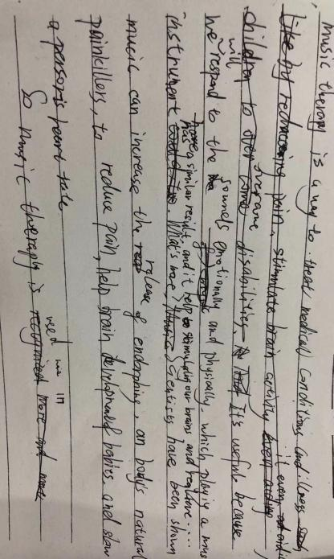Handwriting

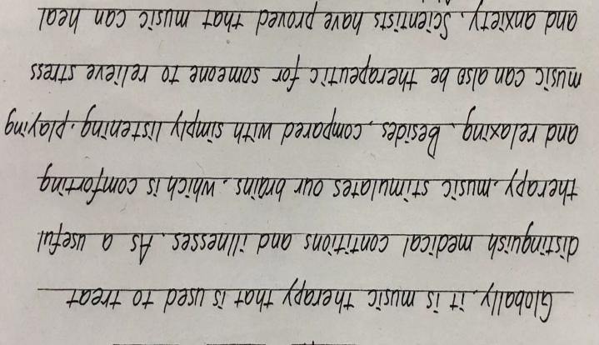

Fag a

1. Assignment:

1). Appreciate the original version;

2). Review what students have learned