**九省联考2025届高三10月联考读后续写**

**文本解构与写作训练**

**Continuation Writing**

**小围巾，大之爱**

**Teaching steps：**

1. **Lead-in**

1. What do you often do in your spare time?

2. What are they doing in the pictures?

3. How do you find the items knitted with love by your mother?

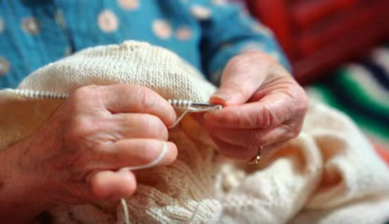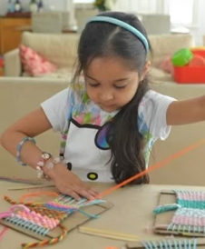

1. **Present the writing task**

第二节（满分25分）

阅读下面材料，根据其内容和所给段落开头语续写两段，使之构成一篇完整的短文。

P1. Emma comes from a remote village surrounded by mountains. Unlike her trendy classmates in New York who are addicted to such high- tech things as smartphones and social media, she prefers knitting(编织).

P2. Emma's love for the traditional skill is deeply influenced by her mother, who can create all kinds of beautiful things with a pair of simple needles. Whenever she is free, she will sit down and start knitting all kinds of things for her children and neighbors. Whether it is a mini bag or a scarf, each item is a unique gift full of love and warmth. And they are deeply loved by the receivers.

P3. Her mother's passion for knitting and generous spirit of helping others have inspired Emma to follow in her footsteps and she has taken up knitting as a hobby, too. By the age of 14, Emma has become especially good at making scarves and gloves. With beauty and practicality, Emma's hand- made gifts never fail to impress her friends as well as her relatives.

P4. Last week, the city was hit by a heavy snowstorm, which left many, particularly the homeless, in a desperate situation. As Emma made her way to school, she noticed a man shaking under the bridge near her school. It was a homeless man she often saw on the route. But today he looked particularly miserable. His face was half -hidden under a piece of worn cloth that hardly served as protection against the cold. Touched by the sight, Emma approached the man and presented her scarf to the homeless man.

P5. "For me, Miss?" asked the man in surprise. "It is too expensive!"

P6. "Please don't mind it. I have made it for myself and I can make another one in a few days!" Emma replied while she was wrapping the scarf around the poor man's neck. "I hope it might keep you away from the terrible cold."

注意：1．续写词数应为150个左右；

2．请按如下格式在答题卡的相应位置作答。

P1. Instantly, the man's eyes brightened and a big smile appeared on his face.

____________________________________________________________________________

P2. Emma shared the idea of setting up a knitting club with some of her "high- tech" classmates.____________________________________________________________

1. **Analyse the three elements of the story**

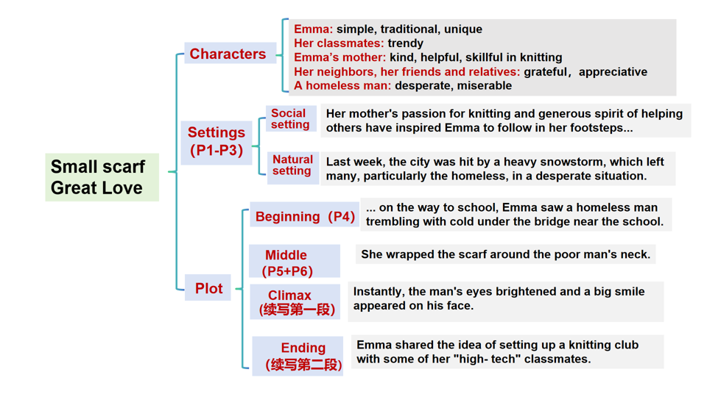

1. **Predict the continuance:**

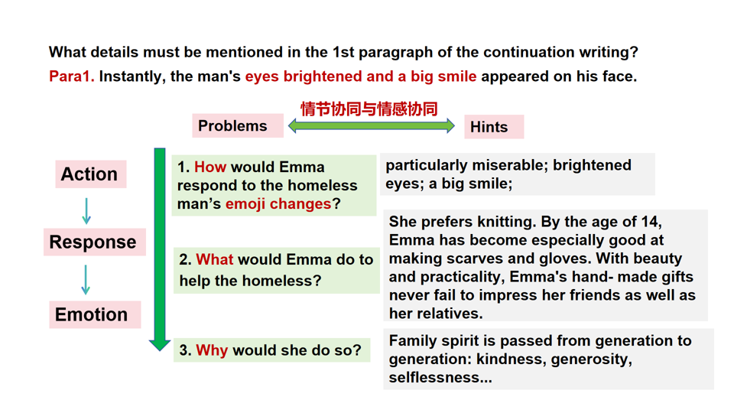

1. 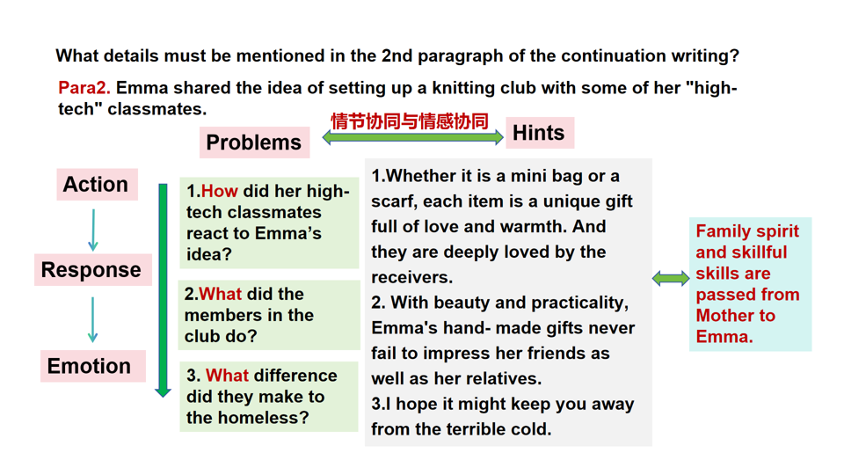**Think about the theme (主题协同）**

Man and Self; Man and Society

Her mother’s **love** for knitting and **generous spirit** of helping others have inspired Emma to follow in her footsteps.

1. Love Loves to Love Love.
2. 因为爱所以爱。

--- James Joyce

2.Small scarves and gloves made with love warm the whole winter.

3.Love is like a ripple, spreading from a home to those in need.

1. 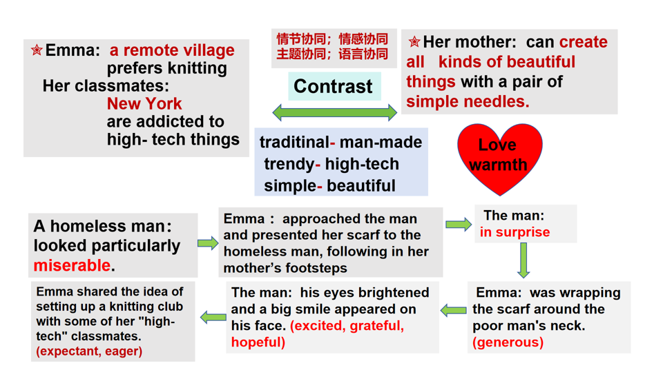**Appreciate the language:**

**VII. Extend the language:**

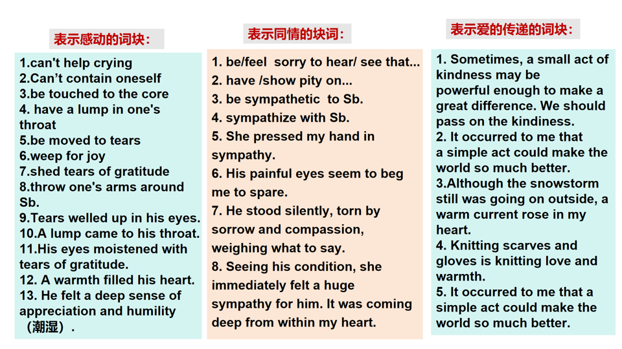

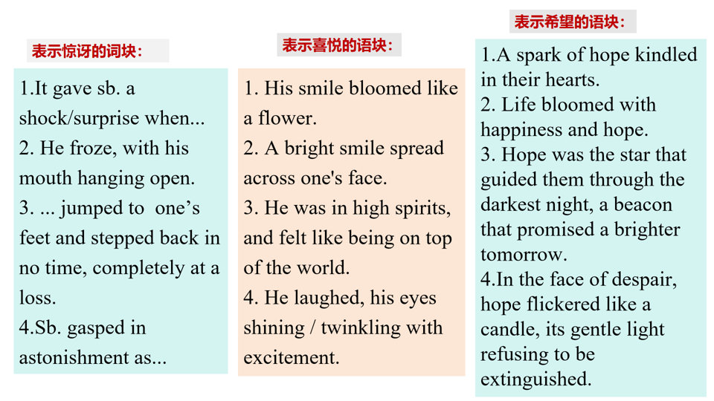

**VIII.Analyze the Students’ writing**

**IX.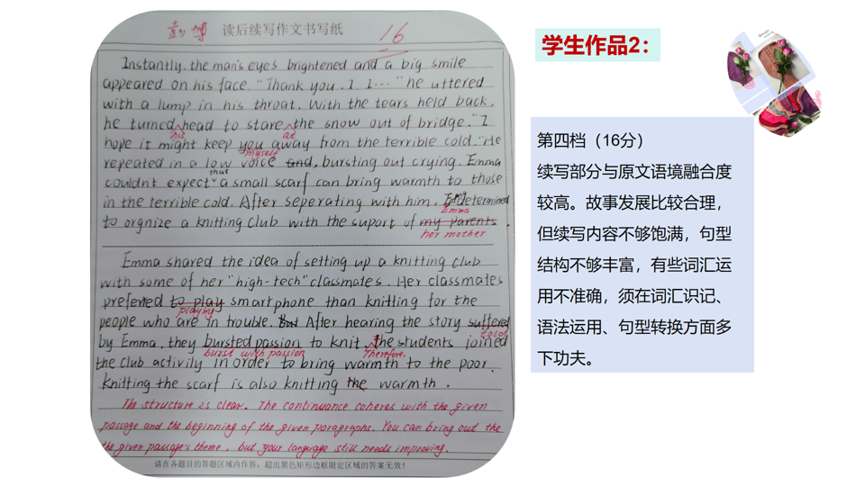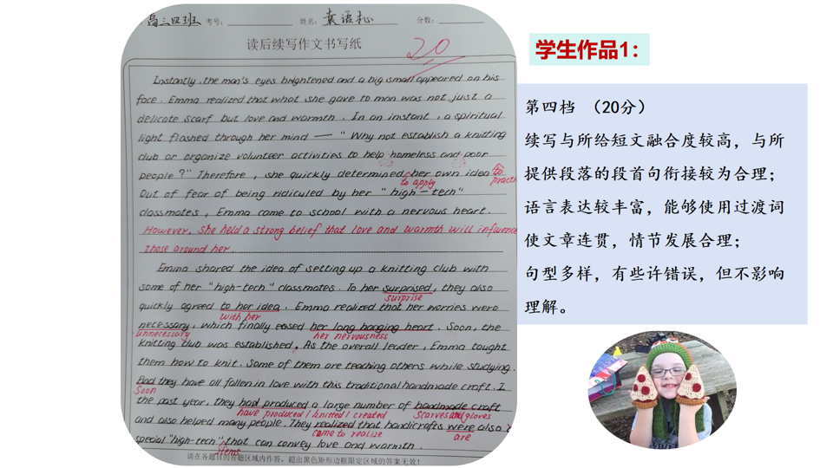 Appreciate possible versions**

**教师下水作文:**

Instantly, the man's eyes brightened and a big smile appeared on his face. Watching such a warm scene, a flood of 1__________(happy) filled her mind. 2________ heavy snowstorm, 3____________(encourage) by her mother’s generous spirit, Emma didn’t feel cold without a scarf. She suddenly realized how 4____________ (significance) knitting is for those in need as well as herself. Therefore, it 5__________ (occur) to her that a knitting club would be set up in the school, 6_______ the classmates fond of knitting could create scarves and gloves.

Emma shared the idea of setting up a knitting club with some of her "high- tech" classmates. 7________(hear) her words, the classmates were both 8____________ (enthusiasm) and hesitant because the idea was novel and needed skills. 9_____________ (immediate) Emma promised to teach them knitting, the classmates were active 10_______ (join) the club. Their spare time for High-tech things 11___________ (make) full use of to make scarves and gloves. Winter 12_____________ (approach), scarves and gloves were distributed to the homeless. Love is like a ripple, spreading from a home to those in need.

**官方范文：**

Instantly, the man's eyes brightened and a big smile appeared on his face. At that moment, Emma realized that what she presented was not just a scarf 1_____ a sign of love and hope. 2________ (inspire), she determined to bring that spark of hope to more 3_________ (home) people. On her 4_______ (arrive) at the school, an idea 5_________ (occur) to her. "Why not set up a knitting club to bring more warmth and hope to 6_______(that) in need?" she wondered.

Emma shared the idea of setting up a knitting club with some of her "high- tech" classmates. At first, she 7_____________(worry) that they might laugh at her "low- tech" idea. To her 8 ____________ (amaze) , they responded to her proposal 9_______________(enthusiasm) . In a few days, the club 10______________(found) and more and more students joined them. Some of them started learning the traditional skill and others used social media 11_________ (seek) help online. By the end of winter, the club distributed more than two thousand hand- knitted items. Never did the kids 12_________ (realize)the marriage of high- tech and low- tech could be so magic!

**网络范文：**

Instantly, the man’s eyes brightened and a big smile appeared on his face. His hands trembled slightly as he 1_____ (hold) the scarf, clutching it as if it were a treasure. “Thank you, miss. This means 2_______(much) than you can imagine,” he said, his voice choked with 3__________ (grateful) . Emma felt a warm bloom in her chest, a feeling deeper than simple 4__________(kind) . It was at this moment 5_______she realized her knitting could serve a greater purpose. She thought of her mother, who had always knitted for neighbors and family, 6________ (give) love through every creation. If only more people7____________ (feel) the warmth of a simple scarf, she thought, a newfound determination growing within her. Inspired, she decided to turn her passion 8_______ something larger, something that could bring comfort to others in need.

Emma shared the idea of setting up a knitting club with some of her “high-tech” classmates. At first, they were 9__________(hesitate), casting doubtful looks as if knitting couldn’t 10______________ (compare) be compared to the thrill of their gadgets. Little did they expect that knitting could make such 11___ impact. Emma passionately shared her experience with the homeless man, 12___________ (explain) how a single scarf had brought him comfort. Her story painted a vivid image, and one by one, her classmates’ skepticism faded, 13__________ (replace) by genuine interest. Soon, a few classmates volunteered to give it a try, excited by the thought of creating something meaningful. With each new member joining, the club's influence grew 14_________ (steady) . As students gathered after school to knit scarves, gloves, and hats, Emma watched with pride as her simple idea 15____________(blossom) into a shared mission to spread warmth and compassion.

**X. Homework**

Edit and polish your writing.

**家风是一种无言的教育，润物无声地影响孩子的心灵。**