**Book3 Unit4 Reading How life began on the earth教学设计**

**人教版高一英语必修三第四单元第一课时**

**江西省上饶中学 陈德荣**

**Ⅰ.教学课型 阅读课**

**Ⅱ.教材分析**

**这节课内容的中心话题是“天文学”。这篇文章是一篇夹叙夹议的说明文。讲述了地球上生命的起源， 先从“宇宙大爆炸” 讲起，具体介绍了各种生物的起源和出现的顺序。文章脉络清晰， 结构分明，“生命起源”这一话题对高中学生来说充满了趣味性，引人入胜，给学生留下很大的思考空间，能够激发学生的想象力，积极去阅读文章，了解生命的起源以及生物进化的过程。接着文章就人类对地球的负面影响和地球是否能延续进行讨论。学生通过略读、速读、摘记等，根据各环节设计的具体任务来学习理解这篇文章，帮助学生进一步了解保护地球的重要性。通过任务型教学，促进学生进行小组合作学习。**

**Ⅲ.学情分析**

**高一年级的同学经过上一学期的学习，对于高中学习方式以及培养的能力都有了一定的认识。在阅读技巧方面，大都学生已经掌握了如略读、跳读、细读等阅读技巧，能在短时间内找到关键词和关键句；但是由于基础不一样，并且地球起源这个话题对于大部分学生来说是陌生的，特别是对于初中基础差暂时落后的学生，所以这也要求我们在设计学案的时候要难度设计要层层递进，区别对待基础不同的学生。**

**Ⅳ. Teaching Objects:** *During the class, students should be able to*

1. Understand the meaning of the reading passage.
2. Practice the following reading skills: skimming and scanning
3. Get the detailed information about how life developed on the earth
4. Practice skills of analyzing things in scientific mind
5. Retell the story by completing the summary

**Ⅴ. Focal points& Difficult points:**

1. Get the detailed information about how life developed on the earth

2. Practice skills of analyzing things in scientific mind

**Ⅵ. Teaching Method:**

Cooperative and Task-based method

**Ⅶ. Teaching Procedures**

**Stage1. Lead in**

Step1. Have a quiz and get to know some common senses about astronomy

Questions:

1.The earth moves around the sun.

2. It takes the earth one day to move around the sun.

3. The earth is the only planet moving around the sun.

4. There is water on the moon now.

5. The earth is the only planet in the solar system which has living creatures.

Step2. Learn two main theories of the origin of life: Creation and Evolution.

**Stage2. Pre-reading**

Step1. “God created the world in 7 days”

Day1: God created day and night

Day2: Sky and ocean

Day3: Dry land

Day4: The sun, moon and stars

Day5: Creatures in the air and sea

Day6: Land animals and man

Day7: God had a rest

**Stage3. While-reading ask Ss to read one paragraph by one paragraph**

Step1. Find the widely accepted theory by reading para.1

The universe began with a “Big Bang” that threw matters…

Step2. Get the history of the earth

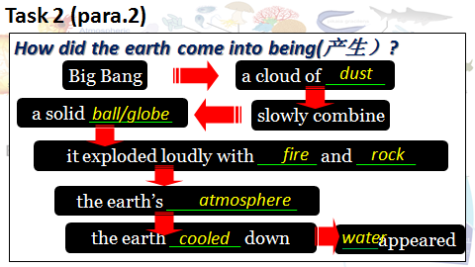

Step3. Answer questions about the functions of water

..................

Step4.Find the detailed information about how life developed on the earth after water appeared?

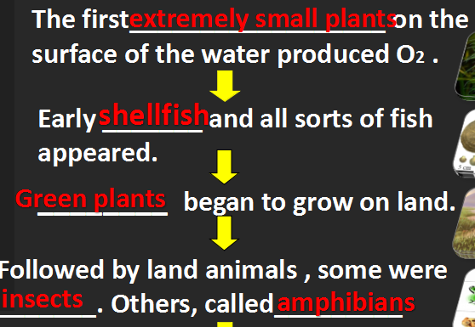

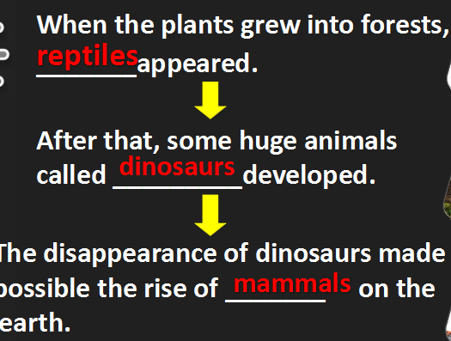

Step5. Q&A. Talk something about what human beings have done to the earth and what we should do to protect our mouther earth.

1. What were those clever animals with hands and feet?

2. What have they done to the earth? What problem are humans causing?

**Stage4. Post-reading**

Summary of the passage

**Stage5. watch a video** about the History of the earth to recall what we learned today.

**Stage6. Assignment homework**