**Text patterns of exposition**

**课前导学作业**

Task：Please read the 2 texts. Divide each text into several parts.

Conclude the main idea of each part and complete the mind map.

*（Tip: Underline the topic sentence of each paragraph. It can help you.）*

*Text1**(Book6 Unit3 Reading)*

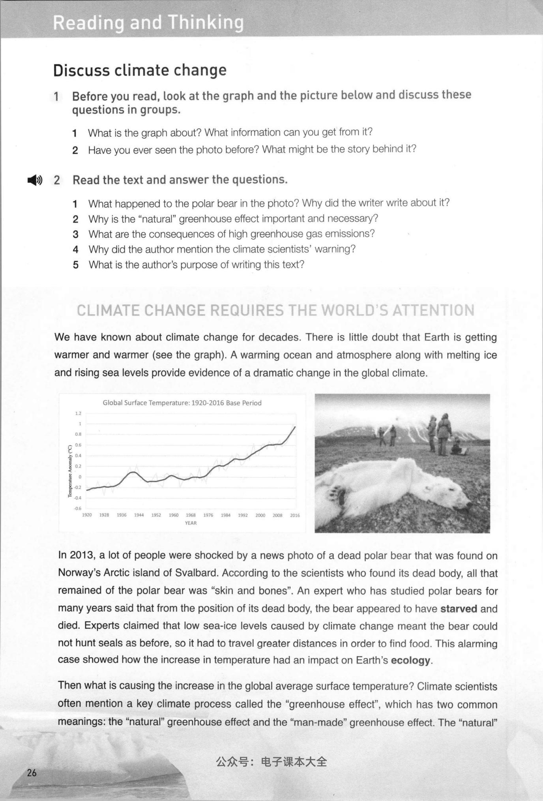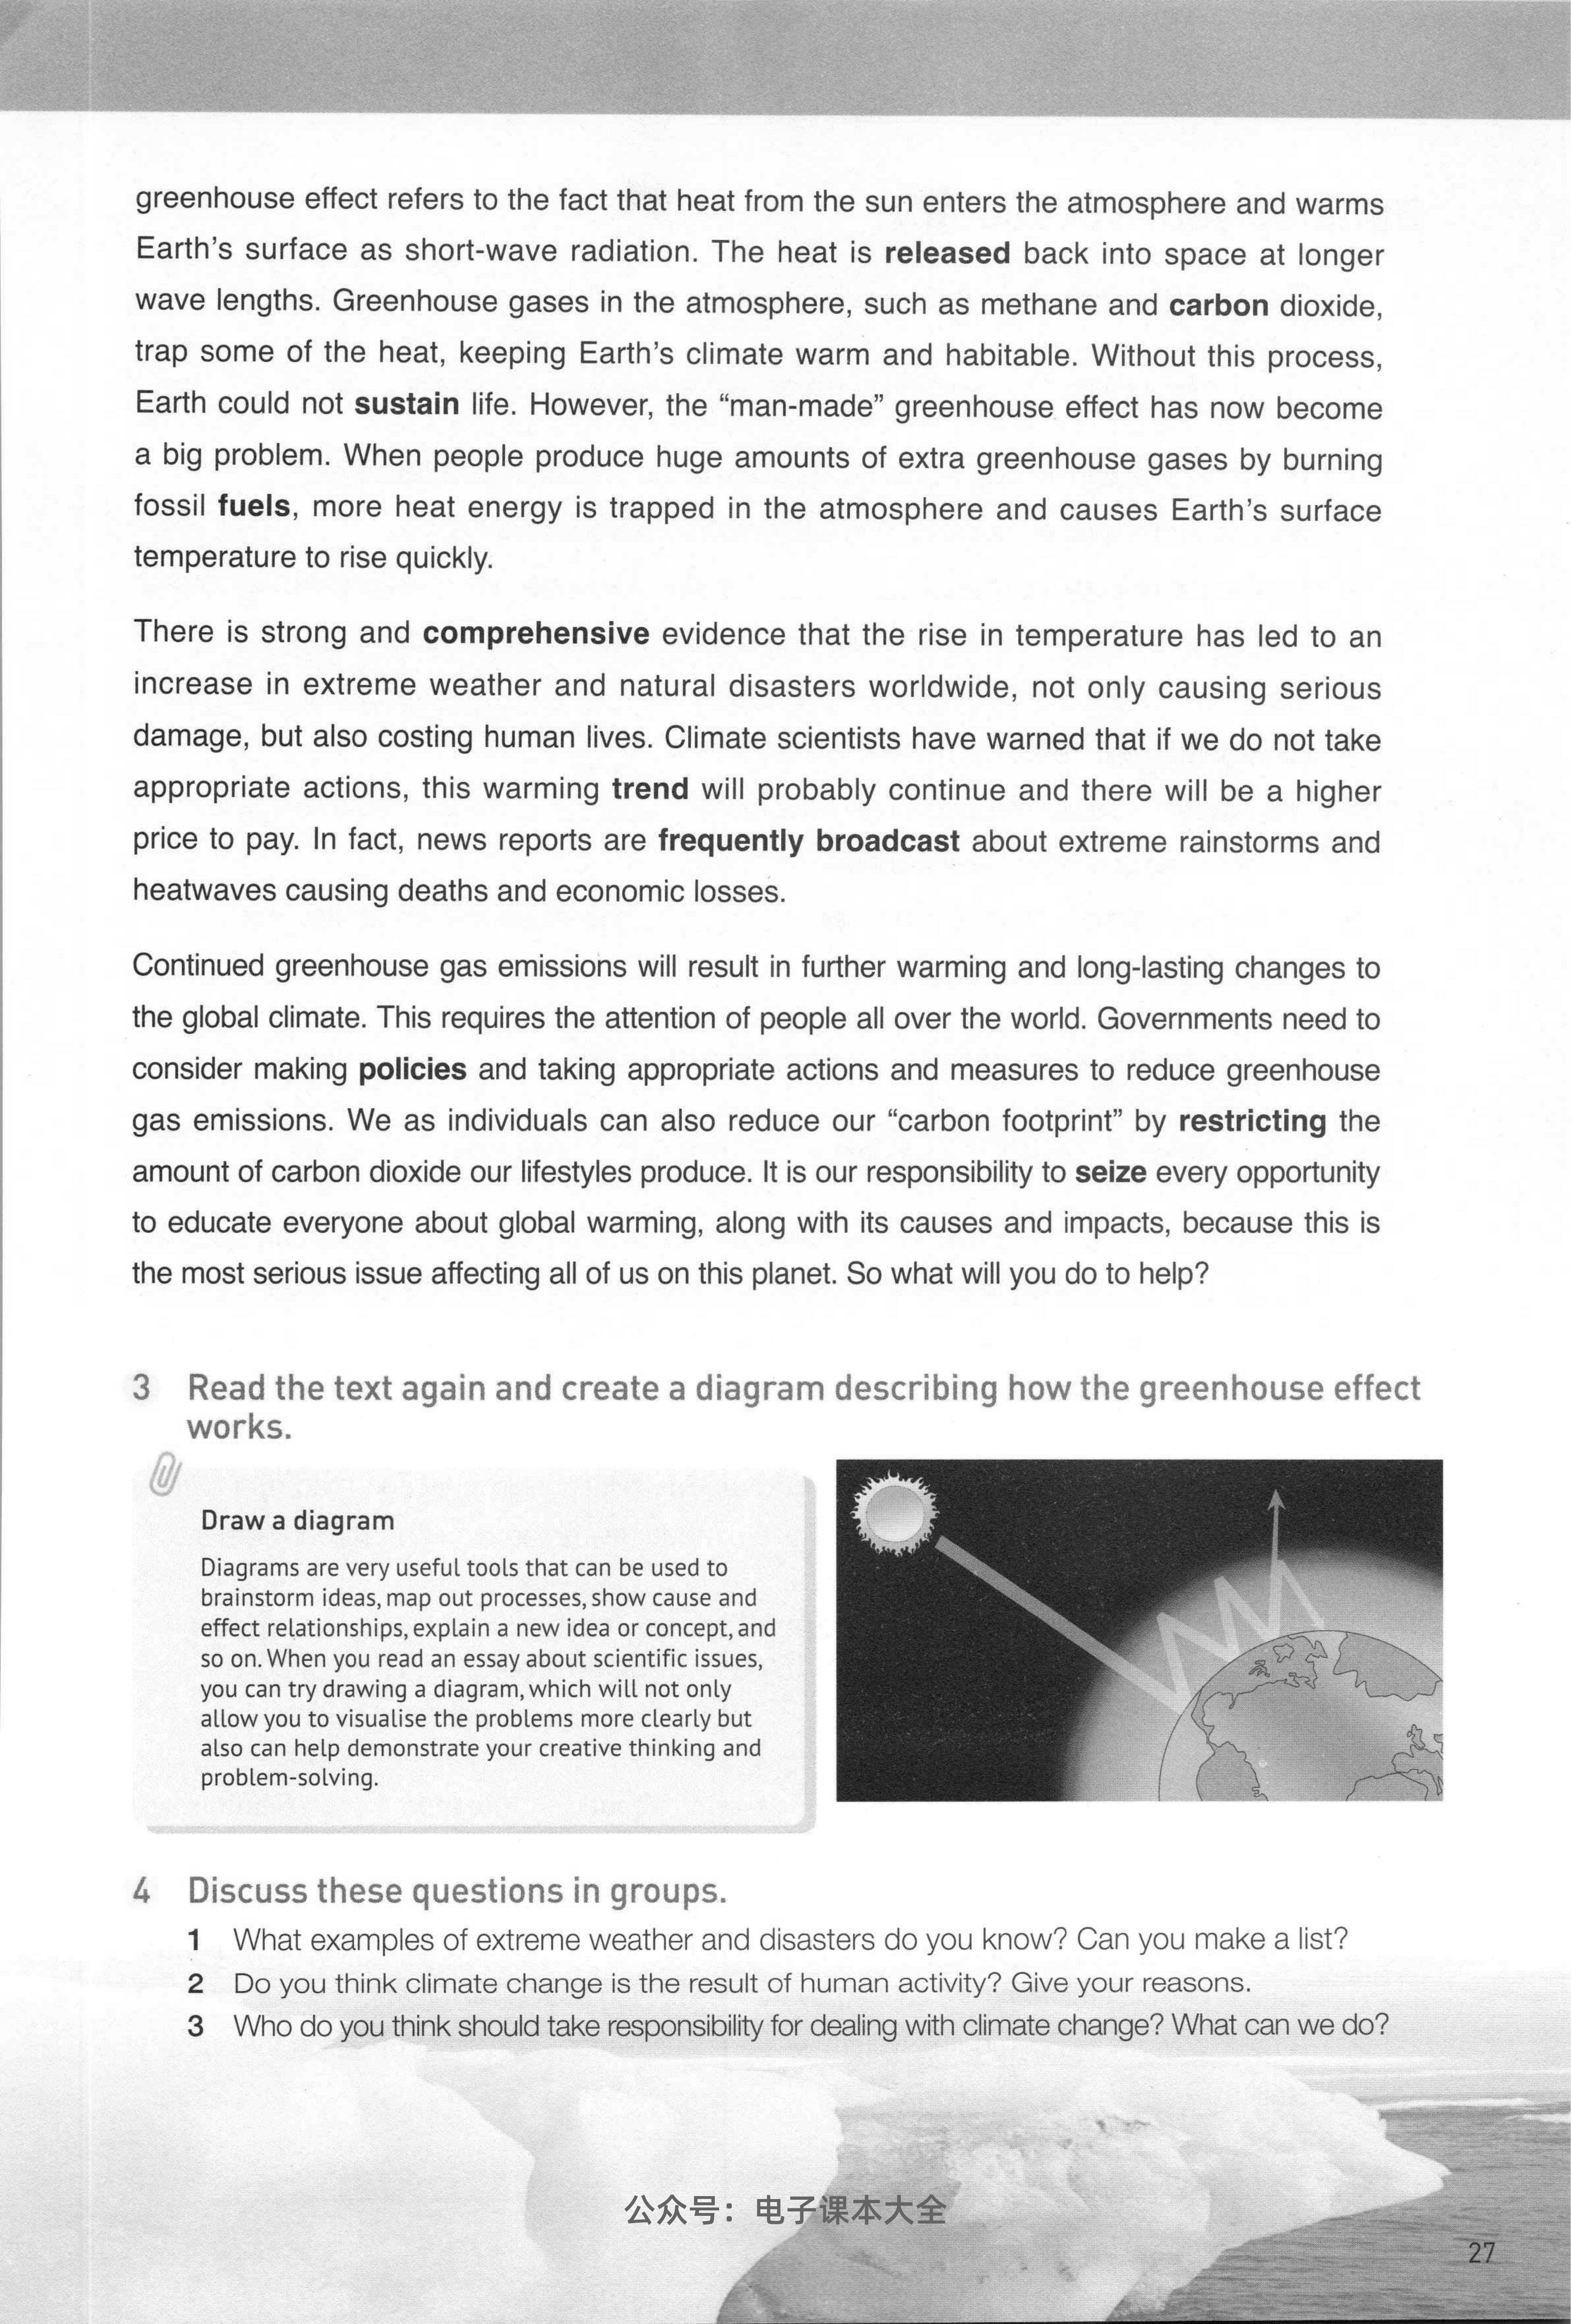



Mind Map:

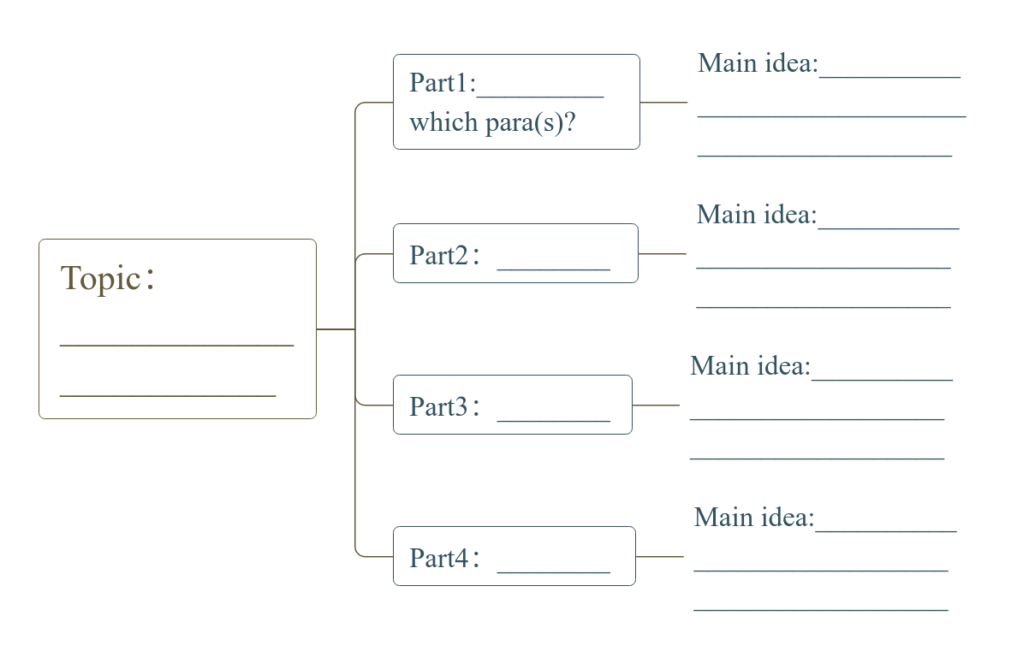

*Text 3**(Book6 Unit2 Reading)*



