**选择性必修四Unit 1 Reading and thinking学案**

**Pre-reading**

Task 1 Explore the relationship between humans and robots。

Task 2 Think about the genre of this text.

Task 3 Think about the title.

**Reading**

Task 1 Reading for the main idea.

Main idea: It is mainly about how a household ________ was ________ ________ in a family.

Task 2 Read for the structure.

Task 3 Clarify the main characters and their relationships to each other.

Task 4 Reading for the changes of Claire’s feelings towards Tony

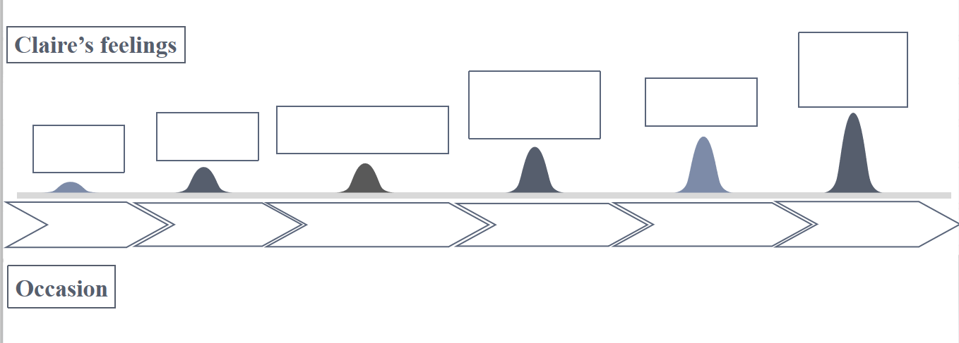Task 5 Read for the result of Clair living with the robot.

Q: What happened before the party began?

**Post-reading**

Task 1 Work in groups and come up with a reasonable ending.

Think about: Q1. What would happen at the party?

Q2. What would happen between Claire and Tony?

Q3. What would happen between Claire and Gladys?

*Then the front door bell rang.___________________________________________________*

*___________________________________________________________________________________________________________________________________________________________________________________________________________________________________________________________________________________________________________________________________________________________________________________________________________________________________________________________________________________________________________________________________________________________*

Think about: Q1. What would happen to Claire? Was she eventually satisfied?

Q2. What would happen to Tony? Did he pass the test?

*The next morning a car drove up and took Tony away ________________________________*

*___________________________________________________________________________________________________________________________________________________________________________________________________________________________________________________________________________________________________________________________________________________________________________________________________________________________________________________________________________________________________________________________________________________________*

Task 2 Think about the questions.

Q1. What are the similarities and differences between Tony and a human being?

Q2. What relationship do you think will develop between humans and robots in the future?

Q3. Nowadays the application of the robots has already become an irresistible trend.

Is it a challenge or an opportunity for the future development of mankind?Why?