——B6u3 Advice From Grandpa
本课是阅读-写作课，文本选自人教版选修六第三单元，A healthy life.
（一）教材分析
文本分成两部分。第一部分是82岁爷爷给吸烟上瘾的孙子写的亲笔信，在信中爷爷提到自己年轻的时候也抽过烟，甚至上过瘾，因此他知道上瘾容易戒烟难，并以亲生体会向孙子说明上瘾的原因、抽烟的危害和戒烟的方法，告诫孙子把烟戒掉。文章脉络清晰，在每段都可以借助中心句理清主要大意。同时，全文是一封建议信，可以借助文本的学习让学生掌握建议信的结构和写法。
（二）教学目标
1. 语言技能
能够读懂建议信；
能都准确找出段落中心句并归纳大意；
能通过原文语言的学习仿写。
2. 语言知识
能够掌握新词汇：due to, be addicted to, accustomed to, automatic, effect, abnormal, unfit, decide on；
3. 情感态度
培养正确的学习动机，明确英语学习的目的是沟通和表达；
认识到烟瘾形成的原因，危害和戒烟的具体措施。
4. 学习策略
通过标题文本和图片预测文本内容；
阅读文本时，通过主题句和文本内容总结提炼主要信息，培养信息整合能力；
在阅读过程中，学生应该提高本身的阅读能力：粗读、略读、细读；培养良好的阅读习惯。
5. 文化意识
养成并倡导健康的生活习惯；
在别人需要的时候给出具有指导性的建议。
（三）教学重难点
1、教师需帮助学生熟悉建议信这一体裁的文本特征，并引导学生利用文本特征迅速获得重要信息，让学生对文本内容进行归纳、梳理，形成较为清晰的脉络。
2、利用学生对吸烟的危害知识的理解激发他们课外收集相关信息。通过文本的学习，让学生熟悉语言、结构、句型等，为之后的写作提供参考模板。
（四）课堂呈现
Step 1：Lead-in
Task 1 Free talk
- What should we do to stay health?
- Do you smoke? /Does anybody around you smoke? Have you ever advised him/her to quit smoking? Did he/she quit smoking?
设计意图：这个环节只要是让学生对本节课的话题感兴趣，同时学生建议别人不抽烟的经历会激发学生学写建议信的求知欲。
Step 2：Fast-reading
Read the title and skim the passage, and answer the questions followed:
- How many parts does the reading text consist of?
- Who wrote the letter? To whom? (What is his tone (语调) when writing the letter?)
- Why did he write the letter?
设计意图：通过对阅读标题的理解，可以准确预测出这是爷爷写给孙子的信，于是就可以引出问题“为什么写这封信”。该环节主要目的是帮助学生培养预测的技能，通过标题就可以有据猜测文章大意。
Step 3：Careful-reading
Task 1: Scan the letter and get the main idea of each paragraph
设计意图：在该过程中培养学生通过略读了解文章结构，并且训练学生通过关键句总结段落大意的能力。
Task 2: Close-reading
Para.1
T: Please read Para.1 carefully and then answer the question.
- How does grandad feel?
He feels… （active, energetic, relaxed, proud ）
- What is grandad’s life like now? How do you know?
…sitting under the big tree
…a long ride to …
…still fit enough to cycle 20 km
…will be 82 years old

A healthy life
Para.2
T: Grandad has a healthy life, how about James? Let’s read Para.2 to find the answer.
- What is James’ life like now? How do you know?
An unhealthy life: started smoking, finding it difficult to give it up.
(He lived an unhealthy life, because he was addicted to smoking.)
- Did grandad scold（责备） James when he knew his grandson smoked?
NO!
- What did he say?
Believe me, I know how easy it is to begin smoking and how tough it is to stop. You see, during my adolescence, I also smoked and became addicted to cigarettes.
- Why did he mention his own experience?
He once had the same experience with James and he knew his feeling very well, which shortens the distance between them, and made his advice more acceptable for James.
Para.3
T: James has been addicted to smoking, how many ways to be addicted to smoking? What are they? Find the link-words to get the answers.
- become physically addicted to nicotine.
- become addicted through habit. = habitually
- become mentally addicted.
Read the paragraph carefully and find the details of each way.
WAYS | DETAILS
physically | …be accustomed to having nicotine…withdrawal symptoms: bad-tempered, in pain
habitually | …over and over again…automatically
mentally | …feel happier, more relaxed …… only feel good when smoking
Para.4
Read Para.4 and find out the harmful effects to smokers and non-smokers.
To smokers:
- Do terrible damage to ______ and _________
- Be difficult for _____________ to become ________.
- _________ and _______ smell terrible
- The ends of fingers _______________
- Become _______________
- Not enjoy _____________
To non-smokers:
- The babies of smoking couples ____________________________
T: Read the para. again and find out: what did not granddad know and what did he know? Pay attention to the sentence pattern.
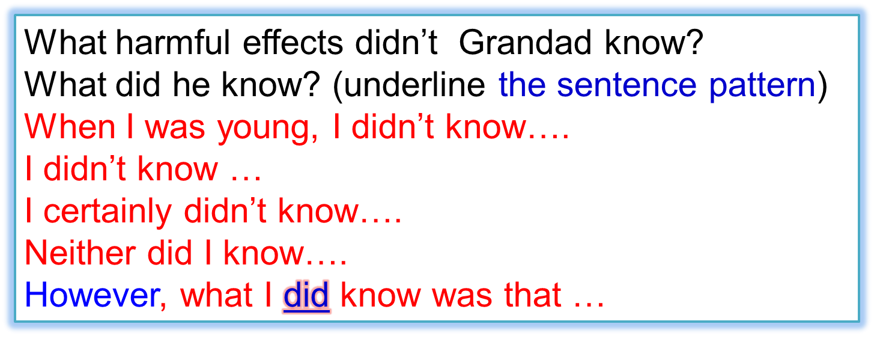
What was Grandad’s feeling by saying so?
He felt very regretful. If he had known the bad effects of smoking, he would not have started smoking.
What kind of picture did Grandad want to describe in this part? Circle the adjectives.
harmful…  terrible…  difficult…  abnormal…  breathless…  unfit… | What’s the meaning of the comparison? | beautiful…  big…  amazing…  long…  now  active…  healthy…
By making such a comparison, grandad wanted to convince (使---信服) James that smoking was harmful and it was time for him to quit.
Para.5 Do you think James want to quit smoking after reading the letter?
设计意图：通过每段的细致阅读，让学生通过回答问题让学生熟悉成瘾和相关危害的一些表达，为之后仿写提供结构，语言，和句式上的支撑。同时利用表格，比较等形式让学生感受到一封就有说服力的信应该包括自身经历，有说服力的证据和针对性的建议等组成。这一环节为了提建议的句式和提建议的方式铺垫，为之后的写作环节准备相应的知识储备。
Step 4：Summarizing
Task 1. The structure of the letter
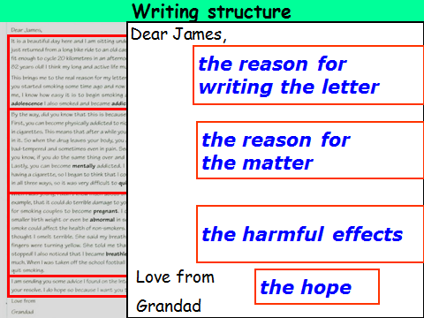
Task 2. The useful expressions to give advice

It’s a good idea…
It’s beneficial to…
You’d better…
You can try…
It will be helpful if …
If I were you, I would…
…

Task 3. How did Grandad advise his grandson?

• Use his own experiences
• Not scold but encourage and give hope
• List the harmful effects of smoking
• Make a comparison
• Advice as a friend
• Use an internet page to offer advice
• Advice in an orderly structure

设计意图：最后的总结，让学生对之前文本出现的结构，句式和一些给建议的方法更加明确，为之后的写作奠定坚实的语言、结构和情感的基础。
Step 5： Assignment
根据以下要求完成作文：
Recently, I have a nephew called Li Qiqi, who is addicted to playing online games like many young people. Write Li Qiqi a letter and tell him the bad effects of playing online games.

