BOOK 1 Unit 3 Sports and fitness （reading & thinking)
---by Hugo
教学目标 | - Learn to introduce some famous legends  - Improve Ss’ skills of reading and expressing themselves  - Know the structure of biography writing  - Learn about the spirits of the legends
教学重点 | The structures of biography writing(two types)
教学难点 | The structures of biography writing (two types)
教具准备 | PPT&computer
教学过程 | - Greeting--ask & answer  Talking about the parade on National Day holiday and introduce briefly about China’s Female volleyball team as well as their coach--Lang Ping.  Come up with the topic today--Living Legend!  - Reading & comprehension (Part One--Lang Ping)  - Skip part one of the text (about Lang Ping) and circle out the words of time  - Read the text again carefully and fill in the blanks.  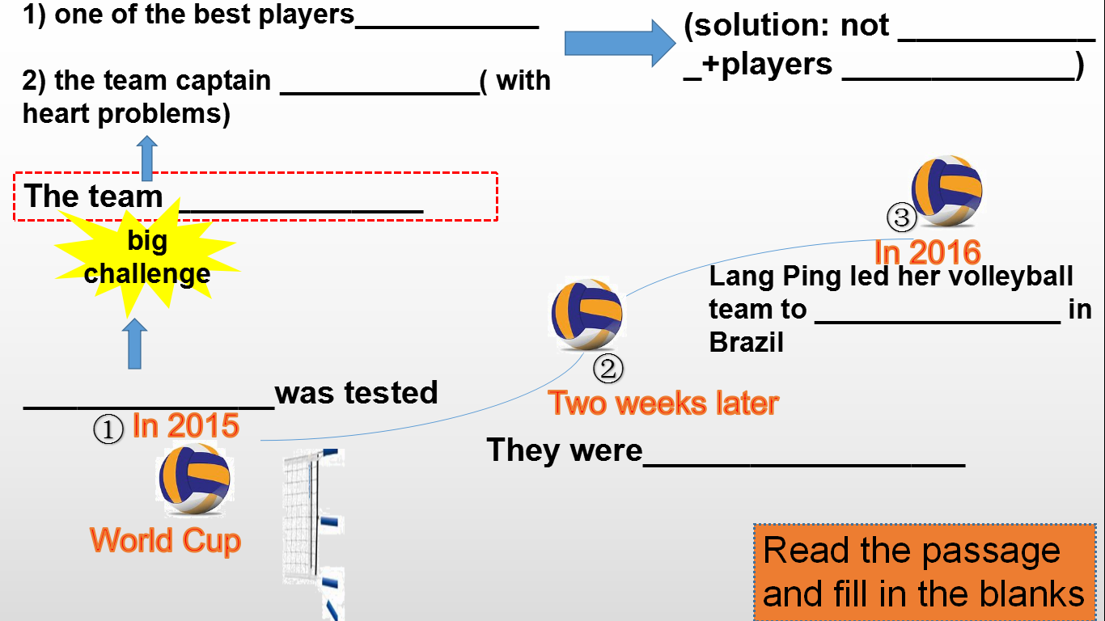  - Finish the exercises in three parts according to different time period  - Ask and answer  How does the author organize the content? Is it in the order of ....? (time order)  What does the author to describe? (experience)  - Talking about the structure  - In Lang Ping’s life experience, she has got three roles? What are they?And what does she do respectively?  - How does the author put the roles together? Which word does the author use to connect them? Why does he organize the content in this way? As--parallel sentences ---to stress her achievements)  - Summarize the first kind of biography writing  - Thinking: Why is Lang Ping called a living legend?  - Reading & comprehension (Part One--Michael Jordan)  - Enjoy the video and introduce the other living legend --Michael Jordan  Ask and answer: What do you know about him?  2.Read part two and answer the questions  1. What's the achievement of Michael Jordan? (find the expressions in the text)  2.How could he achieve that? Does the author organize the text according to the time order? If not, how is it organized? Let’s analyze the sentences one by one)  3, What are the examples for both aspects?  For skills:  For metal strength: the secret to his success is ______________________  ( words +actions---in profession: losing games taught him--_________________  in life: he has learnt to___________________  (e.g. The boys & Girls Club)  How does the author organize the information?  Draw a mind-map of this text  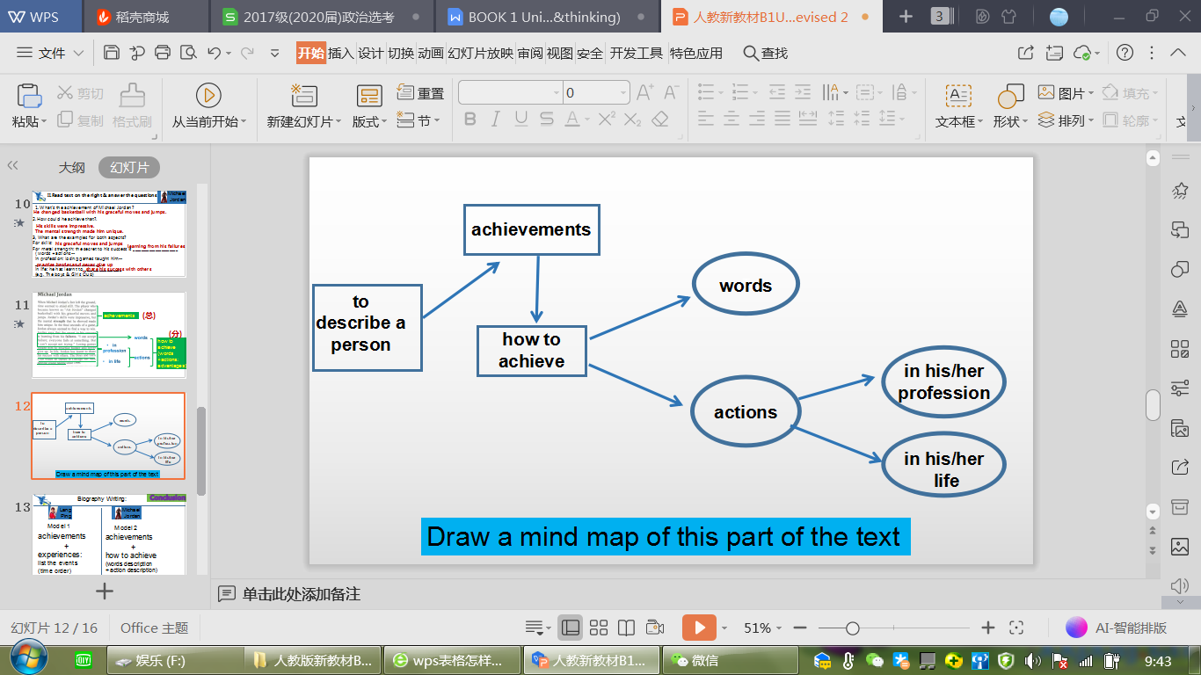  Compare the two kinds of structure of biography, summarize the way of writing biography  - Post-reading  - Discussion  - Introduce Lang Ping or Michael Jordan with the expressions below(choose either of them)  - Why do people call them living legends? Can you say some characteristics of a living legend?  2.Group-work: My living legend  Please think out another living legend, talk him/her with your partner, jot down some expressions if possible  3.Summarize--a few sentences to summarize today’s lesson
作业 | Homework: writing a short passage about a living legend you know
教学评价

