**M3U4 Space Exploration**

**Reading for writing**

**Teaching Objectives：**

By the end of the class, students will be able to

1. get the main idea of the argumentative essay——it is of great significance to spend money and time on space exploration.

2. master the basic structure of an argumentative essay and some basic expressions to write an argumentative essay

3. apply the writing skills to practice——write an argumentative essay of garbage sorting recycle

**Teaching Important and Difficult Points：**

How to make students work out the structure of the argumentative essay in English

How to make students write down an argumentative essay effectively

**Teaching Procedures:**

**hundred**

**thousand**

**million**

**____________关于**

**Step 1: Lead-in**

**Activity 1: Make a guess**

Students will be asked to think about the following questions at the beginning:

Q1: In the former lessons, we know it is difficult for a person to step into the space, but why?

Q2: In addition to a healthy body, what else stop us?

Q3: How much should a person pay to step into space? (an example about an American)

And how much does a country spend on the space exploration yearly? (picture)

**Activity 2: Free talk**

Students will be asked to share their views on “if it is a waste of money to space exploration”.

Q1: Some think it is a waste of money to explore space, do you agree? Why or why not?

T: Opinions are divided on this issue.

Q2: What does it mean? Do you know any other expressions to show people’s opinions?

Ss: Different people have different opinions/ People, however, think quite differently on this issue.

Q3: Can you combine the claim’s and the counterclaims’ opinions into one sentence?

1. Some people argue that…**, while others disagree, t**hey.**..**
2. Some people argue that … Others , **in contrast** , believe that …
3. **Although** more and more people come to believe … **there are still** others who **insist** that …

Q4: Can you repeat our classmates’ opinions with these expressions?

**Step 2: Prediction**

Students will be asked to look through the passage to know the type and the structure of the passage:

Q1: What kind of passage is it? And the feature of this kind? (argument(论点), proof(论据), reasoning(论证), conclusion.)

Q2: Can you divide it into several parts? and why?

Q3: What’s the relationship between the first part and the last part? (echo)

**Step 3: Reading**

**Activity1：Read for the topic and opinions**

Students will be asked read the first para to get the topic and the opinions on the topic:

Q1: What’s the topic of the argumentative writing? / What are the opinions of the two sides? Why? /

What’s the writer’s?

Q2: Do you think the topic is stated clearly? Can you make it more clear and more eye-catching?

1. **Nowadays, there is an increasingly hot topic about whether to…or not.**
2. **There is a drastic discussion about whether it is necessary to … or not. (rewrite)**
3. **Nowadays there is a growing concern for…**
4. **Recently, …has become the focus of the society.**

Q3: Please rewrite the topic.

**Activity2：Read for the proofs**

Students will be asked to read the following paras to answer the following questions:

Q1: What were the proofs to support writer’s argument?

Q2: How did the space exploration help improve food production?

Q3: What did the picture of Earth from space make people realize?

Q4: How did space exploration benefit the products that people use nowadays?

**Adding questions:**

1. How does the writer support his argument? (reasoning)
2. analyzing the data B. contrasting C. listing examples D. presenting results
3. How to make your examples clearly? (Use linking words: firstly, then, besides…)
4. What’s the function of last para? How? (Use conclusive words: in closing, in the end, all in all…)

**Activity3：Summary**

How to organize an argumentative essay?

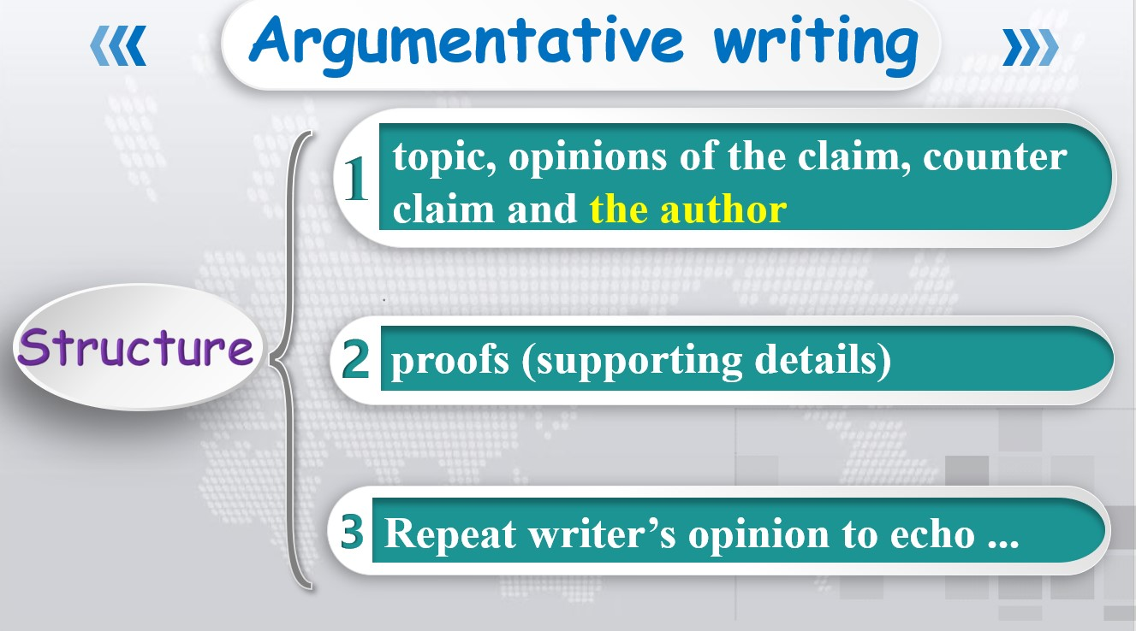

**Step 4: Writing**

Students will be asked to write an argumentative essay of garbage sorting recycle

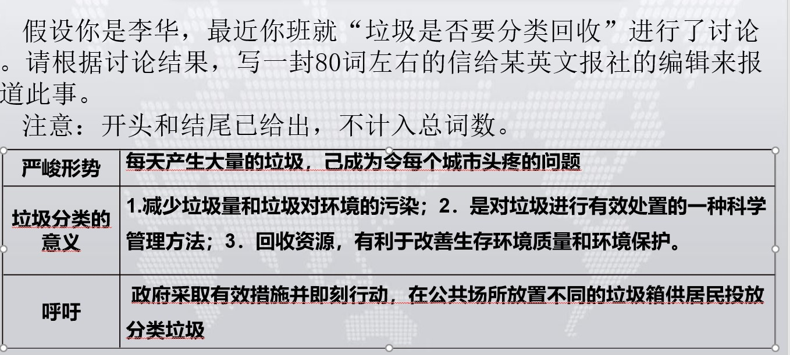

**Sample:**

Recently, garbage sorting recycle has become a focus of the society. Some people argue that it’s not necessary to do this. Others, in the contrast, think we should take actions right away, for society produces a large amount of rubbish every day. And I agree with the latter.

     Firstly, rubbish classification can reduce the amount of rubbish and the rubbish pollution to the environment. Secondly, it is a scientific and effective way to manage rubbish. Apart from that, by classifying rubbish it allows us to recycle resources, which will improve the quality of our living conditions and help the environment.

In closing, I definitely think we should start the activity--- garbage sorting recycle immediately. It will surely be beneficial to both our mankind, but also the environment.