**协同效应在读后续写中的应用**

**教育是一场双向奔赴**

**—温州市2025届高三第一次适应性考试读后续写**

**陕西省礼泉县教育局教研室 高小聪**

**Contents:** Ⅰ. **读后续写命题特征及规律**

**Ⅱ. 读后续写存在的问题**

**Ⅲ. 读后续写中协同效应**

**Ⅳ. 协同效应的具体应用**

**Ⅰ. 读后续写命题特征及规律**

**文体：故事类记叙文，大多源于外国人生活。**

**要求: 考生依据给定材料内容和段落开头（350词左右）续写两段内容**

**(150词左右), 给定材料和续写部分逻辑衔接、情节、结构完整；**

**段落开头语是对续写故事的发展有提示、引导和限制作用。**

**主题: 人与自我、人与社会、人与自然。续写主题以彰显人性美，体现人与社会、人与自然和谐相处为主。**

**续写部分的思路和内容：考生可以根据自己对材料的理解，对材料的结尾有不同的诠释。但是，不能脱离原文，更不要宣扬负能量。**

**Ⅱ.读后续写教学中存在的问题**

**（一）学生的续写作文在结构、内容、语言、主题、逻辑等**

**方面与原文故事协同效应低。**

**（二）教师对读后续写评讲课的准备不足，对所给定的材料**

**理解不够深入 。**

**（三）对所给定的材料的结构、故事情节、情感变化、主**

**题、语言特色缺乏深度分析，因而导致读后续写评讲课**

**的低效，续写能力难以得到提升。**

**Ⅲ. 读后续写中协同效应**

**外语习得的协同效应指学习者较弱的产出能力在与其较强的理解能的协同中不断得到提高的拉平效应。外语学习者语言理解和产出结合的紧密程度决定了其外语学习效率的高低。两者结合得越紧密，协同效应越强，外语学习效果也就越佳（王初明，2012）。**

**要完成续写，学习者需要在理解原文并构建情景模式的基础上创造续写内容。在创造过程中，学习者需与原文的情景模式协同，以确保续写的内容和语言与原文连贯（王敏、王初明，2014）。教师可以从故事结构协同、情节协同、情感协同、语言协同、主题协同五个维度入手。**

**Ⅳ. 协同效应读后续写中的应用**

**（温州市2025届高三第一次适应性考试读后续写）**

**第二节（满分25分）**

**阅读下面材料，根据其内容和所给段落开头语续写两段，使之构成一篇完整短文。**

**The stage lights in the music hall darkened, as the next school’s concert band settled on stage. The First Chair, a young violinist, called upon each section to play, tuning them with precision and grace. The moment the musical director appeared, a wave of applause filled the air.**

**The annual High School Music Festival was the highlight of my year. As a music teacher, I never missed a session, always amazed by the extraordinary talents the musical directors inspired in their students. But this year might be my last visit. With age catching up, my desire for retirement was growing stronger.**

**Honestly, there was always a touch of dissatisfaction and envy in my heart as I watched these school bands, because I had never been able to develop a band to this level. I taught in a small primary school. My students played beginner music, and they were happy when we managed to play from the start all the way to the end of a piece, with all the instruments finishing together. The complexities of full tone, dynamic control, and balance were beyond their abilities.**

**As the band opened with their first piece, the striking sound of violins, accompanied by the lively notes of pianos, set my heart pounding. Wouldn’t it be great to be the musical director for one of these massive high school bands? I thought as the music transported me. When the last notes rang out, there was a brief silence before thunderous applause erupted. My aging eyes scanned (察看) the stage, seeking familiar faces among the performers. But my vision was no longer sharp enough to recognize anyone.**

**During the tea break, I headed toward the entrance hall. “Miss Jones!” a young man’s voice cut through the crowd. I recognized the concert uniform he was wearing. It was the very violinist I had been admiring. Puzzled,I searched his face for familiar features. It turned out to be Bradley, a former student of mine who was difficult to forget. Schoolwork had been hard for him, and he had struggled through all his subjects. It was a pleasant surprise to meet him here. We sat down and had a chat.**

**注意：**

**1．续写词数应为150左右；**

**2．请按如下格式在答题卡的相应位置作答。**

**I remembered the day when he asked to join the school band.________________________________________________________________ I was still smiling as I made my way back to the music hall._________________________________________________________________**

**Step1 Read for structure**

**Activity1：按照拉波夫的叙事分析模式开展语篇分析，实现结构协同。**

**点题（abstract）（P1-2）What：The annual High School Music Festival**

**指向(orientation）（P-2）When： the start of the concert**

**Where： in the music hall**

**Who：I, a music teacher；the first Chair, a young violinist;**

**the musical director; my students**

**Surroundings：The concert atmosphere was professional.**

**进 展(complicating action）&评 议(evaluation）How**

**P2-P5 & 续写P1-续写P2**

**With the annual High School Music Festival developing, the musical directors inspired the extraordinary talents in their students, making me amazed, but dis-satisfactory, envied and self-doubtful. With the band first piece finished, thunderous applause erupted, I felt moved, expectant and frustrated. Reunited with Bradley, the violinist, a former student of mine unexpectedly, I was surprised and proud.**

**结局(resolution) Ending**

**续写P1. Bradley had grown into a confident chief violinist of the Senior High School, leaving me looking back on his endeavour in the school band.**

**回应（coda）distillation**

**续写P2 ①The significance of education/studying is merely about achieving good grades, it’s more about developing one’s abilities and character.**

**② Education is such a two-way “hello, I’m good”between teachers and students.**

**Step2 Read for plots情节协同+情感协同**

**Activity2. Please finish the information-map according to the narrative line and emotional line.**

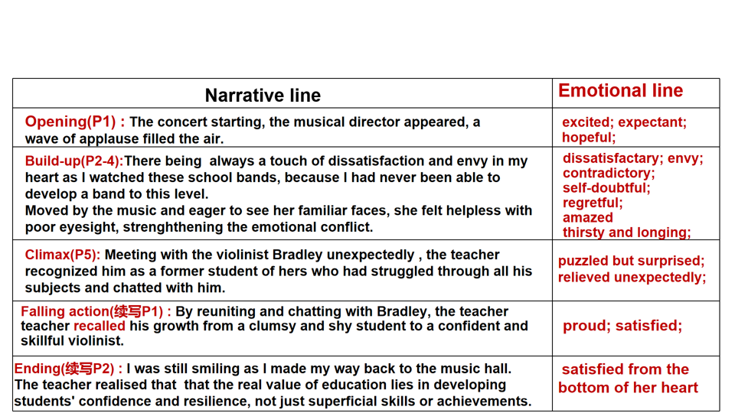**Step3 Read for language styles语言协同**

**Activity3. Analyze the language styles of the given passage.**

**时态和描写手法:**

**一般过去时态、过去完成时；环境描写、心理描写，穿插有效对话。**

**环境描写: 烘托了人物的心情**

**The atmosphere in the music hall was professional.**

**The annual High School Music Festival was the highlight of my year.**

**Teaching in a small primary school, I had never been able to develop a band to this level.**

**When the last notes rang out, ...thunderous applause erupted.**

**During the tea break,it was a pleasant surprise to meet Bradley here. We sat down and had a chat. I was still smiling as I made my way back to the music hall.**

**心理描写: 展示人物内心世界、塑造人物形象、突出作品主题。**

**句式特点: 简单句为主，复合句偶尔穿插使用。长短句混合使用，使写作富有节奏，使读者保持兴趣**

**其他语法结构: with的复合结构, 非谓语动词,无灵主语等，句式多样性，使内容生动、充满活力**

**Step4 build up the framework构建续写框架，主题协同**

**Activity4. Predict the following story plot.**

**Para1. I remembered the day when he asked to join the school band.**

**1. How did I respond to him when he asked to join the school band?**

**2. Why did I agree to his request?**

**3. What progress did he made after joining the school band?**

**Para1. 想到Bradley学业上的困难，我觉得他不适合加入校乐队— 但看到他渴望、热诚的眼神，我答应了他的请求— 出乎意料的是，他每次按时参加乐队的训练— 在不断的努力下，他成了所在高中的首席小提琴师。**

**Para2. I was still smiling as I made my way back to the music hall.**

**1. How did the writer’s feelings change when she saw Bradley’s growth?**

**2. What difference did she make to her students?**

**3. Why did the writer change her ideas?**

**Para2. 我面带微笑回到音乐厅— 感到无比自豪和喜悦— 深刻感悟到教育不仅是教给学生知识和技能，更重要的是要让学生有耐心、毅力、自信— 这就是教育的价值。**

**Step5. Writing and Polishing**

**Activity5. According to the outline, imitate the language style of the given passage to finish the continuation writing.**

**教师下水作文：**

**I remembered the day when he asked to join the school band. Incredible and hesitant, I considered it hard for Bradley to do so. But his eyes filled with 1__________(eager) and enthusiasm touched me thoroughly. “Thank you for 2__________ (protect) a pupil’s self-respect and giving him patience and encouragement, Miss Jones!” , Bradley’s words 3__________ (interrupt) my memories. “You 4_____(do) do well”, I praised him sincerely, “ You insisted on each practice organized by our school band.” A heartfelt smile 5_________(emerge) on our faces. Having bowed deeply to me, he returned to his band.**

**I was still smiling as I made my way back to the music hall. A flood of warmth and 6_____________(appreciate) filled my heart, with self-doubt fading away. I realized that the task of the excellent teacher is 7____________(stimulate) “apparently ordinary” students to unusual effort. As students, to reach your goals, work hard, 8___________ (participation) , practise and do the best you can. 9___________ , education is such a two-way “hello, I’m good” between teachers and students. On the stage of full of love and hope, teachers and students shine together 10____________ (create) their wonderful work together.**

**官方范文:**

**I remembered the day when he asked to join the school band. I was initially 1_________ (hesitate) , aware of his academic struggles and the 2___________(complex) of the music we were rehearsing. Yet, the determined gleam in little Bradley's eyes 3_______(move) me. I agreed, 4________(tailor) parts of the music piece to let him shine without being overwhelmed. “It was you who set me on the music path,” Bradley spoke with 5_________ (grateful) . He then recounted (讲述)his musical journey with the violin, from junior to senior high school, 6___________(ultimate) landing the lead role of First Chair in his school's concert band. I listened attentively, amazed at the transformative power of music. / As he returned to his band, a proud smile spread across my face.**

**I was still smiling as I made my way back to the music hall. As I took my seat, my heart 7_________(swell) with quiet pride in knowing the role I had played in a young man's music journey. The lights 8_________ (dim) again, and the stage came 9 _____ (live) with the energy of young musicians. They began to play, each note 10____________(resonate) with the memory of the first tentative sounds my students had made under my guidance. As the final piece began, I closed my eyes, 11_______(let) the music wash over me. / The music hall, once a place of my longing and unfulfilled dreams, now 12________(echo) with a life well-spent in the service of art and education.**

**网络版本1**

**I remembered the day when he asked to join the school band. At that time, I had believed he was going 1_______ (quit) after a few weeks. Yet, week after week, he showed up, practicing 2__________(diligent) even when the notes seemed too hard to play. Slowly but surely, his efforts began 3________(pay) off. I was moved by his 4____________(persistent) , which eventually led him to join the high school orchestra. The Bradley I saw onstage today 5______(be) far from the timid boy I once knew. He was destined to grow into a 6_________(talent) musician, even if I hadn’t realized it back then.**

**I was still smiling as I made my way back to the music hall. It 7_______ (strike) me that each student I taught had been touched by my efforts in ways I hadn’t anticipated. If Bradley could turn his struggles into success, maybe there were 8___________ (count) others I had inspired without even knowing it. 9_______ (sit) down as the lights dimmed, I felt a surge of 10______ (proud) , knowing that even though my own career may be ending soon, my students’ journeys in music would carry on.**

**网络版本2**

**I remembered the day when he asked to join the school band. Back then, if I hadn't seen the spark in his eyes, I 1__________________ (turn) him down. He had 2________ (bare) shown any interest in his studies, and his grades were far from 3____________ (impress) . Yet, there was something about the way he looked at the instruments that made me say, “Alright, Bradley. Let’s give 4____a try.” If I hadn't believed in him, he probably would never have discovered his 5________(music) talent. Over time, he practiced hard, and I watched him struggle but persistently push forward, his 6______________(determine) shining through. Little did I know that this young boy would one day grace such a grand stage with his talent.**

**I was still smiling as I made my way back to the music hall. Bradley’s success had given me a renewed sense of pride and 7__________ (fulfill) . If my role as a music teacher 8________________(contribute) to his journey, maybe that was worth more than leading a prestigious band. Sitting in the audience, I listened to the rest of the concert with a heart full of peace. Perhaps 9__________ (retire) didn’t have to mean leaving music behind, but simply shifting to a 10________ (quiet) rhythm, knowing I had played a small role in the melody of many young lives.**

**教育，就是这样一场教师跟学生“你好，我也好”的双向奔赴，在这个充满爱与希望的舞台上，老师和学生一起绽放光芒，共同创造出属于他们的精彩。**