EB3U1 ART

Reading and thinking: A SHORT HISTORY OF WESTERN PAINTING

教学设计

金华市孝顺高级中学 严晓倩

* **文本分析：**

该阅读文本是一篇典型的知识性小品文（informative essay），主要讲解西方绘画艺术的发展与变化。阅读语篇的文本结构较简单：第一段是引言，介绍文章的主题和写作目的；其余为主体内容，按时间顺序分为四个部分，各有独立的小标题。文章较为细致地描述了前三个时期的绘画风格，还介绍了各时期的优秀画家及其代表作；而在现代艺术阶段，由于艺术家们对绘画艺术的理解和思考角度不同，多种流派风格各异，作者仅进行了简要概括。文中专有名词多，也有较多与艺术流派相关的专业词汇。

* **教学目标：**

In this lesson, students are expected to

1. extract key information(the four periods, the influential artists, the styles) quickly and accurately
2. analyse some typical western works of art with the help of the key information and decide which period each of them belongs to
3. infer the important factors which drive the style of western painting to change and imagine wildly about the style of future art
4. answer the question “what is art?” with individual understanding of the text and life experience

* **教学重点：**

1. extract key information(the four periods, the influential artists, the styles) quickly and accurately
2. analyse some typical western works of art with the help of the key information and decide which period each of them belongs to

* **教学难点：**

1. infer the important factors which drive the style of western painting to change and imagine wildly about the style of future art
2. answer the question “what is art?” with individual understanding of the text and life experience

* **设计理念：**

1. Situation-based learning
2. Structure-based learning
3. Autonomous learning
4. Deep learning

* **教学过程：**

**Step1 Lead-in**

**Activity1: Ranking game**

The students are asked to reorder four influential western paintings on the blackboard according to the time when they were painted.

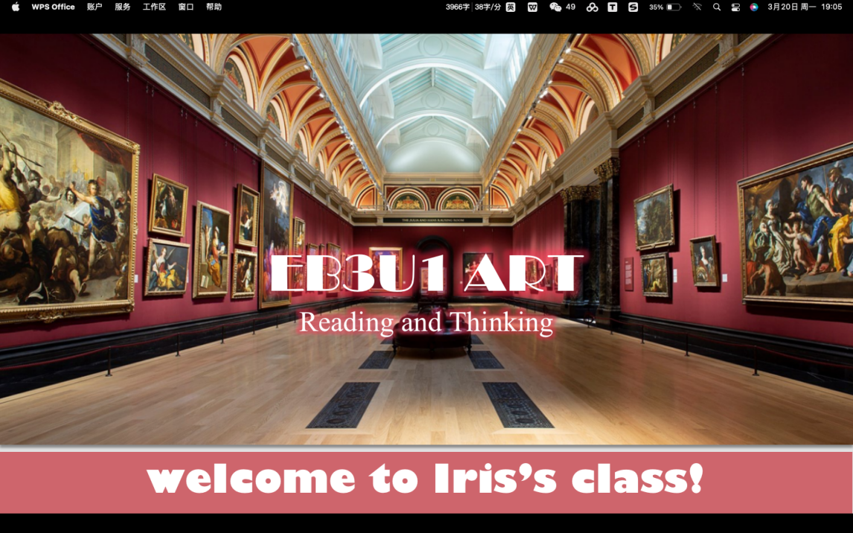

T:Look at the photo, do you know what place it is?

Ss: Art museum.

T: Yes, it’s an art museum. As you can see, these influential western paintings were exhibited in the order of time. But four of them were mixed up.

**Could you please put them in the right order when they were painted?**

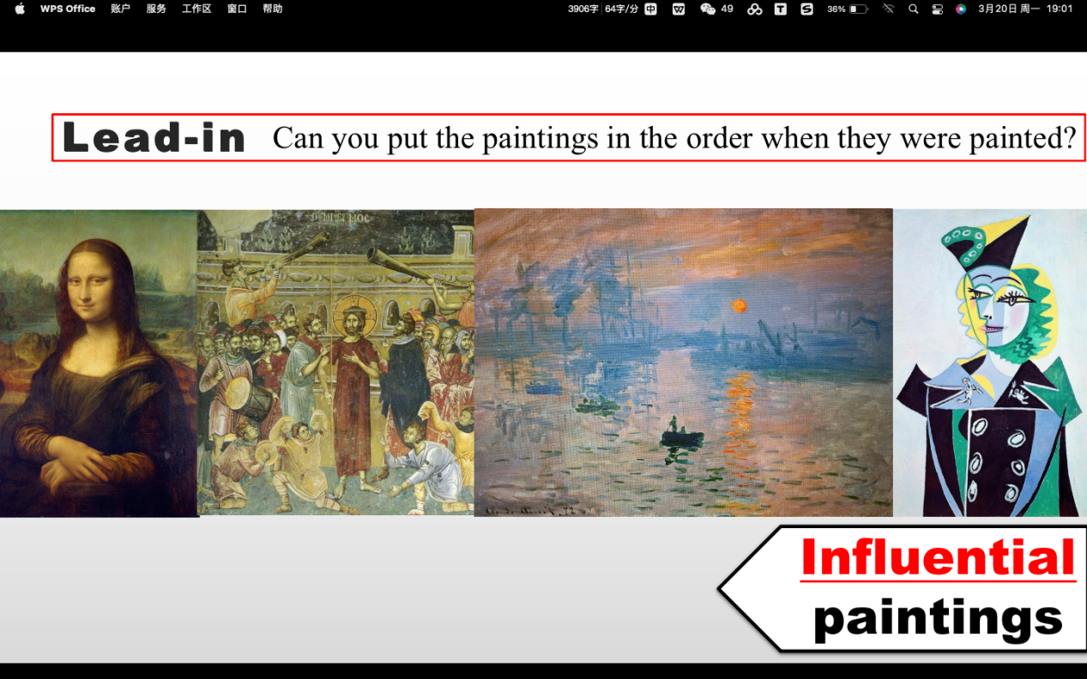

**[Purpose]** This activity aims to arouse students’ curiosity about the different styles of western painting.

**Activity2: Prediction**

The students are asked to predict the key points of the text and ask questions about the text autonomously.

**[Purpose]** This activity stimulates the students to pay attention to the title, subtitles, pictures and outline of the text, and transfer their learning experience in history subject to English subject.

*Possible version*

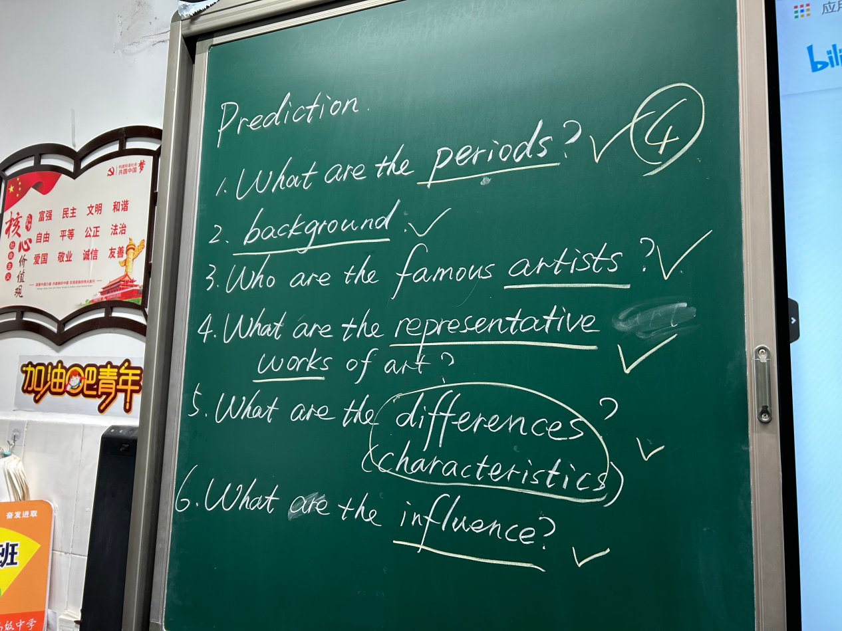

**Activity3: Text type analysis**

The students are asked to figure out the type of this text by skimming the title, subtitles and the first paragraph.

**[Purpose]** This activity aims to help students have a general understanding of the text thus decrease the difficulty of reading.

**Activity4: Scanning**

The students are asked to scan the text quickly and find out answers to the superficial questions- 1what are the important periods?; 2 Who are the influential artists?

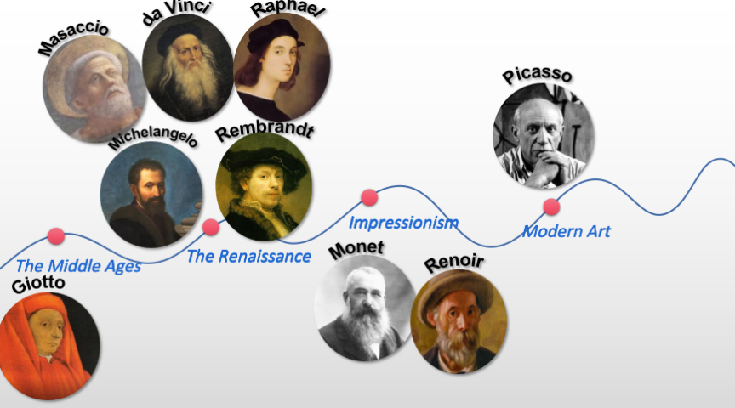

*(The names of the artists may be quite difficult to pronounce, so the teacher can ask one of them to highlight the names on the screen and then teach them to pronounce together.)*

**[Purpose]** This activity aims to decrease the difficulty of detailed reading and start the construction of a mind map.

**Step2 Detailed Reading**

**Activity5: Draw the mind map**

1.The students are asked to read the text in detail and find out the answers to the complicated question-what are the types (characteristics) of each period in the history of western painting?

**[Purpose]** This activity aims to help the students explore the styles of each period by themselves, thus have a better and overall understanding of them.

2.After extracting the styles of each period, the students are asked to evaluate the answer of the Ranking Game by giving reasons.

**[Purpose]** This activity echos with the lead-in activity and helps the students to internalize what they have found in the text.

**Activity6: Summarize the changes**

The students are asked to summarize the changes in fewer and more conclusive words.

**[Purpose]** This activity aims to enable the students to have a deep impressive of the changes.

**Step3 Thinking**

**Activity7: Figure out the reasons of the change.**

The students are asked to scan the text again and infer the reasons behind the change.

**[Purpose]** This activity aims to stimulate the students to inquire the factors beneath the phenomenon.

**Activity8: Analyze the language features**

The students are asked to find out the words that indicating “change” in the text.

***How did the writer show clearly the changes in Western painting styles?***

**[Purpose]** This activity helps the students to identify the words and phrases to express “change”.

**Activity9: Discussion**

The students are asked to imagine wildly about the style of art in the future and give it a specific name like the four periods from the text.

***What will the painting style be like in the future?***

**[Purpose]** This activity aims to develop students creative and logical thinking abilities.

**Activity10: Idea sharing**

The students are asked to share their individual understanding of the question “what is art?”.

**[Purpose]** This activity encourages the students to express their own understandings in the art of language- a short poem, as well as checks the learning outcome.

**Step4 Assignment**

Walk into an art museum and feel the diverse beauty of paintings closely by yourself.

