# **Unit 4 Book 1 学案**

1. disaster / d ɪˈzɑ:st ə(r) / n. ___________；_________

词根词缀：dis(远离,偏离)+aster(star星星)：星星偏离了原来的位置——_________。

______________________ 自然灾害

___________________ 空难

1. tornado /t ɔ:ˈneɪdəʊ / n.__________；__________

破拆法：torn(tear撕扯)+a+do(door门) 助记：__________撕扯着一扇门。

1. drought / draʊt / n. ________;________

类比：dry a.干燥的—— ____________ n.干旱

high a.高的—— ___________ n.高度

see vt.看见—— ___________ n.视野

think vi.想—— ___________ n.想法

1. slide / slaɪd / vi. & vt. (_______, _______ ) ____________；________

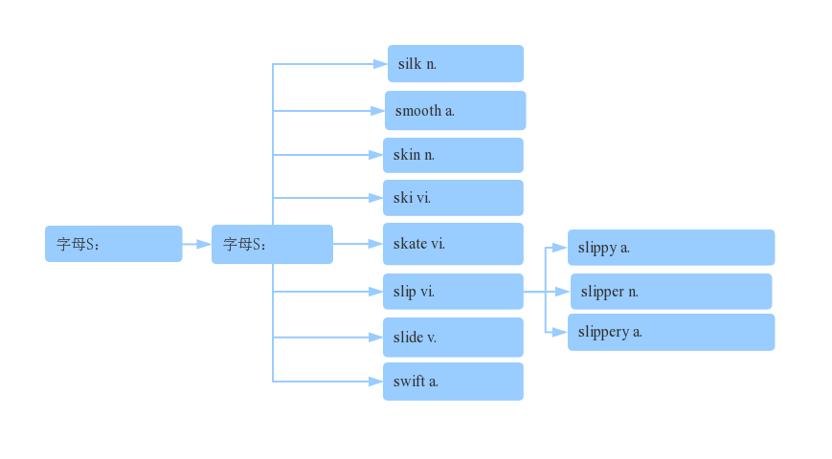

____________________（使）滑入; 溜进

landslide /ˈlændslaɪd/ n. ( landfall) ___________;________

1. tsunami / tsu:ˈnɑ:mi / n._________

破拆法：t(turn转变)+sun(太阳)+a+mi(米粒) 助记：在_______中，太阳变成米粒般大小。

1. flood / flʌd / n. _______;_______vt._______;_______vi._______;___________

a flood of ___________

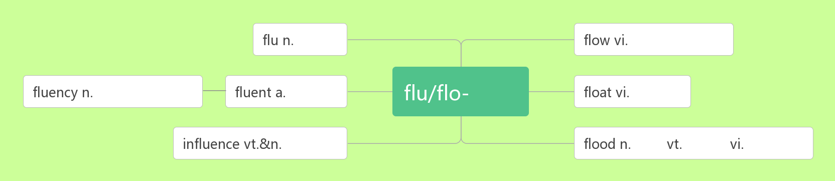

1. erupt /ɪˈrʌpt / vi.& vt. ________;_________

____________ /ɪ'rʌpʃn/ n.爆发

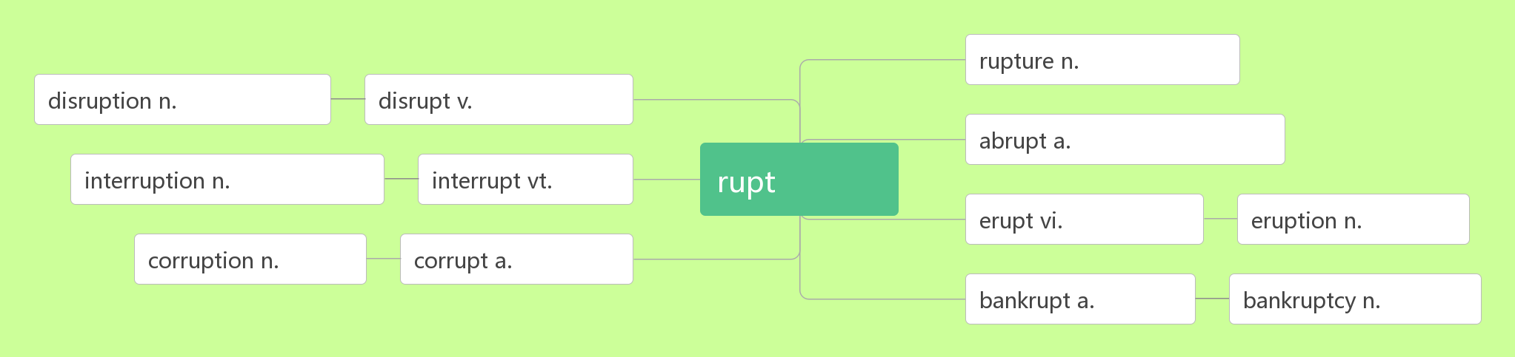

1. magnitude /ˈmæ gnɪtju:d / n. _________，__________

词根词缀：magni(大)+tude(名词后缀，表状态)：大的程度———__________;__________

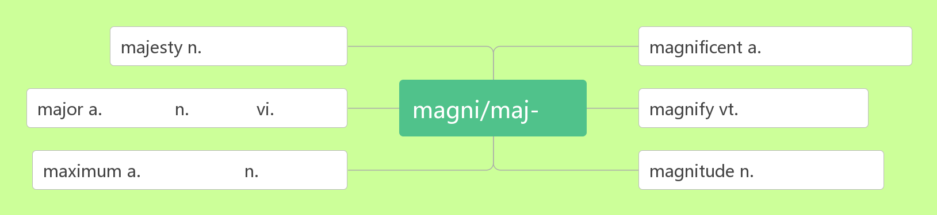

1. rescue /ˈreskju: / n.& vt. _________；__________

音意相通：来施救

rescue sb./ sth. _________… 从……中营救某人/某物

__________ /'reskju:ə(r)/ n. 救援者；救助者

1. damage /ˈdæ mɪdʒ / vt. &.n._______,_________

破拆法：dam(大坝)+age(年纪) 助记：上了年纪的大坝一般都有所_________。

_________________________对……造成损害

词群：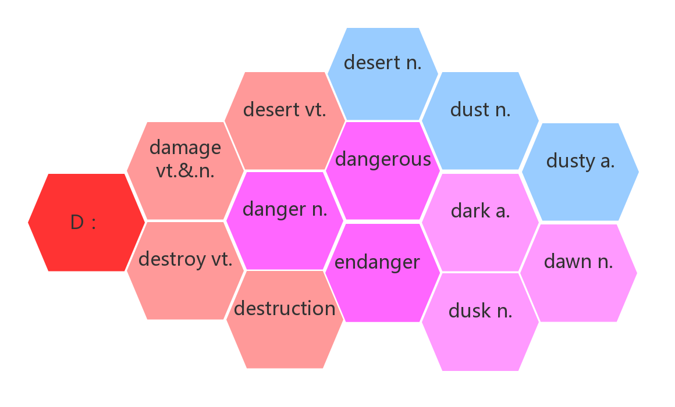

1. destroy/ dɪ'str ɔɪ / vt. _________；___________

破拆法：des(毁掉)+troy(特洛伊，被希腊联军毁掉的名城)

_______________/dɪˈstrʌkʃ(ə)n/ n.摧毁；毁灭

1. evacuate / ɪˈvækjue ɪt / vt. ________;________vi.________

词根词缀：e(外)+vacu(空)+ate(动词后缀)：都到外面，使里面变空——_________

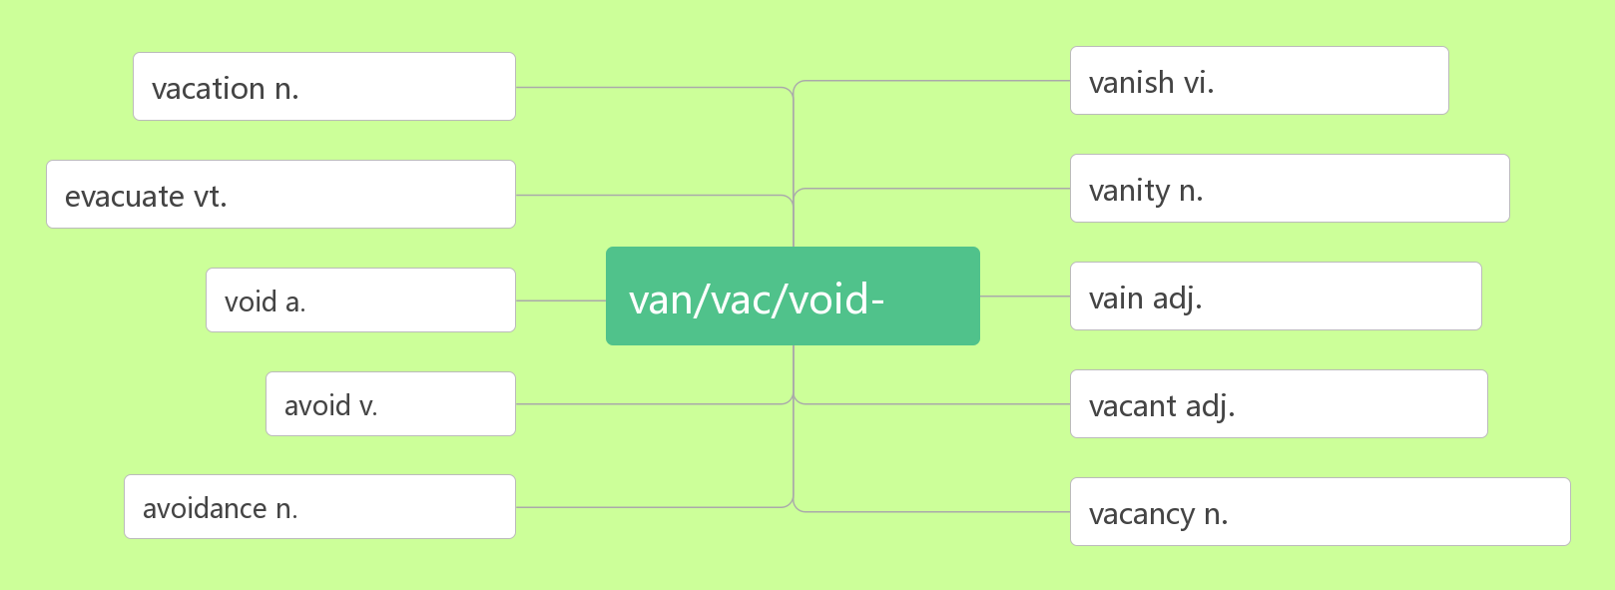

1. helicopter /ˈhelɪkɒptə(r)/ n. _________

破拆法：he(他)+li(离)+cop(警察)+ter(特) 助记：他离警察特远，需要调动_________去帮助他。

1. death /deθ/ n. 死；死亡

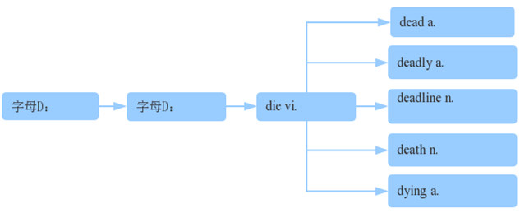

1. affect/ ə'fekt/ vt. 影响；感染；感动

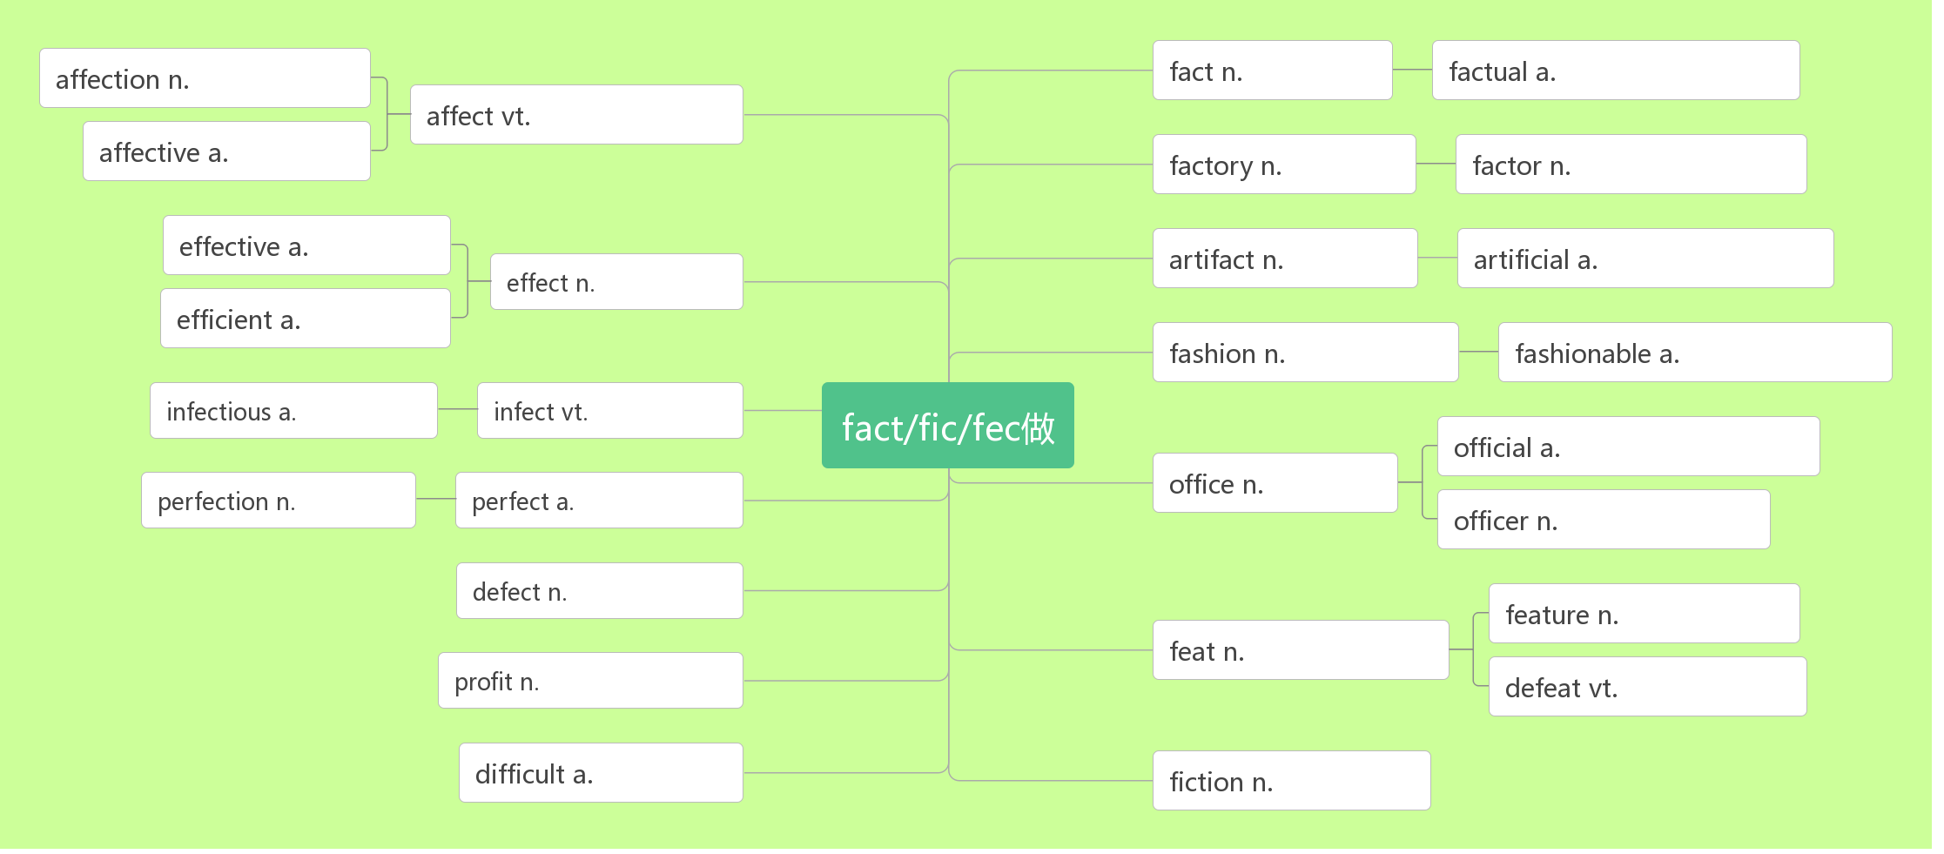

__________/ɪˈfekt/ n.效果，影响

_____________________对……有影响

___________________副作用

____________/ɪˈfektɪv/ a.有效的

_______________/ɪˈfektɪvli/ ad.有效地

____________/ɪˈfɪʃ(ə)nt/ a.高效的

_______________ /ɪˈfɪʃ(ə)ntli/ ad.高效地

____________ /əˈfekʃ(ə)n/ n.喜爱，感情

1. shelter/'ʃeltə / n._________;_________;________ vt.________;________

shelter sb/sth ________ sb/sth 保护……免受……

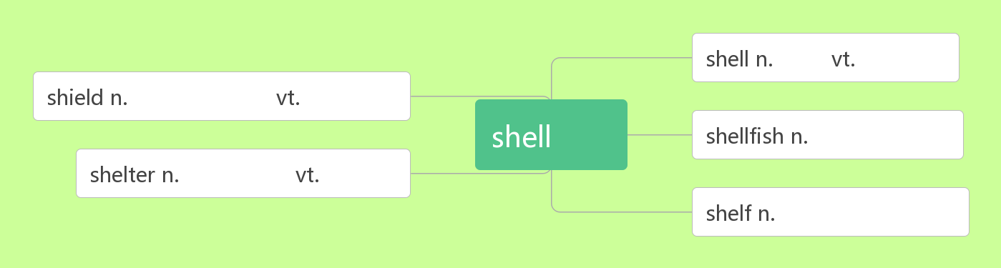

1. crack /kræk/ n. ________,________vi. & vt._________

音意相通：拟声词，咔嚓 助记：咔嚓一声墙壁裂开了。

1. as if ________,_________,_________

as if的用法：as if 后面即可以接_____________也可以接___________,如果后面接的并非真实情况,则要用___________，将时态向________推移一个时态。

1. ruin /'ru:ɪn/ vt. 毁掉；毁坏 n. 毁灭；废墟（多用复数）

____________ 严重受损；破败不堪

【辨析】

|  |  |
| --- | --- |
|  | 只用作动词，指强调用某种摧毁性的力彻底破坏，以致不可能修复，常作"破坏"、"毁灭"解,也可以指希望、计划等破灭。 |
|  | 可以用作动词，也可以用作名词，用作名词时常与 to sb/sth 连用。指部分"损坏"、  "损害"或指价值有所降低。一般被破坏的物品可以重新修复。 |
|  | 可以用作动词，也可以用作名词，用作动词时, 作“毁掉；毁灭；弄糟"解；强调缓慢但无法逆转的毁灭。；用作名词时, 表示"毁灭；毁坏；废墟"等抽象概念。 |

1. percent / pəˈsent / n. _________

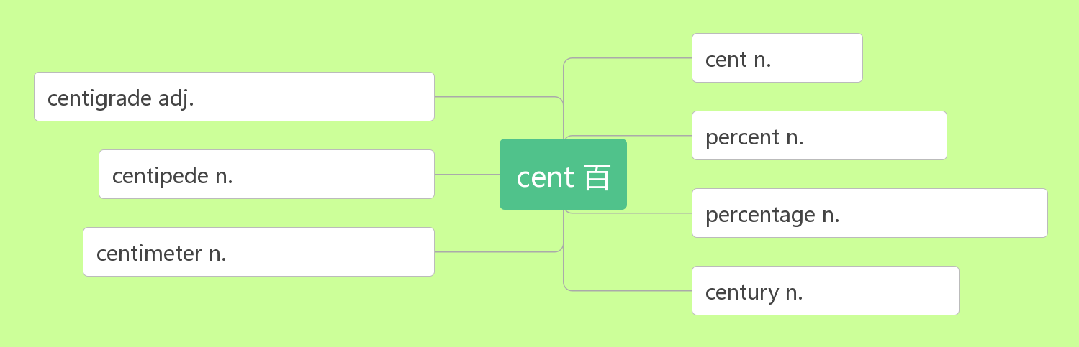

1. brick /brɪk/ n. ______,__________

联想记忆：b(Brazil)+r(Russia)+i(India)+c(China)：金砖四国——brick

1. metal /'metl/n. ________

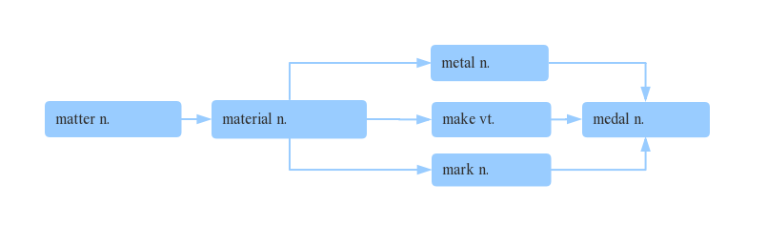

1. shock /ʃɒk/ n.________;________________;_________ vt.___________;_________

______________ 处于震惊/休克中

shocking /ˈʃɒkɪŋ/ adj.________________ （现在分词表示_______内涵，意为“_____________”）

shocked / ʃɔkt/ adj._______________ （过去分词表示________内涵，意为“_____________”）

1. electricity / ɪˌlekˈtrɪsəti / n. ______,__________

拆破法：e(电子)+lect(收集)+tri(去)+city(城市) 助记：收集电子去给城市供电。

electric [ɪˈlektrɪk] adj. _________

electrical [ɪˈlektrɪk(ə)l] adj. ______________

electronic [ɪlekˈtrɔnɪk] a. __________

1. trap /træp/ vt. _________,____________n. _________;__________

_________________ 受困于

____________________________ 诱使某人（做）某事

词群：

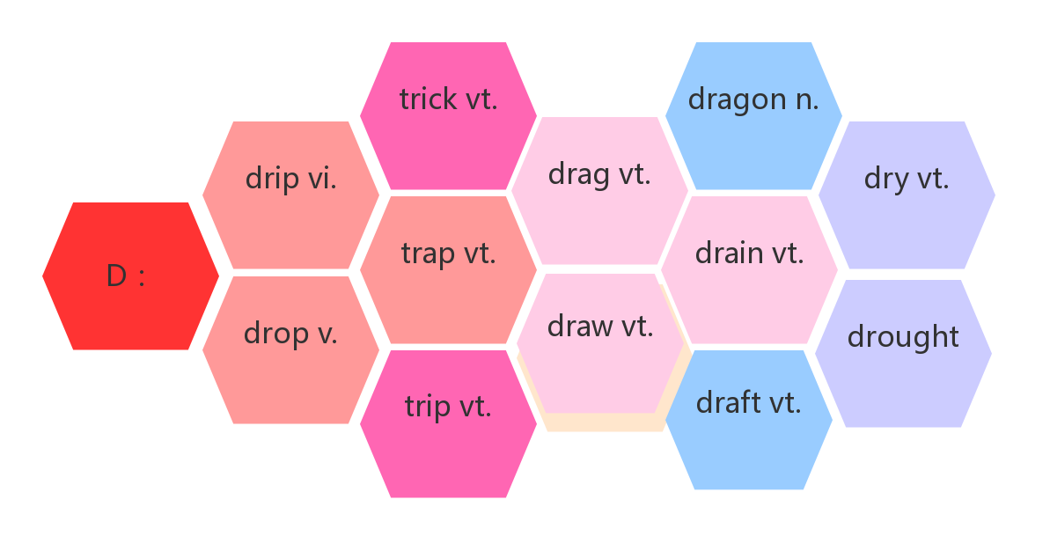

1. bury / ˈberi / vt. ________;__________

破拆法：bu(不)+r(让)+y(养) 助记：既然不让养，就把它埋了吧。

___________________________________________= __________________________ 忙于，埋头于

1. breathe / bri:ð/ vi. & vt.________

breathe in/out ________/________

breath /ˈbreθ / n. _________,_________,___________

take a deep breath _____________

hold one’s breath ____________

out of breath ______________

catch one’s breath ____________

1. revive /rɪˈvaɪv / vt.& vi. ________;___________

__________ /rɪˈvaɪvl/n. 复活；复兴

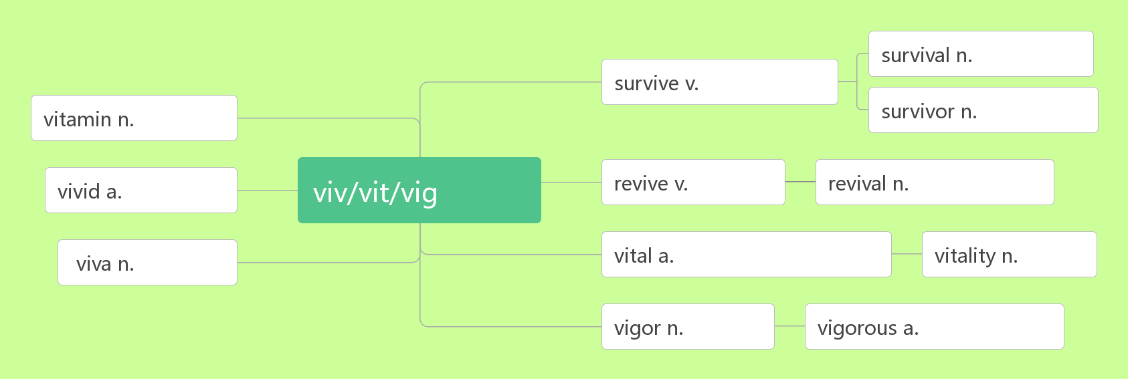

1. effort /'efət / n. 努力

词根词缀：ef(向外)+fort(力量)：向外用的力量——_________。

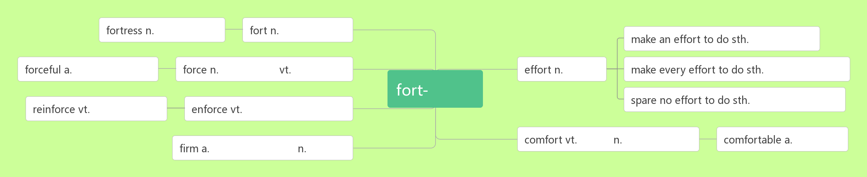

_____________________ 努力做某事

________________________ 竭尽全力做某事

________________________不遗余力做某事

1. unify /ˈju:n ɪfaɪ / vi.& vt. __________;____________

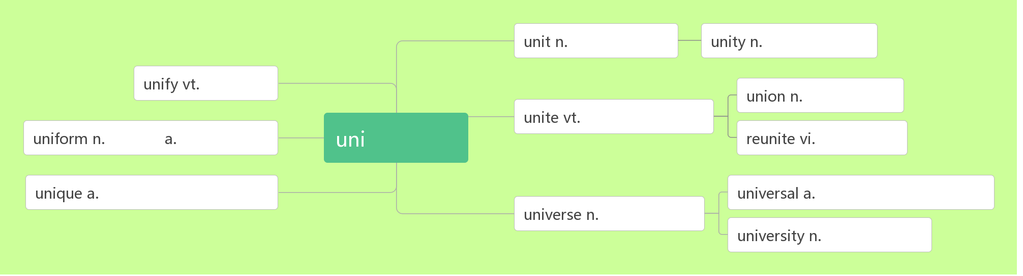

1. wisdom / ˈwɪzdəm / n. _________;_________

wise /waɪz/ adj._________;_________

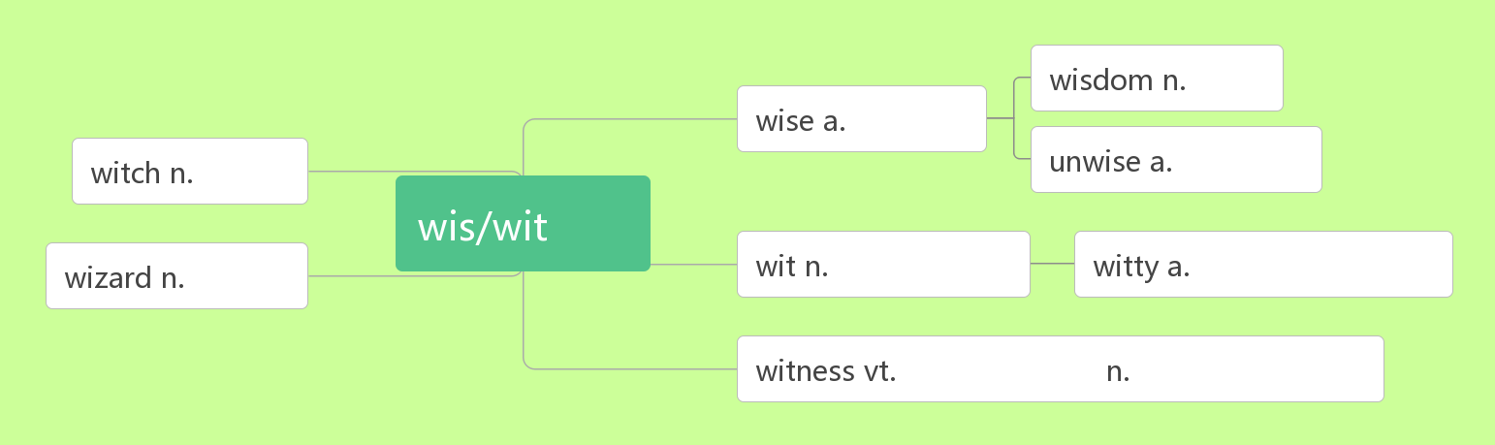

1. suffer /ˈsʌfə(r) /vt. _______,________ vi. ________

_________________ 因……而痛苦；患有（疾病等）

sufferer /ˈsʌfərə(r)/ n．_________,_________,__________

suffering /ˈsʌfərɪŋ/ n. _________,__________

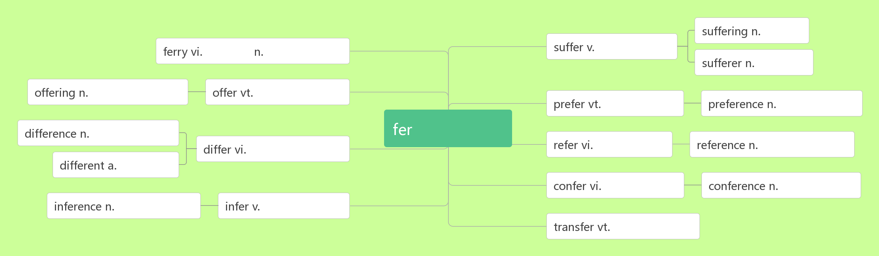

1. volcano /vɒlˈkeɪnəʊ/n. ________

破拆法：vol (发声)+cano(加农炮)：发出加农炮一般的声音——________(喷发)

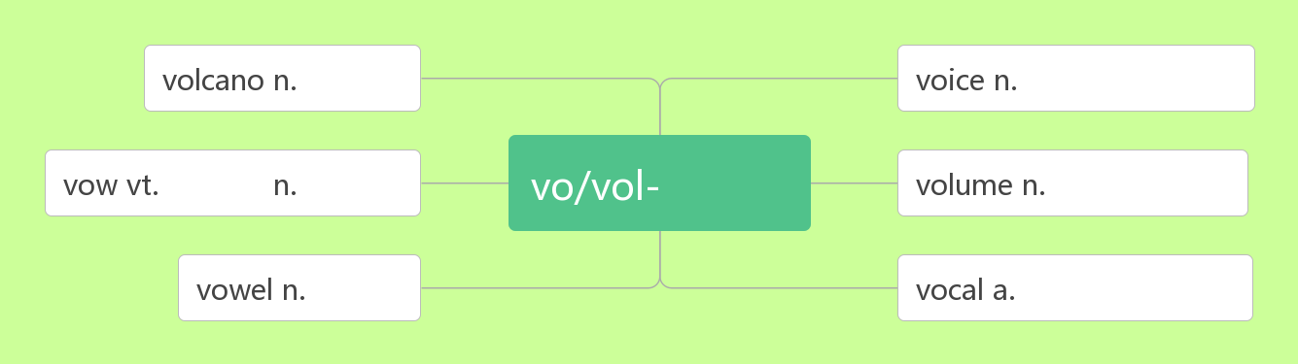

1. supply / səˈplaɪ /vt. ________,_________n.________;_______[pl.] __________

supply sb _______ sth = supply sth ____ sb 向某人提供某物

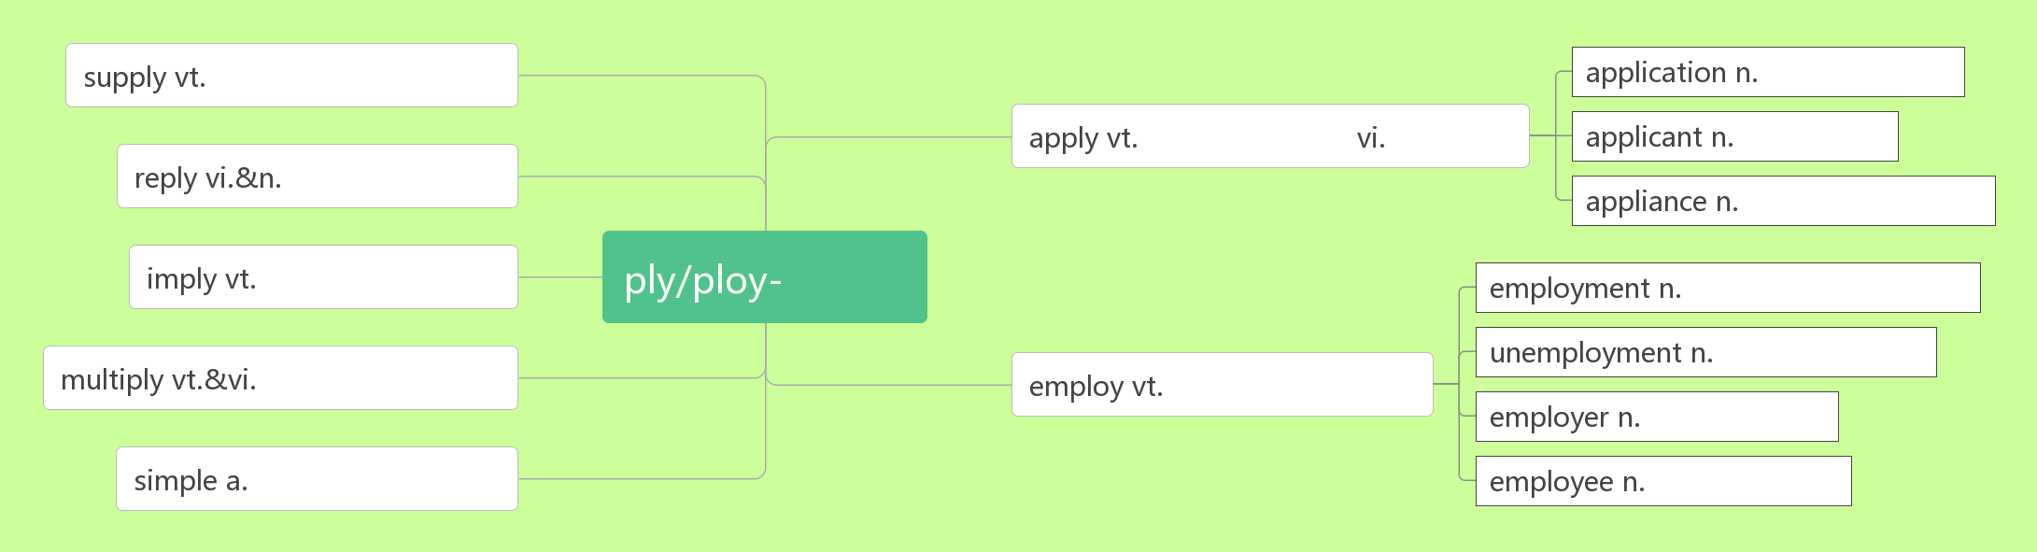

1. typhoon / taɪˈfu:n / n. ________
2. in the open air _________,__________

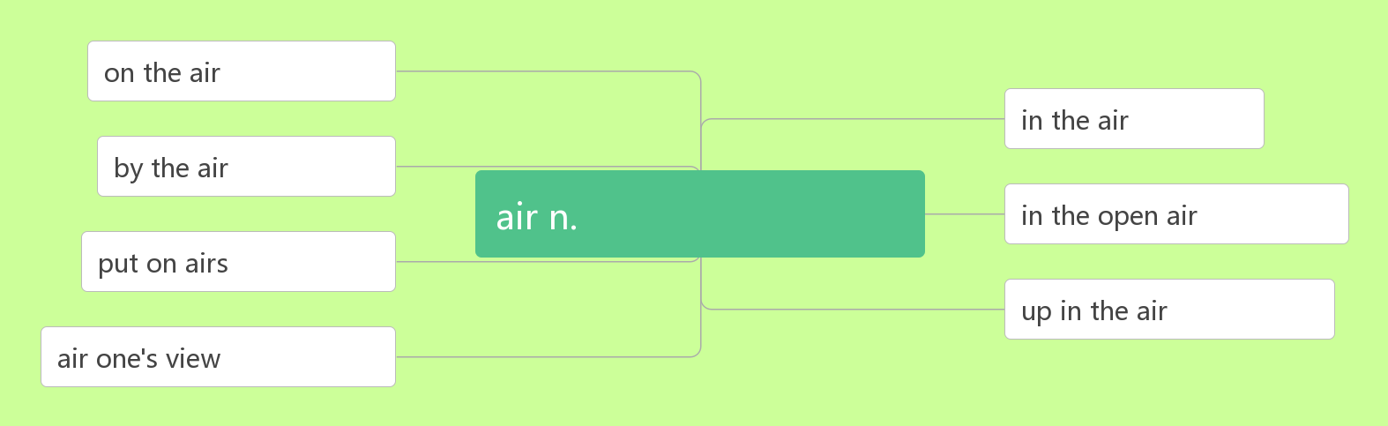

1. hurricane /ˈhʌrɪkən / n ._________

破拆法：hurri(迅速)+cane(棍杖) 助记：________来袭，像迅疾的棍杖肆虐着这个小镇。

1. survive /səˈvaɪv/ vt.___________vi.________;_________

词根词缀：sur(下)+vive(活)：活下去——_________,_________

_____________ 依靠……生存

____________ /sə'vaɪvə/ n. 幸存者；生还者

___________ /səˈvaɪvl/ n.存活；幸存

1. power /ˈpaʊə(r) / n. ________;________;________

音意相通：怕我 助记：我以前幼稚地以为，当我拥有_______后别人都会怕我。

______________________ 断电/停电

__________________ 上台执政

_________________ 丧失权力，在野

powerful /ˈpaʊəfl/ adj._____________;_____________;_____________

1. tap / tæp/vi.& vt. _______,________,________n. _________;_________,_________

音意相通：拟声词，模拟轻拍、轻敲的声音

1. pipe/ paɪp/ n. ________,_________;__________

piper/ˈpaɪpə/ n.__________

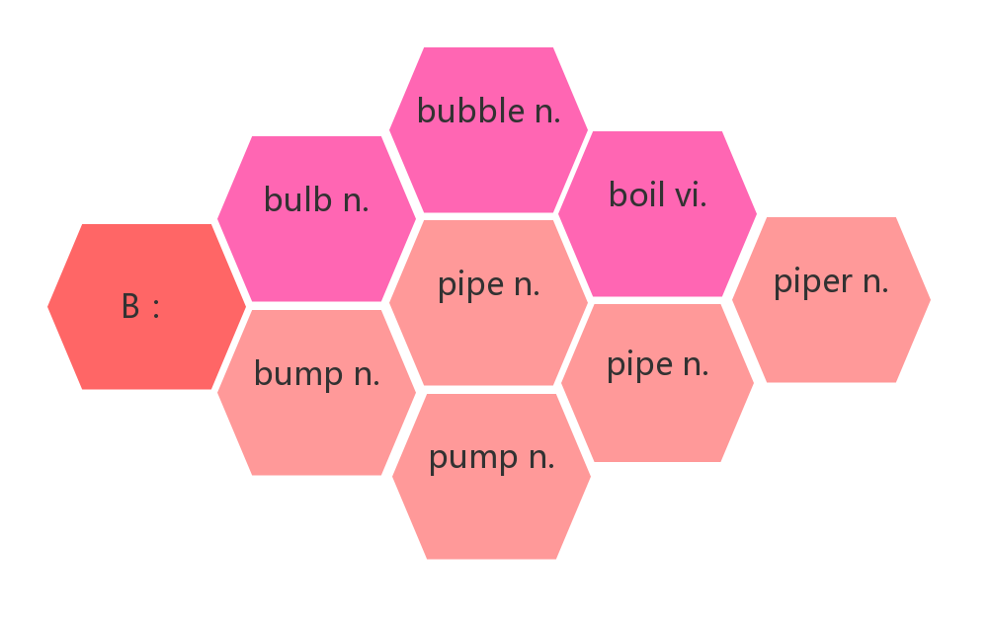

1. whistle /ˈwɪsl/ vi.__________;_____________ n. ___________;___________

音意相通：拟声词，模拟口哨声。

1. emergency/iˈmɜ:dʒənsi / n. ___________;____________

词根词缀：e(出)+merg(沉)+ency(名词后缀): 从沉没中突然浮出来——_____________。

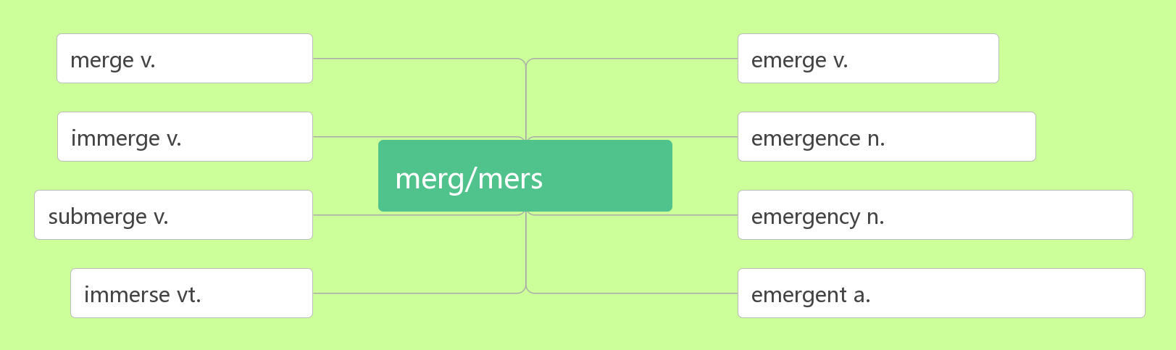

1. calm /kɑ:m/ adj._________,__________ vt._________;_________vi.平静，镇定

________________________________ 保持镇定

__________________________ 使……平静、安静或镇定下来

辨析：

|  |  |
| --- | --- |
|  | （人）情绪镇定冷静的；（天气，海洋等）平静的 |
|  | 强调客观环境很安静或人性格文静 |
|  | 强调人主观上不愿意说话 |
|  | 强调没有动作，静止不动 |

1. aid /eɪd /n.________;________;______________vi.& vt. _________;_________

_____________ 急救

__________________在…的帮助下

1. sweep /swi:p/ vt. & vi._________,_________ (________,________)

音意相通：四围扑 助记：用扫帚在四围扑打，________灰尘。

__________________ 消灭；彻底消除

1. wave / weɪv / n._________;_________vi.& vt. ________;_________

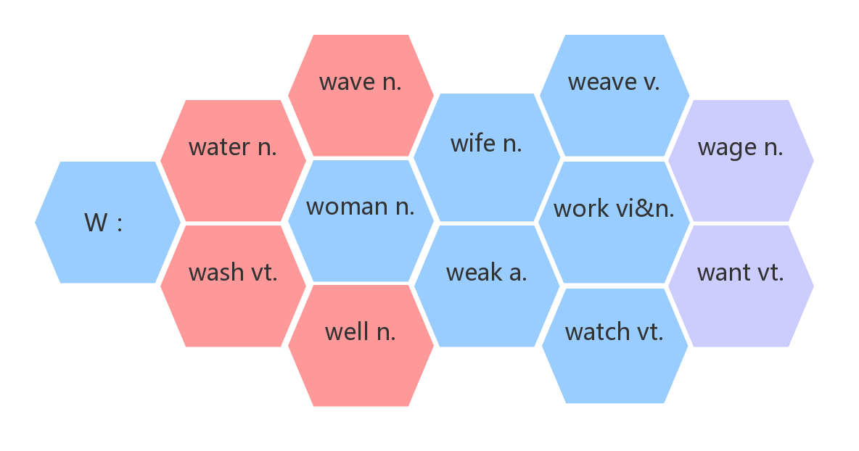

1. strike /straɪk / v.& n._________;_________ (struck, struck/stricken) n. _________

_________________________ 某人突然想到……

________________ 罢工

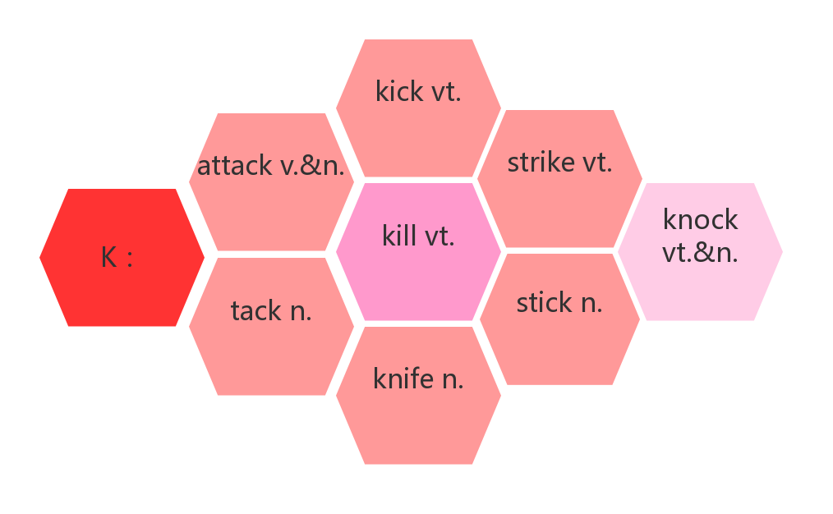

1. deliver/dɪˈlɪvə(r)/ vt. & vi. _________;__________;__________;_________

音意相通：递礼物 助记：为了感谢她为我________，我在她_______演讲的时候给她_______了礼物。

1. summary /ˈsʌməri/ n. ________,_________,________

词根词缀：sum(总结，概括)+(m)ary(名词后缀)：________,_________

___________________ 总的来说

1. length/ leŋθ/ n. ______,__________

类比：long a.长的——__________ n.长度

strong a.强壮的——___________ n.力量；长处

dead a.死亡的——__________ n.死亡

wide a.宽的——_________ n.宽度