**The World**（**0616-0630**）材料分析和教学目标：

本次选用的材料：①、*The Washington Post*的*Expelling cellphones from schools*（该不该禁止学生校内用手机？）②、*Anti-Anxiety For Teens*的*Five Top tips to start Running*（开始跑步的五大技巧）③、*BBC Wildlife*的*Blowin’ in the wind*（在风中飘荡）④、*The times*的*Prisons in crisis as ten guards a week quit at high-security jails*（狱警接连辞职 英格兰高安全级别监狱陷危机）和⑤BBC的新闻报道。通过语法填空、阅读理解、分析长难句、翻译句子、听力填空和词汇拓展等方式，让学生从多角度提升学习兴趣，提高分析句子、运用词块和听力能力。外媒英语新闻可以让学生体验真实语境下的语言运用，拓展学生的国际视野，了解时事，逐步提升跨文化沟通能力，形成正确的世界观、人生观和价值观。

**教学思路：**

**Part 1: News Report 1 *The Washington Post* (June 30, 2024 A20)**

**Expelling cellphones from schools 该不该禁止学生校内用手机？**

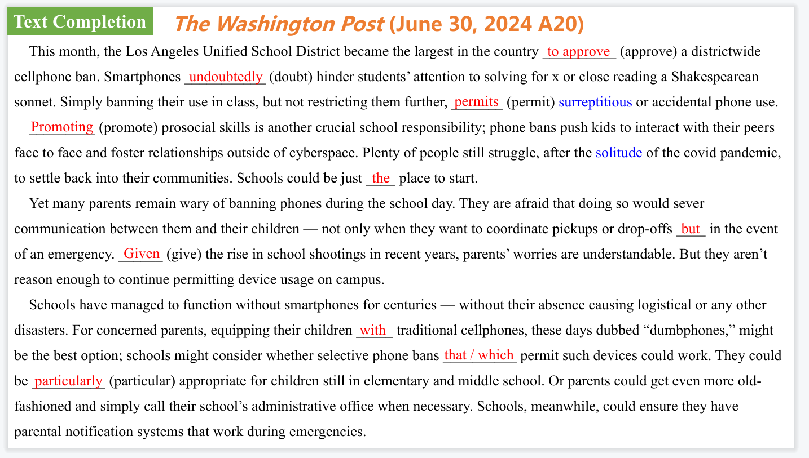

【设计意图】通过语篇填空的形式帮助学生理解新闻的主要内容，同时训练语言语法的运用能力：在语篇的视角下如何正确使用所给词汇，根据语法规则确定词汇的正确形式，使得文章通顺，激活学生的思维和语言。该新闻主题语境是关于“人与社会”中“社会热点问题”这一子主题，通过学习让学生了解关于美国学校禁止学生校内用手机的新闻评论。

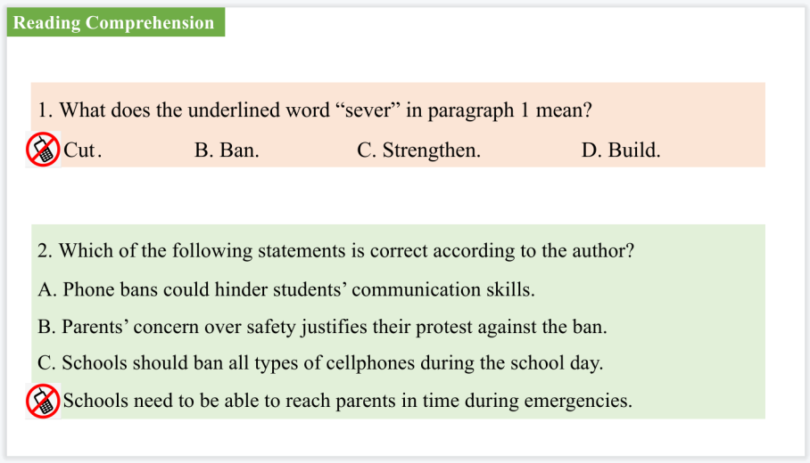

【设计意图】通过阅读理解的形式帮助学生理解新闻的主要内容。

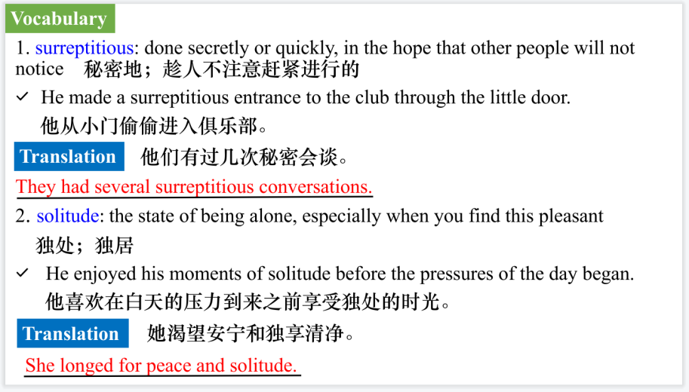

【设计意图】对文本中的词汇进行解读，并通过翻译句子对其进行巩固。

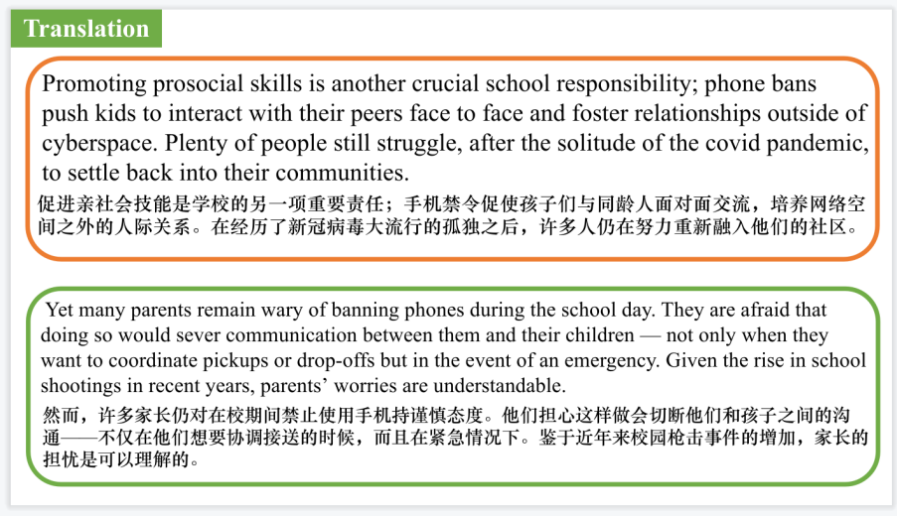

【设计意图】对文中的两个句子进行翻译练习，对其中单词、词组、句法进行巩固并关注句子结构。

**Part 2: News Report 2 *Anti-Anxiety For Teens* (January 2024 P50-51)**

**Five Top tips to start Running 开始跑步的五大技巧**

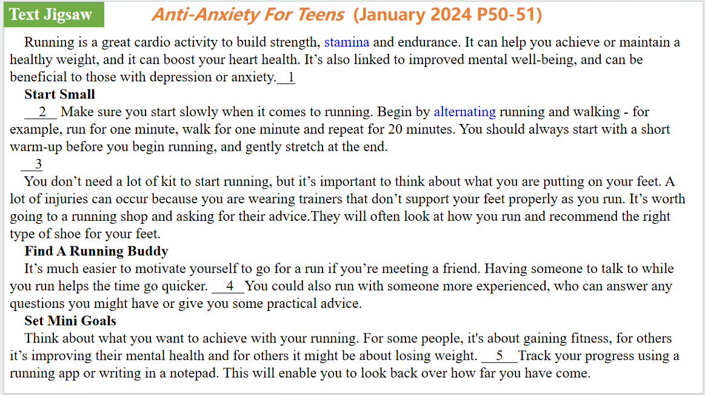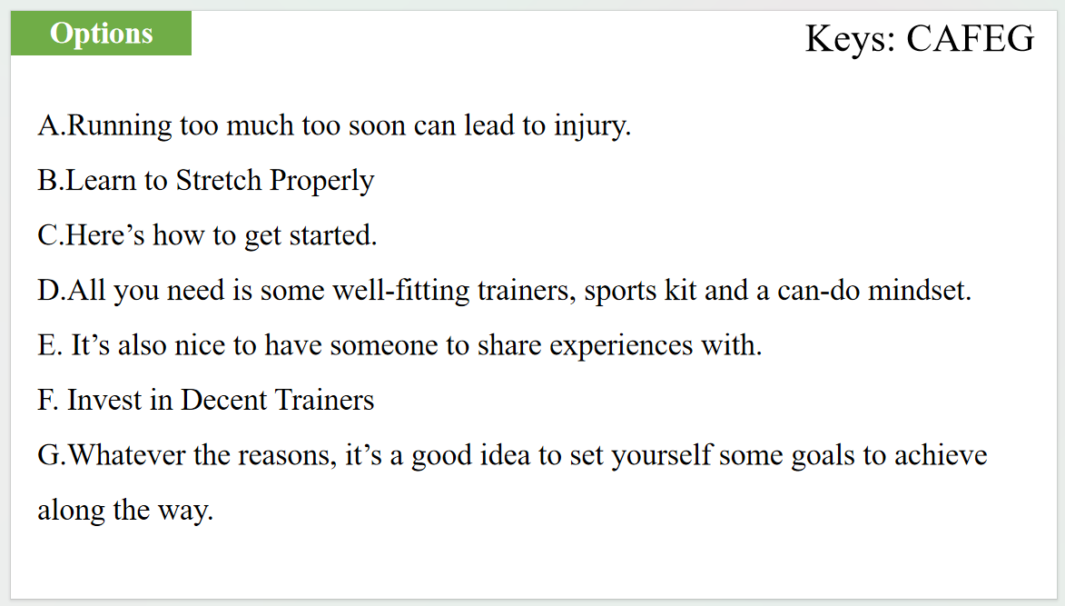

【设计意图】通过七选五的形式帮助学生理解新闻的主要内容。该新闻主题语境是关于“人与自我”中“健康的生活方式”这一子主题，通过学习让学生了解开始跑步的五大技巧。

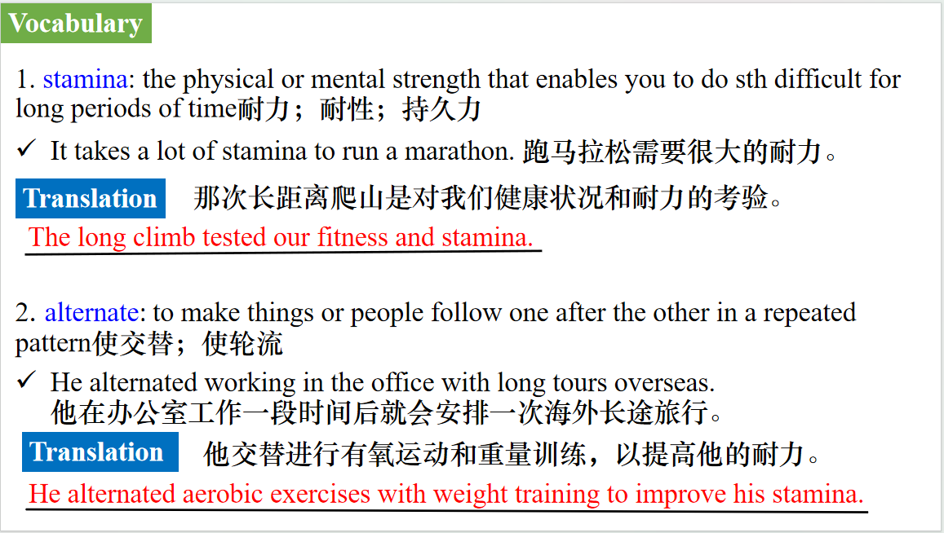

【设计意图】对文本中的词汇进行解读，并通过翻译句子对其进行巩固。

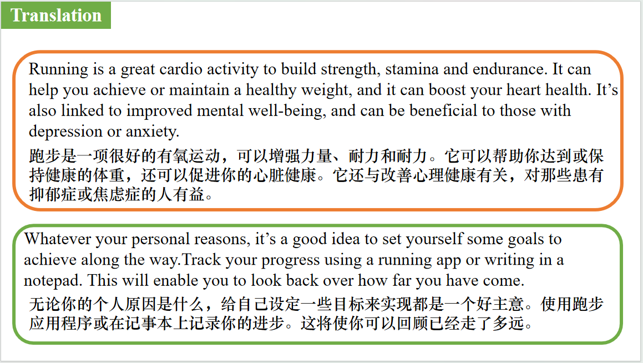

【设计意图】对文中的两个句子进行翻译练习，对其中单词、词组、句法进行巩固并关注句子结构。

**Part 3: News Report 3 *BBC Wildlife* (June 2024 P14)**

**Blowin’ in the wind 在风中飘荡**



【设计意图】通过语篇填空的形式帮助学生理解新闻的主要内容，同时训练语言语法的运用能力：在语篇的视角下如何正确使用所给词汇，根据语法规则确定词汇的正确形式，使得文章通顺，激活学生的思维和语言。该新闻主题语境是关于“人与自然”中“人与动植物”这一子主题，通过学习了解莎草在夏日风中飘荡的自然景观。



【设计意图】对文本中的词汇进行解读，并通过翻译句子对其进行巩固。



【设计意图】对文中的两个句子进行翻译练习，对其中单词、词组、句法进行巩固并关注句子结构。

**Part 4: News Report 4 *The Times* (June 25, 2024 P2)**

**Prisons in crisis as ten guards a week quit at high-security jails**

**狱警接连辞职 英格兰高安全级别监狱陷危机**

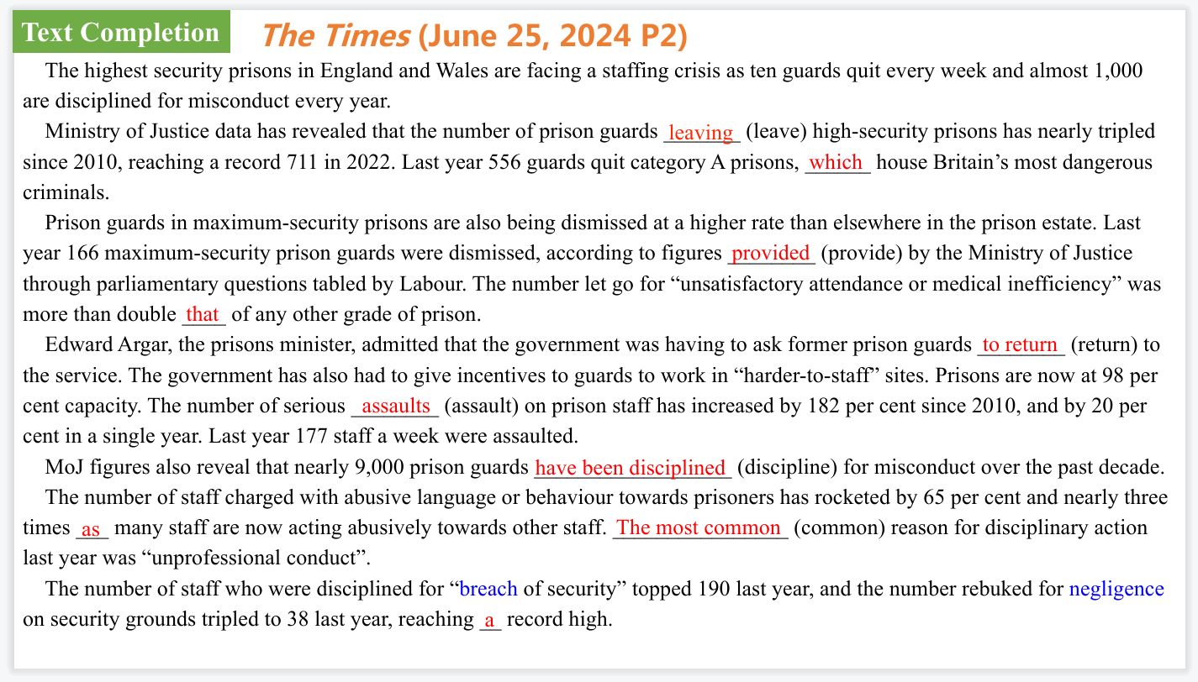

【设计意图】通过语篇填空的形式帮助学生理解新闻的主要内容，同时训练语言语法的运用能力：在语篇的视角下如何正确使用所给词汇，根据语法规则确定词汇的正确形式，使得文章通顺，激活学生的思维和语言。该新闻主题语境是关于“人与社会”中“社会热点问题”这一子主题，通过学习了解英格兰高安全级别监狱陷入人员短缺危机的新闻。

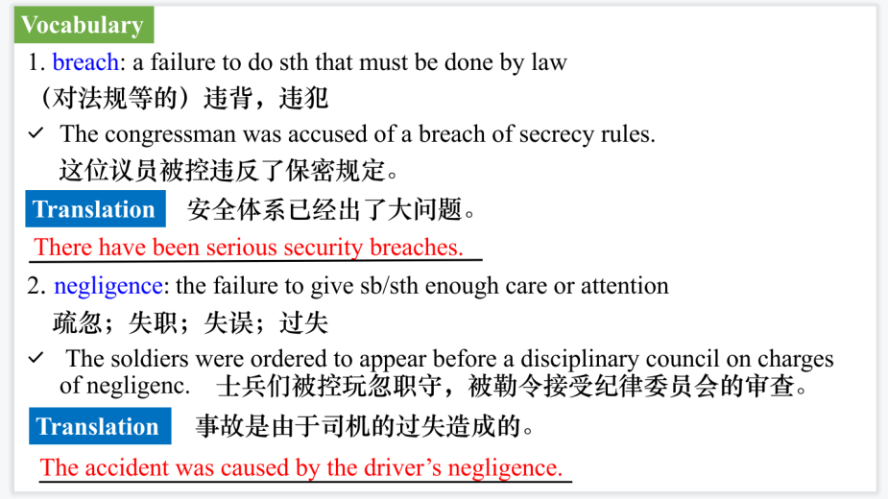

【设计意图】对文本中的词汇进行解读，并通过翻译句子对其进行巩固。

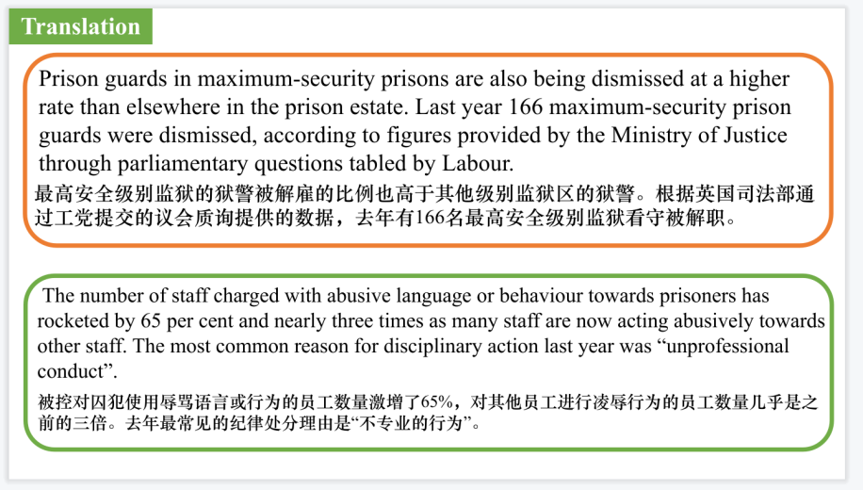

【设计意图】对文中的两个句子进行翻译练习，对其中单词、词组、句法进行巩固并关注句子结构。

**Part 5: BBC News 06/25/2024**



【设计意图】听一则材料，通过听力填空的方式理解文本，考察听力辨识词汇的能力。

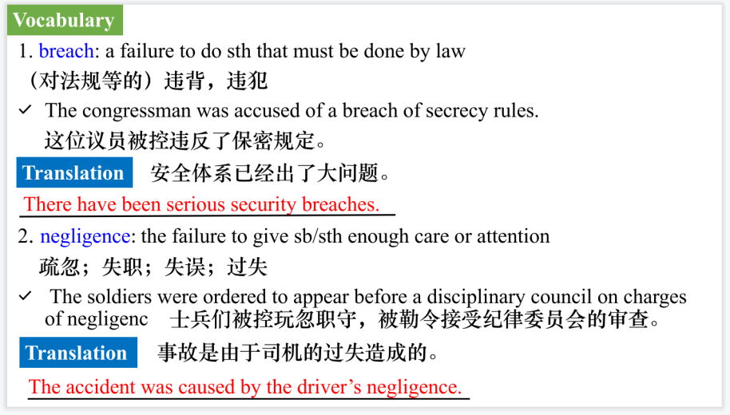

【设计意图】对文本中的词汇进行解读，并通过翻译句子对其进行巩固。

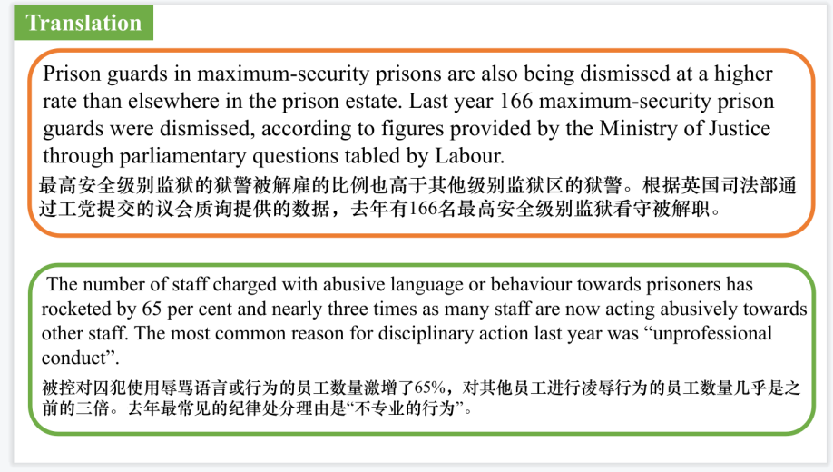

【设计意图】对文中的两个句子进行翻译练习，对其中单词、词组、句法进行巩固并关注句子结构。

附：外刊原文

**Part 1: News Report 1 *The Washington Post* (June 30, 2024 A20)**

**Expelling cellphones from schools 该不该禁止学生校内用手机？**

This month, the Los Angeles Unified School District became the largest in the country to approve a districtwide cellphone ban. For teachers, this is great news. For many kids, it’s less welcome. Parents, meanwhile, are conflicted, caught between wanting their children to learn without distraction and dreading the loss of the constant and easy communication to which they’ve grown accustomed. Everyone needs to learn to live without.

High school hallways teem with students with their heads down — not because they’re immersed in books, but because their favorite influencer posted a new video. Schools have had to remove bathroom mirrors because students were sneaking out of class to make TikTok videos. Digital isolation has taken over school lunchrooms and playgrounds, causing these spaces to become eerily silent. Administrators say the phenomenon has only worsened since the covid-19 pandemic.

Smartphones undoubtedly hinder students’ attention to solving for x or close reading a Shakespearean sonnet. Simply banning their use in class, but not restricting them further, permits surreptitious or accidental phone use. A 2023 study by Common Sense Media revealed that teens check their phones more than 100 times a day on average. On top of the hundreds of notifications lighting up screens and interrupting class lectures, teens now spend 4.8 hours on social media each day. Surgeon General Vivek H. Murthy has been a vocal supporter of limiting screen exposure and social media usage for young adults, even pushing for tobacco-style warning labels on apps such as Instagram and Facebook. The relationship between screen exposure and mental well-being remains unclear, but some studies suggest there is cause for concern.

Promoting prosocial skills is another crucial school responsibility; phone bans push kids to interact with their peers face to face and foster relationships outside of cyberspace. Plenty of people still struggle, after the solitude of the covid pandemic, to settle back into their communities. Schools could be just the place to start.

Yet many parents remain wary of banning phones during the school day. They are afraid that doing so would sever communication between them and their children — not only when they want to coordinate pickups or drop-offs but also in the event of an emergency. Given the rise in school shootings in recent years, parents’ worries are understandable. But they aren’t reason enough to continue permitting device usage on campus.

Law enforcement officials actually advise against mass communication during lockdowns. Having hundreds of students contacting their parents can heighten panic and distract kids from listening to lifesaving instructions.

Schools have managed to function without smartphones for centuries — without their absence causing logistical or any other disasters. For concerned parents, equipping their children with traditional cellphones, these days dubbed “dumbphones,” might be the best option; schools might consider whether selective phone bans that permit such devices could work. They could be particularly appropriate for children still in elementary and middle school. Or parents could get even more old-fashioned and simply call their school’s administrative office when necessary. Schools, meanwhile, could ensure they have parental notification systems that work during emergencies.

The next question for schools is how to ban cellphones. A popular option is requiring the use of magnetic pouches that lock in the morning and unlock when the final bell rings, or in the event of an emergency. This option is the most widely enforced, with more than 3,000 schools using it in 21 different countries. Other options, such as phone lockers or an honor-based system forbidding students from touching their phones, have been less successful.

When smartphone bans are done right, they can make a big difference. At Bethlehem Central High School near Albany, N.Y., for example, academic progress has improved since applying a ban last fall. According to school faculty, students converse with one another in class and in common areas, much like they used to before scrolling through social media feeds became the standard lunchtime activity. They are less distracted and more tuned in to learning. Skeptical students and parents have even said they’re surprised at the success of the newly phone-free school.

Cellphone bans are moving from individual schools to statewide policy in states such as Florida and Indiana. California leaders are considering a statewide policy of their own. All the better; the next generation should learn to appreciate the life of the mind, not just the screen.

**Part 2: News Report 2 *Anti-Anxiety For Teens* (January 2024 P50-51)**

**Five Top tips to start Running 开始跑步的五大技巧**

The great thing about running is that, at its most basic level, it’s simple and cheap to get started. All you need is some well-fitting trainers, sports kit and a can-do mindset. Running is growing in popularity every year. The TCS London Marathon and the AJ Bell Great North Run are both televised events that inspire and motivate hundreds of viewers to try running for themselves -the fact that both these events require entering a ballot and are hugely oversubscribed is testament to the fact that running is a sport with wide appeal. Then there’s park run (park run.org.uk), an amazing venture where you turn up to your local event (there are hundreds that take place around the country) on a Saturday morning and run, walk or jog the 5K course with absolutely no pressure, for free.

Running is a great cardio activity to build strength,stamina and endurance. It can help you achieve or maintain a healthy weight, and it can boost your heart health. It’s also linked to improved mental well-being, and can be beneficial to those with depression or anxiety. Here’s how to get started...

START SMALL

Running too much too soon can lead to injury, and this can often put people off the sport. Make sure you start slowly when it comes to running. Begin by alternating running and walking-for example, run for one minute, walk for one minute and repeat for 20 minutes.You should always start with a short warm-up before you begin running, and gently stretch at the end (more on this later). Consider following a structured programme like Couch to5K (there are a couple of apps available that are broadly the same), which builds you up carefully week by week and therefore reduces your chance of getting injured.

INVEST IN DECENT TRAINERS

You don’t need a lot of kit to start running, but it’s important to think about what you are putting on your feet. A lot of injuries can occur because you are wearing trainers that don’t support your feet properly as you run. It’s worth going to a running shop and asking for their advice.They will often look at how you run and recommend the right type of shoe for your feet. This can help to prevent injury and prevent uncomfortable blisters. Tell the advisor your budget before you start, as running shoes can be quite pricey for higher-end models. Consider some proper running socks, too.

FIND A RUNNING BUDDY

It’s much easier to motivate yourself to go for a run if you’re meeting a friend. Having someone to talk to while you run helps the time go quicker. It’s also nice to have someone to share experiences with. You could also run with someone more experienced, who can answer any questions you might have or give you some practical advice. If you don’t have anyone to run with, consider looking for a club or running course in your area, where you can connect with like-minded people and commit to sticking with running for the long term. Many running clubs will have a beginners’ session or a Couch to 5K-style course to build you up from scratch.

SET MINI GOALS

Think about what you want to achieve with your running.For some people,it's about gaining fitness, for others it's improving their mental health and for others it might be about losing weight.Whatever your personal reasons,it's a good idea to set yourself some goals to achieve along the way.Track your progress using a running app or writing in a notepad.This will enable you to look back over how far you have come.You can also decide on rewards along the way.For example,the first time you run 20 minutes without stopping,you could treat yourself to a new running top.Then you can move on to the next mini goal to keep you on track.

Learn To Stretch Properly

A common cause of injuries is not stretching after you run. Even when you first start out and even if you are doing more walking than running, getting into the habit of stretching for a few minutes after a run will do you the world of good. Make sure that you stretch through your main leg muscles: calves, thighs, hamstrings and quads.You should also stretch your arms and shoulders (where many runners hold a lot of tension), hips and glutes. A full stretch routine doesn’t have to take long, but it should absolutely be considered an essential part of each running session.

**Part 3: News Report 3 *BBC Wildlife* (June 2024 P14)**

**Blowin’ in the wind 在风中飘荡**

Photogenic drifts of billowing white seedheads are a classic feature of peaty uplands in summer. They look especially dreamy backlit with the golden light of dawn or evening. These fluffy heads belong to cottongrass, which is neither a grass nor related to cotton. In fact, it’s a sedge, and spends most of the year blending in with myriad other green bog plants. But from June, as the seedheads dry out, they are transformed into “the snow-white bloom of summer”, in the memorable phrase of well-known conservationist RoyDennis.

In his excellent book Cottongrass Summer,Dennis goes on to explain the importance of this plant as a food in spring for species such as black grouse and red deer. In the past, it was important to people,too. During the hardships of the First World War, the soft seedheads were, like sphagnum moss, used to dress wounds.

**Part 4: News Report 4 The Times (June 25, 2024 P2)**

**Prisons in crisis as ten guards a week quit at high-security jails**

**狱警接连辞职 英格兰高安全级别监狱陷危机**

The highest security prisons in England and Wales are facing a staffing crisis as ten guards quit every week and almost 1,000 are disciplined for misconduct every year.

Ministry of Justice data has revealed that the number of prison guards leaving high-security prisons has nearly tripled since 2010, reaching a record 711 in 2022. Last year 556 guards quit category A prisons, which house Britain’s most dangerous criminals.

Prison guards in maximum-security prisons are also being dismissed at a higher rate than elsewhere in the prison estate. Last year 166 maximum-security prison guards were dismissed, according to figures provided by the Ministry of Justice through parliamentary questions tabled by Labour. The number let go for “unsatisfactory attendance or medical inefficiency” was more than double that of any other grade of prison.

Edward Argar, the prisons minister, admitted that the government was having to ask former prison guards to return to the service. The government has also had to give incentives to guards to work in “harder-to-staff” sites.

Prisons are now at 98 per cent capacity. The number of serious assaults on prison staff has increased by 182 per cent since 2010, and by 20 per cent in a single year. Last year 177 staff a week were assaulted.

MoJ figures also reveal that nearly 9,000 prison guards have been disciplined for misconduct over the past decade.

The number of staff charged with abusive language or behaviour towards prisoners has rocketed by 65 per cent and nearly three times as many staff are now acting abusively towards other staff. The most common reason for disciplinary action last year was “unprofessional conduct”.

The number of staff who were disciplined for “breach of security” topped 190 last year, and the number rebuked for negligence on security grounds tripled to 38 last year, a record high.

In the same period, 40 prison guards were disciplined for sexual harassment, up from five in 2014. The number of guards disciplined for racial harassment has also increased.

There has been a 30 per cent jump in the number of jail officers prosecuted for inappropriate relationships since 2017, reaching a record high.

**Part 5: BBC News 06/25/2024**

Microsoft has regained its position as the world’s most valuable company, taking back the title briefly held by the artificial intelligence company Nvidia. Nvidia’s stock sank up to 8% during Thursday’s trading, erasing more than $270 billion of the company’s market value. Analysts say it’s likely investors were consolidating their profits.

President Biden has declared the wildfires in the US state of New Mexico a major disaster. The extent of the damage is still being assessed, but it’s thought that about 10,000 hectares of land and 1,400 structures have been burned, including hundreds of homes. Will Grant reports.

The decision by President Biden to declare a major disaster over the wildfires in New Mexico immediately frees up federal funding for local, tribal and state agencies trying to tackle the blazes. Specifically, they can access funds and support from the Federal Emergency Management Agency or FEMA, including for fire mitigation measures around the state. It also allows home and business owners who have been affected to access grants and low cost loans to cover the costs of temporary accommodation and repairs.

European football’s governing body UEFA is investigating what it calls potential racist or discriminatory conduct by Albanian fans at their men’s European Championship match on Wednesday. Supporters of both sides are accused of singing abusive chants aimed at Serbs. Serbia had threatened to pull out of the tournament if UEFA didn’t act.

The actor Donald Sutherland whose career spanned seven decades has died. He was 88. Born in Canada, Donald Sutherland starred in some of the most groundbreaking and best known films of the 1970s, including *MASH* and *Don’t Look Now*.