**Book 1 Unit 5 导案**

1. **billion /ˈbɪljən / n. 十亿**

How many billion people speak the UN's official languages as their native or second language?

有几十亿人把联合国的官方语言作为他们的母语或第二门语言？

They have spent billions of dollars on the problem .他们花了几十亿美元解决这个问题。 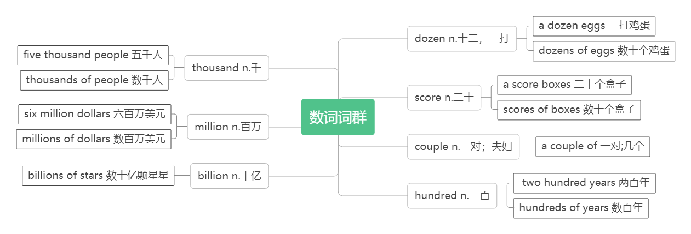

1. **native /ˈneɪtɪv/adj. 出生地的；本地的；土著的n.本地人**

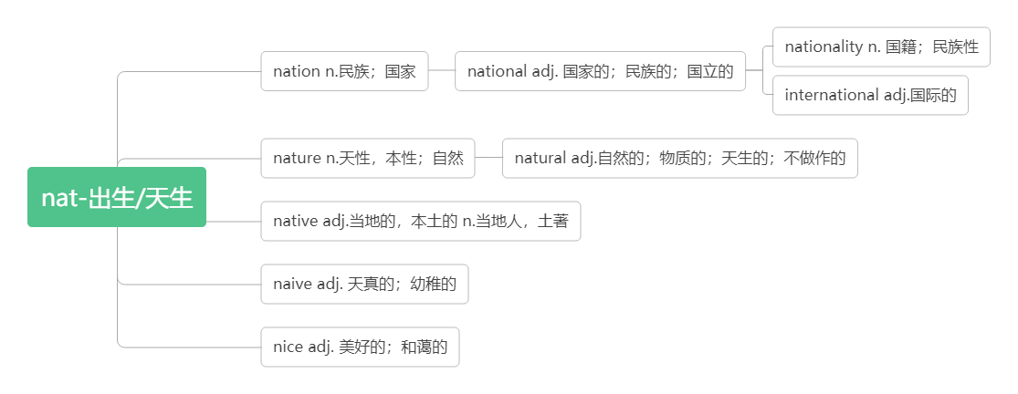

**be native to... 原产于**

Native Englishspeakers can understand each other even if they don’t speak the same kind of English.

以英语作为母语的人，即使他们所讲不是同一种英语，他们也能彼此听懂。

China is our native country, and Chinese is our native language.

中国是我们的祖国，汉语是我们的母语。

Australians are proud of their native wildlife. 澳大利亚人为他们的野生动物感到骄傲。

The panda is native to China. 大熊猫产于中国。

He is a native of Beijing.他是北京人。

1. **attitude /ˈætɪtju:d/ n.态度；看法**

**词根词缀：att-(在)+-itude(度量)：在……上的度量——态度，看法**

**音意相通：爱踢球的 助记：爱踢球的对这场比赛都有自己的态度和看法。**

a positive /negative /firm attitude 积极/消极/坚定的态度

an attitude to /towards对… ..的.态度

What is the attitude of the speaker towards foreign language learning? 演讲者对外语学习的态度是什么？

Beauty is an attitude. It has nothing to do with age. 美是一种态度，与年龄无关。

Remember, keep a positive attitude and good things will happen.记住：保持乐观的心态，好事自然会发生。

We should develop a good attitude to/towards life. 我们应该树立良好的生活态度。

1. **refer /rɪˈfɜ:(r)/vi.提到；参考；查阅(referred , referred , referring)**

**refer to 参考；提到；指的是**

refer to a dictionary 查词典

Pronouns (it, they, she, etc.) refer to something or somebody mentioned earlier.

代词（it, they, she, etc.）指前面提到的某物或某人。

Pay attention to the context of words to help you understand what the pronouns refer to.

单词的上下文，帮助你理解代词指代什么。

In his speech, he referred to a recent trip to Canada. 他在讲演中提到了前不久的加拿大之行。

That remark does not refer to her. 那句话不是指她说的。

Don't refer to the matter again. 不要再提这件事了.

You may refer to your notes if you want. 如果需要，可以参考笔记。

Refer to the dictionary when you don't know how to spell a word.

当你不知道怎么拼写一个词时,查阅一下词典。

**reference /ˈrefrəns / n. 指称关系；参考**

**reference books参考书**

She made no reference to her illness but only to her future plans. 她没有提到她的病，只说了她未来的计划。

I wrote down the name of the hotel for future reference. 我记下了这家酒店的名字，以后也许用得着。

There are several reference books to help you make your choice. 有几本参考书帮你作出选择。

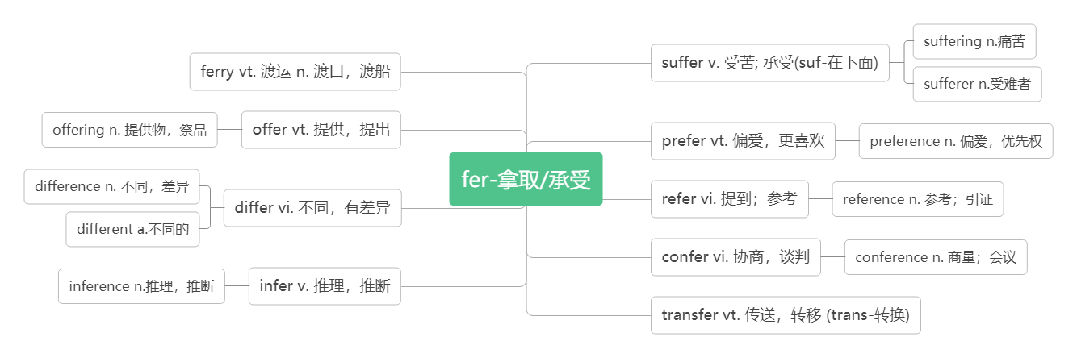

1. **system /ˈsɪstəm / n.体系；系统**

**破拆法：sy-(死要)+stem(主干) 助记：既然身在系统里，死也要跟随主干。**

THE CHINESE WRITING SYSTEM: CONNECTING THE PAST AND THE PRESENT

汉语书写系统：连接过去和现在

solar system 太阳系

a transport system 运输系统

educational system 教育体制

ecosystem生态系统

People think that there are many shortcomings in our educational system.人们认为我们的教育制度有很多缺陷。

The global warming will surely influence the ecosystem.全球变暖一定会影响生态系统。As the public transport system can't satisfy people's needs, many people turn to private cars.

因为公共交通系统不能满足人们的需求，许多人转向了私家车。

1. **civilization /sɪvəlaɪˈzeɪʃn/ n.文明；文明世界**

**词群：**

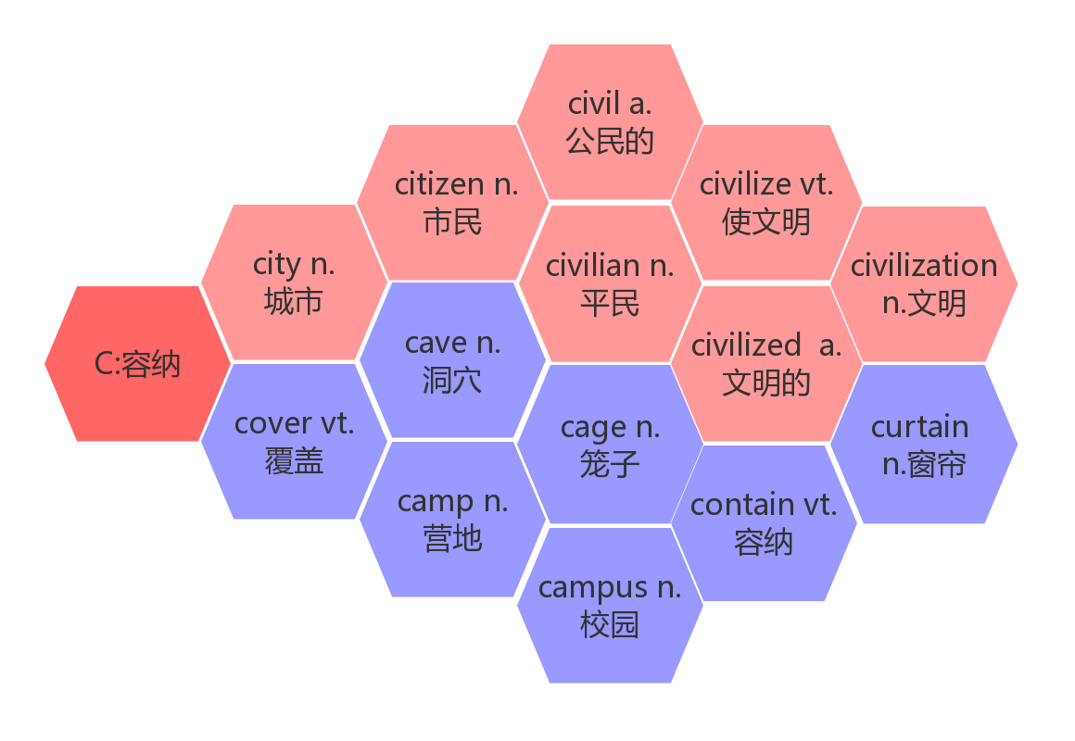

China is widely known for its ancient civilization which has continued all the way through into modem times, despite the many ups and downs in its history.

中国以其古老的文明而闻名，它一直延续到现代，尽管在历史上有许多起起伏伏。

Athens, the capital of Greece, is known as the birthplace of western civilization.

雅典是希腊的首都，作为西方文明的发源地而文明。

The Yangtze is one of the mother rivers of Chinese civilization. 长江是中华文明的母亲河之一。

**civilize /ˈsɪvəlaɪz/ vt.使文明；教化；启发**

Knowledge can civilize people. 知识能够使人有教养。

The wild child found in the forest was gradually civilized 在森林里发现的野孩子逐渐被教化了。

**civilized /ˈsɪvəlaɪzd/ adj. 文明的；有教养的**

A unified writing system is considered to be an important part of civilized society.

统一的书写系统被认为是文明的重要组成部分。

Many volunteers are playing an active part in making Jinan a civilized city.

许多志愿者正为济南建设文明城市发挥积极作用。

He was very kind and civilized. 他非常和蔼可亲，十分有教养。

1. **despite /dɪˈspaɪt / prep. 即使；尽管**

**词根词缀：de(远离)+-spite(special)：不管特别的情况——不管，尽管，即使**

despite the many ups and downs in its history 尽管在历史上有许多起起伏伏

Despite all these differences, lifestyle changes may be affecting French eating habits.

尽管有这些差异，生活方式变化可能在影响法国的饮食习惯。

Despite applying for hundreds of jobs, he is still out of work. 尽管他申请了数百个工作，但仍然在失业中。

She was good at physics despite the fact that she found it boring. 尽管她认为物理枯燥无味，她却学得很好。

in spite of/despite+doing可以转换成though/although 引导的从句

He always did well at school despite/in spite of doing part-time jobs every now and then.

= He always did well at school although/though he did part-time jobs every now and then.

尽管偶尔做兼职，他在学校总是学习成绩很好。

1. **ups and downs 浮沉；兴衰；荣辱**

When life gets hard and you want to give up, remember that life is full of ups and downs, and without the downs, the ups would mean nothing. 当生活很艰难，你想要放弃的时候，请记住， 生活充满了起起落落，如果没有低谷，那站在高处也失去了意义。

The relationship between China and America has seen ups and downs in the past fifty years.

在过去的50 年里，中美两国关系跌宕起伏。

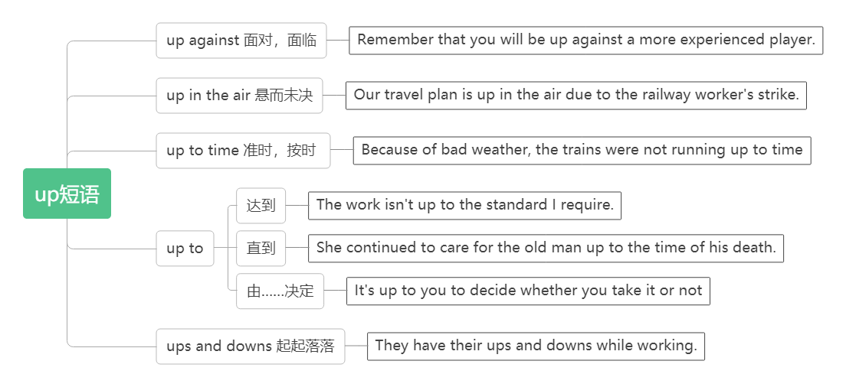

1. **factor /ˈfæktə(r)/ n.因素；要素**

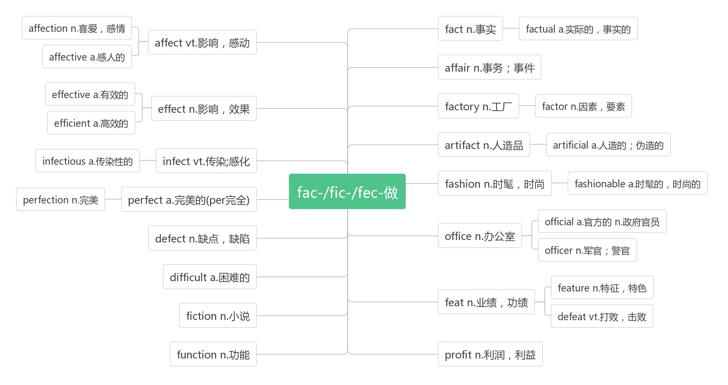

There are many reasons why this has been possible but one of the main factors has been the Chinese writing system. 这种可能是有很多原因的，但主要因素之一是汉语书写系统。

Physical activity is an important factor in keeping healthy.进行体育活动是保持身体健康的一个重要因素。

Knowledge is one of the important factors for a country's development.知识是一个国家发展的重要因素之一。

1. **base /beɪs/**

**vt.建立……的基础**

**base…on/upon把……建立在……基础上**

**be based on/upon 以……为基础/根据**

I based my opinion on facts. = My opinion was based on facts.我的看法是以事实为根据的。

Their marriage was based on love and respect. 他们的婚姻建立在爱和尊重的基础上。

Questions 16 to 18 are based on the passage you have just read. 第16到18个问题来源于你刚刚读过的这段文章。

Based on a true story, the film deeply moved us. 以一个真实的故事为基础，这部影片深深打动了我们。

**n. 底部；根基；基础**

the economic base 经济基础

Plants are the base of the food chain. 植物处于食物链的最底层。

At the beginning, written Chinese was a picture-based language. 起初，书面汉语是一种以图画为基础的语言。

His uncle is going to make a film based on his story in his childhood.

我的叔叔打算拍一部以他的童年故事为基础的电影。

**basis /ˈbeɪsɪs/n.基础**

**on the basis of在……基础上，根据**

We wanted to bottom our plan on a solid basis. 我们想把我们的计划建立在牢固的基础上。

Statement should be made on the basis of fact. 说话要以事实为依据。

**basic** **/ˈbeɪsɪk/ adj.基本的；首要的**

The basic forms of the English writing system are known as letters. 英语书写系统的基本形式是字母。

Sleep is, after all, a very basic need.毕竟，睡眠是非常基本的需要。

Basic skills of reading and writing are needed in communication. 沟通中需要基本的读写技能。

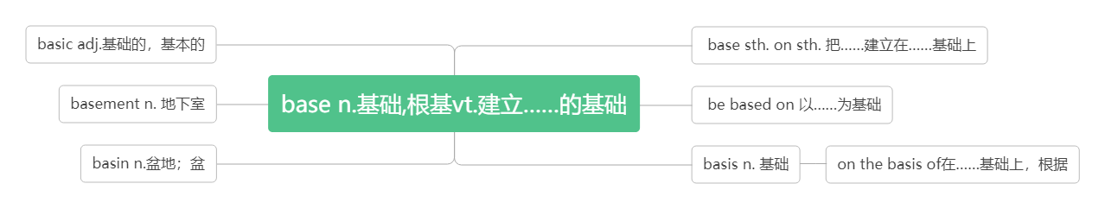

1. **date back to/date from追溯到**

It dates back several thousand years to the use of longgu—animal bones and shells on which symbols were carved

by ancient Chinese people.

它可以追溯到数千年前人们使用龙骨(中国古代人雕刻符号的的动物骨骼和贝壳)的时期。

Oxford and Cambridge date back to the thirteenth century. 牛津和剑桥的历史可追溯到十三世纪。

What time can the marathon date back to?马拉松可以追溯到何时?

Our school dates from the 1950s.我们的学校创办于20 世纪 50 年代。

【注意】

**date back to/date from不用于进行时，也不用于被动语态中，但可以用现在分词形式作定语。**

My family has a vase dating back to the Ming Dynasty. 我家有个花瓶是从明代传下来的。

1. **bone /bəʊn/n.骨头**

It dates back several thousand years to the use of longgu—animal bones and shells on which symbols were carved

by ancient Chinese people.

它可以追溯到数千年前人们使用龙骨(中国古代人雕刻符号的的动物骨骼和贝壳)的时期。

Many passengers suffered broken bones in the accident. 在事故中许多乘客骨折。

This fish has a lot of bones in it. 这种鱼多刺。

词群：

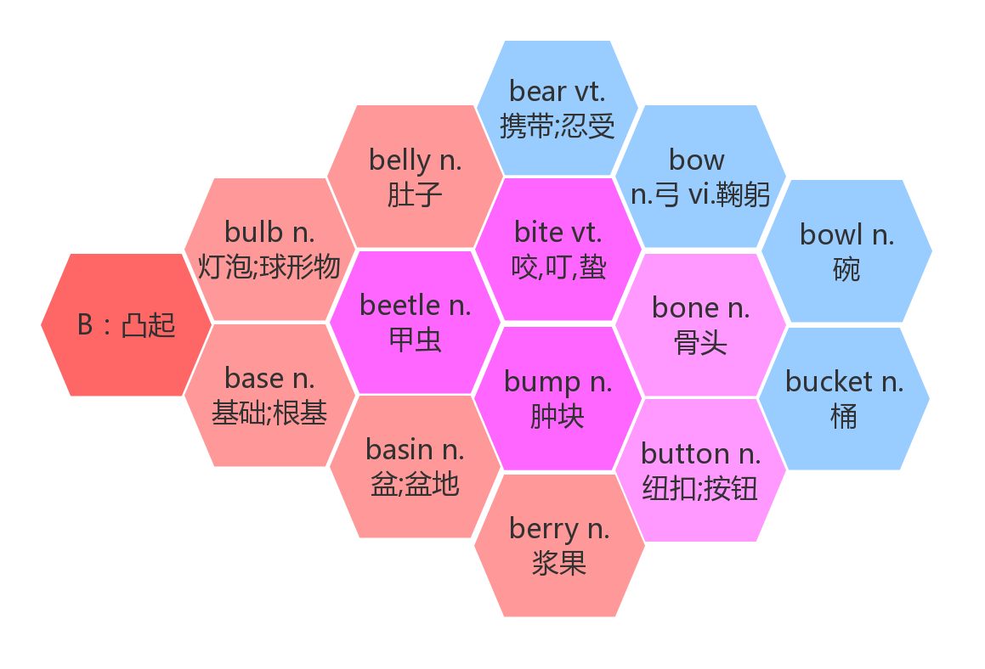

1. **shell /ʃel/n.壳；壳状物**

We collected shells on the beach. 我们在海滩拾贝壳。

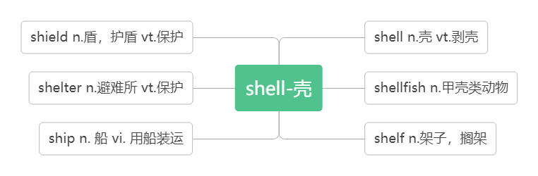

1. **symbol /ˈsɪmbl / n.符号；象征**

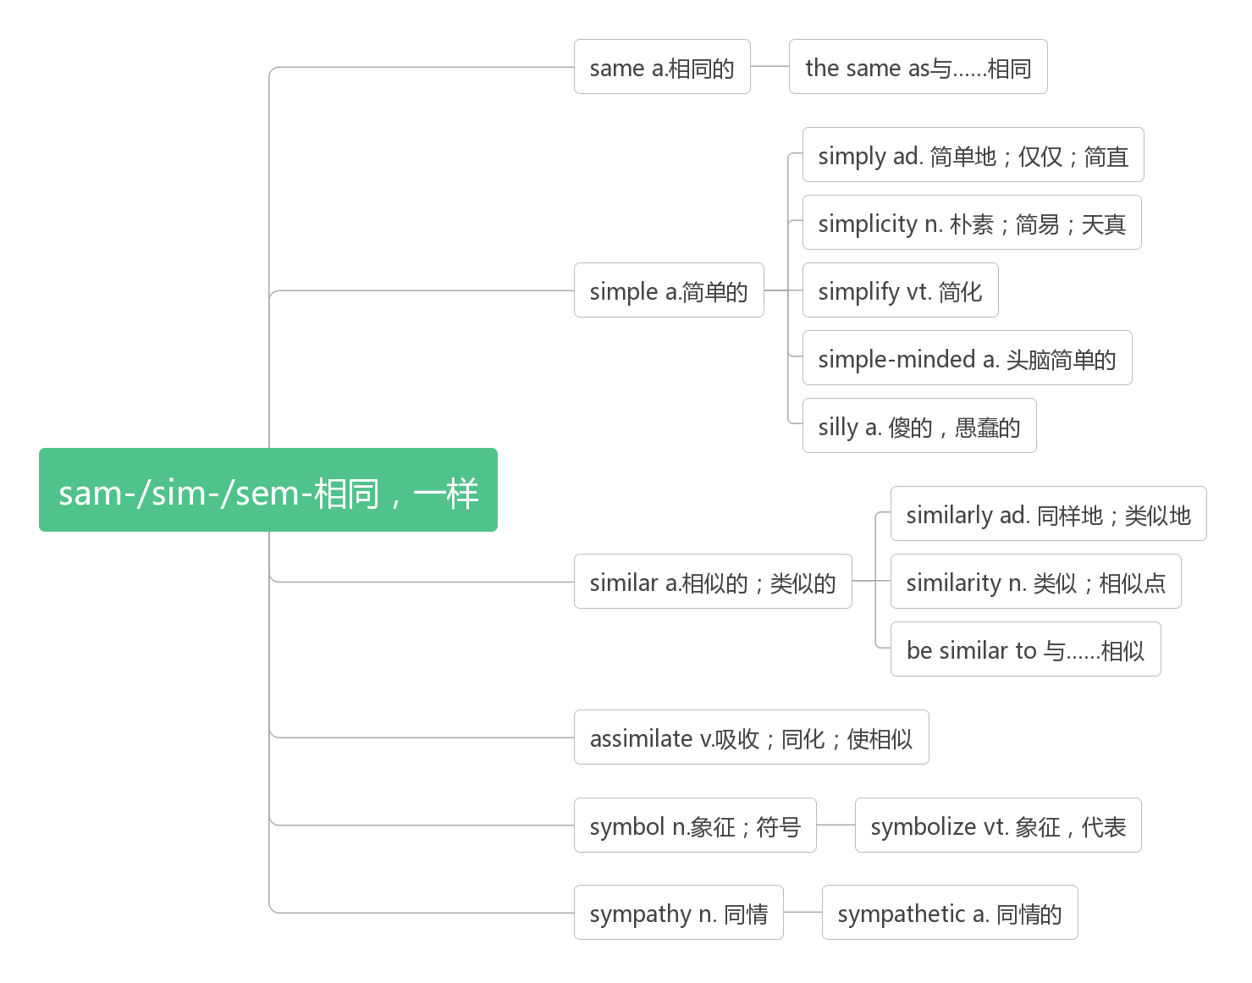

By the Shang Dynasty, these symbols had become a well-developed writing system .

到商朝，这些符号已经成为一个完善的书写体系。

What is the chemical symbol for copper? 铜的化学符号是什么？

Red is a color loved by most Chinese people because it is a symbol of good luck and joy.

红色是大多数中国人喜爱的颜色因为它是好运和喜庆的象征。

The elephant is one of the Thailand’s symbols. 大象是泰国的象征之一。

They never cut up the noodles because the long noodles are a symbol of long life.

他们从不切断面条，因为长面条是长寿的象征。

**symbolize /'sɪmbəlaɪz/ vt. 象征，代表**

Many Chinese characters symbolize their meaning. 许多汉字象征着它们的意义。

What does this strange mark symbolize? 这个奇怪的符号象征什么?

Mickey Mouse symbolizes American culture . 米老鼠是美国文化的象征。

1. **carve /kɑ:v/ vt. & vi. 雕刻**

They carved their names on the desk. 他们把自己的名字刻在书桌上。

The wood had been carved into the shape of a flower.木头雕成了花朵状。

We carve and paint and we enjoy what is carved and painted.

我们从事雕刻和绘画,我们也欣赏雕刻和绘画作品.

词群：

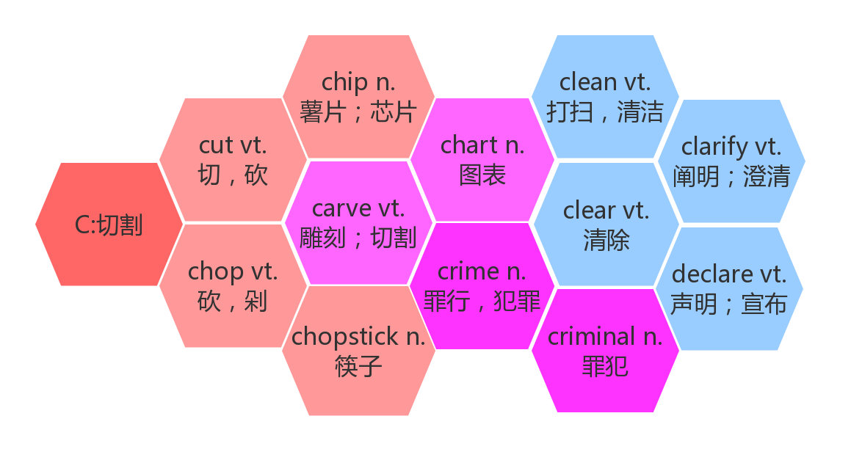

1. **variety/vəˈraɪətɪ/n. 变异体；多样化**

**词根词缀：vary(变异)+-ety(名词后缀)：变异体；多样化**

It was a time when people were divided geographically, leading to many varieties of dialects and characters

那是一个中国人在地理上分裂的时期，导致了多种方言和文字的产生。

**vary/ˈveəri/vi.变异，变化**

Cherries vary in colour from almost black to yellow. 樱桃的颜色由近乎黑到黄各不相同。

**various /ˈveərɪəs/a.各种各样的，多样的**

These data have been collected from various sources. 这些数据是从各方面搜集来的。

**a variety of = varieties of = various多种多样的；各种各样的**

China has a variety of / varieties of / various plants. 中国有着品种繁多的植物。

I decided to leave London for a variety of / varieties of / various reasons. 由于种种原因，我决定离开伦敦。

1. **major/ˈmeɪ dʒə(r)/adj. 主要的；重要的；大的**

Emperor Qinshihuang united the seven major states into one unified country.

秦始皇将七个主要国家统一为一个统一的国家。

Obesity is a major risk factor in many diseases. 肥胖是引发多种疾病的重要因素。

Several major companies are supporting the project. 几家大公司正在对这一项目提供资助。

**n.主修课程；主修学生**

Whether they are interested is the main concern of students when they choose a major?

学生在选择专业时，是否感兴趣是他们最关心的事。

Her major is French. 她的专业课是法语。

She's a French major. 她是法语专业的学生。

**vi.主修；专门研究**

**major in 主修……学科**

She majored in History at Stanford. 她在斯坦福主修历史。

**majority / məˈdʒɒrəti/n. 多数；大部分**

The majority of people prefer TV to radio. 大多数人都喜欢看电视多于听收音机。

In the nursing profession, women are in a/the majority .女性在护理行业中占大多数。

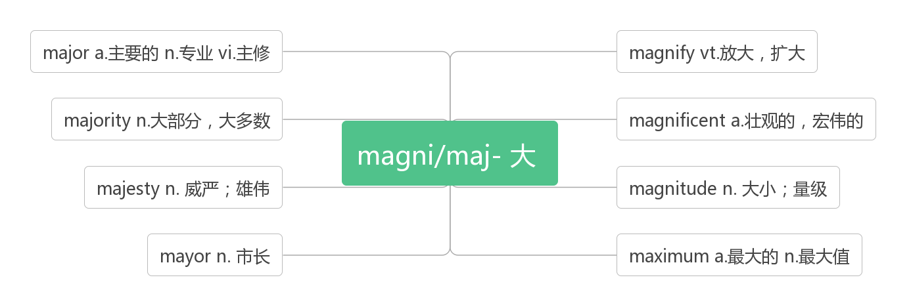

1. **no matter +疑问词 不论……；不管……**

Even today, no matter where Chinese people live or what dialect they speak, they can all still communicate in writing. 即使是今天，无论中国人住在哪里，说什么方言，他们都能通过书写（文字）进行交流。

No matter where you go in life or how old you get, there's always something new to learn about.

不管你生活在哪里，你有多少岁，总有新东西要学习。

Don't open the door, no matter who calls! 不管谁叫门，都不要开！

No matter who breaks the law, he should be punished. 不管谁违反了法律都要受到惩罚。

Any person, no matter who they are, must go through an identity check.

任何人，无论是谁，都必须通过身份检查。

No matter what you say, he won’t believe you. 无论你说什么，他都不相信你。

No matter what a serious problem you may have, you should face the challenge.

不管你遇到多么严重的问题，你都应该去面对挑战。

A determined person always tries to finish the job, no matter how hard it is.

无论工作有多困难，一个有决心的人总是会设法完成它。

I'll help you no matter when you have difficulties. 无论何时你有困难，我都会帮你。

1. **dialect /'daɪəlekt/ n. 地方话；方言**

**词根词缀：dia(不同)+lect(说)：不同地方说的话——方言**

When people use words and expressions different form “standard language”, it is called a dialect.

当人们使用不同于“标准语言”的词语和表达时，那就叫做方言。

I can fluently speak different dialects of Chinese. 我可以流利地讲不同的中国方言。

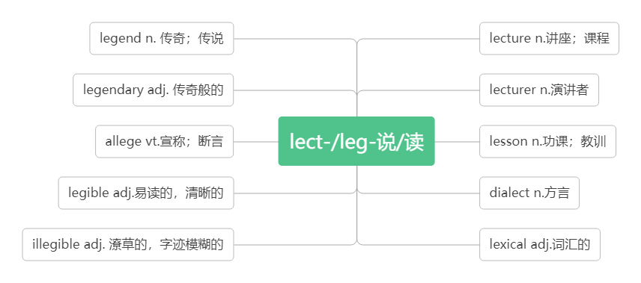

1. **means /mi:nz/n.方式；方法；途径**

Written Chinese has also become an important means by which China's present is connected with its past.

书面汉语也已成为一种把中国的现在与过去联系起来的一个重要的手段。

This is their only means of communication. 这是他们唯一的交流方式。

His bike is his only means of transport . 自行车是他唯一的代步工具。

Physical punishment should not be used as a means of controlling children.体罚不应该作为约束儿童的手段。

**by means of... 用... ... 办法；借助... ...**

He succeeded by means of hard work. 他依靠自己辛勤的劳动而获得成功。

We shall solve this problem by means of law and education. 我们用法律和教育这两个手段来解决这个问题。

The water may be carried by means of a pipe. 水可以用管子输送。

**by no means 绝不，无论如何都不**

He is by no means a brave person. 他绝对不是一个勇敢的人。

【注意】

1. means 是单复数同形的名词，作主语时，谓语的数要根据语境来判断。

Every possible means has been tried to make him give up smoking. 为了让他戒烟，每一种可能的方法都试了。

All possible means have been tried to make him give up smoking. 为了让他戒烟，所有可能的方法都试了。

（2）先行词means 在定语从句中充当方式状语时，引导词用by which。

This is the means by which he solved the problem. 这就是他解决问题的方式。

1. **classic /ˈklæsɪk /adj.经典的；古典的n. 经典作品；名著**

People in modem times can read the classic works which were written by Chinese in ancient times.

现代人可以阅读古代中国人写的经典作品。

Classic music is coming back. 古典音乐又开始流行了。

It is a classic style of Chinese buildings. 这是中式建筑古典风格。

As I grow older, I like to read the classics. 随着年龄渐长，我喜欢读经典著作。

Hong Lou Meng is my favorite literature classic. 《红楼梦》是我最喜爱的文学名著。

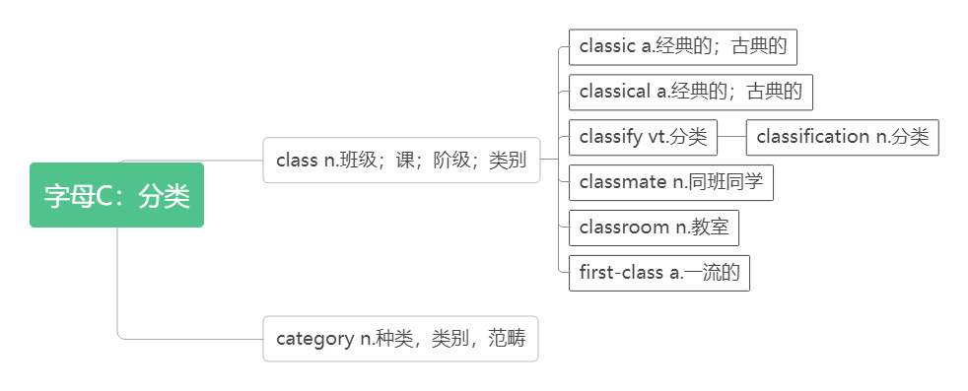

1. **regard /rɪˈgɑ:d/**

**n. 尊重；关注；问候（尤用于信中表示问好）**

The high regard for the Chinese writing system can be seen in the development of Chinese characters known as Chinese calligraphy, which has become an important part of Chinese culture. 从汉字的发展可以看出(人们)对汉语书写系统的高度重视, 被人们所熟知的中国书法已经成为中国文化的重要组成部分。

I have a very high regard for him and what he has achieved. 我非常钦佩他的为人和成就。

We have a great regard for the advanced workers. 我们非常尊敬先进工作者。

He has no regard for anyone's feelings. 他不顾及别人的感受。

Give my regards to your family. 请代我向你家人问好。

**vt. 把... 视为；看待**

**regard … as … 把……看作**

He regarded me as his friend. 他把我当成朋友。

Physics has hurt me a thousand times, but I still regard it as my first love. 物理伤我千百遍，我待物理如初恋。

The eagle is usually regarded as a symbol of courage 鹰常常被人们当作勇气的标志。

Her work is very highly regarded. 她的工作受到高度评价。

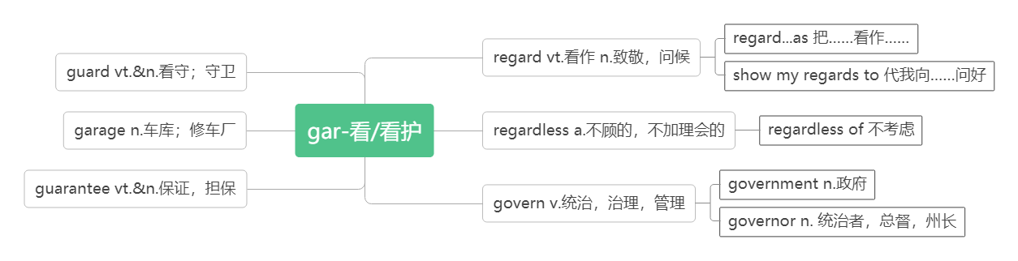

1. **character /'kærəktə(r)/n. 文字；符号；角色；品质**

**词根词缀：char(carv刻)+acter(actor演员)：演员所要刻画的东西——角色，品质**

Chinese characters 汉字

Snow White is one of the most famous Disneyland cartoon characters.

白雪公主是最著名的迪士尼卡通人物之一。

On November18,1978, Mickey became the first cartoon character to have a star on the Hollywood Walk of Fame.在1978年11月18日，米奇成了第一位入选好莱坞星光大道明星的卡通人物。

Knowledge will give you power, but character respect.知识给你力量，品格给你别人的尊敬。

Easy-going is part of his character.随和是他的性格的一部分。

The buildings are very simple in character. 这些建筑造型很简洁。

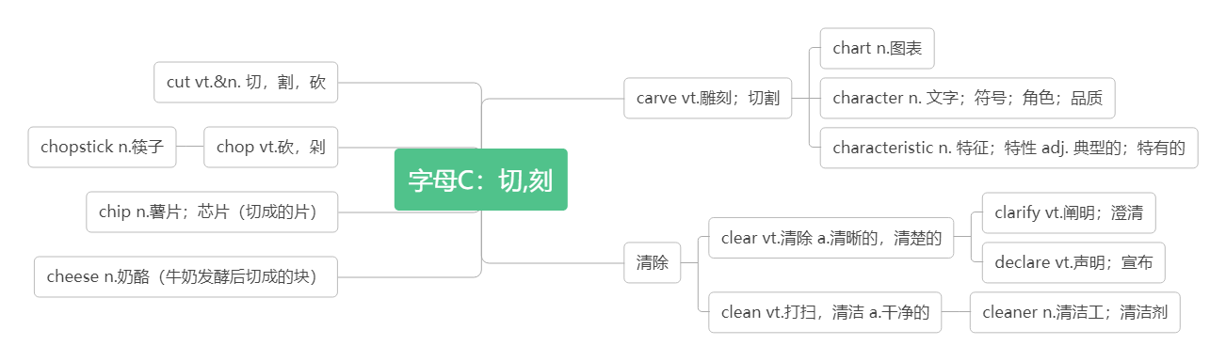

1. **calligraphy / kəˈlɪɡrəfi /n. 书法；书法艺术**

**词根词缀：calli-(漂亮)+-graphy(写，画)：写的漂亮的作品——书法**

The high regard for the Chinese writing system can be seen in the development of Chinese characters known as Chinese calligraphy, which has become an important part of Chinese culture. 从汉字的发展可以看出(人们)对汉语书写系统的高度重视, 被人们所熟知的中国书法已经成为中国文化的重要组成部分。

Chinese calligraphy is a kind of art. 中国书法是一种艺术。

He is good at Chinese calligraphy, especially at the running style. 他擅长书法，以草书见长。

Look! This is my calligraphy work. 看，这是我的书法作品。

1. **global /'gləʊbəl/ adj. 全球的；全世界的**

As China plays a greater role in global affairs, an increasing number of international students are beginning to appreciate China’s culture and history through this amazing language. 随着中国在全球事务中扮演着更为重要的角色，越来越多的国际学生开始通过汉语这一奇妙的语言了解和欣赏中国的文化和历史。

Global warming is a real problem. 全球变暖是个真实存在的问题。

The global economy is beginning to recover.全球经济开始复苏了。

We are trying to find solutions to global fuel shortage.我们正设法找到解决全球能源短缺的办法。

**globe /gləʊb/ n.球体；地球仪；地球**

Seventy percent of our globe's surface is water. 地球表面70%的地方覆盖着水。

According to the World Bank, China accounts for about 30 percent of total global fertilizer consumption.(2018全国卷II) 根据世界银行的数据，中国约占全球化肥总消费量的30%。

**globalization/ˌɡləʊbəlaɪ'zeɪʃn/ n.全球化**

Not only is it impossible to turn back the tide of globalization, but efforts to do so can make us worse off.

不仅全球化的大潮不可能逆转，而且那些不切实际的做法只能使我们的生活变得更加糟糕。

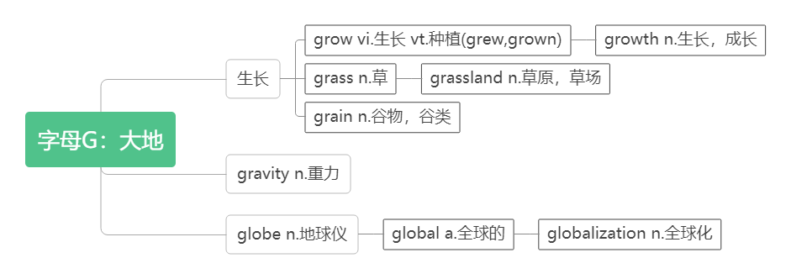

1. **affair /əˈfeə(r) /n.事务；事件**

**词根词缀：af(去)+fair(=fact,做)：要去做的事——事务，事件**

global affairs 全球事务

world/international/ financial /public /business affairs 世界/ 国际/ 财务/ 公共/ 商业事务

The newspapers reported the Watergate affair. 报纸报道了水门事件。

What I do in my spare time is my own affair. 我在业余时间做些什么是我自己的事情。

**同源词**：见10 factor

1. **appreciate /ə'pri:ʃieɪt /vt. 欣赏；赏识；感激；意识到**

**词根词缀：ap(去)+preci(价值)+ate(动词后缀)：去理解其中的价值——欣赏；感激**

appreciate China’s culture and history through this amazing language.

通过汉语这一奇妙的语言了解和欣赏中国的文化和历史。

Anyone can appreciate our music.任何人都能欣赏我们的音乐

The happiest are those who can appreciate the beauty of life. 最幸福的人是那些能欣赏生活之美的人。

His talents are not fully appreciated in that company. 他的才干在那家公司未受到充分赏识。

I'd greatly appreciate your support .我非常感激你的支持。

She appreciated the danger, so she turned and walked away. 她意识到了危险，于是转身走开。

We didn't fully appreciate that he was seriously ill. 我们没有充分意识到他的病情很严重。

**appreciate (one’s) doing sth. 感激（某人）做某事**

He would much appreciate your doing him that favor. 如果你能帮他这个忙，他会非常感激的。

**I’d appreciate it if you could do sth. 如果你能……，我将感激不尽**

I’d appreciate it if you could let me know in advance whether or not you will come.

如果你能提前让我知道你是否来，我将感激不尽。

**appreciation/əˌpri:ʃiˈeɪʃn/ n. 欣赏；感激；领会**

Learning Chinese calligraphy will increase your appreciation of Chinese culture.

学习中国书法将增加你对中国文化的鉴赏力。

It takes time to develop an appreciation for traditional culture, but the effort is worth it.

培养对传统文化的鉴赏力是需要时间的，但也是值得的。

We take this opportunity to express our sincere appreciation of your help.

借此机会我们对你们的帮助表示衷心的感谢

They have a stronger appreciation of the importance of education.

他们对教育的重要性有了更深的领会。

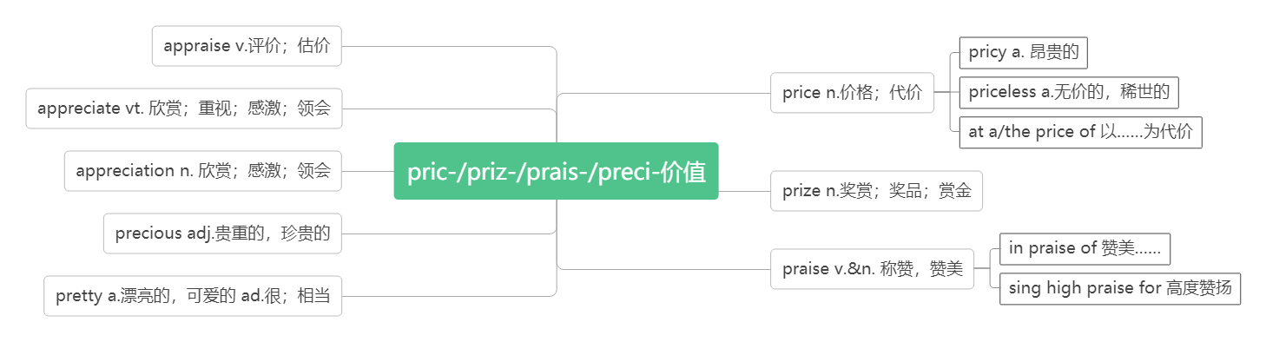

1. **specific/spəˈsɪfɪk/adj. 特定的；明确的；具体的**

Scanning is looking at the text quickly to find specific information such as dates or numbers.

浏览是快速看课文以找到特定的信息，如日期或数字。

The money was collected for a specific purpose.这笔钱是为一个特定用途而筹集的。

It must be based on general ideas rather than specific examples.必须以普遍的观念而不是以特殊的例子为基础。

I asked him to be more specific.我要求他说得更具体些。

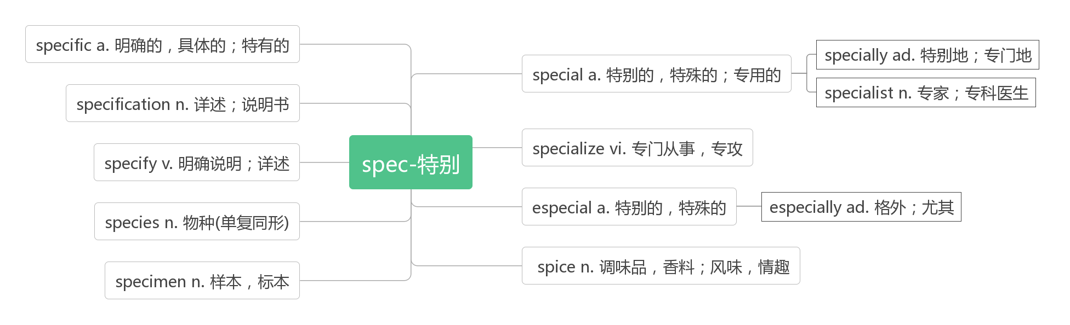

1. **struggle /ˈstrʌgl/vi.& n.斗争；奋斗；挣扎；努力**

**音义相通：死抓勾 助记：他挣扎着死抓着吊车上的钩子才没有掉下去。**

When I started studying German , it was a struggle. 当我开始学习德语时，那是一件很难的事。

Losing weight was a terrible struggle. 减肥是一件非常艰难的事。

I think life is a struggle for survival. 我认为生活就是一场奋力求生的斗争。

His sick mother was grateful for his struggle to support the family.

他的生病的妈妈很感激他为了支撑这个家庭所做的努力。

His goal was achieved through hard struggle. 他通过奋斗实现了目标。

They struggled just to pay their bills. 他们辛苦所得仅敷日用。

The company is struggling to find buyers for its new product. 该公司正竭力为其新产品寻找买主。

**struggle to one’s feet 挣扎着站起来**

She struggled to her feet. 她挣扎着站了起来。

**struggle for sth./to do sth. 为争取……而奋斗**

They were struggling for independence.他们在为争取独立而奋斗。

They were struggling to gain independence. 他们在为争取独立而奋斗。

**struggle against/with 与……斗争；与……抗争**

He struggled against cancer for two years他同癌症抗争了两年。

They had to struggle against all kinds of difficulties. 他们不得不同一切困境做斗争。

1. **tongue /tʌŋ/ n.舌头；语言**

**音意相通：烫 助记：我舌头烫了，说语言说不清。**

The words felt strange on my tongue. 这个单词在我的舌头上感觉很奇怪。

She made a face and stuck out her tongue at him. 她做了个鬼脸，向他吐了吐舌头。

I tried speaking to her in her native tongue. 我试着用她的本族语和她说话。

1. **point of view观点；看法**

I could see the world from a different point of view. 我可以从不同的角度看世界。

Try to see the matter from her point of view. 尽量从她的角度来考虑这个问题.

From my point of view, the party was a complete success.依我看这次聚会非常圆满。

1. **semester / sɪˈmest ə(r) / n.学期**

**破拆法：see(看)+mester(mister先生，老师)：看到老师——学期**

the spring/fall semester 春季/秋季学期

I plan to take chemistry this semester. 这学期我准备选修化学。

They cost hundreds of dollars every semester. 他们每学期花费数百美元。

1. **gas /ɡæs/ n气体；燃气.；汽油(美)**

natural gas 天然气

1. **petrol /'petr əl/ n.汽油(英)**

**音意相通：烧汽油排臭气**

1. **subway /'sʌbweɪ/ n. 地铁;地下通道**

**词根词缀：sub-(下)+way(道路)：底下的道路——地铁；地下通道**

The new subway is now being laid in Jinan. 新的地铁正在济南修建。

ride/take the subway 乘地铁

by subway 乘地铁；从地下通道

He always goes to work by subway. 他经常搭乘地铁上班.

I see the sign there which says " CROSS BY SUBWAY " . 我看见那儿的标志，上面写着“从地下通道过街”。

1. **apartment / ə'pɑ:tmənt/ n. 公寓(美)**

**词根词缀：apart-(分开)+ment(名词后缀)：隔开的一个个套间——公寓**

I’d like to come up to your apartment. 我想来你的公寓。

Even though the company is near his apartment, he has to hurry a little if he wants to arrive on time.

尽管公司靠近他的公寓，如果他想要准时到达的话，还是必须快点。

1. **pants /pænts/ n. [pl.] 短裤；内裤(英)；裤子(美)**

I really need to buy some pants. 我真的需要买些裤子。

In British English, the word “pants” means underwear. 在英国英语中，“pants”一词是指内裤。

1. **beg /beg/ vt. 恳求；祈求；哀求**

**I beg your pardon. 对不起。(请再说一遍)**

**beg sb for sth. =beg sth of/from sb.向某人乞求某物**

They begged him for help.= They begged help of/from him . 他们向他求援。

**beg for sth.乞求某物**

**beg sb to do sth. 乞求某人做某事**

The homeless people were begging for food.那些无家可归的在讨饭。

I begged him to come back to England with me. 我恳求他和我一起回英格兰。

**beggar /ˈbegə(r) / n.乞丐**

I gave the beggar some money out of pity. 出于同情，我给了乞丐一点钱。

The beggar died of cold and hunger. 这个乞丐由于寒冷和饥饿而死亡。

He is so rich and lives like a beggar. 他非常有钱可是生活得象个乞丐。

**42.equal /'i:kwəl/adj. 相等的；等同的**

Men and women enjoy equal pay for equal work. 男女同工同酬。

Women in our country enjoy equal rights with men. 在我国妇女享有同男子平等的权利。

Not all men are equal in ability. 人的能力并不都是一样的。

**be equal to 与……相等；能胜任……**

I can't find a person who can be equal to this work. 我找不到能胜任这个工作的人。

**n.同等的人；相等物**

Our relationship is close and we're equals. 我们的关系很亲密，我们是平等的人。

No one could be his equal at telling stories. 讲故事没人能比得上他。

**vt. 等于;比得上**

Four plus four equals eight. 四加四等于八。

Few pleasure can equal that of a cool drink on a hot day. 很少能有乐趣比得上在炎热的天喝一杯凉快的饮料。

**equally /'i:kwəli/adv.平等地，同样地；均等地**

Men and Women must be treated equally in education and employment.

在教育和就业方面男性和女性必须被平等对待。

Diet and exercise are equally important.饮食和锻炼同样重要。

The money was divided equally among her four children. 这笔钱在她的四个孩子中平分了。

**equality /iˈkwɒləti/ n.平等；同等**

I believe in the principle of equality before the law.我相信法律面前人人平等的原则。

**unequal /ʌnˈi:kwəl/ adj. 不平等的; 不相等的; 不胜任的**

The twins are unequal in height. 这一对孪生儿高矮不一样.

He felt unequal to the job and wished there were someone he could go to for advice.

他感觉难以胜任这项工作，希望有人能给点建议。

**unequally/ʌnˈi:kwəl/ adv.不公平地；不相等地**

She said she was treated unequally but she tried not to notice it.

她说她被不公平地对待, 但她努力地不去在意它.

Their profits were divided unequally. 他们的利润分配不均。

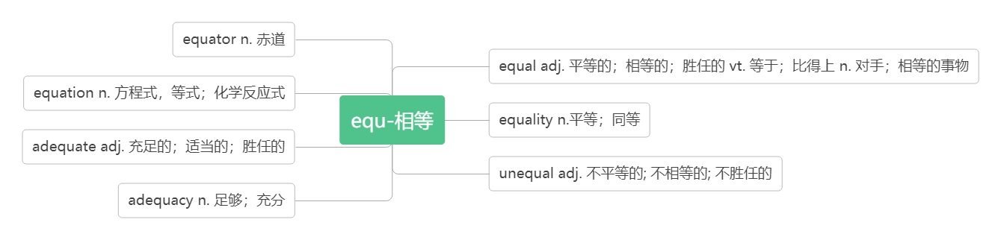

**43.gap /gæp/ n.间隔；裂口；差距**

I only need a few words to bridge the gap between us.

我只需要几句话就可以弥合我们之间的差距。

The gap between Apple and other tech firms is now likely to narrow

苹果和其他科技公司之间的差距现在可能会缩小。

There was only a narrow gap between the bed and the wall. 床和墙之间只有一条窄缝。

**generation gap 代沟**

Both parents and teenagers must try to bridge the generation gap between them.

父母和孩子都必须努力填补他们之间的代沟.

1. **demand/ dɪˈmɑ:nd /**

**n.要求；需求**

I must make it a question, not a demand.我必须把它作为一个问题，而不是要求。

Demand for coal is down. 煤的需求下降了。

There's an increased demand for organic produce these days. 目前对有机农产品有更大的需求。

to meet/satisfy the customers' demands满足客户要求

**in demand 需求巨大**

Good teachers are always in demand. 优秀的老师总是需求很大。

**vt. 强烈要求；需要**

She demanded an immediate answer. 她强烈要求立即作出答复。

This sport demands both speed and strength. 这项运动既需要速度也需要体力。

**demand + that 从句（从句中用“should+动词原形”，should 常可省略）**

The workers demanded that they (should) get better pay and conditions.

工人们要求提高工资和改善工作条件。

1. **vocabulary /və'kæbjʊlərɪ/ n.词汇**

**词根词缀：voc(发声)+abul(able能够)+ary(名词后缀)：能够发出声音的语言单位——词汇**

For me, vocabulary is my biggest problem.对我来说，词汇是我最大的问题。

He has a poor vocabulary , so he can't express himself correctly.

他的词汇量很少，因此无法准确表达自己的想法。

We read to improve our vocabularies. 我们阅读以便扩大词汇量。

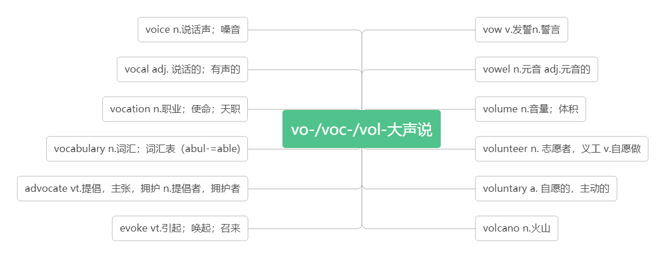

1. **describe /dɪˈskraɪb/ vt. 描述；形容**

Can you describe him to me?你能向我描述一下他的样子吗？

We asked her to describe what kind of things she did in her spare time.

我们请她描述一下她业余时间都在做什么。

It is very difficult to describe my joy in words. 我的快乐难以用语言来形容。

**description /dɪˈskrɪpʃn/n.描写，描述，形容**

Does the writer give a clear description of the problem? 作者是否清楚地描述了这个问题？

She gave an exact description of the accident.她对事故作了精确的描述。

Have you read the description carefully? 你认真读过介绍了吗？

beyond description 难以形容

The scenery was so beautiful that it was almost beyond description.

风景是如此得美丽,以至于几乎难以形容。

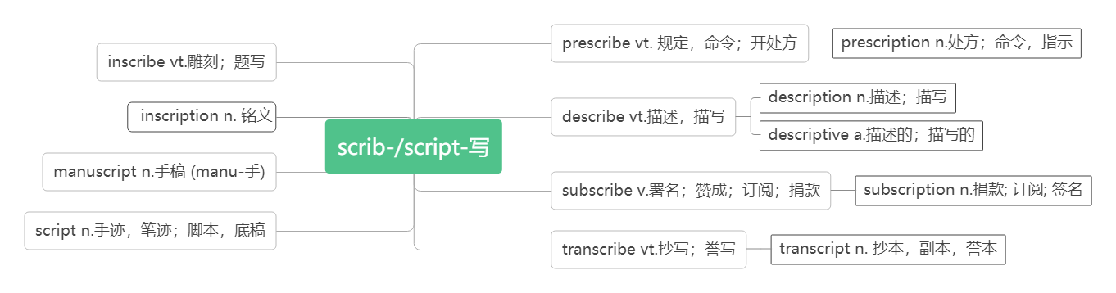

**47.relate /rɪˈleɪt/ vt. 联系；讲述**

**relate A with/ to B 把A与B联系起来**

The professor told his students to relate theory with/ to practice. 教授要学生们理论联系实际。

I can't relate what he does with/ to what he says. 我没法把他做的和说的联系起来。

She related her childhood experiences in her book. 在她的书中，她描述了自己童年的经历。

She related how he had run away from home as a boy. 她讲述了他小时候是如何离家出走的。

**be related to 与……有关联**

This heart attack may be related to his overwork. 这次心脏病发作可能和他工作过劳有关。

**relate to 与…… 相关；涉及；谈到**

Does each sentence relate to the main idea? 每个句子都与主旨有关吗？

His remarks didn't relate to the topic under discussion. 他说的话与讨论的问题无关。

The second paragraph relates to the situation in Scotland. 第二段谈到苏格兰的形势。

