必修三Unit 5 The Value of Money
年 级 | Senior Grade 1 | 授 课  教 师 | 郭文昇 | 学 科 | English | 授 课  日 期
课 题 | The Million Pound Bank Note |  |  | 课时  安排 | 2 | 课 型 | 新授课
文本分析
《百万英镑》是文学作品。本单元阅读是一部分戏剧体裁。起因是两个富豪兄弟用一张一百万英镑钞票打赌，身无分文的Henry正好路过。在询问了一系列问题后，两兄弟确认他就是最合适的人选，于是将那张百万英镑的钞票放在一个信封里交给了他，亨利糊里糊涂地接受了约定。这场戏充分表现了亨利正直、诚实、坦率、要强的性格，为后面进一步展现他的性格和心理活动作铺垫。
Ⅰ. Instructional objectives:
At the end of this class, students will be able to:
1. identify the essay type and the features of a drama;
2. summarize the story process by Story Mountain;
3. assess and analyze the main character’s characteristics critically;
4. understand and guess the implied meanings.
Ⅱ. Key points:
Understand the story process.
Ⅳ. Difficult points:
How to figure out Henry’s feeling and infer the implied meanings.
Ⅲ. Teaching procedures:
1. Task-based approach 2. Cooperative teaching method
Ⅴ. Teaching procedures:
Step1 Before-Reading
Activity 1. Lead-in
Students enjoy some pictures of millionaires and think about the following questions.
Q1. Would you like to be a millionaire like the following people? Why or why not?
Q2. If you had one million, what would you like to do?
设计意图：活跃课堂气氛，调动学生英语学习的兴趣，引出话题，并激发学生熟悉话题背景的相关词汇，做好语言铺垫。
Activity 2. Prediction
Students look at the title to predict the content and the text type. Then, the teacher introduces the basic elements of a play/ drama.
Q1. As you are reading the title, what ideas had go through your mind if you were the writer?
Q2. What is the text type?
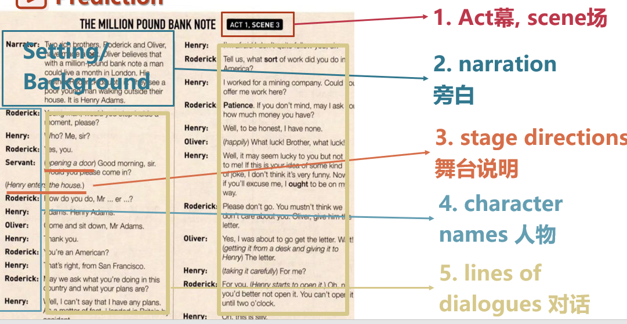
设计意图：通过创设情境，培养学生能够利用标题预测对话内容和作者的行文思路。通过快速阅读验证自己的预测并识别文本类型，让学生了解戏剧文体的五个特点。
Step2 While-reading
Activity 3. Read for Basic Elements
After prediction, students are asked to skim the dialogue to answer the four wh-questions.
Q1. Where did the story happen?
Q2. Who are the main characters
Q3. What happened?
Q4. When did it happen?
设计意图：该活动是为了让学生在主题引领下，通过快速阅读，完成对文章基本信息（4-wh）的梳理、获取和总结。
Activity 4. Read for Plots
According to Story Mountain, the teacher leads students to read the text carefully and fill in the blanks.
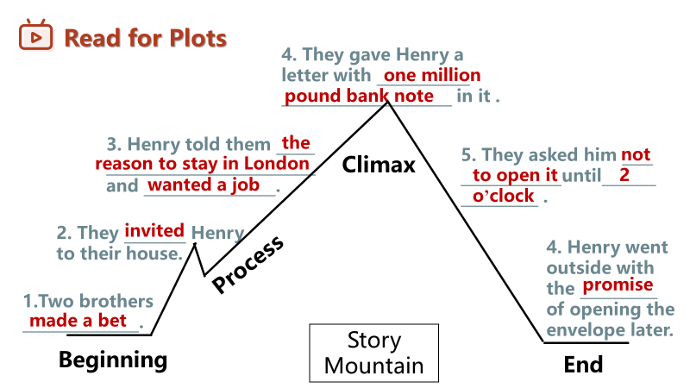
设计意图：利用“故事山”培养学生加工信息的能力，理清故事情节，使学生形成结构化知识的同时建立起信息之间的联系，帮助学生搭建过程性支架，从而更准确全面地理解故事情节的发展。
Activity 4. Read for Henry’s Feelings
The teacher asks the students to read the lines of dialogue and infer the changes in Henry’s feelings. Students use suitable adjectives to fill in the 3D coordinate system.
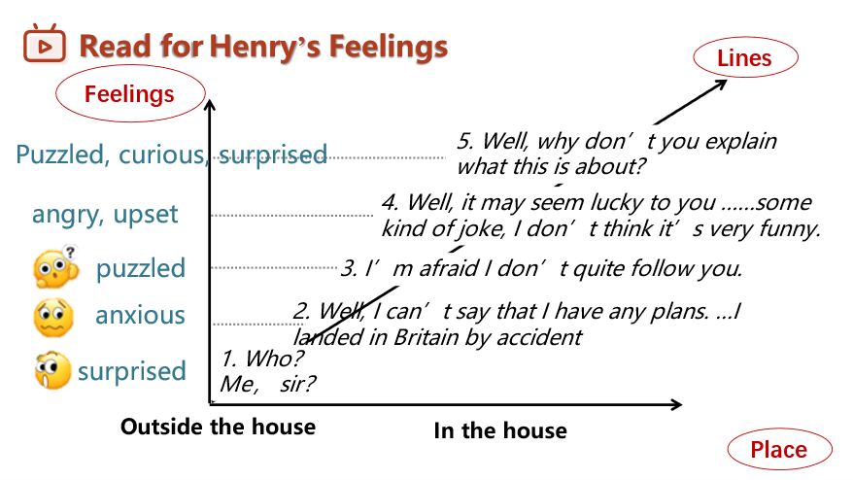
设计意图：学生再一次品读对话，利用三维坐标图，引导学生深层次挖掘主人公Henry的情感在时空线上的变化，培养学生思维的逻辑性，继而实现深度学习。
Activity 5. Read for Personalities
Students read the lines of dialogue again and infer the personalities of the three main characters.
设计意图：学生继续品读对话，从人物品质的角度挖掘文本内涵，用形容词概括三个主要人物的品质，学习他们的诚实、勤劳、智慧，形成正确的价值观，实现立德树人的目标。
Activity 6. Read for Implied Meaning
The teacher guides students to read the following between the lines and explore the implied meanings hidden beneath the literal meaning.
设计意图：学生从继续品读对话，有意识地让学生感知语言，理解语言，了解对话背后的真实含义，激发学生的多元思维。
Step 3. Post-reading
Activity 7. Read for Writing
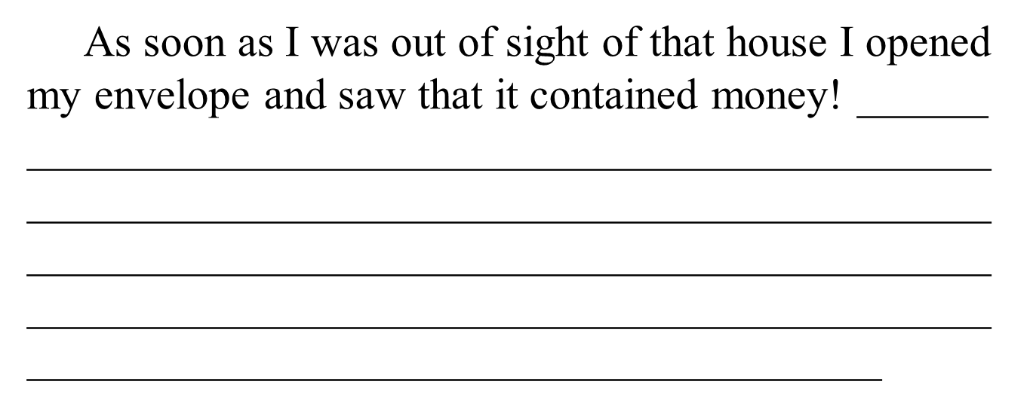Students think about the following question, “What will happen to Henry after 2 o’clock?” Then, they conduct the continuation writing based on their thinking and the first sentence.
设计意图：学生依托语篇和首句进行创造性地表达后续可能发生的故事，从而在思维地提升过程中实现语言的输出和运用，创造性地表达自己地想法和意图。
Activity 8. Thinking
Q1. Why does Henry refuse the brothers’ charity?
Q2. Why don’t the brothers want Henry to open the envelope before 2 o’clock?
Q3. What can we learn from the three characters?
Q4. Is money so important? What do you think of this?
设计意图：通过开放性的问题，将语言知识与学习策略融为一体，巩固所学知识，提升学生问题解决能力，在互动交流中表达个人的观点，正确地看待金钱，促进学生思维的创新性。
Ⅵ. Homework
The students work in groups of four to role-play Act 1, Scene 3.

