**情境化教学问题链案例探析**

**Contribute to Our Community**

**浙江强基联盟2024年8月29日高三联考应用文**

**陕西省咸阳市礼泉县教研室 高小聪**

**Contents:**

**Ⅰ. 新时代党的教育方针**

**Ⅱ.《新课标》高考命题特征**

**Ⅲ. 情境化问题链审思**

**Ⅳ. 案例链接新高考、新教材**

**Ⅴ. 师生作品赏析**

**Ⅰ. 新时代党的教育方针**

**教育必须为社会主义现代化建设服务、为人民服务，必须与生产劳动和社会实践相结合，培养德智体美劳全面发展的社会主义建设者和接班人。**

**--《中华人民共和国教育法》第五条(2021年4月29日，第十三届全国人大常委会第二十八次会议修改)**

**Ⅱ. 《新课标》的命题特征**

**“核心价值金线”贯穿高考命题和评价的始终，“能力素养银线”成为高考命题和考查的重心，情境作为考查载体，是“金线”和“银线”的“串联线”。高考评价体系指导下的高考命题，呈现出“无价值不入题; 无思维不命题; 无情境不成题”的典型特征。使高考由“解答试题”转向“解决问题。**

**Ⅲ. 情境化问题链审思**

**所谓问题链，就是教师以教学目标为导向，以文本内容为基础，基于学生现有的知识与经验，将课本知识转化为具有逻辑性和层次性的一系列问题。其主要特征为各个层次的问题环环相扣，层层递进，彼此相互连接，无法割裂。**

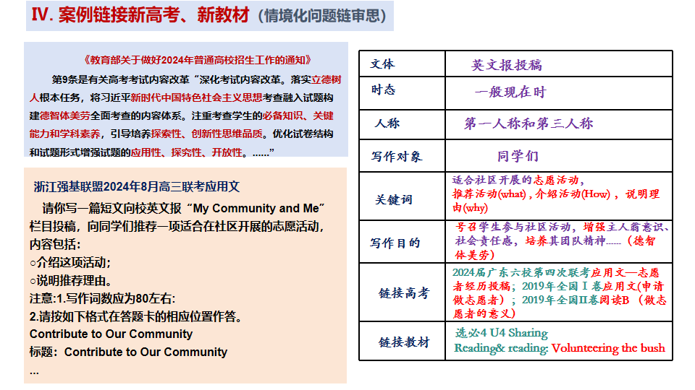

Ⅳ. 案例链接新高考、新教材（情境化问题链审思）

导入性问题链：（Discuss in groups）

1. What’s a community? Have you join in any community voluntary activities?

2. What kinds of voluntary activities are fit to be carried out in the community?

探究性问题链&递进式问题连：

3. How is the voluntary activity/project carried out in the community? (its theme, volunteer service recipient, volunteer assignments ...) (Brief-introduction）

5. Why do you recommend the activity? (meanings)

总结式问题链:

6. What difference will the community voluntary activities make to us?

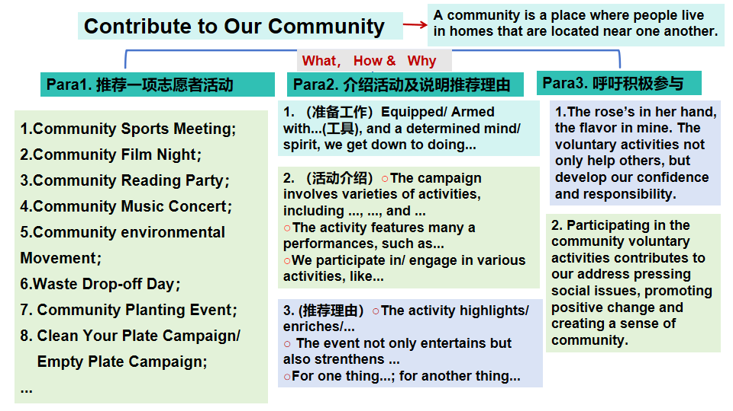

**Ⅴ.师生作品赏析（学生作品1）**

Contribute to Our Community

Nowadays, environmental issues are becoming more and more serious day by day. Therefore, 1__________(deliver) a lecture on environmental protection 2______(one) a month is necessary and significant in the community.

This activity mainly consists of producing, posting and distributing 3____________(environment) propaganda posters, giving public lectures on 4______ to build up a healthy and eco-friendly community. More 5__________(importance), we guide the residents to sort out waste, save water and 6______(make) use of waste... This activity can provide a cleaner and 7_____(tidy) place of living, studying and working as well as enhance people’s 8___________(aware) of environmental protection.

To sum up, I think 9____ meaningful to carry out this volunteer activity in the community, so let us join hands 10__________(create) a pleasant community.

**（学生作品2）**

Contribute to Our Community

With many young people working out of their homes, the community is mainly 1_________(populate) with the elderly and children. So I suggest 2________(carry) out a voluntary caring service campaign in the community 3__________(regular).

For the purpose of helping the left-behind elderly and children, the campaign 4__________(involve) giving the children guidance in studying, having a heart-to- heart talk with them, 5________(chat) with the elderly and doing some housework. The divided groups 6_________(perform) assigned tasks carefully, 7___________(summary) their own work and do our endeavour to serve better as much as possible.

Learning to share 8_______(society) responsibility is our young people's duty;Having great empathy with others’ living situations makes us 9_______(will) to give a helping hand and contribute love and 10________ (warm) to our community.

**老师作品1**

Contribute to Our Community

I recommend a volunteer activity of tutoring the kids at weekends, which is suitable 1__________(launch) in the community.

2_______(give) the volunteer teachers’ specialties and kid’s needs, we can pair with them to help them with 3___________(difficulty) in life and offer academic guidance, 4_________(range) from teaching them standard writing, reciting 5________(class) works,teaching them some learning skills, providing the kids 6______ psychological counseling to carrying out parents-child campaigns.

This activity is a triple-win situation for 7__________(we), the kids and parents in the community. It not only helps children 8_______(good) their studies but also enriches our life, getting rid of 9__________(electron) products as much as possible. Furthermore, it also contributes to 10_________(relief) parents of their worries.

**老师作品2**

Contribute to Our Community

Based on a survey carried out among the residents in the community, the environmental clean-up campaign regularly I recommend 1____________(favor) by the majority.

2______(do)a thorough cleaning in designated public places, we are divided into groups to perform 3______________(vary) tasks as planned. Some are picking up litter; some 4___________（collect） useless stuff and putting stuff in order; some cutting trees and flowers; some 5_______(gift) for drawing paint some lovely and fragrant pictures on the wall... 6______ great efforts, the community 7_________(take) on a clean and pleasant look.

The rose’s in her hand, the flavor in 8______(I). As a member of the community, we should take an active part in such these voluntary activities. Not only can the 9__________(act) develop a sense of community and responsibility but 10___________(strength) team spirit.

**学而不用则废，用而不学则滞。**

**—周海中**