单元学习主题

本单元围绕“肢体语言(body language/non-verbal language)”这一主题，介绍不同国家、不同文化、不同场合、不同语境、不同模态中肢体语言所表达的意义。内容贴近生活，具有很强实用性，而且能够帮助学生更关注文化对比，培养学生文化知识和学习能力。

|  |  |  |
| --- | --- | --- |
| 单元学习任务 | 课时内容 | 承载的学科核心素养 |
| When in Rome, do as the Romans do. Which ways can we employ in achieving this? What should we pay special attention to? And why should we act in this way? | reading and thinking | 理解多模态语篇传递要义、组织结构，厘清主要观点和事实之间的逻辑关系，能够以尊重文化多样性的方式调试交际策略。 |
| learning about language & discover useful structures | 较为熟练地整合性运用已有的英语语言知识，了解语篇恰当表意所采用的语言手段，有效传递信息，在日常人际交往中，建构适当的交际角色。 |
| using language 1 (listen and speaking) | 理解多模态语篇传递的要义和具体信息，有效陈述事件、传递信息，感悟中外优秀文化的精神内涵，梳理正确价值观。 |
| using language 2 (writing) | 理解语篇传递的要义和信息，分析它的组织结构、文本特征和语篇连贯性，利用各种信息渠道，反思学习效果并据此优化学习策略和方法。 |

第一课时 Reading and Thinking

文本分析：

该板块的活动主题是“理解肢体语言”。主要阅读语篇是从地域文化的角度解读各种肢体语言的相似处、不同处及用处的说明文。文章词肢体语言的基本功能入手，说明正确理解和运用肢体语言一定要考虑低于文化中的得体性。文章采用“总 – 分”机构和举例子、作对比的阐述方式，向读者传递三层信息：①肢体语言很重要，有重要社会交际功能；②肢体语言有一定地域文化属性；③正确理解和运用肢体语言才能发挥它的交际功能。（选必一教师教学用书p144）

读后活动中采用的视频来源于OMG美语“各种笑”，主要观看目的是在语言学习的同时进一步解读笑的各种用法，为帮助学生深入挖掘肢体语言的重要性提供支架，也契合opening page上的引语”What I hide by my language my body utters.” 引导学生认识到肢体语言恰当使用的重要性，有助于让学生形成积极人生态度。

活动设计：

该板块从阅读opening page上的引语导入，通过引导同学观察被提问同学的肢体语言，导入主要阅读语篇Listening to how Bodies Talk。在读中，帮助同学借助“信号词”等信息源，找到每个段落的主题句并归纳段落大意，进而梳理语篇结构。然后通过填写表格、回答问题对语篇中的肢体语言使用场合和意义进行整理，并对文中没有展开的部分进行合理推断。最后结合课文内容，在观看视频后，对肢体语言的意义再进行探讨，尝试升华主题。

教学目标：

1. 在主题活动中掌握相关表达方式并能加以使用；

2. 掌握这种介绍性说明文的语篇结构和展开方式；

3. 能够结合上下文进行推断，理解文中“言下之意”；

4. 能够用肢体语言相互鼓励。

教学重点：

1. 利用信号词分析说明文的语篇结构及在主题句后，支持性细节的展开方式；

2. 理解对肢体语言进行描述的表达方式和使用场合；

3. 学习发挥肢体语言在人际交往中的积极作用

教学步骤：

Step 1:Lead-in: Opening page

Ask the students to turn to the opening page and read the quote on it. Encourage them to translate it into Chinese and provide a sample version for their reference. Then ask the 2 questions one by one:

1. When you say “yes” do you really mean “yes”?

2. Do you like English?

Before asking the 2nd question ask the other students to tell if he/she means “yes” when he/she says “yes”.

设计意图：由对opening page上引语的讨论和理解入手，以具象化的肢体语言诠释该句，并引起学生关注。

Step 2: Pre-reading activities:

Ask the students to turn to page 38 and pay attention to the title and illustration here, try to answer the following questions:

1. What do you think will be talked about in the text? (After reading the title)

2. What do you think the young lady might want to convey with her body language? Where is this picture on this page? Is this passage probably a narrative? An expository? (After reading the illustration)

设计意图：lead-in部分大多数同的活动正是listen to how bodies talk的具体行为，由lead-in的问题直接过渡到看标题猜主题问题衔接可以比较紧密，之后再定位插图，回答问题，在下文读取信息之前先进行预测。

Step 3: While-reading activities:

Activity 1: read for topic sentences

Ask the students to go through the passage and try to find the topic sentence in each paragraph with the help of some “signal words”.

设计意图：通过跳读skimming抓取文中相关信息并熟悉表示上下文逻辑关系的词组和其他表达方式。

Activity 2: Tell the main idea and structure

From the information provided in the topic sentences, divide the passage into 4 parts and tell the main idea of each part and structure of the whole passage.

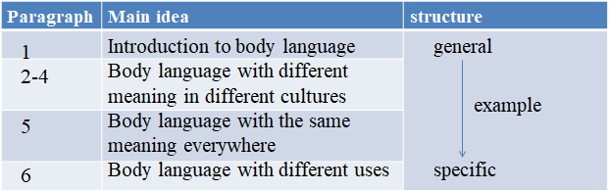

设计意图：通过整合信息，推断出语篇结构和段落大意，并厘清主要观点和事实之间的逻辑关系。

Activity 3: Read for specific information

①According to the table above, locate where the following information comes, and then fill in the blanks in the table below:

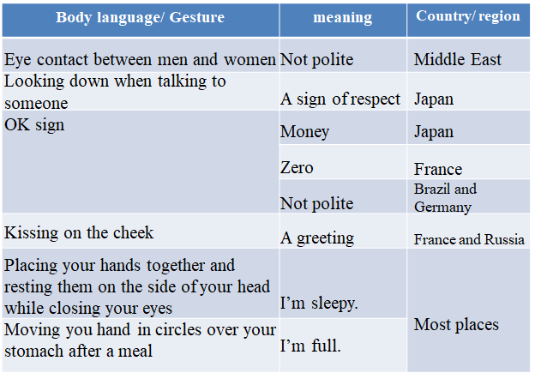

设计意图：通过填表，熟悉不同地区的肢体语言在使用中的异同处。

② Answer the questions

1. What is body language? (paragraph 1)
2. What could it demonstrate when your make eye contact with the person you talk to? (paragraph 2)
3. How to display “zero” in France? What does the identical sign mean in Japan? (paragraph 3)
4. Why doesn’t the passage give some details about the “OK” gesture being impolite in Brazil and Germany?
5. How does the passage give examples in paragraph 4?

设计意图：通过回答问题，熟悉文中支持性细节和描述方式，同时练习“推断”， 理解文中“言下之意”。

Step 4: Post-reading activities:

Activity 4: Tell the sentence structures used

Ask students how the 6th paragraph tells us the different uses of smile? Can you find out the varies sentence structures?

设计意图：熟悉说明文中展示细节的陈述方式，并为读后练习做好铺垫。

Activity 5: Watch the video and act

1. When we smile or laugh do we always feel happy? How many kinds of laugh are talked about here?

2. The picture and sound in the video doesn’t match well? Can you and your partner help to demonstrate these expressions?

3. Look around. When you put a smile on your own face, do you put on a smile on your friends’ face?

设计意图：在对整个语篇的结构和语言有一定理解后，结合opening page上的问题，对主题进行进一步发掘。

Step 5: Assignments:

1. Read the passage again and try to figure out the answer to the question: “which is more convincing, your verbal or non-verbal language?”

2. Finish off the concerned exercise in your exercise book.

设计意图：巩固课堂所学并进行对自身学习状态的反思和评价。