2020学年第一学期杭州市期末统测读后续写教学设计

----昌化中学 李冬琴

13071830531

主题语境：人与动物

语篇类型：记叙文

语篇研读：该故事所给部分讲述的是 “我”从小养到六个月的猫咪丢失了，“我”伤心欲绝。“我”去每一个他可能会出现的地方寻找，一连找了好几个星期，都不见他的踪迹。在他走丢的两个星期后，“我”把他用过的小床、碗、玩具等收了起来，以免自己触景生情。但我一直没有放弃寻找他。在一个秋日的早晨，去上班的路上，因为天气不错，也因为时间还早，我就一直走路。等公交车来了，我也还想继续走下去，因为我的内心感觉今天会发生一些事情。故事的情感线索较为清晰：前五段主要是因为喵咪走失而伤心，第六段里作者对好天气描写的似乎在告诉读者，那一天他会找到他的猫，因此这一段里，作者的情感是充满希望的。

设计思路: 通过坐标图来梳理语篇的故事线和情感线，即“what”，并从中推断出作者的隐含信息、写作意图和情感态度，即“why”。同时，通过分析主要人物我和猫咪，我不放弃寻找猫咪，可以预测我找到了我的猫。同时，猫咪没有很好的街头智慧（street-smarts），可以预测出作者找到猫之后，猫咪饥肠辘辘、毛发凌乱等情况。在研读续写部分的首句之后，用Q-A（问题回答策略）来设计情节和提供语言支架，同时对多个不同类型的结尾进行展示和探索，并提供有关常见宠物猫和狗，以及人与宠物之间的互动的语料库，以期对学生在故事构写、画面感表达、丰富结构等方面有所帮助。

教学过程：

Step1：Read the story and analyze the story line and emotinal line

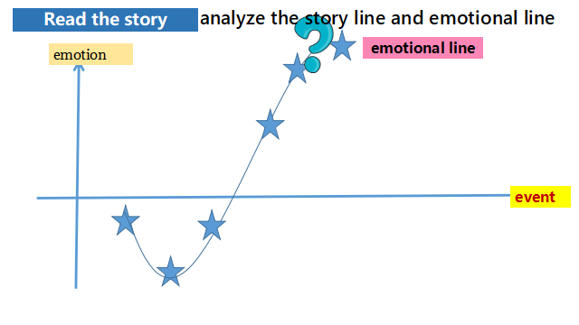

在学生梳理故事线（para1—para5），教师可以问学生：Did the writer want to give up searching for the dog? How do you know ?

在学生梳理para6，教师问学生：Why did the writer especiallyt stress the good weather?

设计说明：通过坐标图来梳理语篇的故事线和情感线，即“what”，并从中推断出作者的隐含信息、写作意图和情感态度，即“why”。

Step 2: Know the main characters (明确主要人物)

Find basic information about “I” and “my”cat in the story.

设计说明：通过分析主要人物，学生可以熟悉人物，掌握人物的特征挖掘作者真正想要表达的情感和写作意图。

Step3： desigh the plot and list the outline

Para1：1. What did I see? What was the cat like/doing? 2.What did I do? How did the cat react ? 3. How did I feel?

Para2:1. How did the cat react when arriving at home? 2. What did we do after arrving home? 3. How did I feel having the cat back home?

设计说明：研读所给首句和关键词，并用问题的方式对文章的结局进行合理推测，建构，培养学生的逻辑思维和推理能力，并初步确定续写方向和细节。接着教师领导学生对问题进行回答，并罗列相关词块表达，丰富写作细节。

Step4 Conclude the passage in various ways

设计说明：教师展示不同的结尾方式，培养发散性思维和丰富故事表达。

Step5 Accumlate the language about pets(especially a cat and dog)

设计说明：教师提供的语料库，都是来自英文小说，尤其有关狗的动作描写，选自《奇迹男孩》。帮助学生积累丰富地道的表达方式，同时引导学生课外阅读英文文学作品。

Step6 Appreciate the sample writing

设计说明：通过欣赏优秀习作，整体感知，积累素材。

试题呈现：第二节: 读后续写（满分25分）

阅读下面短文，根据所给情节进行续写，使之构成一个完整的故事。

My very first fur baby was a white cat named Rebel, I got him from the Animals center, and he quickly took over the house and my heart. He was almost six months old when he disappeared, and I was heartbroken.

I searched for him everywhere, talking to the neighbours, putting up posters, and even offering a reward. I checked the shelter and the emergency vet clinic to see if he had been injured or picked up. No one had seen him, so I kept searching.

I lived in the city, close to high traffic road, and Rebel didn't have “street smarts” because he was an indoor cat I also had an idea that if he got lost. he wouldnt be able to find his way home. Every time I went out, I would search for him as I drove down the road. Nothing.

Weeks went by with no sign of my cat. Everyone said I had to accept the result that was certain to happen --either he was dead, or someone else had him and was giving him a good home. I didn't accept that, I just couldn't.

After two weeks with no sign of him, I put his bed, toys, food, bowls, and litter box into storage so I wouldnt have to walk by the sad reminders every day. But I still wasn't ready to give up.

One morning, I left for work a few minutes early and started walking to the bus stop a block away. It was a nice autumn day, pleasantly cold and sunny a good day for a walk. I arrived at the bus stop and checked to see if the bus was coming, but little early. Something told me to keep going, so I decided to walk to the next bus stop, I got there and saw the bus coming, but I just kept walking and watching the bus swiftly pass by, knowing I was going to be late for work. But something told me to keep going.

Para.1 I continued to walk for another twenty minutes.________________________

Para.2 I turned around and carried him home.________________________________