Book 3 Unit 2 Reading for Writing
Share your opinions about a moral story
The Stone in the Road
- View  and  Predict | What questions come to your mind at the sight of the title ?  - ___________________________________________________________  - ___________________________________________________________
- Read  and summarize | 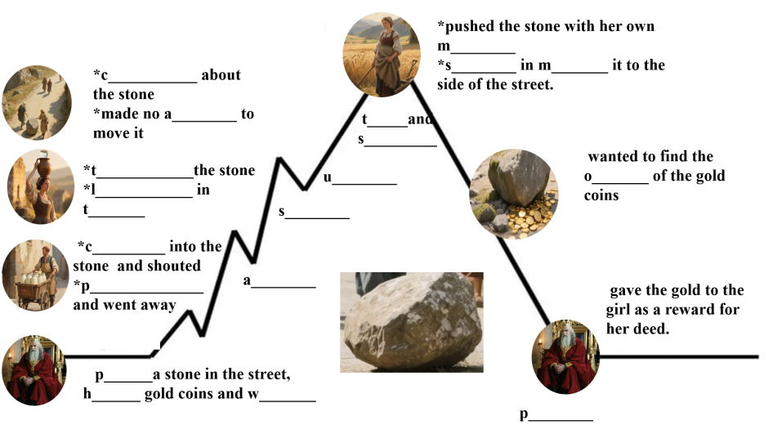  A short description of the story  __________________________________________________________________________________________________________________________________________________________________________________________  ______________________________________________________________
- Analyze  and  Reflect | The “stone” refers to ______________________________________ in life.  The “milkman” and the “woman” refer to those who ___________________  ______________________________________________________________  The “girl” refers to people who ____________________________________  ______________________________________________________________  The author is trying to ___________________________________________  _____________________________________________________________  The story is intended to __________________________________________.  I (don’t) think the author succeeded in getting his point across because _____________________________________________________________  _____________________________________________________________.  If I were a 21st-century king, I would _______________________________.  The author has done a great job in __________________________________  ______________________________________________________________  However, ______________________________________________________  _____________________________________________________________.  I would (not) recommend the story because __________________________  _____________________________________________________________  _____________________________________________________________  _____________________________________________________________.
A Review of the Fable A Stone in the Road

__________________________________________________________________________________________________________________________________________________________________________________________________________________________________________________________________________________________________________________________________________________________________________________________________________________________________________________________________________________________________________________________________________________________________________________________________________________________________________________________________________________________________________________________________________________________________________________________________________________________________________________________________________________________________________________________________________________________________________________________________________________________________________________________________________________________________________________________________________________
_______________________________________________________________________________

