**设计思路**

本课件的设计依托KWL教学法，即：What students already know about body language, What students want to know about body language和What students have learnt about body language, 并尝试从传统阅读课教学模式向自主阅读模式过渡。

导入部分通过问题链的形式考查学生对body language的既有认知，继而引出对单元引言的理解。随后自然过渡到对单元配图的解读：通过描述图中人物的肢体语言，推测其情绪，感知肢体语言是如何传递信息的。随后利用图片描述中的语块让学生推测body language的组成，即：facial expressions, gestures and postures.

读前，学生依据标题和配图对文章内容、文体进行推测，形成阅读期待。

在阅读过程中，学生通过自问自答，了解了WHAT (what is body language),HOW (how does body language demonstrates meanings) 以及WHY(Why do we need to learn body language?)­ 三个核心问题，掌握了文章的主旨大意。在教师引导下，通过各段的细节梳理，学生又从语言知识、写作技巧、跨文化交际等方面对肢体语言有了更深的了解。

阅读活动结束后，学生通过头脑风暴反思本节课所学，教师利用学生的输出对本节课进行总结，并引导学生要尊重文化的差异，在不同的情境下使用恰当的肢体语言。同时对标题进行二次解读，学生通过讨论对标题的理解或重拟标题来发展批判性思维和创造性思维。

**教学设计**

**Activity 1 Get to know body language**

Q&A:

1. What do you think is the function of language?
2. What can you do if your message doesn’t get across?
3. Which is more reliable in conveying messages, spoken language or body language?

**【设计意图】**通过问题链的形式考查学生对body language的既有认知，继而引出对单元引言的理解：What I hide by my language my body utters.

1. What might they be doing and how do they feel?

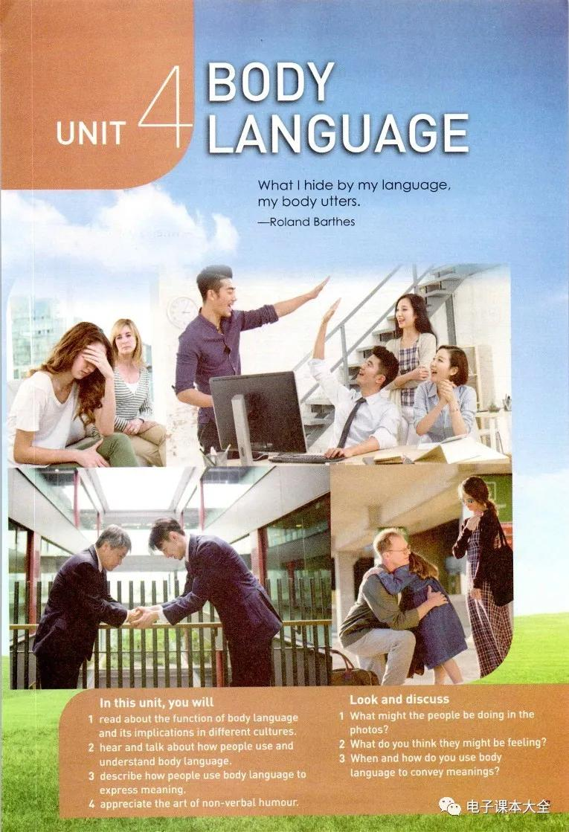The girl is _________her face with her _____ , showing _______________________________

while the woman who sits next to her is __________ her lip corners, looking at her and showing __________.

The men are _________________________ and the women are __________, all looking _________________ to _________ a success in the office.

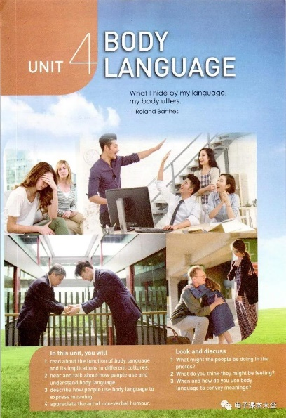The men in business suits are _____

and _____________with each other, showing ________.

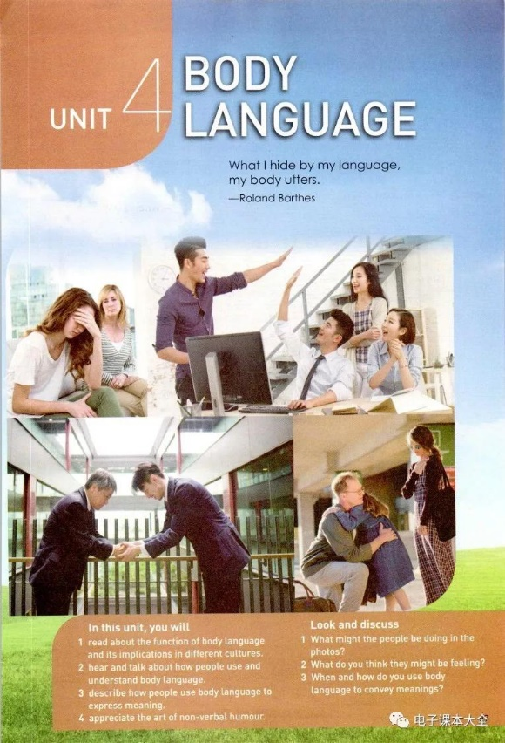This can be a family reunion occasion when the man is ________ his daughter and _________ her on the back, whispering _________________. Meanwhile, the girl and the woman might be weeping for____.

**【设计意图】通过描述图中人物的肢体语言，推测其情绪，感知肢体语言是如何传递信息的。**

1. What does body language consist of?

* facial expressions
* gestures
* postures

**【设计意图】利用图片描述中的语块让学生推测body language的组成，即：facial expressions, gestures and postures, 从而拓展学生的“已知”，并为文本阅读做背景知识的铺垫。**

**Activity 2 Make a prediction**

Read the title and the picture and discuss:

* What do you want to know from the text?
* Does the girl’s gesture have a universal meaning or does its meaning vary from countries?
* What is the writing type of the text?

**【设计意图】学生依据标题和配图对文章内容、文体进行推测，形成阅读期待。**

**Activity 3 Read for topic sentences**

1.Read through the passage and locate the topic sentence(s) in each paragraph.

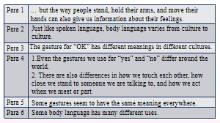

**【设计意图】通过“寻读”定位每一段的主旨句。注意第四段比较特殊。**

2. Divid the text into 4 parts and summarize the main idea of each part.

Part 1(Para.1) Introduction to body language

Part 2(Para.2-4) Body language with different meanings in different countries.

Part 3(Para.5) Body language with the same meaning everywhere.

Part 4(Para.6) The function of body language.

**【设计意图】依托主题句对文章的脉络进行梳理，并学习“概括”技能，用自己的语言总结各部分主要内容。**

**Activity 4: Read for specific information**

Para.1

Q&A:

1. How do we communicate with each other?
2. What kinds of body languages are mentioned?/How will bodies talk?
3. What will our body tell us?/Why do we learn to read body language?

Para.2-5

1. Read Para. 2-5 and fill in the form on Page 39.
2. Work out the structures of Para.2-4
3. How does the writer support his ideas?
4. Can you find the logical relationships among the examples in Para. 2-4?
5. Can you draw a mind-map to show the structure of Para.2-4?
6. Can you come up with other gestures that share the universal meanings?

Para.6

1. What different uses of smiling are mentioned in Paragraph 6?
2. How does the writer tell us the different uses of smile?
3. Can you find out the varied sentence structures?

**【设计意图】自主阅读与传统阅读模式相结合。通过回答读前的问题，验证推测，并通过What, Why, How的回答了解文章的主旨。通过对各段的细节梳理，学生从语言知识、写作技巧、跨文化交际等方面对肢体语言有了更深的了解。**

**Activity 5: Reflection**

1. What have you learned from this passage?

* Body language is important in our daily life.
* It varies from culture to culture.
* We should respect different cultures.
* We should apply appropriate body language according to different contexts.

1. Do you think the title “Listening to how bodies talk” is a good title? If so, how do you understand it? If not, how would you like to change it?

**【设计意图】学生通过反思本节课所学，在教师的引导下对本节课进行总结和升华。对标题进行二次解读，发展学生的批判性思维和创造性思维。**