**2023年12月浙江四校联盟高三联考英语**

**应用文 讲评学案**

**PART 1 强化审题意识**

【题目呈现】

假定你是李华，写信给留学生朋友James，告知他国际学生服务中心(International Students Service Center)正面向留学生开展主题为“My China Surprise”的短视频征集活动，内容包括:

1.活动介绍；

2.视频要求；

3.鼓励参加。

注意：

1.写作词数应为 80 左右；

2.请按如下格式在答题卡的相应位置作答。

Dear James,

______________________________________________________________________________________________________________________________________________________________

Yours,

Li Hua

【基本信息把握】

|  |  |  |  |  |
| --- | --- | --- | --- | --- |
| 文体体裁： |  | | | |
| 写信对象： |  | | | |
| 人称时态： | □第一人称 | □第二人称 | □一般过去时 | □一般将来时 |
| 写信语气： | □正式 | □非正式 | □均可 |  |
| 写信背景： |  | | | |
| 写信目的： |  | | | |
| 注意点： | ① 关注部分微妙的字眼，如题干要求中的“_______________”  ② 三大要点的篇幅长短需要根据其在整体信件中的重要性有所取舍。  ③ 鼓励参加的口吻和语气要_____，姿态不能过高，亦不能过低。 | | | |

【审题易错分析】

审题误区1：错用时态

How is it going？Our International Students Service Center hosted a a video shooting contest themed “My China Surprise” . 错误：________________________

Good luck! Our International Students Service Center will carry out a short video contest themed “My China Surprise” .错误：________________________

**Tip 1 for observation:** _______________________________________________________

审题误区2：目的-文体混淆

Knowing that our International Students Service Center is launcing a a video shooting contest, I am writing to invite you to make one with me. 错误：________________________

Considering our International Students Service Center is collecting short videos, I am writing to recommend the contest to you.错误：________________________

**Tip 2 for observation:** _______________________________________________________

审题误区3：要点混淆

The contest is aimed to collect videos shot by foreign students, whose requirement is to ignite foreign students’ recognition of China.

错误：____________________________________________________________________________

**Tip 3 for observation:**

handle the relationship between two points seriously and avoid conflicts and imbalance.

审题误区4：语气态度

What has been stated above is relevant information I can offer. I will be highly appreciated that you can have a brilliant try and make great success.

Please evaluate the last paragraph composed by this student.Give some comments.

____________________________________________________________________________

**Tip 4 for observation:** _______________________________________________________

**PART 2 建构思维框架**

①首段复现背景

转述题干提供的背景信息，即国际学生服务中心正面向留学生开展主题为My China Surprise的短视频征集活动，尽可能将题干中的信息进行充分利用，字数控制在两句话左右。

②次段陈述主体

第二段是整篇应用文写作的核心部分，也就是所说的“主体”（body），即围绕活动介绍与视频要求两大维度，前者可以写“是什么-为什么”等，后者可针对视频本身展开，即”时长、清晰度、要素“ 字数控制在四句话左右，可各自分配两句话，该部分对语言精炼要求较高。

③尾段表示鼓励

根据题目要求，可以用一句话来体现鼓励的含义，不一定直译，最好有参加，参与等字眼的出现。

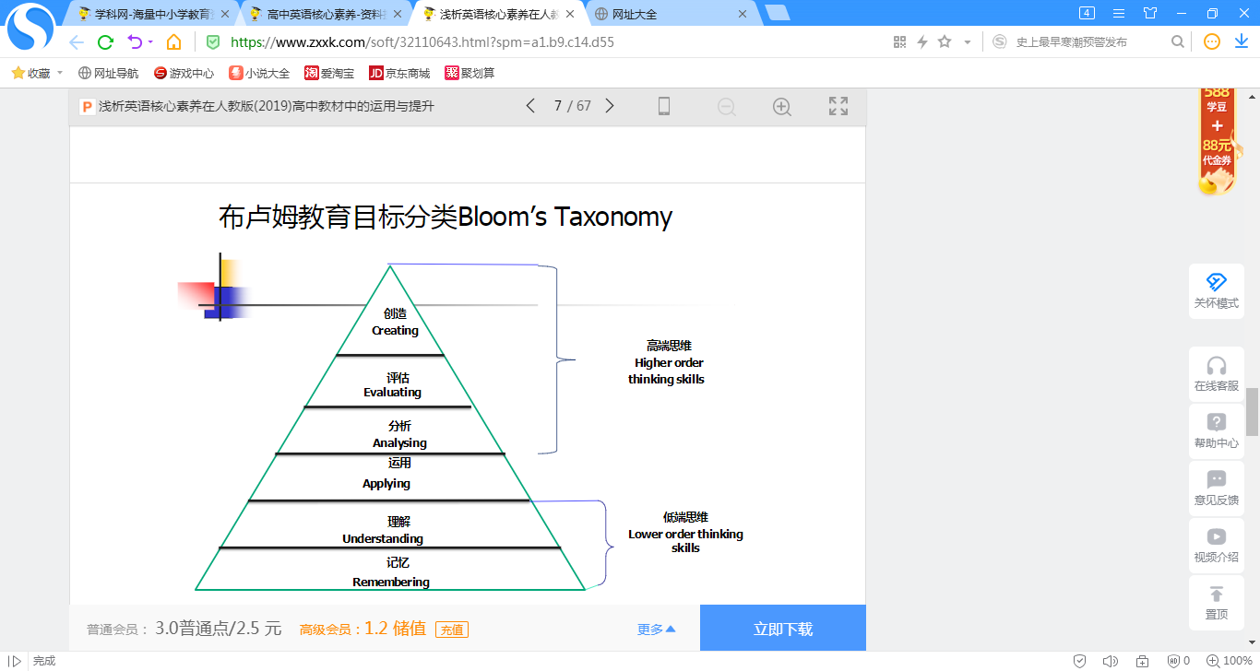

**PART 3 语料积累运用**

**【首段】**

Q:首段如何表达两大目的-告知与鼓励参与？

___________________________________________________________________________

Good news! The International Students Service Center **is organizing** a video shooting contest themed “My China Surprise” and I **strongly recommend** you give it a shot.

I hope this letter finds you well. I am writing to **share the exciting news** with you – the International Students Service Center is organizing a short video contest **centered around** "My China Surprise." and **expect/anticipate** your extraordinary entry!

**Task: Give your comments on the two examples.**

____________________________________________________________________________________________________________________________________________________________________________

**Expansion:Different occasions to inform.**

____________________________________________________________________________________________________________________________________________________________________________

**【次段】**

Q:活动介绍主要可以写什么方面？

______________________________________________________________________________

活动目的：

The activity **is meant to** invite international students to showcase their unique experiences in China through short videos. It's a great opportunity to **highlight the diverse and enriching** aspects of life here.

活动目的：

**The purpose of** this activity is to showcase the personal experiences, cultural encounters, and **memorable moments** in China through the eyes of international students.

呈现方式：

With the theme of My China Surprise, the project welcomes stories about life in China from foreigners’ perspectives. It can involve **various segments**, such as speech clips and interview clips.

**点睛：总结“目的是”表达法**

Q:视频要求有什么角度与方面？

______________________________________________________________________________

**①**Participants are encouraged to create videos **capturing special moments** of their life in China. The videos should be **creative, informative, and no longer than 3 minutes**.

**②In terms of** video requirements, the length should be no longer than 3 minutes. It can be **creative, humorous, or even documentary-style**. The video should capture interesting scenes or challenges that you have faced in China, and most importantly, demonstrate the surprises you **encountered** during the stay.

.

**③Submission is open** until Jan. 15th, 2024, and there are very exciting prizes awaiting the winners.

**【尾段】**

①I strongly encourage you to take part in this **fantastic initiative**. It's not only a chance to express your experiences but also an opportunity to **connect with the international community** and **witness the beauty of cultural exchange**.

② Considering your colorful life, singular creativity and **considerable expertise in** photography, your video will definitely make a very **competitive entry**. I’m looking forward to your excellent performance in the contest! Best wishes!

**Task: 总结“参与”的表达.**

____________________________________________________________________________________________________________________________________________________________________________

**【范文1】**

Dear James.

Good news! The International Students Service Center is organizing a video shooting contest themed “My China Surprise” , and I strongly recommend you give it a shot.

All foreign students living in China are welcome to share their unexpected adventures,surprising moments and cultural revelations through the lens. There are no strict restrictions on the topics, allowing participants ample freedom to capture whatever they find captivating and intriguing. Submission is open until Jan. 15th, 2024, and there are very exciting prizes awaiting the winners.

Considering your colorful life, singular creativity and considerable expertise in photography, your video will definitely make a very competitive entry. I'm looking forward to your excellent performance in the contest! Best wishes!

Yours

Li Hua

你觉得本文的得分是_________

理由与可取之处：______________________________________________________________________________________________________________________________________________________________

**【学生习作】**

Dear James,

Here comes fantastic news! The International Students Service Center is organizing a short video shooting contest with the theme of “My China Surprise” , which is worth your vigorous participation.

Without explicitly stipulated restrictions, all overseas students in China are encouraged to create works to promote cultural interaction. The activity requires participants to capture their colorful life, ranging from fortuitous adventures to memorable moments with cultural revelations. Even trivial but surprising moments in daily dribs and drabs can take on a refreshing effect through your unique lens-selection. The deadline for submission is on Jan 15th, 2024. Simultaneously, great presents are awaiting the winners.

Your ingenious idea, abundant life and expertise in photography is bound to make you stand out. Highly anticipate your performance! Best wishes.

Yours,

Li Hua

你觉得本文的得分是_________

理由与可取之处：______________________________________________________________________________________________________________________________________________________________

**PART 4 赏读话题迁移**

**【体裁迁移1：通知】**

假定你是校英文网站的编辑李华。八十周年校庆之际，校英文网站将举办主题为“Discovering our beautiful campus”的短视频、摄影作品征集活动。请你写一则通知，发布在校英文网站上，内容包括：

1. 作品要求；

2. 奖项设置；

3. 截止时间。

注意：

1. 词数100左右；

2. 可以适当增加细节，以使行文连贯。

参考词汇：八十周年校庆the 80th anniversary of the school

**Notice**

_______________________________________________________________________________

_______________________________________________________________________________

_______________________________________________________________________________

**【参考范文】**

Our school’s English website will collect short videos and photographs of our campus for an online exhibition during the 80th anniversary of the school. The theme of the activity is discovering our beautiful campus.

Your works can focus on wonderful landscapes or unforgettable moments. And the English description of each work should be no less than 100 words. There are three first prizes, five second prizes and ten third prizes in this activity. Please submit your works to our website no later than May 30, 2023.

It’s a great chance to display your talent. Seize the chance!

The School’s English Website

**【体裁迁移2：投稿】**

假定你是某国际学校的学生李华，你校的视频制作俱乐部（Video Production Club）正在征集关于春节记忆的短视频以供展示. 请你给该活动的负责人Alan写封邮件并投稿，内容包括：

1. 表明意图；

2. 介绍作品；

3. 表达期望。

注意：

1. 词数100左右；

2. 可以适当增加细节，以使行文连贯。

参考词汇：八十周年校庆the 80th anniversary of the school

**Dear Alan,**

_______________________________________________________________________________

_______________________________________________________________________________

_______________________________________________________________________________

_______________________________________________________________________________

_______________________________________________________________________________

_______________________________________________________________________________

_______________________________________________________________________________

_______________________________________________________________________________

_______________________________________________________________________________

_______________________________________________________________________________

**Yours，**

**Li Hua**

**【参考范文】**

Dear Alan,

I'm Li Hua, a senior 3 student. Learning that your club is collecting short videos about memories of the Spring Festival for show, I'm writing to submit a relevant short video made by myself.

The 3-minute-long reunion-themed video, which is attached below, shows several sweet moments at the Spring Festival when all my family members were spending the traditional festival together. Among them, my favorite moment is when my grandfather watched all the other family members making jiaozi and smiled. For most Chinese people like me, family reunion is the sweetest memory of the festival.

I hope my short video can be selected to spread love and warmth. I'm looking forward to your reply.

Yours sincerely,

Li Hua