教学设计
【文本分析】
【What】本课时的语篇话题（诗歌）属于主题语境—人与自然，人与生活，文章涉及诗歌的韵律，节奏，并介绍了几种不同内容和形式的简单诗歌。
【Why】本文文章内容简单自然浪漫，具有很强的吸引力，能让学生初步认识和理解简单的诗歌，辨识诗人身份，找出诗歌的韵律，并表达由诗歌激起的联想，继而加深对诗歌的理解，体会诗歌所传达的情感，这有助于学生走近诗歌，体会诗行所传达的美，进而更加热爱生活，热爱自然，提升文学素养，让生活活得如诗一般。
【How】本文是一篇说明文，结构为总分总结构，第一段总括全文，阐述写诗的目的；第二段起分析不同种类的诗歌，并罗列了共计八首五种不同类型的英文诗歌，分别为：节奏明快，韵律和谐，不断重复利于记忆的童谣（Nursery rhyme）；诗行灵活，带韵脚的清单诗（List poems）；五行诗（Cinquain）；俳句（Haiku）,和被翻译为英文的唐诗（Tang poems）。
【教学目标】
- Understand the main features of five forms of English poems and the emotions conveyed respectively.
- Identify the similarities and differences among the five forms of English poems.
- Create a short English poems.
【教学过程】
Step One：Lead-in: What is a poem ? Watch the video and fill the blanks.
In children's eyes:A poem is ____________.A poem is lovely ________.A poem is ________.
A poem can be __________ and can be ____________.A poem makes you _______________.
Step Two: Reading
Activity 1: Skimming and scanning
1.学生通过观察文章标题，指出文章将介绍什么内容。
What is the main topic of the reading passage?It is about a few simple _____ of ___________.
2.学生通过快速跳读文章每段开头，快速识别五种不同类型的诗歌名称。
How many forms of poems does the passage talk about? What are they? 5
3. Brainstorm:Why do you think people write poems? 小组快速制作思维导图。
Activity 2: Understanding: Focus on language style, rhyme, feelings of poems
六人一组共同决定、讨论某种类型诗歌的特点、所传达的情感和读诗后的个人感受。
- 小组内群学深入研究语篇, 关注押韵，重复和行数，音节等方面。
- 学生每组选择一名同学汇报研讨发现。
A Nursery rhyme
Hush, little baby, don’t say a word,
Papa’s going to buy you a mockingbird.
If that mockingbird won’t sing,
Papa’s going to buy you a diamond ring.
If that diamond ring turns to brass,
Papa’s going to buy you a looking glass.
If that looking-glass gets broke,
Papa’s going to buy you a billy-goat.
If that billy-goat runs away,
Papa is going to buy you another today.
1.Read Poems A and find out the rhyming word for the following words:
word ____________ sing ________ brass ____________broke _________ away ________
2.Sing the poems along the video clips
B C List poem
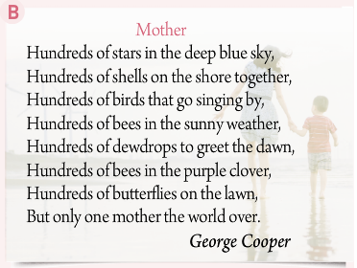
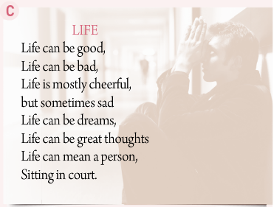

1. What's the pattern of poem B and C?
2. What are the rhymes of poem B and C?
D Cinquain
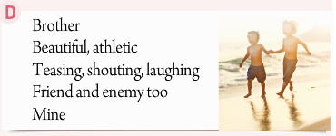
Line 1: a noun (name the subject of the poem)
Line 2: two adjectives (describe the subject)
Line 3: three -ing verbs (describe the subject's actions)
Line 4: four words (give the writer's opinions or feelings)
Line 5: a word (give another name for the subject)
E Haiku（17 syllables）
A fallen blossom
is coming back to the branch.
look, a butterfly!
F Tang Pems
Where she awaits her husband,
On and on the river flows
Never looking back,
Transformed into stone.
Day by day upon the mountain top,
wind and rain revolve.
Should the traveller return,
this stone would utter speech.
(by Wang Jian)
Step Three：Summary
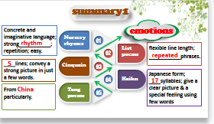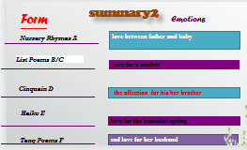
Step Four：Consolidation： Tell which form the following poems belong to?
Step Five：Imitation and creation
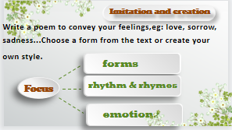
Step Six： Homework 学生创作诗歌，制作诗歌展。

