**借用“3C”策略写好读后续写3个衔接句**

**I. Learning Objectives**

**In this class, we are expected to**

1. observe excellent linking sentences to summarize “3C” strategies;

2. apply “3C” strategies to write linking sentences;

3. comment on partners’ linking sentences with a checklist.

**II. Learning Steps**

**Step 1 Observe the following linking sentences to summarize the common points.**

1. What do the circled words have in common?
2. What do the underlined parts have in common?
3. What do the parts in shadow have in common?

**2025年3月昆明市统测**

The mother elephant took a step forward, her eyes never leaving me. Feeling at a loss, I was frozen on the spot, with my hands still clutching the scissors. ********** Encouraged and relieved, I turned to the calf, moved the scissors swiftly and cut the wires cautiously until finally, with a soft cry, the calf was set free and limped to join the mother elephant.

Hours later, I watched the mother elephant and her calf from a distance through cameras. I saw them walk side by side and slowly disappear into the heart of the forest, with a sense of satisfaction and wonder welling up in my heart. **********

“3C”

**Step 2 Apply “3C” strategies to write the linking sentences.**

**2023年全国新高考(I&II卷)读后续写**

When I was in middle school, my social studies teacher asked me to enter a writing contest. I said no without thinking. I did not love writing. My family came from Brazil, so English was only my second language. Writing was so difficult and painful for me that my teacher had allowed me to present my paper on the sinking of the *Titanic* by acting out a play, where I played all the parts. No one laughed harder than he did.

So, why did he suddenly force me to do something at which I was sure to fail? His reply: “Because I love your stories. If you’re willing to apply yourself, I think you have a good shot at this.” Encouraged by his words, I agreed to give it a try.

I chose Paul Revere’s horse as my subject. Paul Revere was a silversmith (银匠) in Boston who rode a horse at night on April 18, 1775 to Lexington to warn people that British soldiers were coming. My story would come straight from the horse’s mouth. Not a brilliant idea, but funny; and unlikely to be anyone else’s choice.

What did the horse think, as he sped through the night? Did he get tired? Have doubts? Did he want to quit? I sympathized immediately. I got tired. I had doubts. I wanted to quit. But, like Revere’s horse, I kept going. I worked hard. I checked my spelling. I asked my older sister to correct my grammar. I checked out a half dozen books on Paul Revere from the library. I even read a few of them.

When I handed in the essay to my teacher, he read it, laughed out loud, and said, “Great. Now, write it again.” I wrote it again, and again and again. When I finally finished it, the thought of winning had given way to the enjoyment of writing. If I didn’t win, I wouldn’t care.

*A few weeks later, when I almost forgot the contest, there came the news.* ① ______________

_______________________________________________________________________________

_______________________________________________________________________________

********************②________________________________________________________________________________________________________________________________________

_______________________________________________________________________________

*I went to the teacher’s office after the award presentation.* ③__________________________

_______________________________________________________________________________

_______________________________________________________________________________

**Step 3 Comment on partners’ linking sentences with the checklist.**

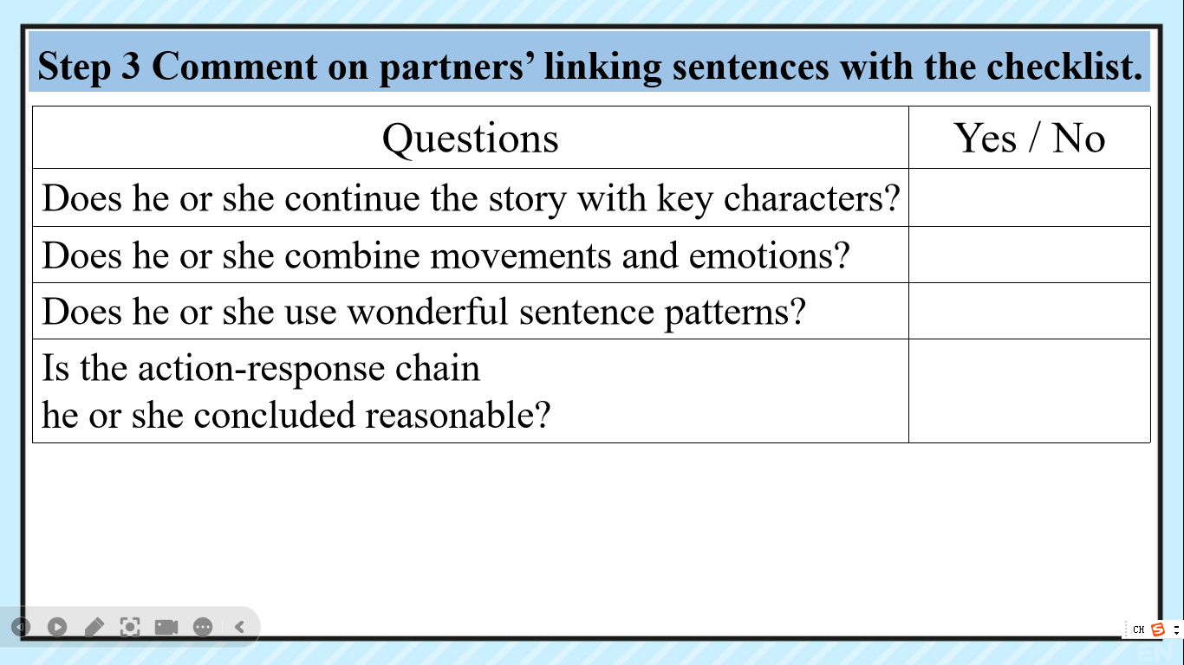

**III. After-class Assignment**

**1. Compulsory Task (必做)**

Read the story below and write the three linking sentences.

**2. Optional Task (选做)**

Think of more strategies to help us make linking sentences better.

**2021新课标I&II卷读后续写**

A MOTHER’S DAY SURPRISE The twins were filled with excitement as they thought of the surprise they were planning for Mother’s Day. How pleased and proud Mother would be when they brought her breakfast in bed. They planned to make French toast and chicken porridge. They had watched their mother in the kitchen. There was nothing to it. Jenna and Jeff knew exactly what to do.

The big day came at last. The alarm rang at 6 a.m. The pair went down the stairs quietly to the kitchen. They decided to boil the porridge first. They put some rice into a pot of water and left it to boil while they made the French toast. Jeff broke two eggs into a plate and added in some milk. Jenna found the bread and put two slices into the egg mixture. Next, Jeff turned on the second stove burner to heat up the frying pan. Everything was going smoothly until Jeff started frying the bread. The pan was too hot and the bread turned black within seconds. Jenna threw the burnt piece into the sink and put in the other slice of bread. This time, she turned down the fire so it cooked nicely.

Then Jeff noticed steam shooting out of the pot and the lid starting to shake. The next minute, the porridge boiled over and put out the fire. Jenna panicked. Thankfully, Jeff stayed calm and turned off the gas quickly. But the stove was a mess now. Jenna told Jeff to clean it up so they could continue to cook the rest of the porridge. But Jeff’s hand touched the hot burner and he gave a cry of pain. Jenna made him put his hand in cold water. Then she caught the smell of burning. Oh dear! The piece of bread in the pan had turned black as well.

As the twins looked around them in disappointment, their father appeared.① _____________

_______________________________________________________________________________

_______________________________________________________________________________

********************② _________________________________________________________

_______________________________________________________________________________

_______________________________________________________________________________

The twins carried the breakfast upstairs and woke their mother up. ③ ___________________

_______________________________________________________________________________

_______________________________________________________________________________