人教版Module 6 Unit 5 An Exciting Job教学设计
浙江省天台中学 汤杰礼（317200）

一、整体设计思路
本课是本单元的第二课时，学生在第一课时中已经了解并讨论火山、地震、飓风等强大的自然灾害对人类的危害，引导他们交流有关火山方面的知识，并让他们想出减少自然灾害带来损失的方法。在讨论中学生已经初步了解本单元的主题：尽管自然界有无穷的威力，但只要人类注意保护自然，就可以有效地预测灾害和减少灾害所带来的损失；同时学生已经基本掌握本单元主题的相关词汇。本课主要目的是让学生通过文本的阅读，了解火山学家的工作内容，性质以及重要意义。在文中，作者自述了一次近距离观察研究一座刚爆发过的火山的经历，让读者对火山学家的工作有了一个更直观的了解，最后作者还表达了自己对工作的高度热情—20年后，火山对他的吸引力依然不减。通过阅读，让学生感受、体会并掌握预测（predicting）、略读（skimming）、细读（scanning）、释义（paraphrasing）、归纳要点（summarizing）和排比（parallelism）、比喻（simile）、对比（contrast）等阅读和写作技巧，把握篇章结构和中心内容，获取关键信息；同时通过学习，学生可以从中感受到自然灾害的威力以及人与自然和谐相处的必要性，提高其关注自然界、保护大自然和预防自然灾害的意识，使他们认识到人类只有保护自然，了解自然，才能预测自然灾害，避开自然灾害、减少其带来的灾难，并适当地改造和利用自然，与其和谐共处。
首先，通过free-talk的互动让学生分享他们对自己将来职业的期许，并谈谈为什么。然后通过自身教书育人的经历引出课文的主题An Exciting Job.
其次，根据新课标对学生阅读技能的要求，引导学生围绕标题“An Exciting Job”，通过阅读去思考、寻求“What job is it? Why is it exciting?”的答案，培养学生掌握预测（predicting）、略读（skimming）、细读（scanning）、释义（paraphrasing）、归纳要点（summarizing）和排比（parallelism）、比喻（simile）、对比（contrast）等阅读和写作技巧，把握篇章结构和中心内容，获取关键信息，提升学生英语口头表达能力。
最后，将学生分成4人小组，让他们根据所学内容，思考并讨论作者为什么在描写自己工作时用“exciting”一词以及作者是否是一位合格的火山学家，运用恰当的形容词进行归纳并根据文本内容说出理由，以此来培养学生的推断、归纳和口语表达能力，提升学生的批判性思维能力。

二、教学目标
1．知识目标：通过学习使学生了解火山学家的工作内容、性质以及重要意义；掌握描写火山学家工作和观察火山爆发所需的词汇和句型表达，同时学会仿写某一具体工作（如：运用从笼统到细节，从远到近的写作手法）。
2．能力目标: 使学生通过阅读训练，提升预测（predicting）、略读（skimming）、找读（scanning）、释义（paraphrasing）、细读（close reading）、归纳要点（summarizing）和排比（parallelism）、比喻（simile）、对比（contrast）等阅读和写作技能。
3．情感目标：通过学习，使学生感受到自然灾害的威力以及人与自然和谐相处的必要性，提高其关注自然界、保护大自然和预防自然灾害的意识，使他们认识到人类只有保护自然，了解自然，才能预测自然灾害，避开自然灾害、减少其带来的灾难，并适当地改造和利用自然，与其和谐共处。
4．策略目标：通过设置小组学习任务，培养学生的推断、归纳和口语表达能力以及合作学习意识。

三、教学重难点
1.掌握描写火山学家工作和观察火山爆发所需的词汇和句型表达，同时学会仿写某一具体工作（如：运用从笼统到细节，从远到近的写作手法）。
2. 理解课文内容，让学生体会如何运用排比、比喻、对比、释义来猜测、印证阅读内容，并进行要点归纳，感受文本的结构。

四、教学过程
An Exciting Job
Pre-reading（导入话题与处理词汇） | Step1 Warming up and leading in  1. Have a free talk with the Ss with the question “What do you want to be in the future and why?” and ask them to share their ideas:  (…… a(n) doctor/teacher/policeman/artist/robot designer/……, because I ‘d like to …)  2. Provide the Ss with a short passage on my teaching job and ask the Ss to fill in the blanks with given words in proper forms:  evaluate potential appoint occasional actual excite enthusiastic about feel alive  Having graduated from Zhejiang Education College, I was ____________ as an English teacher in Tiantai High School. Sometimes preparing lessons, sometimes correcting students' homework, and sometimes ___________ students' performance in school, I am never bored. Although my job is ___________ time-consuming, I don't mind because teaching _________ me and makes me ___________. Most importantly, I inspire every student to develop their ____________ to the fullest. Today I am still as _________________ my job as the day I first started. ____________, teaching is part of my life.  (Keys: appointed; evaluating; occasionally; excites; feel alive; potential; enthusiastic about; Actually)  Conclusion: My teaching job is an exciting one.  3. Show a picture of a volcanologist, asking what the man in the picture is and how his job is. Is his job exciting?  (A volcanologist is a scientist who studies the activities of ________ and is an expert in the subject of ________. volcanoes, volcanology)
设计意图 | 通过free-talk的互动让学生分享他们对自己将来职业的期许，并谈谈为什么。然后通过自身教书育人的经历引出课文的主题An Exciting Job，同时强化文本的核心词汇。
While-reading（梳理文本，拓展内涵，培养阅读、写作微技能） | Step 2 Reading the title for prediction  Reading strategy: Make a prediction based on the title “AN EXCITING JOB” before reading.  What job is it?  Is it exciting? And why? (Write the reading title “An Exciting Job”on the Bb)  Step 3 Reading for the structure of the text. (Skimming)  1. Reading strategies : Read fast to prove their predictions and summarize the main idea for each paragraph.  Get the Ss to read the whole story fast to prove whether their guesses are right.  Ask the following questions to help the Ss to finish this reading task:  Qs : The key words can help us summarize the main idea. What key words can you find in each paragraph? What is each paragraph mainly about? How many parts can the text be divided into?  2. Give the Ss 3 minutes to summarize the main idea of each part with the help of the key words.  (Para. 1 the greatest job, my job; Para. 2 my job, our work; Para. 1 + 2 = Part 1 Description of my job. Para. 3 my first sight; Para. 4 my first experience; Para. 3 + 4 = Part 2 My first experience. Para. 5 enthusiastic about, be amazed at; Para. 5 = Part 3 my love for my job and volcanoes) (Write them on Bb.)  Step 4 Reading for detailed information. (Scanning)  T: Now let’s analyze the reading passage part by part. Let’s come to Part 1 first: Description of the job.  Part 1: Description of the job. (Para. 1-2)  Q1: Why does the author think his job is the greatest?  The greatest job: (idea)  - travel to unusual places (fact)  - work alongside people from all over the world (fact)  - am never bored (fact) (sometimes ... sometimes ... sometimes … and sometimes …) (the figure of speech: parallelism)  - occasionally dangerous, but danger excites me and make me feel alive. (fact)  - the most important ... protect ordinary people from the volcano (fact)  Conclusion: For one thing, he meets and works with people globally (global). For another, what he does helps to protect ordinary people from suffering great damage of volcano eruption.  In this step, get the Ss to know “the greatest job” is just the author’s idea, and details like “travel to unusual places” are all the facts. Besides, get the Ss to know the author used 4 “sometimes” to express his emotion “never bored”, employing the figure of speech, parallelism. Encourage the Ss to follow the example to make such a beautiful sentence. Actually, in the leading-in step, there is another example: Sometimes preparing lessons, sometimes correcting students’ homework, and sometimes evaluating students’ performance in school, I am never bored.  Q2: What is the author’s daily work? (Underline the key verbs) and why is a volcanologist’s job important?  - collect … for a database  - evaluate  An important job  - help … to predict  - warn … to leave  In this step, get the Ss to know where Mount Kilauea lies as well.  Q3: What method did the author employ while writing his job?  The writing method of the job description is from general to detail.  Part 2: The first experience. (Para. 3-4)  1. Para. 3 The first sight  Q1: Why is the lava that flows down Mount Kilauea more dangerous than the actual eruption?  Boiling rock erupts (erupt) from a volcano and crashes (crash) back to earth, so it causes less (little) damage than you might imagine. This is because no one lives near the top of Mount Kilauea, where the rocks fall. The lava flowing (flow) slowly like a wave down the mountain causes far more damage because it buries everything in its path under the molten rock.  In the step, get the Ss to know the author used simile, employing “like” here.  Q2. The flowing lava causes great damage, while the auther wrote “However, the eruption itself is really exciting to watch and I shall never forget my first sight of one.”. Why?  The author used the figure of speech – “contrast/comparison” here to describe the fantastic sight of the volcano eruption and highlight his exciting job.  Q3 : How did the author describe the volcano eruption?  The volcano eruption was fantastic because of the detailed description of sense, including sound, sight.  2. Para. 4 The first experience  Q1: What should the author and other volcanologists do after it erupted?  put on special protective suits – made their way to the edge – looked down into the center – climbed down to collect some lava (other volcanologists) / stayed at the top and watched (the author)  Q2: What can we infer from the sentence “This being my first experience, I stayed at the top and watched them. ”?  From the sentence, we can learn that the author was cautious, cooperative but inexperienced.  Q3: What method did the author apply while writing his first experience?  The writing method of the author’s first experience (Part 2) is from far to near.  Part 3: Love for the job and volcanoes (Para. 5)  Q1: Why is the author still enthusiastic about his job?  - He is amazed/impressed by the beauty of eruption as well as its potential to cause great destruction.  - He can evaluate the collected information to predict the potential volcanic eruption to warn and save people.  Conclusion: The job still excites him.  Q2: What is the relationship between the first and the last paragraph?  They echo each other.
设计意图 | 1. 通过对文章标题的解读，让学生带着猜测去阅读，获取相关的基本信息并带着各自的期待去理解文章。  2. 通过略读(skimming)、细读(scanning)，让学生弄清基本信息，抓住文章中心，把握文本的框架结构，理清作者为什么用“An Exciting Job”作为标题，激发学生从文本细读中整合信息，发现上下文的写作逻辑和技巧，并基于找到的细节信息去思考提炼写作意图，同时关注句子在文中承上启下的作用和修辞：排比、比喻和对比等写作技巧。  3. 通过细读和释义，让学生养成基于细节信息去思考提炼文本所反映的深层次的含义，同时学会归纳要点的阅读技巧，提升归纳总结能力。
Post-reading（提升和发展学生思维） | Step 5 : Further understanding  Get the Ss to discuss in pairs:  Q1: Why does the author use “exciting” to describe his job as a volcanologist? Give your reasons.  - He can witness/see the fantastic sight of volcanic eruption. (The fantastic sight of volcanic eruption excites him.)  - The occasional danger of his job excites him and makes him feel alive.  - He can help protect ordinary people from the harm of volcanoes.(The importance of his work excites him.)  Q2: Do you think whether the author is a qualified volcanologist or not? (answer with evidence from the text)  - adventurous (Although my job is occasionally dangerous, I don't mind because danger excites me.);  - sympathetic (However, the most important thing about my job is that I help protect ordinary people from one of the most powerful forces on earth--the volcano);  - professional (collect and evaluate information; quick-reacted after the eruption and proper dressed in the research on the spot; have studied for many years);  - cautious/cooperative (This being my first experience, I stayed at the top and watched them);  - enthusiastic (Today, I am just as enthusiastic about my job as the day I first started).
设计意图 | 1. 通过文本解读，让学生进行讨论，思考作者为什么在描写自己作为一名火山学家时用力“exciting”一词以及作者是否是一位合格的火山学家，并说出理由，以此来培养和提升学生的批判性思维能力。  2. 给学生搭建一个展示平台，引导学生根据本课堂所学的内容，结合自己的认识和思考，学会从文本中寻找依据来归纳火山学家的品质，并且感受到Enjoy our jobs, enjoy our life的真谛。

五、板书设计
Blackboard design
“An Exciting Job”
What job?
Why?
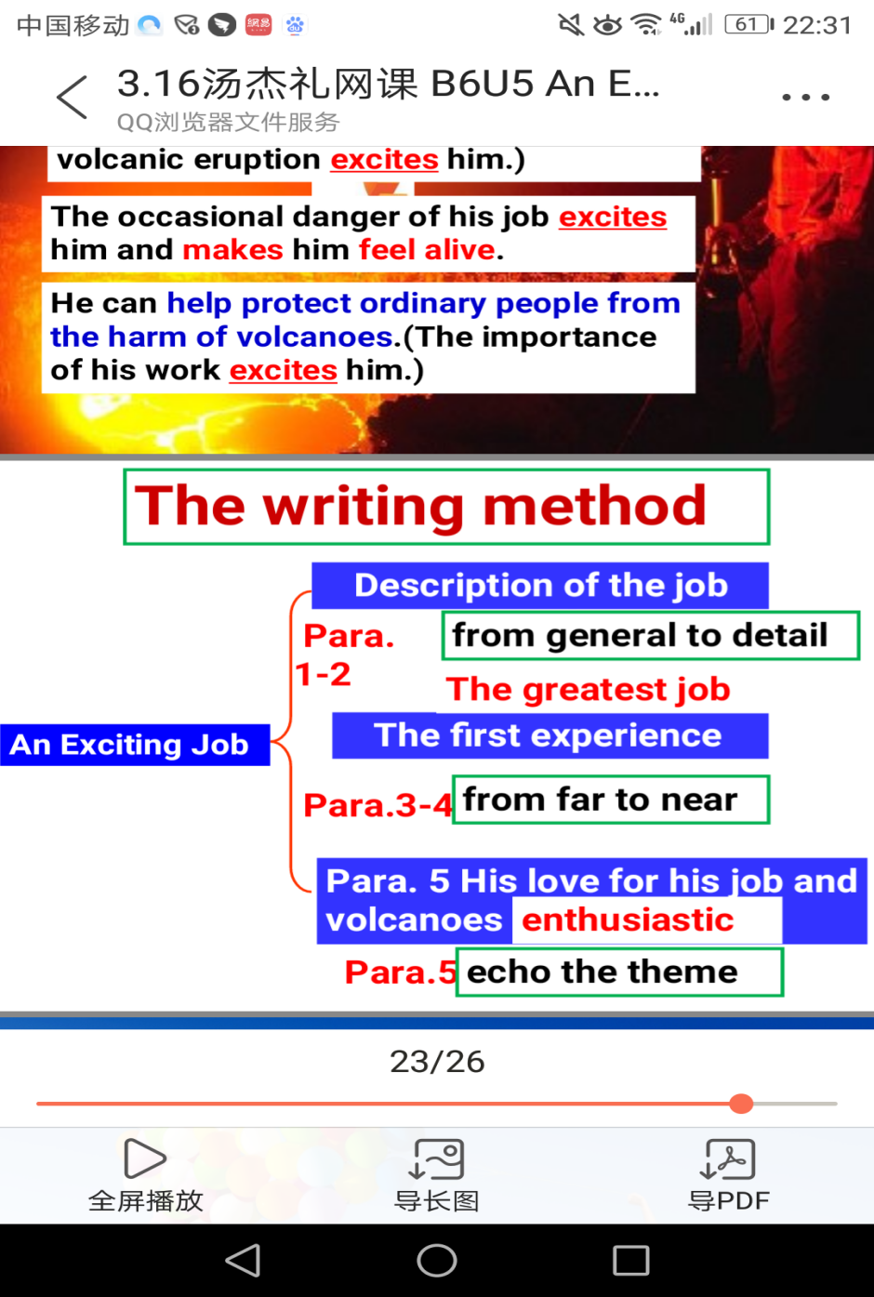

六、教学反思
①紧扣以读促写的教学目标，在教学中运用预测（predicting）略读（skimming）、细读（scanning）、释义（paraphrasing）、归纳要点（summarizing）和对比（comparing）等阅读策略，提高学生对篇章的阅读理解力，培养了他们快速获取信息的能力，也提升了学生文本的鉴赏能力和运用排比（parallelism）、比喻（simile）、对比（contrast）等写作技能。
②利用自己教书育人的工作经历引出文章主题“An Exciting Job”，学生会比较熟悉，容易使他们融入语境，引起他们的共鸣，同时也解决了文章中的一些主题词汇。
③运用各段落的关键词归纳段落大意，理清文章的框架结构，提升学生对文章主题的归纳能力和对文章谋篇布局的把握能力。
④阅读教学中的任务型问题设计既有考查学生阅读理解能力的浅层次问题，也有让学生发挥的深层次问题，体现由浅入深的层次性教学，同时也有助于培养学生的语言运用能力。
⑤在读后教学环节设计了体现批判性思维的深层次理解题“作者是否是一位合格的火山学家”，要求学生运用恰当的形容词进行归纳并根据文本内容说出理由，以此来培养和提升学生的批判性思维能力。
⑥多媒体教学的运用。教学过程中多媒体的有效运用不仅丰富了教学手段，改进了教学方法，同时还体现了创新教育中有效辅助的优势，如：采用CAI 辅助教学视听效果好，可增强教学的直观性，从而调动学生学习英语的积极性，提高学生创新思维的意识和能力。
但由于是疫情期间网课，师生互动没有像平时课堂的常态课那样面广与热烈。

