Cope with the compositions related to different activities

►targeted reading and structure building

1. Read and think

Read the requirements in the passage and make sure which aspects should be considered while students write a composition in a limited time. Fill the blanks in two dimensions---outline and details as follows:

|  |  |  |  |
| --- | --- | --- | --- |
| 审题 |  | 细节 |  |
| 文体类型 |  | 时态 |  |
| 目标受众 |  | 语气 |  |
| 语言风格 |  | 人称 |  |
| 篇章结构 |  | 项目 |  |
| 内容要点 |  | 意义 |  |

1. Activate the words and expressions for different writing styles.

Make use of the writing resource to outline the beginning and the ending of the composition on the spot. Students are encouraged to review the main steps of composing a complete article and put the detailed words expressions and sentence patterns in use.

|  |
| --- |
| Begin with a casual greeting |
| Acknowledge your friend |
| Tell your friend why you are writing (purpose) |
| Plan the main point of the letter |
| Bring your letter to a close |
| Sign off |

1. Design the main body.

Inspire the students to quicken their thinking process with the key items----development of a paragraph, a multidimensional introduction of activities, some concrete description of significance, several appropriate cohesive words or phrases and many applicable sentence patterns.

|  |  |
| --- | --- |
| 段落布局 |  |
| 内容多维 |  |
| 意义具体 |  |
| 衔接合理 |  |
| 功能句式 |  |

The main difficulty is focused on displaying some exactly suitable activities. Students will widen their way of designing different activities for different type. Activities can be planned in various types, such as knowledge learning activities, hands-on learning activities and creative thinking activities. What should be paid attention to is that corresponding purpose or significance needs to be written concise and practical, not so general.

1. check a sample composition together

►Analyze and form a fixed format

Choose some sentences which are easy and universal to use, ensuring most students can take advantage of them.

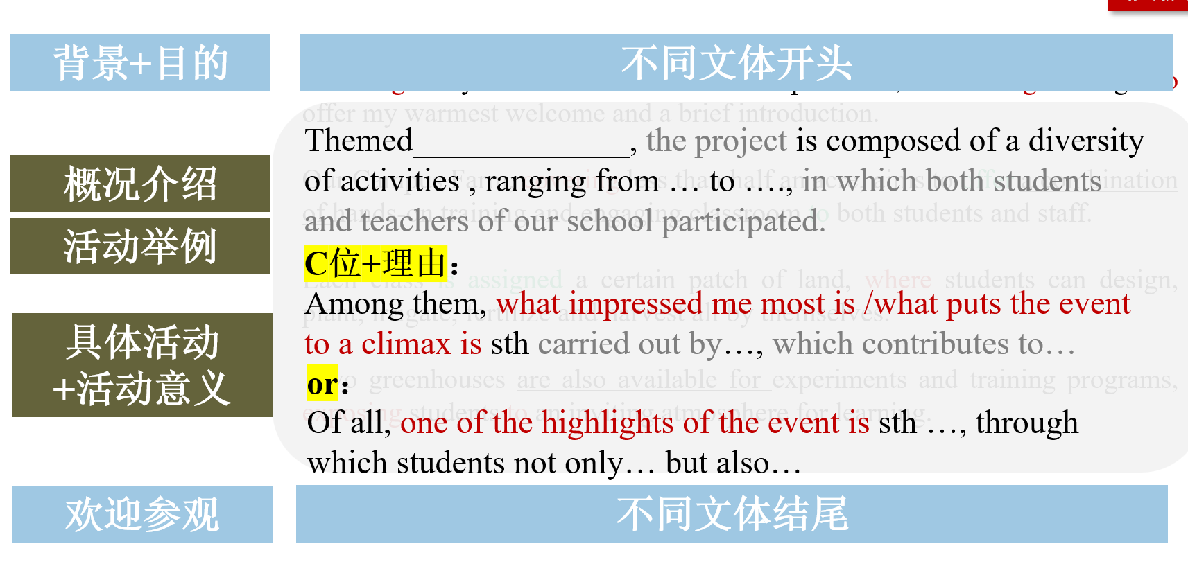

►Practice the pattern and recommend a website for experiencing different school activities and learning the authentic usage of words.