**2024年1月浙江第一次高考（首考）应用文评析与教学设计**

**【理论支撑】**

夏超萍、阮烨卿（2022）认为，在应用文写作审题中，带入特定的角色（命题者、作者、读者和阅卷者）进行应用文写作，分析要点信息、进行整合和输出，能使学生审题时才能充分地把握材料的表层信息、深层信息，乃至隐含信息。

基于此原则导引，可围绕四个维度进行审题分析。

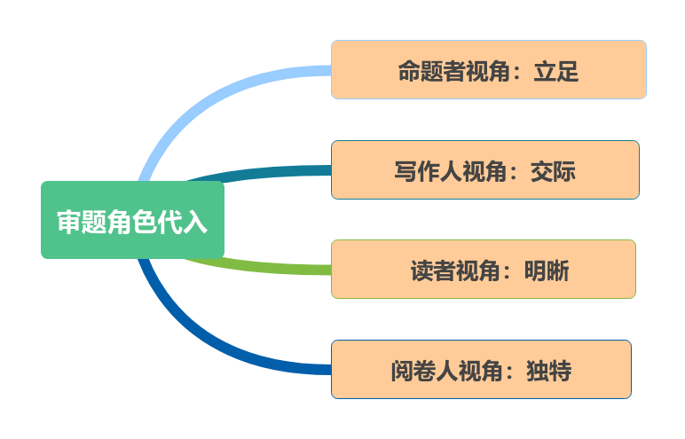

从命题者角度看，这则活动通知要求学生参加主题为“携手行动，节约粮食”的作文比赛。主要核心包含两大要点：

活动目的——在介绍活动目的时，可以借鉴新闻报道的客观陈述风格，以清晰明了的语言表达比赛的宗旨和意义。强调粮食节约的重要性，可能会包括保护环境、减少浪费、关注“三农”等方面。参赛要求——在说明参赛要求时，可以采用更为正式的语言，类似于书信的语气，明确指出参赛资格条件、作文主题限定范围、字数要求、提交截止日期等。此部分需要准确传达比赛规则，使学生明确了解要求的概况。

总体而言，这则活动通知要在介绍活动目的时，保持客观、清晰、有深度；而在说明参赛要求时，以更正式的语气明确传达比赛的规则，使得文章交际性增强。这种融合了不同风格的应用文命题旨在考查学生的写作逻辑和语言表达能力。

**【教学目标】**

**Writing this article requires the ability to convey information clearly and concisely in a notice format. The teaching objectives include:**

**1. Clarity and Conciseness:** Express the purpose and competition requirements in a clear and concise manner, adhering to the specified word limit of around 80 words.

**2. Format Adherence:** Follow the given format of a welcome message for an English Writing Competition, including the title, greeting, purpose introduction, and competition requirements.

**3. Language Proficiency:** Demonstrate proficiency in English language usage, including appropriate vocabulary, grammar, and sentence structure.

**4. Creativity and Engagement:** Infuse creativity in presenting the information to engage the readers and encourage their participation in the competition.

**5. Effective Communication:** Convey the essential details effectively to ensure that the readers understand the purpose of the competition and the requirements for participation.

**6. Attention to Detail:** Pay attention to details such as the specified word count, format, and any additional instructions provided.

In summary, the ability to write this article involves a combination of language proficiency, adherence to format, creativity, and effective communication skills to convey the information clearly and engage the target audience.

**【参考教学分解】**

**1. Introduction to Notice Writing:**

- Provide an overview of the characteristics and format of notice writing.

- Highlight key elements such as title, greeting, purpose, and requirements.

**2. Understanding the Theme:**

- Discuss the theme of the competition, "Join Hands, Save Food," and its significance.

- Encourage students to brainstorm ideas related to food conservation.

**3. Analysis of Sample Notice:**

- Share a well-crafted sample notice (the one we discussed earlier) and analyze its structure and language use.

- Point out how the purpose and requirements are clearly communicated.

**4. Vocabulary and Language Use:**

- Discuss relevant vocabulary and phrases suitable for a notice, emphasizing clarity and formality.

- Provide examples of appropriate language for introducing the purpose and requirements.

**5. Guided Writing Practice:**

- Conduct a guided writing session where students collectively draft a notice on a different topic or theme.

- Offer feedback and corrections, focusing on language accuracy and adherence to the notice format.

**6. Independent Writing Exercise:**

- Assign students the task of writing their own notice for the English Writing Competition.

- Encourage creativity while ensuring they follow the format and meet the word count requirement.

**7. Peer Review and Feedback:**

- Facilitate a peer review session where students exchange and provide feedback on each other's notices.

- Emphasize constructive criticism and the importance of clarity in communication.

**8. Revision and Finalization:**

- Allow students to revise their notices based on peer feedback and further guidance.

- Discuss any common challenges or questions that arise during the writing process.

**9. Presentation and Discussion:**

- Have students present their final notices to the class, promoting discussion and sharing of ideas.

- Discuss the effectiveness of different approaches and language choices.

**10. Reflection and Self-Evaluation:**

- Ask students to reflect on their writing process and identify areas of improvement.

- Provide individual feedback on their overall performance in notice writing.