OCB2U4-Reading and Thinking Seeing the True North via Rail: Vancouver and the Heart of Canada

# Task 1 Read for Travel Experience

Read paragraph 3-6, draw a mind map about their travel experience. Your map should include the following information. (G1-3: para. 3-4; G4-6: para. 5-6)

* What they **saw/did/learnt** • How they **felt**

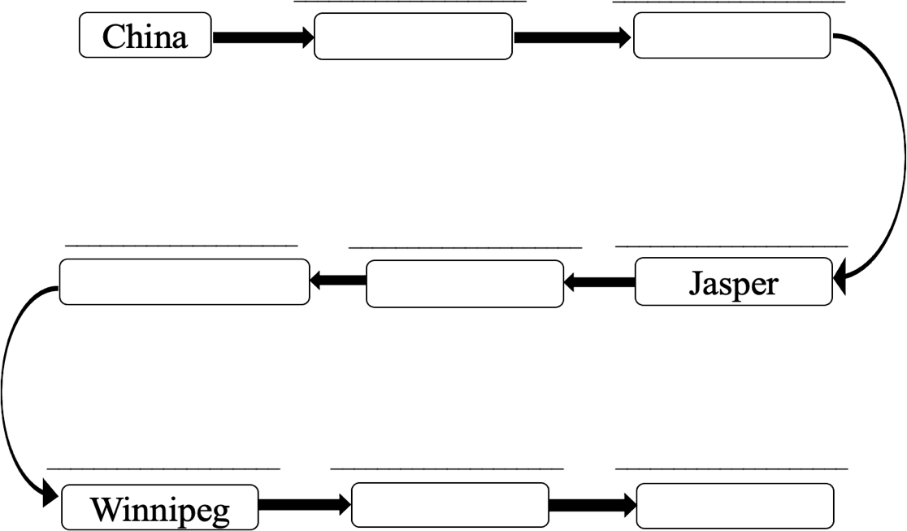

# Task 2 Discuss in groups

Based on what Li and Liu saw and learnt, what do you think they have gained from the journey?

|  |  |
| --- | --- |
| What they saw/did/learnt | What they gained |
|  |  |

# Assignment

Write down your travel experience of a long journey, including the following information:

* + the places you visited
  + what you saw/did/learnt
  + how you felt
  + what you have gained

The rail journey across the vast land really makes a difference to me.