**Teaching objectives:**

After this class, students will be able to:

1. Get the basic information and comb the plot of the given passage.
2. Cope with the difficulties about content and theme
3. Apply what they’ve learnt to solving difficulties in their own life

**Read the article again before class**

1.Andy's finger traced the lines on a blank United States map, each state represented by a number. He whispered to himself, “New Jersey is eating Pennsylvania, and Ohio is a chicken nugget(鸡块).” Beside him lay another paper with numbers 1-50 written down. Despite 20 minutes of intense concentration, all Andy had to show for his efforts were those numbers.

2.“Ok, and Utah is the washing machine. No, Montana is the washing machine. Or North Dakota? Gah! They're all washing machines!” Andy was caught in his confusion.

3.This wasn't the first time his memory had failed him during a test. No matter how hard he studied, nothing seemed to stay in his brain for long. He had tried memory tricks, even spending nights examining an old paper map in his bedroom. It had given him a glimmer of hope, but now that hope felt distant.

4.The time was up, and Mr. Crane began collecting the answer sheets. Andy quickly stuffed his blank test into the pile, wanting to forget about it. Unfortunately, his brain seemed to remember only the things it should forget. During lunch, Andy stared at a map, frustrated that he had handed in a blank sheet of paper.

5.Andy's friend Aaron shrugged, “You only need a 70 to pass.”

6.“Yeah, well it’s hard to get a 70 when you hand in a blank sheet of paper,” Andy mumbled, frowning.

7.Aaron popped a grape into his mouth. “Well, Mr. Crane will let you retake (补

考)it tomorrow.

8.Andy was the only one standing at Mr. Crane’s desk after school. He apologized quickly, head drooping. But instead of scolding him, Mr. Crane patted his shoulder, saying, “I think you are trying, but you might learn better by being active. Just practice more!”

9.Andy looked into Mr. Crane‘s eyes, finding comfort in the teacher’s understanding gaze. Mr. Crane invited Andy to help him organize a pile of magnets (磁铁), each with the name of a state on it. On the wall hung a large magnetic map - part of a review game the class had been playing.

*Para.1 :As Andy arranged the magnets, an idea suddenly came into his minds.*

*Para.2 : When doing homework, Andy was told he scored an 88 on the retake.*

1. 主题：人与自我、人与社会
2. 文本解读

**Teaching process:**

Activity 1: Read for basic information

* *Who are the main characters?*
* *Where did the story happen?*
* *When did the story happen?*

|  |  |  |  |
| --- | --- | --- | --- |
| Time line | What did Andy do | What’s the result | What caused the result |
| Before the test |  |  |  |
| During the test |  |  |  |
| During the test |  |  |  |

Activity 2: Read for plot

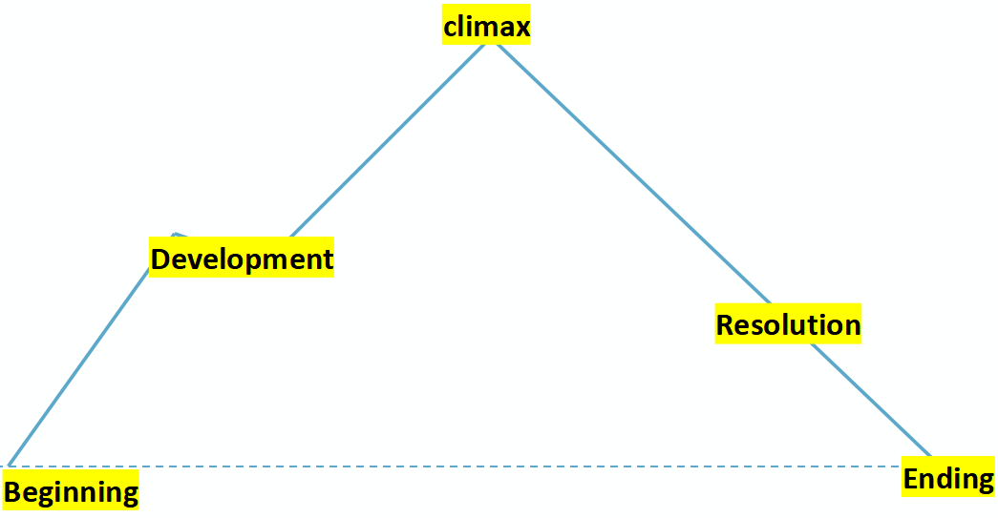

Activity 3:Weave the plot

* *Ask logical questions based on the given sentences of Para.1 & Para.2*

*Para.1 :As Andy arranged the magnets, an idea suddenly came into his minds.*

*What was the idea?*

*What did Andy do?*

*What was Mr. Crane’s reaction?*

*Para 2: When doing homework, Andy was told he scored an 88 on the retake.*

*How did Andy feel?*

*What did Andy do then?*

*What was Andy’s reflection?*

Activity 4:Thinking & Discussion

* *Think and discuss to answer the questions raised before.*
* *Learn from the peers(appreciate some samples)*
* *What’s the theme? (Try possible endings)*

Activity 4:Reflection

* *What do you get out of this short story?*

Activity 5:Assignment

* *Read the article below and finish writing Para.1(只写第一段)*

1.I knew I would have a beyond-busy summer. I would be a junior teacher for the Little Dragons Karate (空手道) Camp. And I had to do summer swim team. And Ollie and I already had two customers for our dog-walking business.

2.“You might be biting off more than you can chew,” my mom said with a warning glimpse when I talked to her about it and announced, “I want to do everything!”

3.“Don’t worry.” I grinned. “I have strong teeth!”

4.My mom smiled back. “In this case, it’s your organizational skills, not your teeth, that need to be strong.” I didn’t take it to my heart.

5.And the first week really was no problem. My friend Ollie was out of town and karate camp hadn’t started, so my swim stuff was all I needed to worry about. The next week was great too. I swam, and a Little Dragon at karate camp told me I was his favorite teacher ever!

6.I did learn, though, that staying organized with two activities was harder. My backpack was already stuffed with a towel and swim things, so I needed another for my karate clothing. Riding my bike from karate camp to the pool with two backpacks was a challenge. But I still had it under control until Ollie got back.

7.“We’re late getting our business together!” he said. “We’ll have to spend every spare minute preparing.”

8.“But I don’t have any spare minutes!” I said.

9.“Did you forget we agreed to walk Alfie every Saturday? And Muffin on Tuesdays at 4:00?” Ollie asked. I couldn’t let Ollie down, so I took out a third backpack and filled it with dog toys, treats, and plastic bags. I thought I was all set.

10.But I was wrong! It didn’t take long for my dog-walking stuff and karate stuff and swim stuff to get all mixed up, forgotten, or lost. One day, I forgot my karate backpack and had to borrow Emma’s extra outfit, which was too tight. The next day, I remembered my karate stuff but forgot my swimsuit, so I had to help out in the snack shop and stay out of the pool all afternoon. And another time, when I reached into my dog-walking pack for plastic bags, all I could find were swim goggles(护目镜) and sunscreen.

*Paragraph 1: Worse still, I had to keep track of all the special times.*

*Paragraph 2: Luckily, I, with my parents, came up with a solution to get organized.*