人教版新教材高中英语Unit 2 Book 1 学案

1. castle [ˈkɑ:sl] n._________,__________

破拆法：cast(抛掷)+le(了) 助记：抛掷了的武器都被________挡了下来。

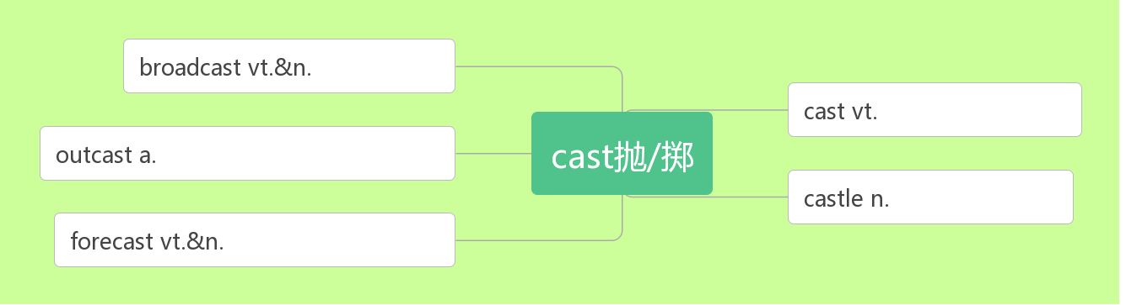

1. apply [əˈplaɪ] vi.___________vt. _________,__________

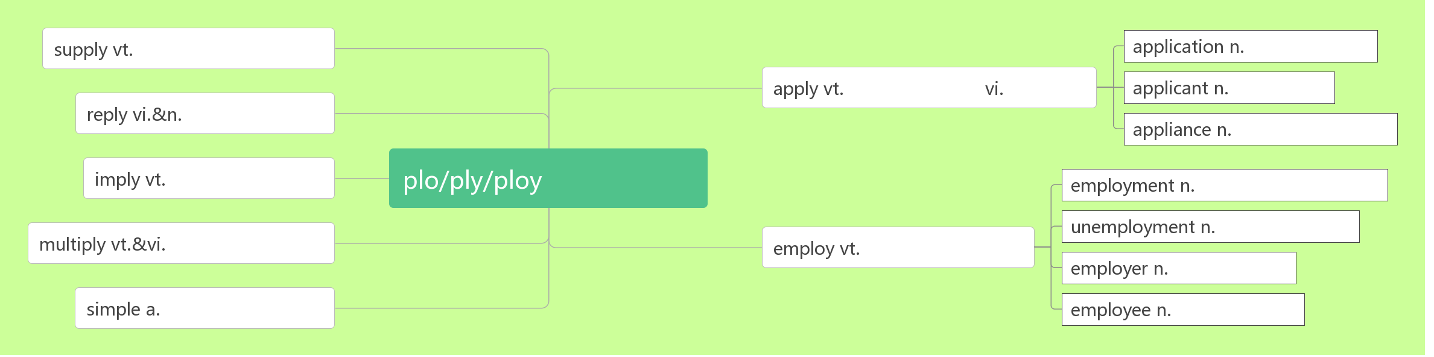

apply ____ sb._______ sth. 向某人申请...

apply sth ____ sth 把某物应用于/涂抹在...上

application [æplɪˈkeɪʃn]n.__________;__________;__________

applicant [ˈæplɪkənt]n.____________;_____________

1. visa [ˈvi:zə] n________

词根词缀：vis(看)+a(去)：去给别人看的东西——__________

1. rent [ rent] vt__________;__________vi._________n._________
2. pack [pæk]vi. & vt._______________vt._________ n._________________,__________

pack some _____________ 打包一些衣服

______________________ 将(东西)装箱打包

_______________ 一包；一盒；一群；一堆

1. amazing [əˈme ɪzɪŋ ] adj.__________;__________ (现在分词表示_______内涵，意为“______________”)

amazed [əˈme ɪzd ] adj.__________;___________(过去分词表示________内涵，意为 “________________”)

amaze [ əˈme ɪz ]vt. ____________;__________

____________________________对……感到惊叹

1. arrangement [əˈreɪndʒmənt]n._________;__________

词根词缀：ar(去)+range(排列)+ment(名词后缀):去排列好——_________

____________ [əˈre ɪnd ʒ ]vt.安排; 筹备

arrange _________ 安排; 安顿

1. extremely [ ɪkˈstri:mli ] adv.__________

词根词缀：ex(强调)+trem(发抖)+e+ly(副词后缀): 极端到令人发抖的——__________

extreme [ɪkˈstri:m]adj.___________;____________

1. source[sɔ:s]n._________,__________,_________

拆破法：s(水)+our(我们的)+ce(测) 助记：要测出我们的河水的源头。

1. narrow [ˈnærəʊ]adj.狭窄的vi.& vt._____________

拆破法：na(那)+r(让)+row(一排) 助记：路太窄了，那就让大家排成一排。

1. flat [ flæ t ]adj. __________;__________ n._________;_________

拆破法：fl(fly)+at(在) 助记：飞机要在平坦的地方起飞

1. powerful [ˈpaʊəfl ]adj. ___________;__________;__________

power[pa ʊə]n._________;__________;__________;_________;__________

come to/into power____________

nuclear/wind/solar power ________/ _________/ __________

power _______/____________ 断电/ 停电

1. empire[ˈempa ɪə(r)]n._________

emperor[ˈempərə(r)]n.__________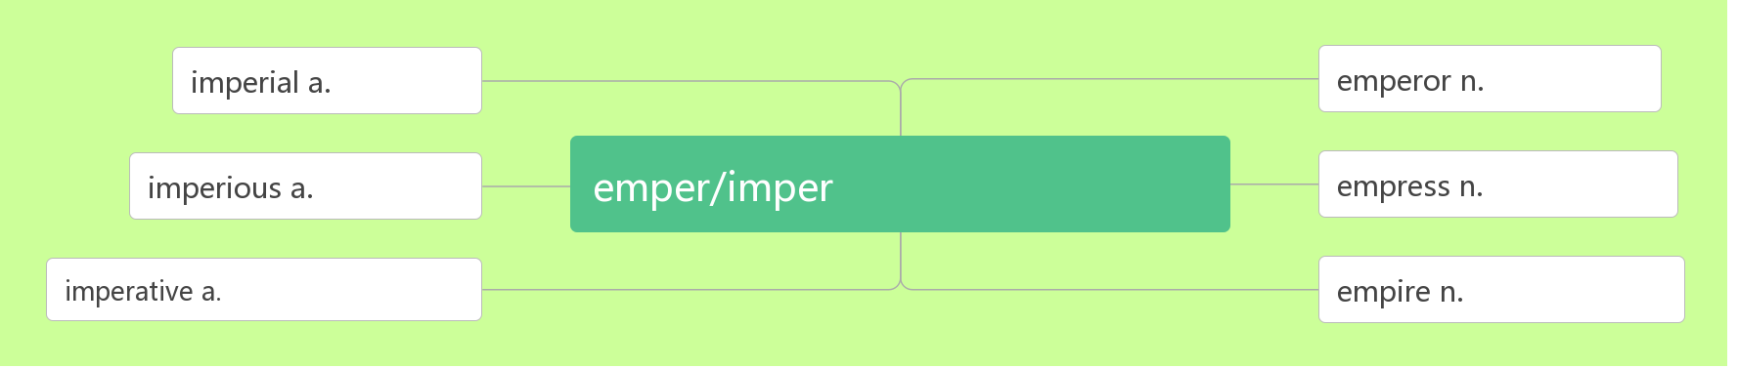

1. site [saɪt ]n.________,_________;_________

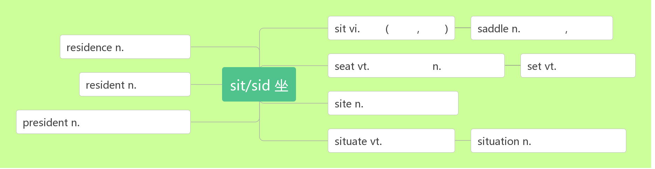

1. control [kən'trəʊl]vt. ________,________,________n. ________,________,________,_____________

词根词缀：contr(相反)+rol(滚轮)：从反方向使滚轮停下来——_________

take control of ___________;____________;

1. official [ə'fɪʃl] adj. ________;_________;__________ n. _____________

____________ adv. 官方地；正式地

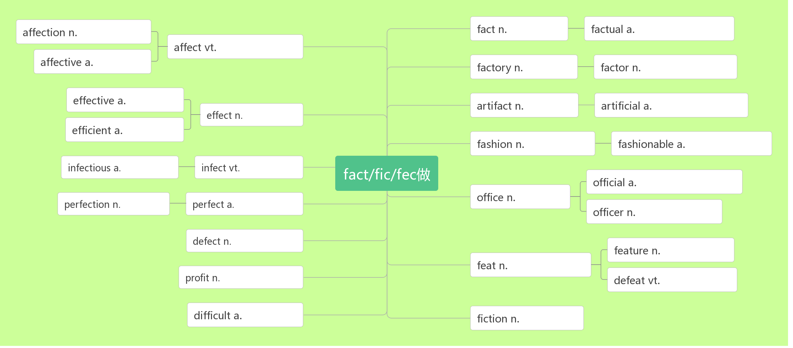

1. recognise[ ˈrekəgnaɪz] vt.___________,_________,_________ (*NAmE*-ize) 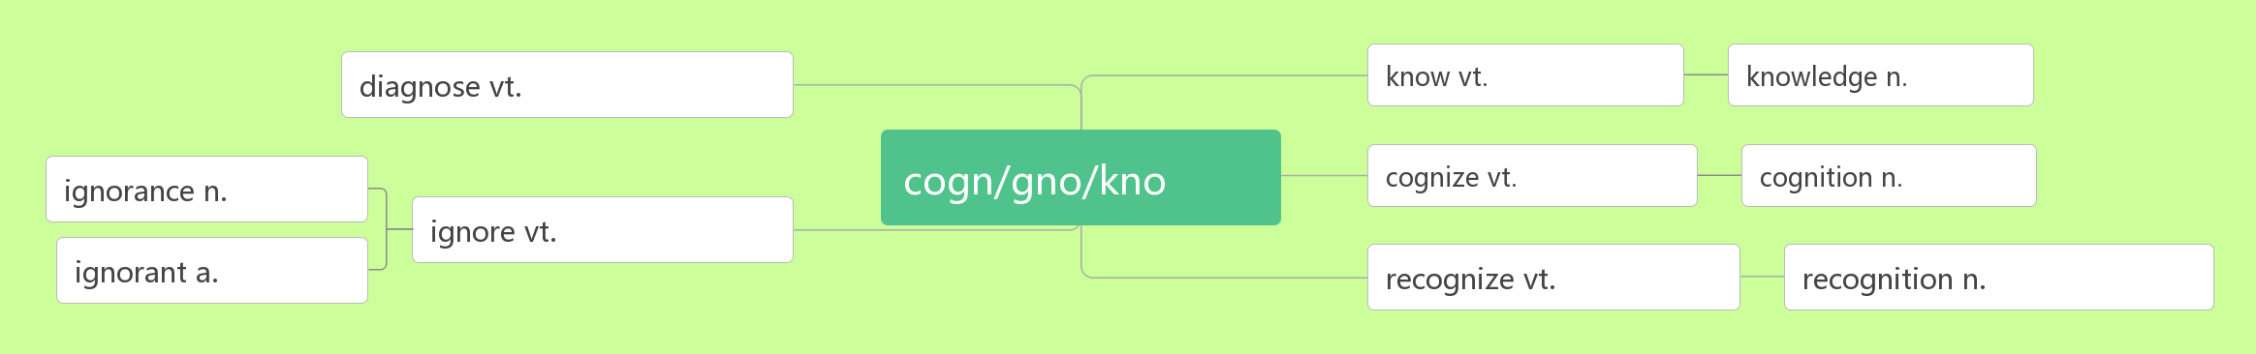

recognise …________/________ 把……当做；承认…… 为

recognition[rekəgˈnɪʃn] n. ________;__________;__________

1. type [taɪp]n._________;__________ vi. & vt._________
2. flight [flaɪt]n. ________;_________;_________
3. accommodation[əˌkɒməˈdeɪʃn] n._________,__________;___________

词根词缀：ac(去)+com(共同)+mod(模式)+ation(名词后缀)：去用共同的模式招待——_________

1. unique [juˈni:k]adj. _________,__________,___________

unique _____ sb /sp. 是某人/ 某地特有的

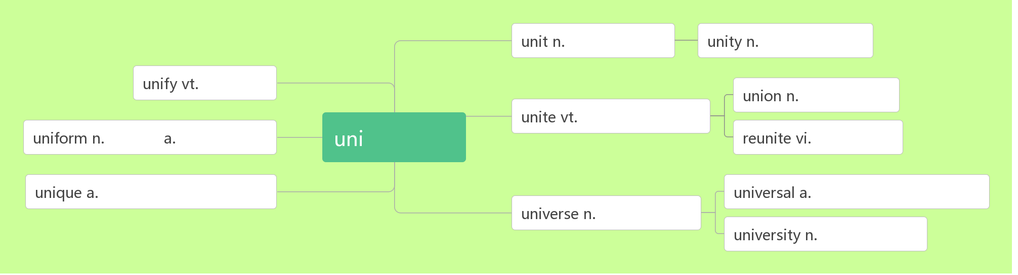

1. path [pɑ:θ ] n.________,__________,_________
2. destination[destɪˈne ɪʃn] n.____________:_________

词根词缀：de(下)+stin(站=stand)+ation(名词后缀):下一个要站的地方——____________

1. other than _____________
2. admire [ədˈmaɪə(r)]vt. __________,__________;_________

音意互通：我的妈呀 助记：我的妈呀，你做的事太令人钦佩了。

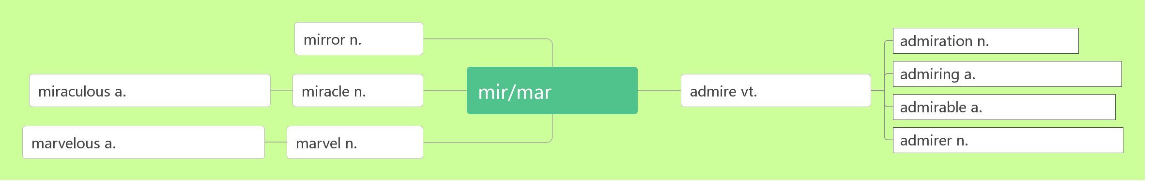

admire sb __________________ sth. 因(做)某事而钦佩/ 羡慕某人

admiring [əd'ma ɪərɪŋ] adj.__________;___________

admirable[ ˈædmərəbl] adj._____________;_____________

admiration / ˌædməˈreɪʃ n] _________;__________;__________

to watch/gaze_______ admiration 赞赏地观看/凝视着

1. architect [ˈɑ:kɪtekt ] n__________,______________

词根词缀：archi(大师)+tect(铸造，织造)：建筑的大师——____________

architecture [ˈɑ:kɪtekt ʃə(r) ]n. ___________,__________

1. brochure [ˈbrəʊʃə(r)] n. ____________

音意相通：布鲁塞尔 助记：在布鲁塞尔旅游，你需要一本旅行手册。

____________________ 旅游手册

1. package[ˈpækɪdʒ]n. ________;___________ vt._____________

词根词缀：pack(包装)+age(名词后缀)：_________

____________________ 包价旅游

_________________ 一包/ 盒/ 袋

1. contact [ˈkɒntæ kt ]vt._________,__________n._________,__________

词根词缀：con(一起)+tact(接触)：接触到一起——__________。

1. transport [ˈtræ nspɔ:t]n.__________;_________vt. [trænˈspɔ :t]_________;__________

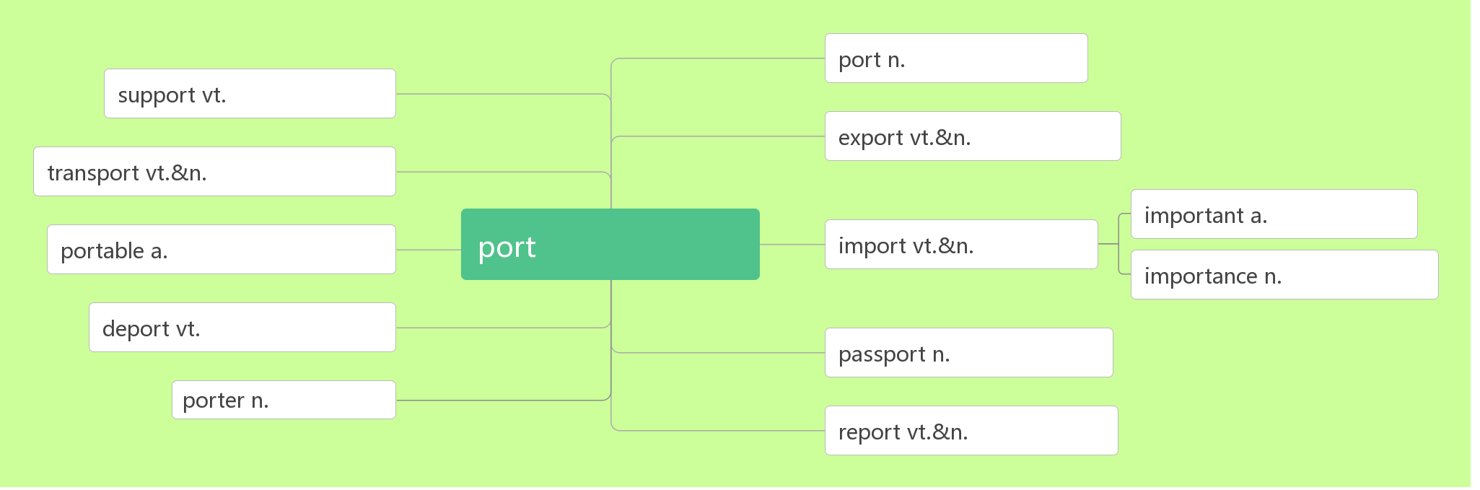

________/_____________________ 空运/ 路运

_______________________ 公共交通；公交车辆

1. hike [haɪk ]vi.___________vt._____________n._________,______________

__________________ 去远足；去徒步旅行

___________ [ˈhaɪkə(r) ] n.远足者；徒步旅行者

1. make up_______,________,________,_________,_________

__________________ 由……组成/ 构成

1. soldier /ˈsəʊldʒə (r)/ n.________,_________

破拆法：sold(sold)+i(我)+er(人) 助记：士兵就是把自己卖给国家的人

1. economy[ ɪˈkɒnəmi] n._________;____________

词根词缀：eco(家)+nom(管理)+y(名词后缀)：对家的管理——_________

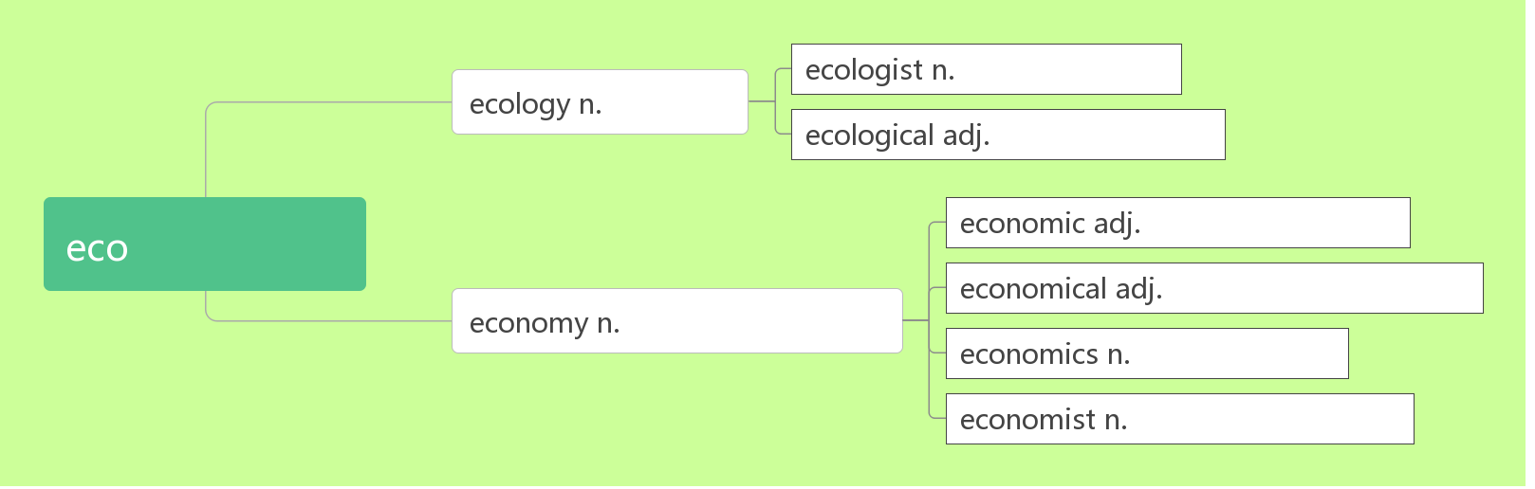

economy class _______________

a market economy ______________

1. credit [ˈkredɪt] n.________,_________,__________,___________

词根词缀：cred(相信)+it(去)：去信任——_________

助记：有了_______才能________上学，要获得老师的________就要拿到_________。

__________________ 值得赞扬

_______________ 信用卡

___________________. 用信用卡支付

1. detail [ˈdi:te ɪl ] n.________,_________,____________ vt._________

破拆法：de(得)+tail(尾巴)：得到秋毫之末——__________

____________l 详细地

1. check in (在旅馆、机场等) __________

check out _____________（旅馆等）

1. request[r ɪ'kwest]n.&vt.(正式或礼貌的)_________;__________

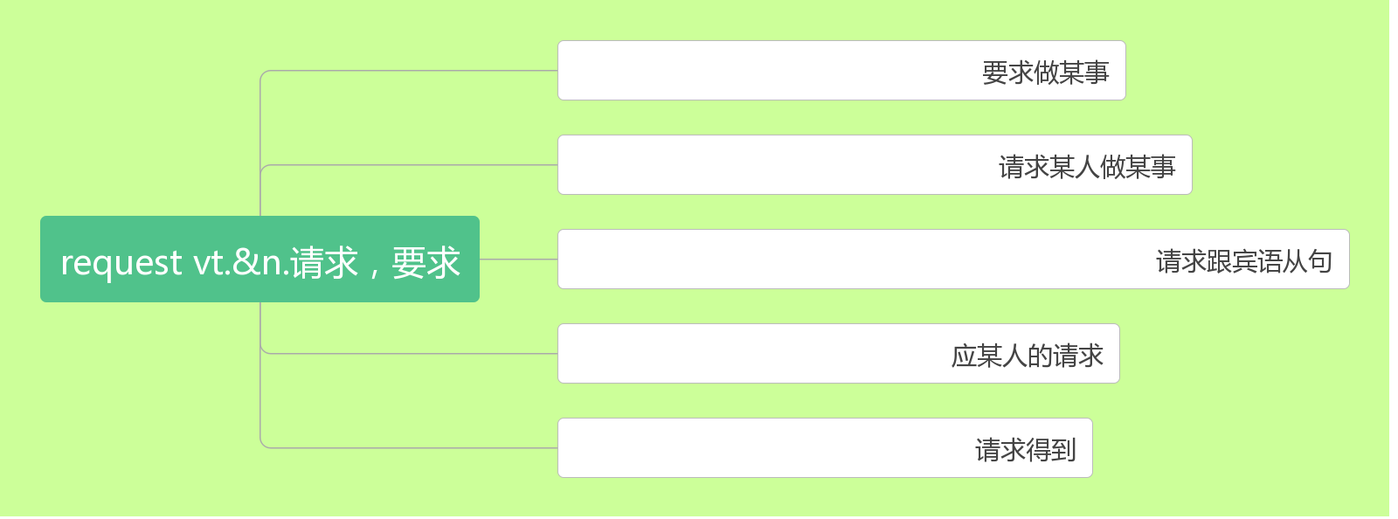

1. view [vju:]n.________;_________;_________ vt.______;__________

___________________在某人看来

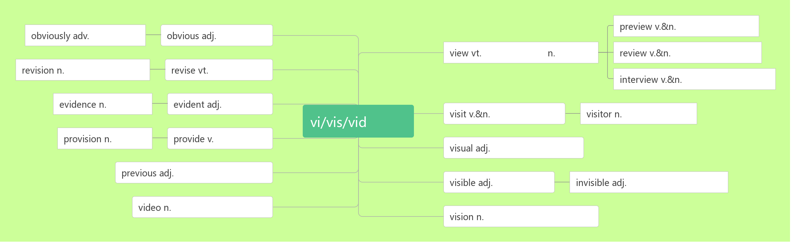

1. sight /saɪt/ n. ________;_________;__________
2. statue[ ˈstæ tʃu:] n._________,__________

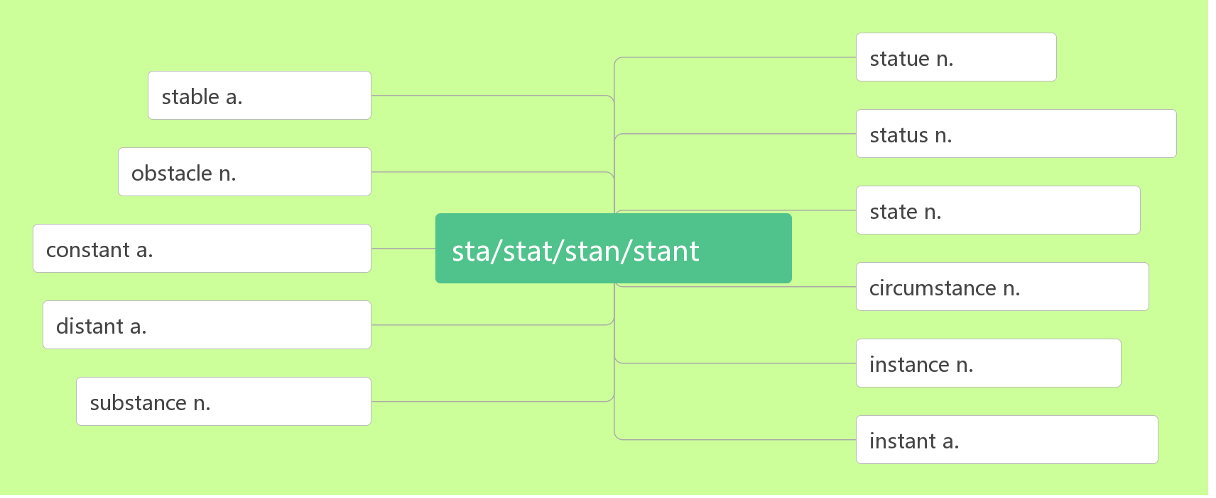

1. tomb [tu:m ] n.________

音意相通：土墓 助记：平原地区的坟墓基本上都是土墓。

1. unearth [ʌnˈɜ:θ] vt._________,_________

词根词缀：un(不)+earth(土壤)：不留在土壤中——_________。

1. comment / ˈkɒ ment /n._________,_________vi.& vt. ______________;_________

词根词缀：com(一起)+ment(mind)：把想法拿到一起——__________

____________________无可奉告

______________/__________________/_______________ 表达意见；作出评论