WORK SHEET for *The First Hunting*

**Results of the survey:**

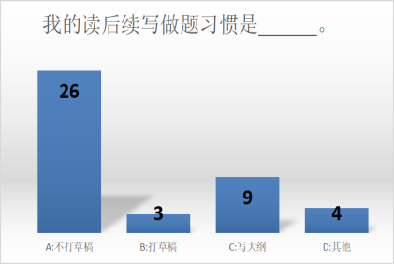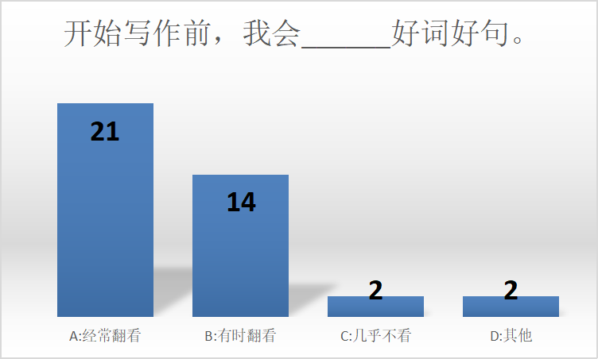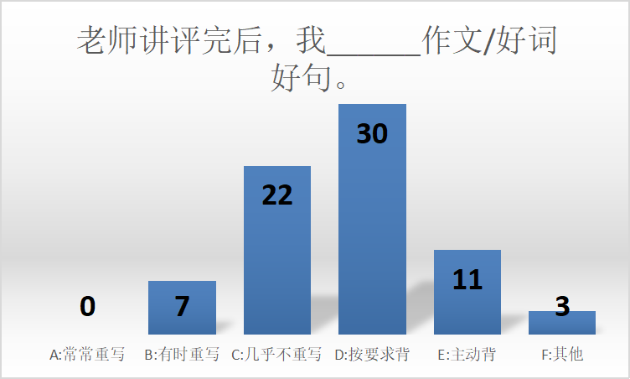

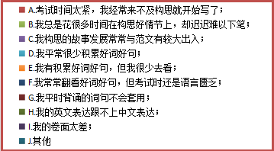

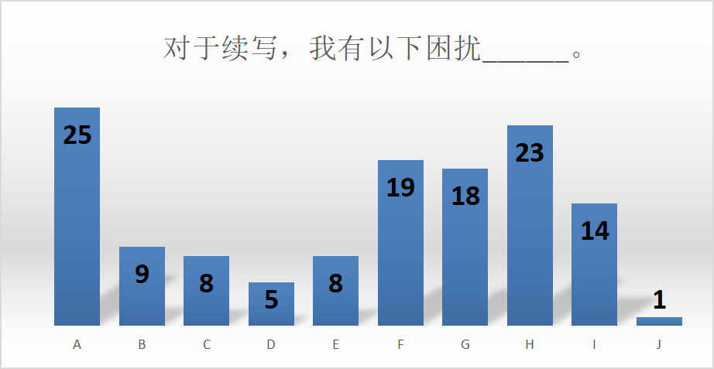

Let’s try to solve these disturbing problems!

**Activity 1: Get logical and reasonable plots**

1. Skim for main idea:

Time:____________________________ Place:____________________________

Characters:_______________________ Event:____________________________

2. Read to raise questions:

*Para.2 To Jeremy’s surprise, his father was handing the camera to him.*

____________________________________________________________________________

____________________________________________________________________________

____________________________________________________________________________

____________________________________________________________________________

____________________________________________________________________________

Para.1 *His father asked in a controlled voice, “Why didn’t you shoot?”*

____________________________________________________________________________

____________________________________________________________________________

____________________________________________________________________________

____________________________________________________________________________

____________________________________________________________________________

**Activity 2: Pursue a better continuation writing**

1. Compare different versions of similar idea

* 结尾（主题升华）

Version 1: Jeremy and his father enjoyed the last red light from the sun and the peace of natural rather than hunting other animals.

Version 2: The sun highly rose in the sky, melting the ice and breaking the boundary between father and son.

Version 3: Though their task is hunting, but they brought nothing but get peace with the nature.

Version 4: For the later time, Jeremy never went hunting and he became a great photographer.

**Your comment: __________________________________________________________________**

**______________________________________________________________________________________________________________________________________________________________**

2. Get some well-written sentences from the original text:

____________________________________________________________________________

____________________________________________________________________________

____________________________________________________________________________

____________________________________________________________________________

____________________________________________________________________________

____________________________________________________________________________

____________________________________________________________________________

____________________________________________________________________________

3. Group work: Rewrite it and make it a better one!

Students’ version 1:

*His father asked in a controlled voice, “Why didn't you shoot?”* Jeremy kept silent, standing and shivering. “You know dear. If you want to be a remarkable duck hunter, this experience should be indispensable and significant to you!” Blamed by his father, Jeremy would not complain for he didn't want to argue with his father. But tears broke out of his lids and he shrieked, “I hated the duck hunting all the time, why I came there was just desire your approval! What I really cherished was camera but not gun!” After draining out these words, he returned to be silent, sobbing in low. At the extraordinary time, his father whizzed passed him.

Your revised version:

___________________________________________________________________________

___________________________________________________________________________

___________________________________________________________________________

___________________________________________________________________________

___________________________________________________________________________

___________________________________________________________________________

___________________________________________________________________________

___________________________________________________________________________

Students’ version 2:

*To Jeremy's surprise, his father was handing the camera to him.* “Sorry, my son. I don’t know that you hate to shoot ducks, I shouldn’t demand you to do that." His father said mildly. “Now, do things which you like, We can take some photos and record this trip." Jeremy was touched and hurled himself toward his father. Everything paled into insignifican in comparison with father's love. Now, Jeremy was the happiest son in the world.

Your revised version:

___________________________________________________________________________

___________________________________________________________________________

___________________________________________________________________________

___________________________________________________________________________

___________________________________________________________________________

___________________________________________________________________________

___________________________________________________________________________

___________________________________________________________________________

**Some good sentences from peers**

1). Jeremy面对父亲质问时

* With heart thumping wildly and sweat oozing constantly from his forehead despite the freezing cold weather, Jeremy stammered, “...”
* A ripple of fear mingled with regret surging through him, sweat oozing from his forehead, Jeremy stuttered, “...”
* Mind going blank and head drooping, Jeremy shuffled his feet awkwardly, remaining in silence. After a while, he mumbled, “...”
* Thump! Thump! Thump! Jeremy’s heart palpitated violently. How could he answer it? His mind was in a daze.
* Jeremy kept silent for a few minutes with his head down, grasping the gun tightly. Suddenly, he raised his head, and murmured, “...”

2). Jeremy坦言对狩猎的厌恶/对摄影的喜爱时

* “I...I just didn’t have the guts and cruelty to shoot. They were so, so cute and innocent.” Head drooping, he wasn’t dare to look into his father’s eyes.
* Hard as he tried, everytime he made up his mind to shoot, conscience would sting him sharply. “I just can’t make it!” Jeremy blurted, almost on the verge of collapse.
* “I hate the gun! What I really want is shooting with my camera.” Suddenly, a deathly hush descended over the father and son.
* “Because I don’t want to kill creatures for fun!” Tears obscuring/blurring his vision, he realized he’d made a big mistake.

3). Jeremy看到父亲递相机时

* Widening his eyes, Jeremy stared at the camera incredibly.
* Jeremy felt a flutter in his stomach, and then he took the camera.
* The nagging anxiety gaving way to a tidal wave of joy, Jeremy’s face blossomed into clusters of flowers, with pleasure dancing around every corner of his face.

4).父亲递过相机后

* Wordlessly, his father patted him on the shoulder, signaling him to crouch down and wait.
* “You are right,” he patted Jeremy on the shoulder and sighed, “But you have to admit that’s the law of nature, without which humans would never be able to survive. Anyway, I respect your choice.”
* “Am I not brave enough, dad?” “Of course not. You are brave for your determination to pursue your dream, and you are brave for your resolution to stay true to yourself. There are many ways to be brave in life.” Father reassured him, and then locked him in a tight embrace.

5). 环境描写（含主题升华）

* Silence engulfed the two and the awkward atmosphere tortured Jeremy.
* The sun craned its neck from the clusters of clouds, as if it were smiling at Jeremy. Not until that moment did he realize that only the kindness would win him respect.
* The crystal-clear bay mirrored the azure sky above, both of them shimmering and glistening. That special morning witnessed Jeremy and his father going back home with not a duck but their understanding and love for each other.
* The mild wind embracing both Jeremy and the ducks, the tranquil scenery was embedded in his memory, forever. He firmly believed that the charm of nature lay in harmony rather than violence.