24届高三9+1期中考英语读后续写
……使我爱上阅读的猫
杭州二中树兰高级中学 郭合英
Teaching goals：
After learning this lesson, the students will learn:
- The interpretation of the story.
- To combine Chekhov's Gun with the given sentences to create a story.
- To aid the students to accumulate relevant languages.
- To Analyze students’ composition.
Teaching focus：
1. What is Chekhov’s Gun?
2. How to combine Chekhov's Gun with the given sentences to create a story that fits well with the
original text.
- To aid the students to accumulate relevant languages.
Teaching difficulties：
1.How to combine Chekhov's Gun with the given sentences to create a story that fits well with the
original text.
2. To accumulate relevant languages.
Teaching process：

Step 1. 续写文本解读
9+1联盟高三期中考试读后续写
“This Saturday, we'll be visiting cats at the animal shelter. If you'd like to join us, here's an application form", said Ms. Delgado, the school librarian who had held the reading engagement event for students.
Ben loved cats and he had always wanted one, so he hurried to take an application form. Then Ms. Delgado added, “We'll be reading to the cats and award readers who make most progress.” Ben stopped. Reading aloud can be a challenging task. Ben might feel his heart racing, his palms sweating, and his voice shaking as he read. He might stumble over words or lose his place in the text. He might feel like everyone was watching him and judging him. Still, he really wanted to visit the cats, so he took an application form anyway.
On Saturday, Ben arrived at the shelter with some of his classmates. “This is Max,” the shelter worker told Ben as she handed him a gray cat. Ben carried Max to a beanbag chair and sat down. Max settled onto his lap. He took a book he'd been working on and started reading. Max, very different from other cats walking around the room while the kids read, purred （发出呼噜声）on his lap as if he had understood what Ben read.
“I'm glad Max is staying and listening to my reading and he is the best cat ever,” Ben told Dad excitedly.“I'm glad you two are friends,” Dad said. All week, Ben's heart was filled with anxiety as he waited for Saturday to arrive. He was eager to read to Max and the anticipation of spending time with his feline（猫咪的）friend made him restless and nervous. When it arrived, Ben got to read to Max again.
“What if someone adopts Max?” Ben asked Dad later. “I guess you'd read to a different cat,” Dad said.“But I don't want a different cat. I wish we could adopt Max,” Ben said to Dad. He knew they couldn't because Mom had allergies(过敏). Ben loved the cat so much that he even told his next-door neighbor, Mrs. Patel, about Max. “Max sounds like a special cat,”said Mrs. Patel.
注意：
1.续写词数应为150左右；
2.请按如下格式在答题卡的相应位置作答。
Para1:
Week by week, Ben realized that reading seemed easier with Max’s company.

Para2:
But on Saturday, Ben couldn’t find Max at the shelter.

- 完成语法填空，了解大意
The school librarian told Ben he could visit cats for the reading engagement event held for students at the animal shelter this Saturday on condition that he had to fill in 1 application form and read to the cats. Hearing this, Ben hesitated. He loved cats a great deal, 2 , it was a big challenge to read, 3 made him very nervous because he was afraid to read in public. Still, he 4 (real) wanted to visit the cats, so he took an application form anyway.
On Saturday, Ben arrived at the shelter with some of his 5 (classmate). The shelter worker handed Ben a gray cat named Max. Ben carried Max to a beanbag chair, 6 (start) reading. Max purred on his lap as if he 7 (understand) what Ben read while Ben read. Ben lost his heart 8 the cat.
On returning home, he begged his father 9 (adopt) the cat. But his father kept him 10 (inform) that they couldn't because Mom had allergies. Ben even told his next-door neighbor, Mrs. Patel, about Max. Ben made much progress in reading with Max’s company , But one Saturday, Ben couldn’t find Max at the shelter……

- 基本要素分析
who
when
where
what
why
how

- 情感分析
文章原句 | 暗含的情感
Ben loved cats and he had always wanted one, so he hurried to take an application form.
We'll be reading to the cats and award readers who make most progress.said Ms. Delgado.
Still, he really wanted to visit the cats, so he took an application form anyway.
“I'm glad Max is staying and listening to my reading and he is the best cat ever,” Ben told Dad excitedly.
Ben's heart was filled with anxiety as he waited for Saturday to arrive. He was eager to read to Max …
“What if someone adopts Max?” Ben asked Dad later.
I wish we could adopt Max. But he knew they couldn't because Mom had allergies.
But on Saturday, Ben couldn’t find Max at the shelter.

Step2：续写情节推理
- 利用契诃夫法则，找出读后续写隐含的矛盾冲突。
- 利用契诃夫法则，提高续文与原文故事情节发展的契合度。
- 利用契科夫法则，做到续文与原文的语言协同。
所用法则 | 需解决  的问题 | 原文句子 | 暗示情节发展
契科夫法则 | 矛盾冲突 | - Reading aloud can be a challenging task. | 矛盾1： 最初阅读一种挑战。（解决方法：在猫的陪伴下，最后阅读会变成小菜一碟。）
 |  | - He knew they couldn't because Mom  had allergies(过敏). | 矛盾2：妈妈过敏无法养猫。  （解决方法：邻居收养。）
 | 情节发展 | Ms. Delgado added, “We'll be reading to the cats and award readers who make most progress.” | 情节发展1：在猫的陪伴下，Ben能够静下心来读书，最后阅读提升获得奖项。
 |  | “But I don't want a different cat. I wish we could adopt Max,” Ben said to Dad. | 情节发展2：Ben非常想收养这只猫，可是妈妈过敏无法收养，但是他告诉了邻居Mrs. Patel，她可以收养这只猫，这样Ben就可以天天看到这只猫了，如果不是这样的结果，那么这句话就不应该在原文中出现。
 |  | Ben loved the cat so much that he even told his next-door neighbor, Mrs. Patel, about Max.
 | 语言协同 | 学生可根据自己的情节做到语言协同

Step3：续写语言积累
- 每当Ben给Max读书时，他总是坐在Ben的腿上打着呼噜好像他已经听懂了Ben所读的
一切，这使Ben能够静下心来去读他想读的一切。

- 随着时间的流逝，Ben逐渐战胜了自己。阅读对他来说不再是一种挑战，而是小菜一碟。

- 他完全陶醉在阅读之中，品味着书香，没有了阅读时的心跳加快，掌心出汗和声音颤抖。也许是猫静谧的的陪伴让他有了仿佛在世外桃源的感觉，他放飞了思绪。阅读丰富了他的世界，也丰富了他和猫的故事。

- 他被颁发了最佳阅读奖，这使他异常开心仿佛在空中飘一样。他迫不及待地想要和他最爱的猫分享这个好消息。

- 尽管搜遍了每一个角落，仍然未能捕捉到Max的一丝影子，Ben认为一定已经有人收养了他的猫朋友，这让他非常沮丧，眼噙泪水，他的心陷入了悲伤的海洋。

What was the theme?
温馨画面定格
当Ben急急忙忙跑到邻居家时，一看到那只猫，Ben就紧紧地抱住他就像一位母亲看到远行归来的游子。小灰猫睁开钻石般的眼睛盯了Ben一会儿，然后扑向Ben的怀里，伸出他那毛绒绒的爪子趴在Ben的肩头一动不动。此刻，阳光沐浴着他们，Ben的心里暖暖的，从心底感激着邻居为他所做的一切。

人生感悟篇
正是在那个时刻，Ben突然明白了：人和动物之间有真正的精神寄托。在猫的陪伴下，Ben 能够静下心来，安逸地享受阅读，犹如蜜蜂在花园里辛勤地采蜜，Ben的阅读能力快速提升。猫也享受着陪伴Ben的温馨时刻，“喵喵”地在Ben面前撒着娇。

虚拟语气结尾
没有这只猫，Ben 浮躁的心就无法安静下来; 没有这只猫，阅读可能依然是Ben的拦路虎。此刻Bem明白了：人和动物之间是有真挚情感的，就如同Max和他一样。

Step4：Analyze the students’ works.
融洽度不高的学生作品分析
Students’ composition 1
Students’ composition | My opinions
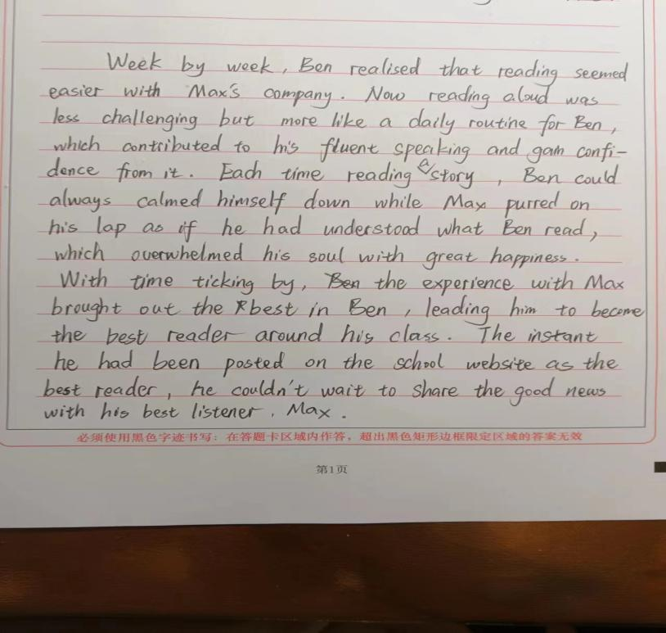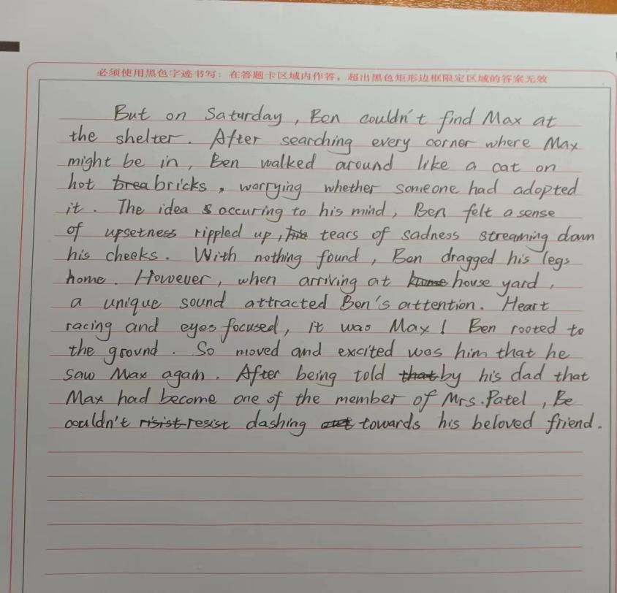 | 融洽度不高的地方：
 | 融洽度高的地方：
Students’ composition2
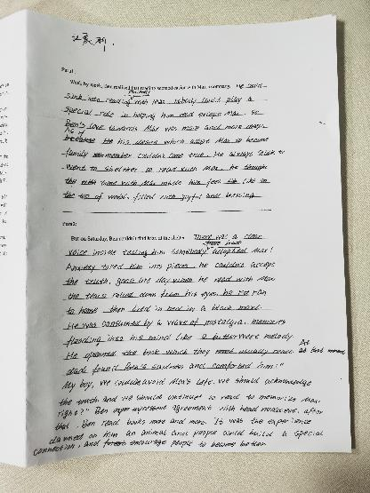 | 融洽度不高的地方：
 | 融洽度高的地方：

Students’ composition 3
Students’ composition | My opinions
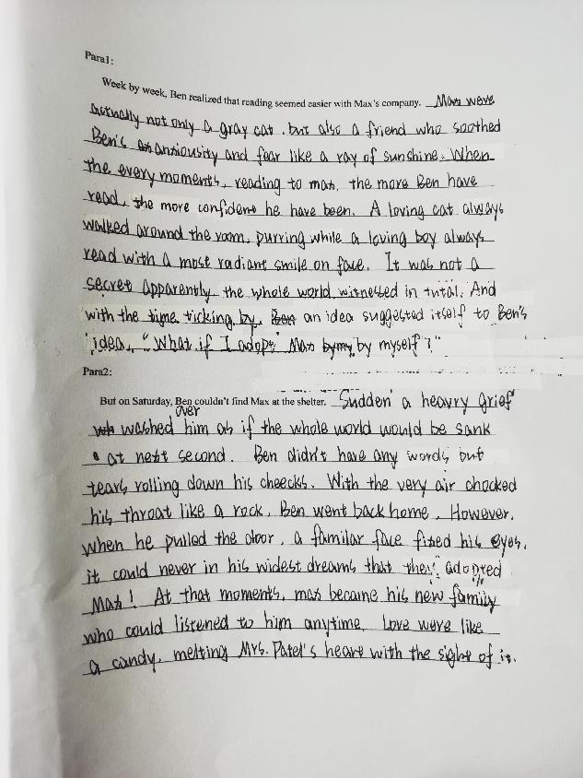 | 融洽度不高的地方：
 | 融洽度高的地方：

融洽度较高的作品分析
Students’ composition 1
Students’ composition | My opinions
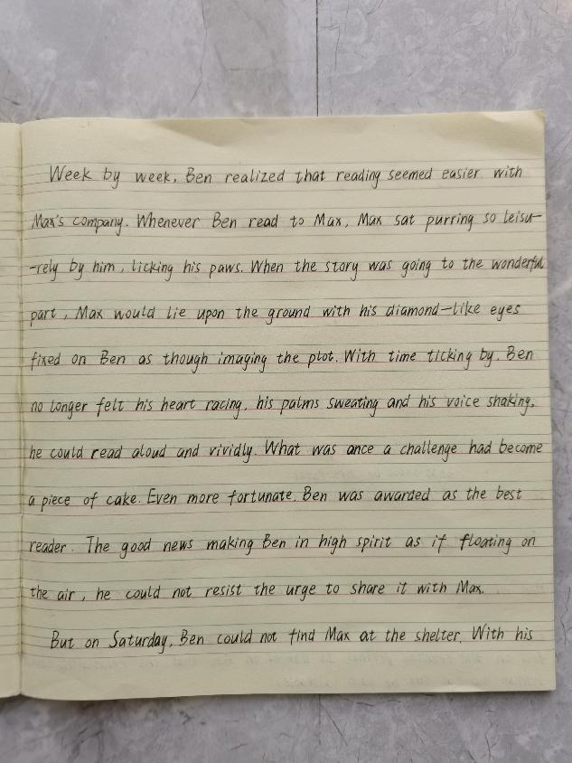  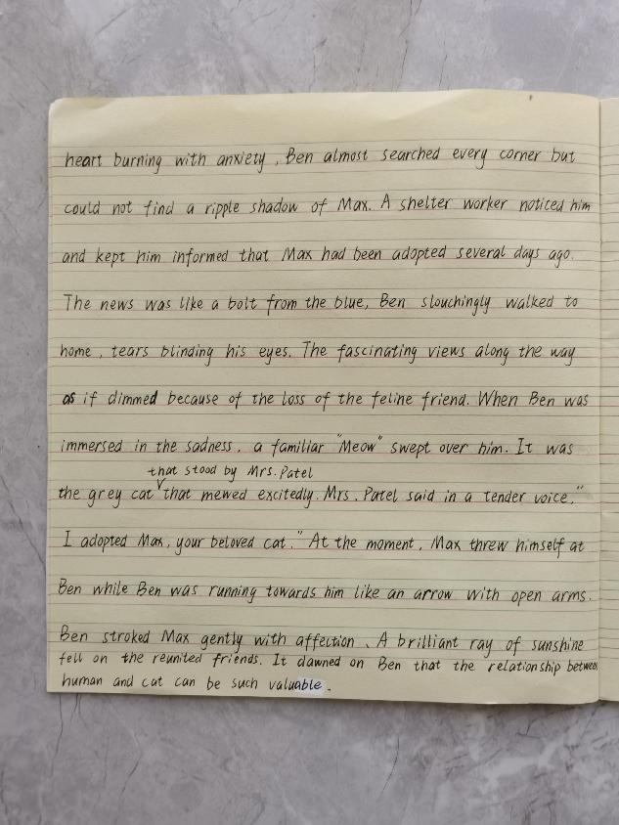 | 融洽度不高的地方：
 | 融洽度高的地方：
原创作品
Week by week, Ben realized that reading seemed easier with Max’s company. Each time Ben read, Max always settled onto his lap, purring, which made Ben be sedate to read. It was the quiet company of the cat that made him feel as if he were in a paradise, letting his thoughts fly. Ben savored the book without his heart racing, his palms sweating, and his voice shaking. Never in his wildest dreams was he presented the best readers , which made him in high spirits as if floating on the air. He couldn’t hardly wait to share the good news with his beloved cat.
But on Saturday, Ben couldn’t find Max at the shelter. Though searching every concer , still failing to capture a a ripple of shadow of Max, Ben was overwhelmingly frustrated, with tears sparkling in his eyes and his broken heart sinking into the sad ocean. Just then, Dad entered, and he smiled mysteriously, telling Ben it was Mrs. Patel, the next-door neighbor that had adopted Max due to Mom’s allergies. Dad’s words were like a ray of sunshine, soothing Ben’s grief magically. He ran to Mrs. Patel’s home like an arrow off a string. He decided to give her a bear hug because she had adopted this special cat: a cat who had chemistry with Ben; a cat who helped Ben fall for reading.

A Possible answer
Week by week. Ben realized that reading seemed easier with Max’s company. The presence of the gray cat made him feel more relaxed and comfortable. He noticed that Max’s purring had a calming effect on him, allowing him to focus better on the words in front of him. Ben was amazed by how much he enjoyed reading aloud to Max. Still, he was surprised when Ms. Delgado gave him the Most Improved Reader award. Ben felt a sense of pride and accomplishment as he held the certificate in his hands. He couldn’t wait to show it to Max.
But on Saturday, Ben couldn’t find Max at the shelter. He looked around the room, hoping to catch a glimpse of his feline friend. However, Max was nowhere to be found. Ben’s heart sank as he realized that someone might have adopted Max. Just then, Mrs. Patel walked into the visitors’ room, carrying Max. " I’m adopting him," Mrs . Patel said " You can come over every day to read to him. " Hearing what Mrs. Patel said, Ben jumped with excitement and threw his arms around Mrs. Patel. Of course, he didn’t forget to hug Max tightly who gave a contented purr.

