**基于协同效应提升表达能力的读后续写讲评**

（以2021年6月浙江读后续写“第一次打工赚钱”为例)

杭州二中树兰高级中学 郭合英

读后续写：

My dad, George, only had an eighth grade education. A quiet man, he didn’t understand my world of school activities. From age 14, he worked. And his dad, Albert, took the money my dad earned and used it to pay family expenses.

I didn’t really understand his world either：He was a livestock trucker, and I thought that I would surpass（超过）anything he had accomplished by the time I walked across the stage at high school graduation.

Summers in the mid-70s were spent at home shooting baskets, hitting a baseball, or throwing a football, preparing for my future as a quarterback on a football team. In poor weather, I read about sports or practiced my trombone（长号）.

The summer before my eighth grade I was one of a group of boys that a neighboring farmer hired to work in his field. He explained our basic task, the tractor fired up and we were off, riding down the field looking for weeds to spray with chemicals. After a short way, the farmer stopped and pointed at a weed which we missed. Then we began again. This happened over and over, but we soon learned to identify different grasses like cockleburs, lamb’s-quarters, foxtails, and the king of weeds, the pretty purple thistle. It was tiring work, but I looked forward to the pay, even though I wasn’t sure how much it would amount to.

At home, my dad said, "A job’s a big step to growing up. I’m glad you will be contributing to the household." My dad’s words made me realize that my earnings might not be mine to do with as I wished.

My labors lasted about two weeks, and the farmer said there might be more work, but I wasn’t interested. I decided it was not fair that I had to contribute my money.

注意：

1. 所续写短文的词数应为150左右；

2. 至少使用5个短文中标有下划线的关键词语；

3. 续写部分分为两段，每段的开头语已为你写好；

4. 续写完成后，请用下划线标出你所使用的关键词语。

Paragraph 1:

When I brought my paycheck home — it was $119 — my dad wanted to talk to me. _____

Paragraph 2:

I was surprised that my dad allowed me to use the money as I wished. ________

设计理念：

本节课从“协同 ”概念为着眼点，从主题协同、冲突协同、语言协同、人设协同、情节协同及情感协同六个方面为切入点，引导学生基于协同效应提升读后续写表达能力的提升，从而走出读后续写的写作误区，避免他们走弯路，从而快速提升读后续写的写作能力。

教学目标：

Based on synergy, the teachers help the students improve the ability to write continuous writing.

After teaching this lesson, you will

1. What is synergy?

2. Which aspects should be in accordance with original text in synergy?

3. How to consist with the original through analyzing some examples.

教学步骤：

**Step1：导入：Lead-in：**

To stimulate the students’ interest, the teacher will show a short video on the understanding between father and son.

**Step 2: 文本解读：**

（1）语法填空

My dad who only had an eighth grade education was a livestock trucker. He didn’t comprehend my circle of school activities. He worked for money at the age of fourteen.

1 , all his money made by him had to pay family expenses. I 2 (firm) reckoned that I would surpass anything he 3 (complete) by the time I walked across the stage at high school graduation. The summer before my 4 (eight) grade, I

5 (take) on to work as one of jobbers in a neighboring farm. Our task is to look for weeds to spray with chemicals, soon we 6 (learn) to identify different grasses. It was tiring work, but I hankered for the pay, even though I wasn’t sure how much it would amount

7 . However, my father told me to use the money made by me 8 (pay) family expenses. My dad’s words made me realize that my earnings might not be 9 ( me) to do with as I wished. Though the farmer told me there might be more work, I wasn’t

10 (interest). I concluded it was unfair that I had to contribute my money.

（2） 理清脉络

Elements of

the story

**Step 3：What is synergy?**

|  |
| --- |
| 1. The concept of synergy? |
| 1. Which aspects should be in accordance with original text in synergy? |

**Step 4: Explain the specific application in writing through some examples.**

According to the concept of synergy, the teacher will explain them in detail to the students one by one through some examples to assist them in improving the ability to write continuous writing .

1. Thematic synergy 主题协同

My dad, George, only had an eighth grade education. A quiet man, he didn’t understand my world of school activities. From age 14, he worked. And his dad, Albert, took the money my dad earned and used it to pay family expenses.

……

At home, my dad said, "A job’s a big step to growing up. I’m glad you will be contributing to the household." My dad’s words made me realize that my earnings might not be mine to do with as I wished.

My labors lasted about two weeks, and the farmer said there might be more work, but I wasn’t interested. I decided it was not fair that I had to contribute my money.

|  |
| --- |
|  |

(2) Conflicting synergy 冲突协同

My dad, George, only had an eighth grade education. A quiet man, he didn’t understand my world of school activities. From age 14, he worked. And his dad, Albert, took the money my dad earned and used it to pay family expenses.

I didn’t really understand his world either： He was a livestock trucker, and I thought that I would surpass（超过）anything he had accomplished by the time I walked across the stage at high school graduation.

……

At home, my dad said, "A job’s a big step to growing up. I’m glad you will be contributing to the household." My dad’s words made me realize that my earnings might not be mine to do with as I wished.

My labors lasted about two weeks, and the farmer said there might be more work, but I wasn’t interested. I decided it was not fair that I had to contribute my money.

|  |
| --- |
|  |

(3) Public persona synergy 人设协同

My dad, George, only had an eighth grade education. A quiet man, he didn’t understand my world of school activities. From age 14, he worked. And his dad, Albert, took the money my dad earned and used it to pay family expenses.

I didn't really understand his world either: He wan a livestock trucker, and I thought that 1would surpass ( 超过) anything he had accomplished by the time I walked across the stage at high school graduation.

…… After a short way, the farmer stopped and pointed at a weed which we missed. Then we began again. This happened over and over, but we soon learned to identify different grasses like cockleburs, lamb's-quarters, foxtails, and the king of weeds, the pretty purple thistle. It was tiring work , but I looked forward to the pay, even though I wasn't sure how much it would amount to.

At home, my dad said, "A job's a big step to growing up. I'm glad you will be contributing to the household. " My dad's words made me realize that my earnings might not be mine to do with as I wished.

My labors lasted about two weeks, and the farmer said there might be more work , but I wasn't interested. I decided it was not fair that I had to contribute my money.

|  |
| --- |
|  |

1. Emotional synergy 情感协同

……

The summer before my eighth grade I was one of a group of boys that a neighboring farmer hired to work in his field. He explained our basic task, the tractor fired up and we were off, riding down the field looking for weeds to spray with chemicals. After a short way, the farmer stopped and pointed at a weed which we missed. Then we began again. This happened over and over, but we soon learned to identify different grasses like cockleburs, lamb's-quarters, foxtails, and the king of weeds, the pretty purple thistle. It was tiring work , but I looked forward to the pay, even though I wasn't sure how much it would amount to.

At home, my dad said, "A job's a big step to growing up. I'm glad you will be contributing to the household. " My dad's words made me realize that my earnings might not be mine to do with as I wished.

My labors lasted about two weeks, and the farmer said there might be more work , but I wasn't interested. I decided it was not fair that I had to contribute my money.

The son’s emotions:

|  |
| --- |
|  |

The father’s emotions:

|  |
| --- |
|  |

1. Plot synergy 情节协同

Paragraph 1:

When I brought my paycheck home — it was $119 — my dad wanted to talk to me.

|  |
| --- |
|  |

Paragraph 2:

I was surprised that my dad allowed me to use the money as I wished.

|  |
| --- |
|  |

1. Language Synergy 语言协同

用下划线标出句子所用的语法靓点及高频词汇

My dad, George, only had an eighth grade education. A quiet man, he didn't understand my world of school activities. From age 14, he worked. And his dad, Albert, took the money my dad earned and used it to pay family expenses.

I didn't really understand his world either: He was a livestock trucker, and I thought that I would surpass ( 超过) anything he had accomplished by the time I walked across the stage at high school graduation.

Summers in the mid-70s were spent at home shooting baskets, hitting a baseball, or throwing a football, preparing for my future as a quarterback on a football team. In poor weather, I read about sports or practiced my trombone ( 长号).

The summer before my eighth grade I was one of a group of boys that a neighboring farmer hired to work in his field. He explained our basic task, the tractor fired up and we were off, riding down the field looking for weeds to spray with chemicals. After a short way, the farmer stopped and pointed at a weed which we missed. Then we began again. This happened over and over, but we soon learned to identify different grasses like cockleburs, lamb's-quarters, foxtails, and the king of weeds, the pretty purple thistle. It was tiring work , but I looked forward to the pay, even though I wasn't sure how much it would amount to.

At home, my dad said, "A job's a big step to growing up. I'm glad you will be contributing to the household. " My dad's words made me realize that my earnings might not be mine to do with as I wished.

My labors lasted about two weeks, and the farmer said there might be more work , but I wasn't interested. I decided it was not fair that I had to contribute my money.

**Step 5 词汇积累：To show, not to tell**

|  |  |  |
| --- | --- | --- |
| 生气的表达 | wailing 呜咽  pull a long face 拉长脸  smile wryly at 为……发出苦笑  growled 怒吼道  discolored 面容失色的  fly into a rage 暴跳如雷  fly into a fury 勃然大怒  on the point of exploding  快要气炸了 | curl one’s lips 撅起嘴唇  go into a rage 大发脾气  heart-breaking 令人心碎的  storm off 怒气冲冲地走了  a sharp pain of misery 极为难过  make sb. hot under the collar  怒火冲天/ 勃然大怒  I felt the loss deeply.  我非常难过。 |
| 高兴的表达 | A cackle escaped my throat. 我不禁咯咯地笑了。  make a chuckling noise 轻声地笑  grin from ear to ear 笑得合不拢嘴  lift me up 让我高兴  sigh with relief 舒了一口气 | |
| 紧张的表达 | set my heart racing 使某人心跳不已  restless 坐立不安  pace up and down 走来走去  gulp nervously 紧张地吸了一口气  break out in a sweat 突然出了一身汗 | |
| 形容人的 | a nut-brown man 一个褐棕色皮肤的人  a plain man 一个朴实的人  an honest sort 一个老实人  a plain-speaking man 一个有话直说的人  a sharp-looking man 看起来很严肃的人  a poor old wreck 一个又穷又老的废物  get off his knees 站了起来  raising himself on his elbow 用手肘支起身体  puffing on his pipe 吸着他的烟斗  grim-faced 面目狰狞的  bloodshot eyes and swollen lips 眼睛充血，眼睛肿胀  lose one’sfooting 失去平衡  stopp in his tracks 停住了脚步  hobble 一瘸一拐地走  ambling 步履蹒跚的  stumped off 步履沉重地走开了 | |
| 备用词汇 | loom up ahead of me 浮现在我眼前  at the idea of 一想到  gawp at 直愣愣地看着  look at me with hope in his eyes 充满希望地看着我  for all we were worth 拼命，竭尽全力  waste money terribly 大肆挥霍  my courage sank 我渐渐失去了勇气  ring in my ears 在我耳边回想  set foot in my house 踏进我的房间  pluck up courage 鼓起勇气  to one’s dismay 使某人惊讶的是  Inside his head thoughts raged like a storm. 种种念头令他的脑海风起云涌  speak our minds freely to each other 彼此畅所欲言  pangs of conscience 良心的折磨  a shred of guilt 一丝负疚  His mind was riddled with guilt. 他的心中充满了内疚。  be beside oneself 情绪失控  come to think of it 想起来了  Eg. Come to think of it, that's smart advice even for job hunters who aren't lawyers.  想想看吧，这确实是一条非常明智的建议，即便是对于不做律师的求职者来说，也同样有用。 | |

**Step 6: 学生范文解析**

**范文1**

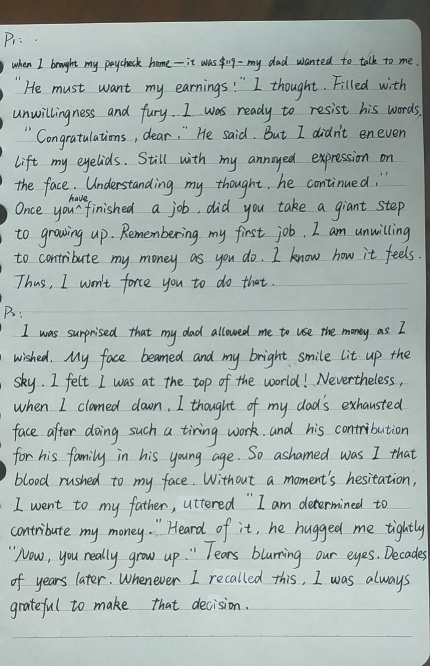

范文点评：

可取之处：

不足之处：

**范文（2）**

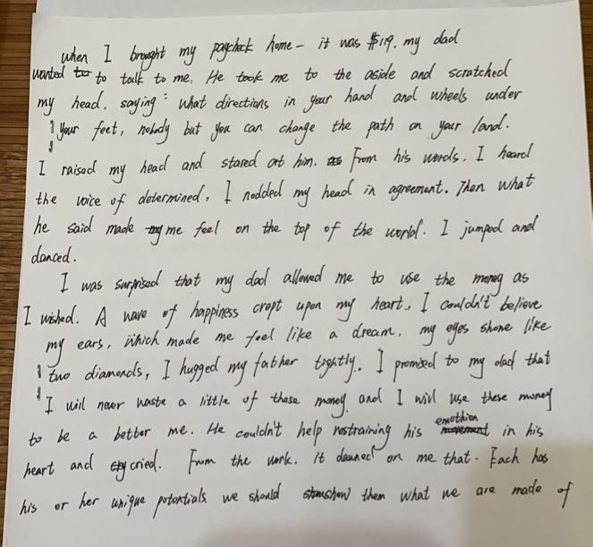

|  |  |
| --- | --- |
| **可取之处：** |  |
| **不足之处** |  |

A possible version： 原创

When I brought my paycheck home--it was$119--my dad wanted to talk to me. It was the last thing that I wanted to talk. with my heart pounding just like a deer, I had intended to slip back to my bedroom tiptoeing, when an aged voice set my heart racing, “Congratulations to you on the paycheck”, which made me thrown into a dark world and sank into hopelessness. The thought that I had been yearning for future trombone loomed up ahead of me again, tears beginning to blur my vision. Reluctantly, I moved inch by inch towards him ,curling my lips. Father gawped at me, lost in thought. So quiet was he that he said nothing. Maybe his first money rang a bell. Like a bolt out of the blue, he blurted out, “You can use the money as you wish, my son! ” With the words, he stumped off.

I was surprised that my dad allowed me to use the money as I wished. In a flash, my depression gave way to well-being. I grinned from ear to ear as if floating on the air. I determined to buy a new trombone without delay. However, when I looked out, gazing at my father’s receding figure with his legs hobbling, moving from side to side like a duck, a shred of guilt crept upon on me. My father worked his fingers to the bones to support the family, I shouldn’t have been so selfish. Moved by his figure, I rushed out and hugged him tightly, sobbing, “Dad, I am willing to contribute my money. I’ve grown up. I’ll share the family expenses with you.” Hearing this, my father smiled with tears in his eyes. From then on, we spoke our minds freely to each other.

**好词积累：**

|  |
| --- |
|  |

**Step7: Homework**

To sum up what you have learned in this lesson.

|  |
| --- |
|  |