**洗白袜子妙招与点赞人数**

**—2024年3月陕西省咸阳市二模应用文教学设计**

陕西省咸阳市礼泉县教研室 高小聪

**设计理念 (Design philosophy)：**

通过本节课的教学，了解如何写图表类（调查报告类）**应用文，**通过**《课标》对写作的要求**、 **解读写作任务**、**段落建构及语料建构**等步骤，为学生进一步写作搭建**“脚手架”**，并联系**高考调查报告类应用文**的写作，将范文设计成**语法填空**的形式，**感知词块、语法及连词的使用**，提高学生**写作整体迁移的能力**。

****教学目标（Teaching Goals）：****

After teaching this lesson, students will be able to:

1. know what factors should be included in a piece of graphical practical writing;

2. learn about the layout and contents of graphical practical writing;

3. write a piece of graphical practical writing;

4. Pay much attention to combine language input with language output effectively.

****教学步骤（Teaching procedures)：****

****Step1. Lead-in (明确《课标》对写作要求）****

1.“普通高中英语课程语言技能内容要求”：“必修 —在书面表达中借助标题、图标、图像、表格、版式等传递信息、表达意义。

2.“高中英语课学业质量水平二”：（2-13）能在书面表达中有条理地描述自己或他人的经历，阐述观点，表达情感态度/（2-14）能在表达过程中有目的地选择词汇和语法结构，确切表达意思，体现意义的逻辑关联性。

3.“高中英语课学业质量水平三”：（3-13）能通过书面方式再现想象的经历和事物，对事实、观点、经历进行评论。

****Step1. Interpret writing task (解读写作任务）（**Preparation for writing）**

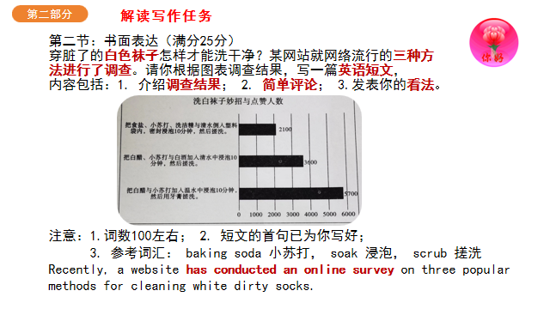

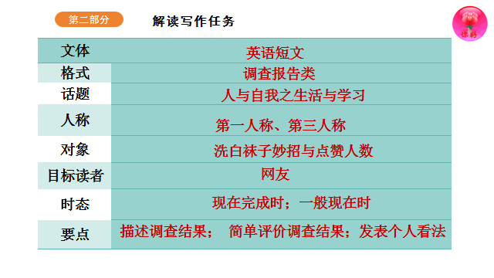

****Step3.Paragraph construction（段落建构）****

****Para 1. The beginning ：引言****

**要点1：对洗白袜子三种妙招调查。**

****Para 2. The body：调查结果+简单评价****

**要点2.洗白袜子三种妙招及点赞数（调查结果）**

**要点3：从洗白色脏袜子的有效性，环保性以及对棉织物 的保护方面入手。**

****Para 3.The ending ： 提出个人的看法****

**要点4：可根据个人的洗袜子的习惯选用一种妙招并说明好处。**

****Step4. Corpus construction（语料建构）****

****Para.1 The beginning ：调查报告的引言部分****

**(1).穿脏了的白色袜子怎样才能洗干净？某网站就网络流行的三种方法进行了调查。**

**① Recently, a website has conducted/carried out/made /done an online survey on three popular methods for cleaning white dirty socks.**

**② A survey has been carried out/conducted/made on three popular methods for cleaning white dirty socks on a website.**

**③ Recently, a website has carried out a survey on...**

**The results show that students have different attitudes towards...**

**④ Recently a survey has been done to find out what the netizens think of three popular methods for cleaning white dirty socks.**

**Para2. The body：调查结果**

**①如图表所示，把白醋与小苏加入温水中浸泡10分钟，然后用牙刷搓洗，这种方法获赞5700；**

**According to the survey/ As is shown in the chart/According to the figures given by the graph, the socks are soaked in warm water mixed with white vineger and baking soda for 10 minutes and then scrubbed with toothpaste, getting 5700 likes.**

**②然而，白醋、小苏与白酒导入清水中浸泡10分钟，然后搓洗，获赞3600；**

**while a mixture of white vineger, baking soda and spirits is used to soak dirty white socks for 10 minutes and later you can scrubb them , favored/liked by 3600.**

**③把食盐、小苏打、洗洁精与清水倒入塑料袋内，密封浸泡10分钟，然后搓洗。**

**The third way advises/ recommends/suggests putting dirty white shoes in a sealed plastic bag filled with salt, baking soda and dishwashing soap before scrubbing, given 2100 nods.**

**④ 该柱形图/横条形图/饼形图/曲线图描述/说明/显示……**

**The column chart/ bar chart / pie chart/ graph describes / tells / shows /displays...**

**Para3. The ending ：简单评价+ 提出个人的看法**

**① Obviously the first way rank first/ highest, while the third turn out to be the lowest. This is because natural washing supplies are better received than chemical ones.**

**②The survey demonstrates that most of us prefer natural washing supplies to chemical ones, which is harmful to our health and damage socks.**

**③ People’s preference for natural and household products over commercial whiteners is evident in these results. These methods are not only effective but also environmentally friendly.**

**Para3 The ending ：简单评价+ 提出个人的看法**

**① As for me/ In my opinoin/ As far as I can see/ As far as I’m concerned/Personally, I’m favor for the first way, which contributes to protecting our skin as well as socks.**

**② I hold the opinoin that the first eco-friendly way will not only remove the the most stubborn stains from white socks but also make them wear well.**

**③ In a word/ In short/ Generally speaking, opinions vary from one person to another on three popular methods for cleaning white dirty socks, of which I like the first way better.**

****Step5. Appreciate good writing &interlink Gaokao（范文赏析与链接高考）****

**Recently, a website 1 ______________(conduct)an online survey on three popular methods for cleaning white dirty socks. The results are as follows.**

**2_____is shown in the bar, soaked in warm water mixed with white vineger and baking soda for 10 minutes, socks 3______________(scrub)with toothpaste, getting 5700 4_______(like), while put in a mixture of white vineger, baking soda and spirits for 10 minutes, socks are washed 5___________(careful), favored by 3600 netizens. The third way advises 6_________(put) dirty white shoes in a sealed plastic bag filled with salt, baking soda and dishwashing soap before scrubbing, 7________(give) 2100 nods.**

**Obviously the first way rank the 8_________(high), while the third turns out to be the lowest. This is because natural washing supplies are better received 9________ chemical ones. As for me, the first eco-friendly way will not only remove the most stubborn stains from white socks but also make them wear 10_______(good).**

Learning English Beyond the Classroom

How will you arrange for your English extracurricular study? It is a going-on hot topic 1_________(launch) by our English newspaper.

The bar chart 2_______(show) that of all the four types, listening to English songs and watching English movies 3__________(account) for over half percent, 4_________(leave) reading English originals or scanning learning websites far behind 18% and 12% 5_____________(respective). Behind this phenomenon, we can find that it is much attractive to get 6____________(entertain) and relaxation from the top two, 7_______ the rest types are much tedious and dull.

In brief, I hold that we can make the proper decision 8____________ (balance) study and entertainment. English is 9_____ tool to learn more useful knowledge. We may make our life after class meaningful and 10 ____________(instruct), not just for a little fun.

****Step6. Reflection and Improvement（反思与改进）****

**2024年3月陕西省咸阳市二模应用文的特点**：

**创新度: 这道题要求根据有关洗白袜子妙招及点赞数调查结果，写一篇英语短文，密切联系生活常识，增加了新颖的写作场景和受众，提高了试题的实用性。**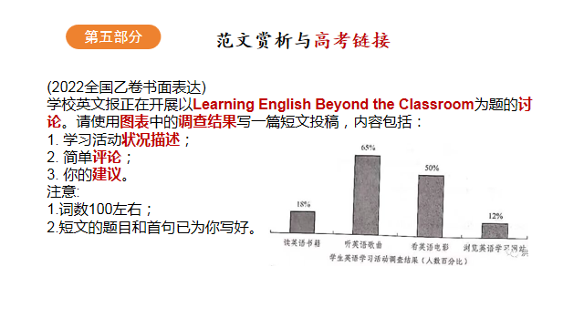

**综合性: 需要综合运用多项能力，包括对图表信息的概括能力、调查结果优劣的比较能力以及发表个人看法的独立思考的能力，是一项调动思维的综合性任务。**

**创意思维: 把"洗白袜子的妙招"这种生活小常识融入到应用文（调查报告），体现了创新思维能力和试题的原创性。**

**学生在应用文写作中存在的主要问题：**

**1.读者意识不明确； 2. 体裁结构不明晰；3. 词汇贫乏词不达意；**

**4.语法错误层出不穷；5. 文章内容不充实；6.文章结构不合理等。**

**提高学生的写作能力，是一个循序渐进的过程：**

**1. 注重语言输入，尤其注重阅读教学，将泛读与精读有效结合，分析文章的体裁、结构框架、语言框架、情感框架，勾画出文章的思维导图，为有效的输出提供坚实的基础。**

**2. 结合单元话题， 进行写作常考话题作文的训练，积累和补充话题词块及句型，做到天天一小练（50-80words），一单元一大练（话题作文80words左右）。**

**3. 根据《高中英语新课标》，对规定的内容进行全面覆盖、重点训练。**

**4. 有效讲评，给出作文评价量表，将学生自评、生生互评和老师讲评相结合，发现问题、解决问题，在限定实践内重新写作，而不是仅仅去抄写范文。**