
选择性必修一Unit 1 People of achievement
Period 3 Using language2--Introduce someone you admire
教学设计

Teaching Aims:（教学目标）
1.To learn Albert Einstein’s life and his achievements.
2.To figure out the organization and language features of the text.
3.To identify how to introduce someone you admire.
4.To write an introduction about someone you admire.
Teaching procedures:（教学流程）
Step1：Lead in—Guessing
- Guess who the person is according to the given clues.
①a Jewish
②Nobel prize winner Albert Einstein
③The theory of relativity
2. Some famous quotations from Albert Einstein.
Step2：Pre-reading
Video Time: Albert Einstein
Step3：While-reading
- Read for the genre
What's the genre of the text? A. Exposition B. Narration C. Argumentation D. Practical writing
- Read for the structures
Read the text and summarize the structure of the passage? Title ; Lead; Body :End
- Analyzing the text
①Title: 
1. Let the reader know the content directly or arouse the readers' interest by giving some information.
2. A good title can be brief but eye-catching, indicating the content.
②Lead:
Albert Einstein ,who is perhaps the greatest scientist in modern physics ,is often considered one of the smartest men who ever lived. He made numerous contributions to the world , the most well-known being the general theory of relativity and the famous formula E= mc². Einstein was not only a genius ; he was a courageous and kind figure loved by many people.
“What’s the main idea of the text?” Albert Einstein’s life and his achievements.

Lead：
1. Introduce the topic of the passage.
2.General introduction of Albert Einstein and his great contributions.
③Body:
How does the writer develop the text? In chronological order.(按年代次序地)
Activity :Read the passage and make a timeline of his life.
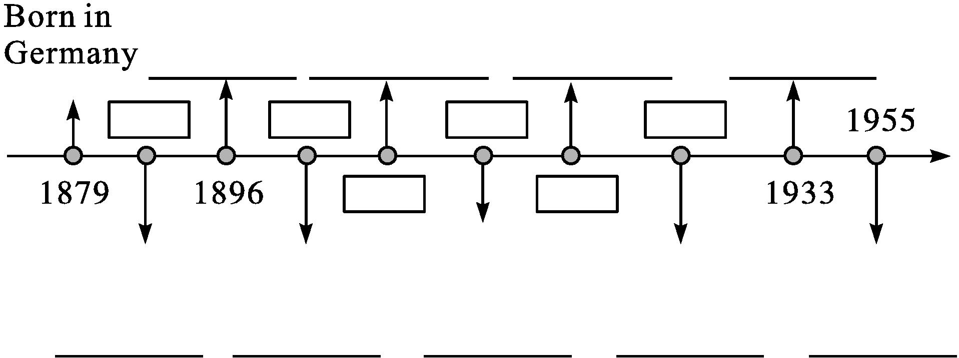
④End:
Find the descriptions that tell us what Einstein looked like and what kind of person he was.
⑤Analyzing language features.
What rhetorical devices are used in the passage? Give examples.
Step4: Post-reading—Summary
1.The structures of the text.
2.What aspects are included while writing a biography or introduction of a certain person?
Step5: Writing
Write an introduction about someone you admire：
①Choose the person you are going to write about.It should be someone you think is great in some way.It can be an ordinary person,such as a parent,a relative,or a friend.
②Make a list of things that need to be included in your introduction.
③Finish and revise your draft with your partner.
④Share your writing.
Step6: Show time
Step7: Homework
你校英语俱乐部将举办主题为“My Hero”的讨论活动。请你用英语写一篇发言稿，介绍你心中的英雄。
要点包括：
1. 他/她的职业；
2. 他/她可称为hero的理由；
3. 你对hero的理解。
注意：1. 词数80左右；
2. 开头和结尾已给出。
Good afternoon, everyone
____________________________________________That's all. Thank you!

