应用文写作之推荐信

假定你是李华，某国际学校学生。新学期学校开设了文学、科技和摄影三个社团，你校新西兰交换生Biff不知如何选择，写信向你求助。请你给他回信，内容包括：

1.推荐某一社团；

2.简介该社团；

3.告知申请方式。

参考词汇：

文学社 the literature club

科技社 the science club

摄影社 the photography club

注意:1.词数80左右；

2.可适当增加细节，以使行文连贯。

**审题1:试题信息的取舍**

|  |  |
| --- | --- |
| 信息点 | 是否要写，写什么？ |
| 你是李华，某国际学校学生 |  |
| 新学期学校开设了文学、科技和摄影三个社团 |  |
| 你校新西兰交换生Biff不知如何选择，写信向你求助。 |  |
| 简介某一社团 |  |
| 申请方式 |  |
| 格式 |  |

**审题2:框架结构要点 Structure+Points**

**Paragraph 1: Background +purpose**

新学期学校开设了文学、科技和摄影三个社团，你校新西兰交换生Biff不知如何选择，回信给予帮助。

**Paragraph 2: Body**

简介某一社团 (文学社 the literature club，科技社 the science club，摄影社 the photography club选其一)

**Paragraph 3: Conclusion**

申请方式＋收尾

Para.1 background (背景信息) ＋ writing purpose（写作目的）

新学期学校开设了文学、科技和摄影三个社团，你校新西兰交换生Biff不知如何选择，回信给予帮助。

1. Knowing that you are stuck in choosing the club, I’m delighted/ willing/honored to do you a favor/lend you a hand/offer my advice.

2. Sorry to learn that you have trouble in/have no idea about choosing the club, I’d like to offer my recommendation./I’m dropping these few lines to keep you informed of the ...club.

3. I am sorry to learn that you are at a loss about choosing the club, and I highly recommend you choose the ...club.

Para.2 某一社团＋简介＋（申请方式）

1. What tops my recommendation is the literature club.

2. ...I highly recommend you choose the literature club. (第一段)

What puts the literature club at an advantage is its precious chance to savor/relish the glamour of ...

3. The reason why I recommend the literature club is...

4. What is highly recommended is...

5. The literature club has varieties of activities which are tailored to meet your requirements./to/for you.

文学社 the literature club简介:

1. 开展写作、辩论、诗歌朗诵等比赛，陶冶参与者情操，锻炼参与者能力，丰富校园文化生活;

1. carry out the contest about writing, debate and poetry reading，which will cultivate our mind, practice the abilities and add spice to our campus life;

2. 请校内外专家学者开展系列文学讲座，拓宽视野，增长见识；

2. invite the experts in and out of our school to deliver lectures, broadening our horizons/views and expanding the knowledge;

3. 举行趣味猜谜活动，使我们对中国文学有更深入的了解;

3. There are funny riddle guessing games as well, which makes it possible for us to gain a deeper glimpse into Chinese literature;

4. Not only can it boost your integrated skills, but also enables you to perceive the importance of Chinese literature;

Interpreted as the most appealing club, the literature club carries out several contests about writing, debate and poetry reading, which will cultivate our mind, practice the abilities and add spice to our campus life. Besides, some experts are always invited to deliver lectures, broadening our horizons/views and expanding the knowledge. There are funny riddle guessing games as well, which makes it possible for us to gain a deeper glimpse into Chinese literature.

科技社 the science club:

1. do/conduct researches/experiments, not only can you have a deeper understanding of the universe, but you can obtain great knowledge about science.

2. stir up your passion for science and help you to explore the unknown secrets about the world.

3. visit the museum and appreciate the technological works, which will certainly trigger your interest

and curiosity, finally sowing the seed of innovation and creation in your future.

What is highly recommended is the science club, where you can conduct researches, not only can you have a deeper understanding of the universe, but you can obtain great knowledge about science.

Besides, we can visit the museum and appreciate the technological works, which will certainly trigger your interest and curiosity, finally sowing the seed of innovation and creation in your future.

摄影社 the photography club:

1. offter a fantastic chance to learn and practice photographing,which will equip you with rich knowledge about photogaraphy, get your skills improved and relieve yourself.

2. It’s a perfect place to relish masters’ masterpieces, here you can enjoy the unique charms of the pictures, totally bathed in the glamour of photography/ which is a true feast both for our mind

and soul.

The photography club is a perfect place to relish masters’ masterpieces, here you can enjoy the unique charms of the pictures, totally bathed in the glamour of photography/ which is a true feast both for our mind and soul. In addition, it offters a fantastic chance to learn and practice photographing, which will equip you with rich knowledge about photogaraphy, get your skills improved and relieve yourself.

Para.3 （申请方式）＋结尾：

1. If it’s the club you’re looking for, don’t hesitate to sign up at literatureclub@126.com.

2. Please send your application form to literatureclub@126.com.And I bet it won’t let you down.

3. It’s such a fabulous club that you can’t afford to miss, so join it by contacting Tom at 13346578967.

4. If you are interested, you can fill in an application form on the school website before Dec.31.

Possible version:

Dear Biff,

Learning that you have trouble in choosing the club, I’d like to offer my recommendation.

Interpreted as the most appealing club, the literature club carries out contests about writing, debate and poetry reading, which will cultivate our mind, practice the abilities and add spice to our campus life. Besides, experts are always invited to deliver lectures, broadening our horizons and expanding the knowledge. There are funny riddle guessing games as well, making it possible for us to gain a deeper glimpse into Chinese literature.

Therefore, don’t hesitate to sign up at literatureclub@126.com.

97w

Yours,

Li Hua

参考范文：

Dear Biff,

Knowing that you are at a loss when choosing an appropriate club to attend, I am writing to recommend the literature club and keep you informed of some information about it.

The club gathers its members on Thursday, from 4:00 p.m. to 5:00 p.m. Enjoying a high popularity among students, the club is bound to bring you into a magical world of literature, providing you a platform

where you can communicate with great minds in those masterpieces. If possible, some particular literature salons will be arranged on a regular basis. Please send your application form to literatureclub@126.com.

I’m sure your participation will be highly welcomed.

Yours,

Li Hua

Dear Biff,

Sorry to learn that you are at a loss about choosing the club, I’m delighted to do you a favor.

What is highly recommended is the science club, where you can conduct researches, not only can you

have a deeper understanding of the universe, but you can obtain great knowledge about science. Besides, we can visit the museum and appreciate the technological works, which will trigger your interest

and curiosity, finally sowing the seed of innovation and creation in your future.

It’s such a fabulous club that you can’t afford to miss, so join it by contacting Tom at 13346578967.

Yours,

Li Hua

3.

Dear Biff,

I am sorry to learn that you are stuck in choosing the club, and I’m dropping these few lines to keep

you informed of the photography club.

The photography club is a perfect place to relish masters’ masterpieces, here you can enjoy the unique

charms of the pictures, totally bathed in the glamour of photography/ which is a true feast both for our mind

and soul. In addition, it offters a fantastic chance to learn and practice photographing, which will equip you

with rich knowledge about photogaraphy, get your skills improved and relieve yourself.

Please send your application form to literatureclub@126.com. And I bet it won’t let you down.

Yours,

Li Hua

1.审题有误——介绍了三种club, 没有聚焦某一俱乐部，离题

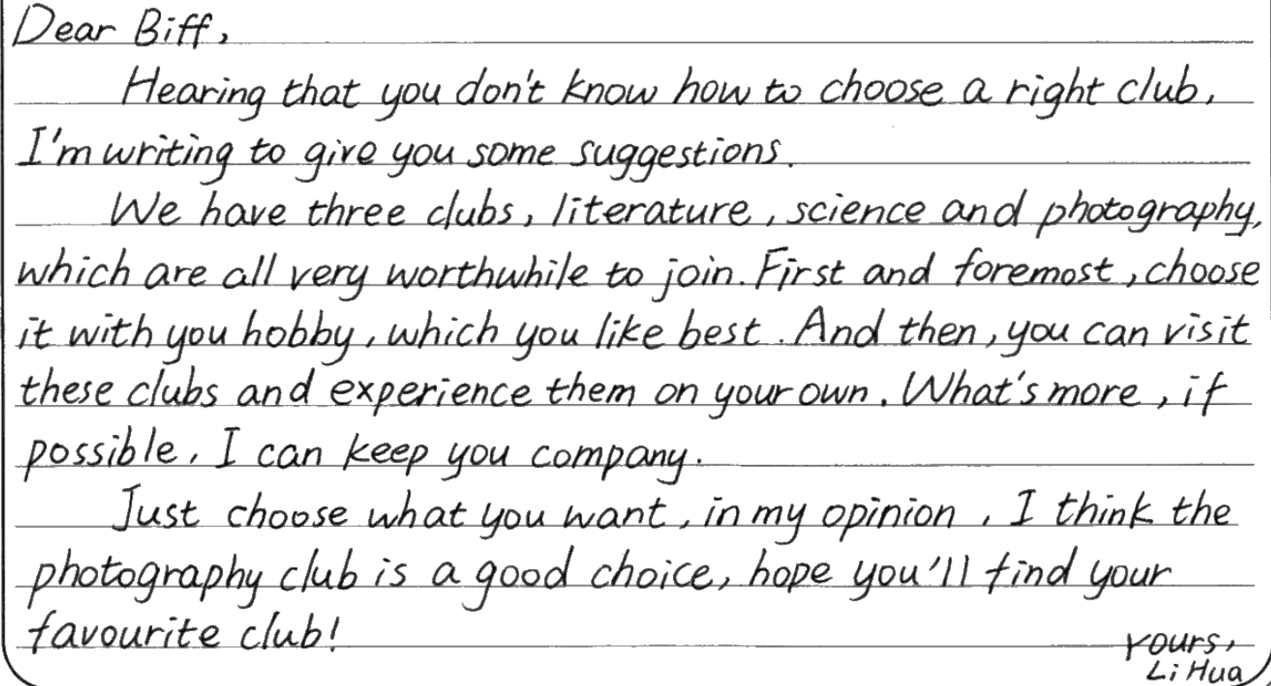

2.字迹工整，语言准确并优美，句型结构丰富，值得大家学习。

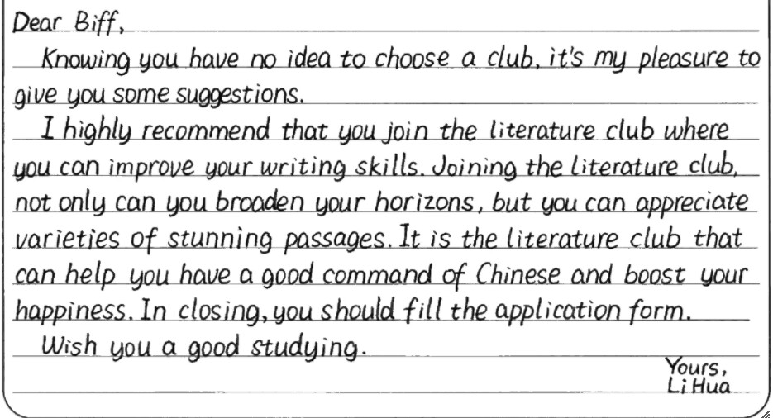

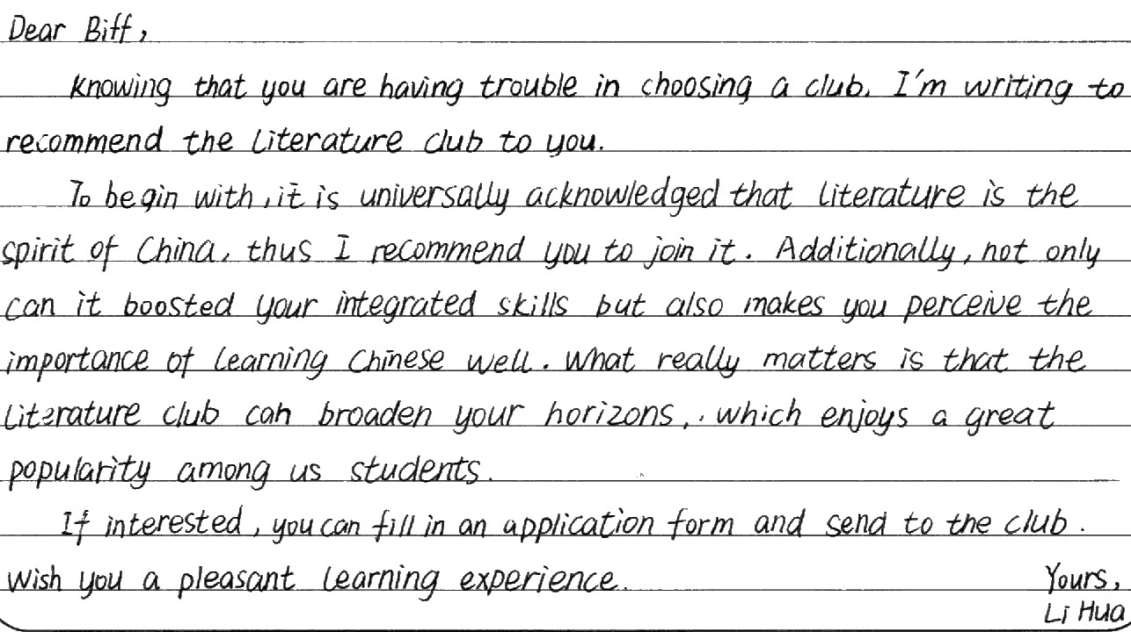

1. 难得的一篇关于the photography club的作文，虽然有些许语言错误，但还是有可圈可点之处.

